Universities in Crisis: What We Need to Know

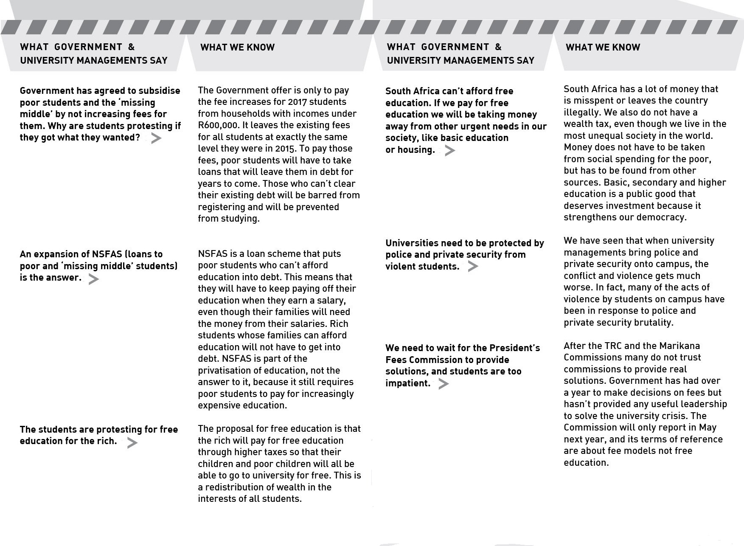

Free Education for All
The Free Education for All model moves away from the idea of education as a privatised commodity. It conceptualises education as a public good for the benefit of all that must be funded via the state that collects our taxes - in this way all of us pay.
The funding for HE therefore shifts from a model of fees + state funding + private donors to one that is primarily state funding. State funding of HE as a percentage of GDP would therefore increase to a level more in line with global standards. No one should pay up-front fees or registration costs. This means the poor students don’t have to go through dehumanizing means testing. It also means that poor students do not leave HE with an extra debt to carry. All students will pay back through contributing to society.
This model has been critiqued by some as being Free Education for the Rich since the rich also won’t have to pay fees. However, the rich will pay through taxation. 1) The rich can pay more taxes to this end: only 10% of High Net Worth Individuals (who earn over R7million a year) are registered tax payers. If this is increased to just 50%, an extra R92 Billion is made available. 2) Illicit cash flows to the value of hundreds of billions of Rands have left SAA since 1994, which could otherwise have been taxed. 3) A wealth tax of the richest 10% of the population is the most efficient and democratic way to get the rich to pay for education and these funds are sufficient to also pay for other social goods such as healthcare. 4) The Auditor-General also found (2014 and 2015) wastage amounted to over R60 billion. So the R40-R50 billion needed for ‘free’ education exists.
In this model, if rich students study overseas or in private institutions, or are not studying at all they’ll still be contributing to higher education through their (parent’s) tax unlike the state’s proposal. ‘Third Stream Funding’ by private donors should be put into a common pot and redistributed to supplement the ‘HBI’.
Free Education for the Poor
The slogan ‘Free Education for the Poor’ is the most talked about but the model has hardly been developed. Most people using this slogan actually propose a model similar to the government’s position which is a debt-funded model (see next panel).
This model is premised on means testing in which students have to prove their parent’s income. This requires a standard of who counts as ‘poor’ – a superficial classification that currently even excludes the working poor such as mineworkers. This is why the ‘missing middle’ has become an important group in the debates – those that are too poor to afford fees but too rich for NSFAS and have to go to the banks for loans.
In this model the universities would still run on a fees model but the government pays the university on behalf of poor students as a form of bursary (not a loan as it currently is). Students defined by means testing as ‘poor’ would leave the university system without any debt. State funding of HE would have to either go directly to the institution or through an intermediary and would have to increase.
Rich students are envisioned to voluntarily contribute to HE by paying increased fees, despite that most universities have only a small population of rich students. This encourages universities to focus on attracting more rich students and encourages rich students to leave the public education sector thus leaving the sector underfunded.
In this model ‘Third Stream Funding’ by private donors is left unregulated which increases the inequality between universities. Currently the third stream funding inequalities mean that Wits receives 45% of its funding from private sources while the average is 30% and the University of Limpopo only receives 10%. This also leaves universities susceptible to volatile economic pressures.
Current Government Position
In September 2016 Minister Blade Nzimande announced the government’s position on how to address the funding crisis at universities in 2017:
- 0% increase in fees for poor and ‘missing middle’ students (everyone whose household income is less than R600 000).
- An increase of up to 8% for students earning more than R600 000 determined by each university.
This position is thus not a model for free education. It’s a no fee increase position for 2017 that maintains the payment model in which the fees of poor students are paid to the universities through NSFAS. It also maintains a debt model in which poor and missing middle students (who are mostly also poor in terms of generational wealth) have to repay those loans at a later date. This contributes to the debt cycle of poverty and ignores the huge debts that poor families already deal with including Black Tax, house repayments etc., while rich students will walk out of university without any debts to pay off.
This model also perpetuates the idea that education is a commodity to be bought and sold, and valued for its capacity to improve individuals rather than as a public good aimed at benefitting South African society broadly.
This model’s reliance on NSFAS entrenches the debt cycle, is not sustainable (low repayment rates), allows for increased corruption, and directs state resources via a financial intermediary rather than directly thus increasing costs.
The government’s model also leaves ‘Third Stream Funding’ intact thus perpetuating inequalities (see middle panel). In the logic of this model, more and more people will end up being excluded from HE due to financial reasons.
Other Issues
Autonomy – Some have argued that if the state pays for HE, then universities should become state institutions. As called for in the ANC’s slogan “AutonomyMustFall”. Universities should work in the collective public interest not the state. Universities cannot do without autonomy from state power but neither can they do this without state funding. Hence we want autonomous institutions that are state funded and accountable to communities.
Private universities – It has been suggested that the crises in higher education will lead to a proliferation of private higher education universities. The government has recently put in place measures to allow this to occur. This is absolutely not to the benefit of the collective public interest. The rich should not be allowed to opt out of public institutions. Privatisation will increase inequality.
Graduate Tax - A graduate tax will increase the burden on new graduates, many of whom are first time graduates in their families and thus have extensive other demands on their incomes alongside their NSFAS and/or bank loan repayments. In addition there are a significant amount of rich people without degrees or major income who would be left off the hook. Therefore the tax models on the super-rich (by income and wealth) are more redistributive.
It is vital that we also struggle for free and quality Early Childhood Development and Schooling which we don’t have at present.
Not only tuition fees but the full cost of study is necessary for success at university, including: registration; meals and accommodation; books, equipment and travel.
Beneficiaries of HE, all students, should be expected to contribute to society when leaving university through community service and by working in public institutions after graduation. Equal participation in the benefits of public funding by virtue of citizenship would support the creation of socially cohesive attitudes amongst students rather than differentiating between ‘rich’ and ‘poor’ students.
Questions to Debate
- What effect does debt have on your life and on the lives of those in your community?
- What are your experiences of means-testing?
- Should the rich contribute to HE voluntarily or should they be required to contribute to the collective interest?
- What is access? Getting your foot into the door and/or what happens afterwards when you are inside of the institution?
- Should HE be imagined as a public or individual good?
- What is your ideal university system? What would a public, decolonized African University look like?
- What could replace commissions as the way forward?
- How does a free decolonized HE sector benefit all aspects of society?
Resources
- Pathways to Free Education - https://drive.google.com/file/d/0B6dVO9Lj0oLkTkVtT3lxVHYwRlE/view
- The Conversation - https://theconversation.com/free-education-is-possible-if-south-africa-moves-beyond-smoke-and-mirrors-65805
- Submission to the commission for Free Education - https://www.uj.ac.za/faculties/facultyofeducation/cert/Documents/CERT%20FEES%20COMMISSION%20SUBMISSION%20Hlatshwayo_Maharajh_Marawu_Motala_Naidoo_Vally.pdf
- Why Neoclassical Arguments against Free Education are Bullshit https://drive.google.com/file/d/0B8t2tgFHF8teOFFXQVFHblI0MGM/view
- Forslund, Dick and Rudin, Jeff. 2015. ‘Paying for University Education’. Amandla Issue 43/44 December p14-15
Higher Education Funding Models
The new student movement in South Africa has had a few major thrusts: decolonization including of the curriculum, ending racism, patriarchy, anti-privatisation which has criticized the exponential increase in student fees and the corporatisation of our universities. This pamphlet is concerned with funding, although it is understood that financial access to education cannot be separated from the critique of the corporatized and colonial nature of the university.
The funding crisis at universities comes from two developments in higher education:
1. The number of students at universities has doubled since the end of apartheid (the proportion of black students has increased from 52% to 81% since the end of Apartheid). This is a very positive development for our democracy, but at the same time 200,000 qualifying matriculants are still excluded from Higher Education (HE) for financial reasons.
2. Government has not funded this increase in student numbers properly, so the amount of money given by government per student has dropped every year. This has created a funding crisis at universities, and universities have had to recover their costs by increasing student fees, which have increased every year beyond inflation. It has also led to a reduction in student support programs and mass lectures thus increasing the push-out rate such that over 50% of students don’t get their first degree but are saddled with debt. The funding crisis is turning our universities from quasi-public institutions to private institutions, which exacerbates the financial exclusion of the poor

