Time Value of Money – EEE3078 Tutorial

Brief introduction to the TVoM software
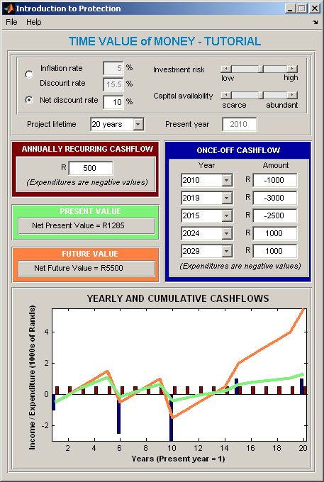
The Time Value of Money (TVoM) software shown above, along with this tutorial, have been developed to illustrate the impact of inflation and discount rates on the cash flows of a project, i.e. how time influences the value of money in a project.
The top-most part of the TVoM window above allows the user to enter either the inflation / discount rates, or the net discount rate relevant to the specific project. These rates are correlated to one another, and to the investment risk and capital availability of the project; the software automatically updates the correlated values if any one is changed.
The lifetime of the project, i.e. 10, 15 or 20 years, can also be selected. For simplicity, it is assumed that the present year (i.e. the first year of the project) is 2010.
Annually recurring income / expenditure along with five once-off incomes / expenditures can be entered. These values are shown on the graph at the bottom of the window (colour coded) along with the cumulative present value and future value. The green cumulative present value graph adds each year’s income / expenditure, converted to its present value, to the total. In the same way, the orange future value graph adds each year’s income / expenditure, but with no present value conversion.

1 – Download and open TVoM in MATLAB
- Save the ‘TimeValueOfMoney - software.e’ file that was emailed to you into a folder on your PC.
- Rename this file to ‘TimeValueOfMoney - software.exe’ (email don’t like .exe files!)
- Run this program on your PC, and install into a new folder of your choice, e.g. c:\tvom
- Open Matlab
- Change Matlab’s current directory to the folder that you installed into during step c.
- Run tvom.m in Matlab

2 – Background to inflation, discount and net discount rates
- How are the inflation, discount and net discount rates linked to one another mathematically (supply the formula)?
The formula links all three rates mathematically, where the factor r – 1 is called the net discount rate
- Using the mathematical relationship above, calculate the net discount rate, given an inflation rate of 2% and a discount rate of 7%.
r = (1+0.07) / (1+0.02) = 1.049
therefore the net discount rate is 1.049-1 = 0.049 = 4.9%

- Net discount rates of around 3% to 6% are typically used for projects in developed countries like the USA, while net discount rates of 8% to 15% are used in developing countries like South Africa. Explain how the availability of capital and the investment risks associated with the project defines the net discount rate used.
Net discount rate is a composite indicator of the opportunity cost of capital. If capital is scarce, the investor will expect a high yield on the investment as reward for using the scarce capital to invest. Similarly, if the investment risk is large the investor will expect a large return on the investment to justify the risk.

- Click on the top one of the two radio buttons (a radio button looks like this: ) in the TVoM software and enter an inflation rate of 2% and a discount rate of 7%. Notice that the net discount rate is automatically recalculated, and that the capital availability and investment risk sliders are adjusted to reflect the project scenario. Note down these values, making sure that the net discount rate agrees with your calculations in 2b)
Net discount rate:………………4.9%……………………….
Capital availability:……………abundant…………………………
Investment risk:………………low…………………………
- Click on the bottom radio button and enter a net discount rate of 10%. Note down these values:
Net discount rate: 10%
Capital availability:…………towards scarce……………………………
Investment risk:………………towards high…………………………

3 – The concept of present value
- Assume that the present moment is 1 January 2010. Two project expenditures of R60 000 each is planned for 2012 and 2017 respectively, that is year 3 and 8 of the project. Assuming a net discount rate of 10%, calculate the present values of these expenditures using a mathematical formula.
Using the formula with r = 1.1 and Cn =-R60000:
n=3: PV = -R45 079
n=8: PV = -R27 990

- Interpret your answer. Why is expenditure 8 years in the future worth so much less in present value terms than expenditure 3 years in the future?
A way of understanding this concept is to take think about the results of investing the R27 990 in the present in a bank account with 10% interest per year. In 8 years time the investment would have grown to R60 000.
Looking at it the other way around: the further into the future that an expense occurs, the less its impact on the present value of the project. This is because the capital required for this expense is only tied up into the project further into the future, with the associated loss in potential investment earnings from this capital therefore also occurring only later.

4 – Once-off and annually recurring income / expenditure
- Assume that a project with a lifetime of 20 years has an income of R15000 per year in current prices. Assuming a net discount rate of 10%, calculate the present value of these annually recurring incomes using a mathematical formula.
Using the formula , with r = 1.1, n = 20 and Ca =R 15000, PV = R127 703

- How is the net present value calculated?

All the incomes and expenditures of a project are converted to present value, and added together.
- What would be the net present value of the project described in 4a), assuming two once-off expenditures of R60 000 in years 3 and 8, as calculated in 3a)? Would you invest in this project?
NPV = -R45 079 + -R27 990 + R127 703 = R54 634,
Yes, the NPV is positive / shows net income
- Select a net discount rate of 10%, and a project lifetime of 20 years in the TVoM software window. Now enter an annual recurring cash flow of R15000, and two once-off expenditures, of -R60 000 each in 2012 and 2017. Note down the net present value (NPV) and net future value (NFV), and verify that the NPV calculated by the software is the same as your answer in 4c).
NPV:………………R54634………………..
NFV:…………………R180000…………………….
- The resulting yearly and cumulative cash flows should look similar to the graph below, with the green graph representing cumulative present value and the orange graph cumulative future value:
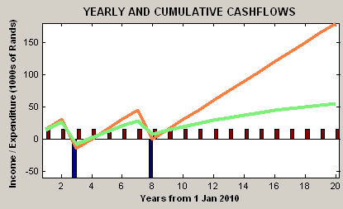
- Now change the 2017 –R60 000 once-off expenditure to rather occur in 2028. The resulting graph should now look as follow:
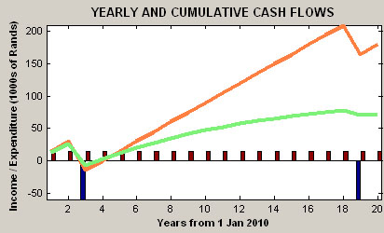
- What are the new NPV and NFV?
NPV:……………R72814………………………………
NFV:……………R180000………………………………
- Why is the NPV of the project so much higher when the R60 000 expenditure is delayed until 2028 instead of 2012?
The present value of the 2028 expenditure is so much less than if it were to occur in 2012.

This work is licenced under the Creative Commons Attribution-Non-Commercial 2.5 South Africa License. To view a copy of this licence, visit http://creativecommons.org/licenses/by-nc/2.5/za/ or send a letter to Creative Commons, 171 Second Street, Suite 300, San Francisco, California 94105, USA.

