Introduction to Protection - EEE4089F Tutorial

Due date: 16h00 Friday 13 April 2007

Brief introduction to the ProtectionIntro software
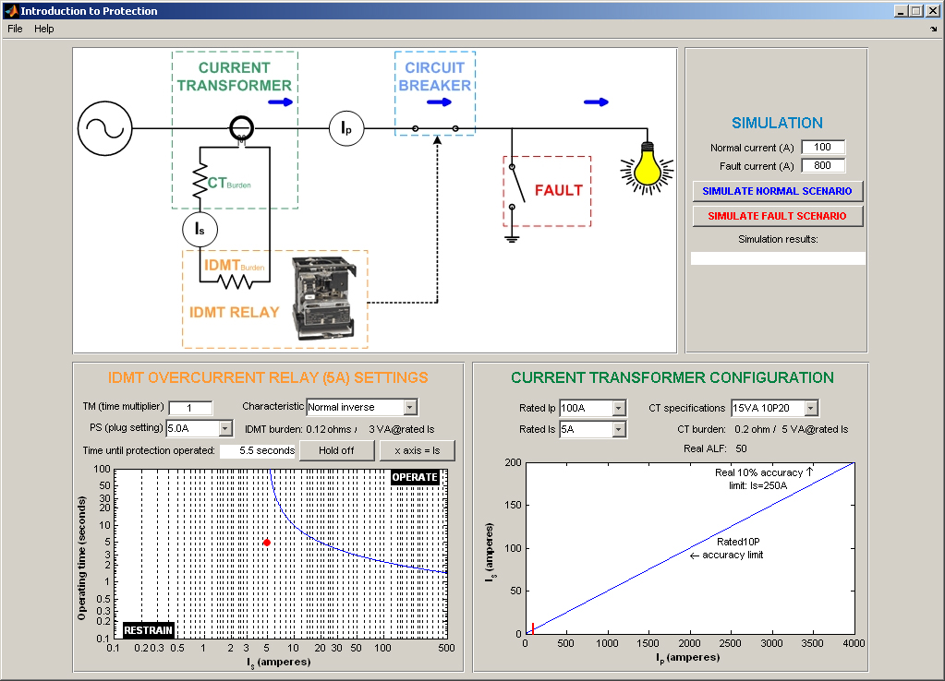
The ProtectionIntro software, shown above, simulates a basic feeder that transfers power from a source through a circuit breaker to a load, represented by the light bulb, or through a faulty short-circuit to ground.
The ‘Current Transformer’ (CT) measures the current in the feeder (I_{P}). The size of the current in the secondary winding of the CT (I_{S}) is a function of I_{P} as graphed in the ‘Current Transformer Configuration’ window area. The short red vertical line in the graph represents the operating I_{P} when simulating, while the actual and rated accuracy limit factors are also shown. The settings in this window area specify the configuration of the CT.
The ‘IDMT Relay’ is configured by adjusting the settings in the “IDMT Overcurrent Relay (5A) Settings’ window area. The resulting operate/restrain curves as a function of I_{S} or I_{P} (depending on whether the ‘x axis’ button has been selected or not) and operating time are shown in this window area’s graph. The red bullet represents the operating point of the system during simulation.
Pressing either the ‘Simulate Normal Scenario’ or the ‘Simulate Fault Scenario’ buttons in the ‘Simulate’ window area simulates one of two operating scenarios. During the Normal scenario the ‘Circuit Breaker’ contact is closed and the ‘Fault’ contact is opened, and I_{P} equals the value entered in ‘Normal Current’. During the Fault scenario the ‘Circuit Breaker’ and the ‘Fault’ contacts are closed, and I_{P} equals the value entered in ‘Fault Current’. Once the ‘IDMT Relay’ triggers the ‘Circuit Breaker’ to open, I_{P} is zero. The results of the simulation and the operating time of the relay are shown by ‘Simulation results’ and ‘Time until protection operated’.

1 – Download and open ProtectionIntro in MATLAB
- Go to Vula, Resources, Tutorials and Tests, and download ‘Basic Protection Tutorial.exe’
- Run this program on your PC, and install into a new folder of your choice, e.g. c:\protection
- Open Matlab
- Change Matlab’s current directory to the folder that you installed into during step b.
- Run protectionintro.m in Matlab

2 – Protection background
- Why is over-current protection required for the feeder shown in ProtectionIntro?

- Why not just use an instantaneous relay instead of an IDMT relay to protect the feeder? Such a relay will be both cheaper and less complex than an IDMT relay.

- What is the use of a CT? Why not just connect the relay directly to the feeder?

3 – Understanding the effects of CT settings
- Select a ‘CT specification’ of 5VA 5P20 in the ‘Current Transformer Configuration’ window area. What does the 5VA, 5P and 20 values represent? Select some of the other ‘CT specification’ values and note the dependency of both the rated and the actual accuracy limits on these specifications.

- Set ‘Rated I_{P}’ to 50 A and ‘Rated I_{S}’ to 5 A. From the I_{P} versus I_{S} curves in the ‘Current Transformer Configuration’ window area, read the maximum feeder current for which the CT specified in 3a. will still operate within its rated guaranteed accuracy. How was this value calculated?

- Using the ProtectionIntro software, find the theoretical magnitude of I_{S} for a feeder current of 1900 A? Is the CT still accurate at this current for the rated relay burden?

4 – Understanding the effect of IDMT Relay settings
Four settings specify the shape of the operate / restrain curves for an IDMT relay: the PS, TM and characteristic settings of the relay and the ratio of the CT. The following tasks will illustrate the impact of each of these settings.
- Select ‘TM’ = 1, ‘PS’ = 10 A and a Normal Inverse ‘Characteristic’. Now click on the ‘Hold’ button to select hold on, thereby allowing multiple operate / restrain curves to be plotted in the graph area. Plot the operate / restrain curves for ‘PS’ = 10 A, 5 A and 2.5 A, and reproduce the curves on the provided axes below. Label each curve clearly. Record how the internal resistance of the IDMT relay as seen by the CT (‘IDMT burden’) changes as PS changes.
IDMT internal resistance, as seen by CT (ohms)
PS = 10 A
PS = 5 A
PS = 2.5 A

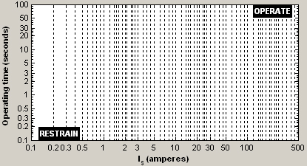
- Explain how the physical construction of an IDMT relay causes its internal resistance, as seen by the CT, to change as a function of the PS value as seen in 4a.

- Toggle ‘Hold’ to off. Select ‘TM’ = 1, ‘PS’ = 5 A and a Normal Inverse ‘Characteristic’. Toggle ‘Hold’ on, and plot the operate / restrain curves for ‘TM’ = 1, 0.5 and 0.1, reproducing these curves on the provided axes below. Label each curve clearly.

- Toggle ‘Hold’ to off. Select ‘TM’ = 1, ‘PS’ = 5 A and a Normal Inverse ‘Characteristic’. Toggle ‘Hold’ on, and plot the operate / restrain curves for the four different ‘characteristics’, reproducing these curves on the provided axes below. Label each curve clearly.

- Toggle ‘Hold’ to off. Toggle ‘x axis=Is’, thereby changing the x-axis of the operate / restrain graph to represent I_{P}. Select ‘TM’ = 1, ‘PS’ = 5 A, a Normal Inverse ‘Characteristic’, a ‘Rated Ip’ of 100 A and a ‘Rated Is’ of 5 A. Toggle ‘Hold’ on, and plot the operate / restrain curves for ‘Rated Ip’ = 100 A, 50 A and 10 A, reproducing these curves on the provided axes below. Label each curve clearly.
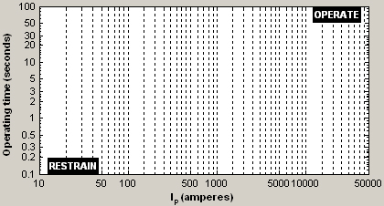

5 - The importance of CT and Relay burdens in CT configuration
The rated ALF for a CT is normally specified by the user according to the system parameters (particularly operating current and fault current). However, this rated ALF is only valid if the IDMT burden is equal to the accuracy load of the CT specification. The IDMT burden is however a function of the PS settings of the IDMT relay, as shown earlier, and the resistance of the wire connecting the CT to the relay.
- The schematic below presents a simplified model of the protection CT secondary winding connected to an IDMT relay. Assuming that I_{M}, the magnetising current, is negligible, calculate the actual accuracy limit factor, given the following values: R_{IDMT} = 0.5 ohms, R_{CT} = 0.2 ohms, R_{line} = 1 ohms, CT specification = 5VA 5P20 and I_{Srated} = 5 A
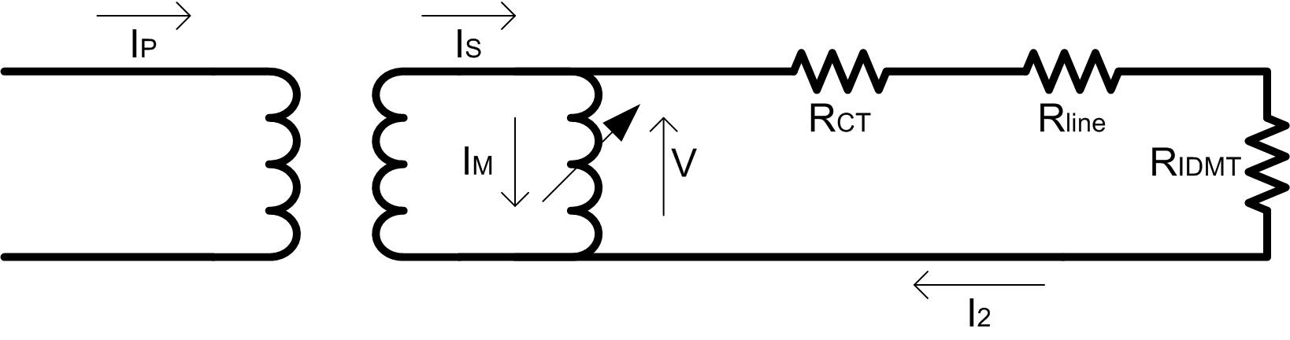

- Note that the actual ALF ( = 4.7 ) calculated in 5a. is much lower than the rate ALF ( = 20 ) due to the high resistance of the wire connecting the CT to the relay. Name a reason why CTs with Is ratings of 1 A are usually used in power system applications, while CTs with Is ratings of 5 A are standard for most other industry applications.

- Configure the CT and IDMT relay settings as follow: Rated I_{P} = 100 A, Rated I_{S} = 5 A, CT specification = 5 VA 5P20, TM = 0.2, PS = 2.5 A, Normal Inverse, Normal current = 50 A, Fault Current = 1300 A. Click on ‘Simulate Normal Scenario’ and verify that the protection does not trigger. Now click on ‘Simulate Fault Scenario’. What is wrong with the protection configuration in this scenario, and how can this be corrected?

6 – Exercises
Make use of the ProtectionIntro software to verify your answers to the following exercises:
- A 5 A normal inverse IDMT relay is connected to a 100 A / 5 A protection CT. The relay settings are PS = 4 A and TM = 0.2. Calculate the operating time for a primary current of 800A. Normal inverse: t = 0,14 * TM / ((I/PS)^0,02 - 1)

- A 5 A normal inverse IDMT relay is connected to a 100 A / 1 A protection CT. The relay settings are PS = 4 A and TM = 0.2. Calculate the operating time for a primary current of 800A.
Note the effect of using mismatched CT / relay pairs.

Answers to ‘Introduction to Protection’ tutorial

2 – Protection background
- Over-current during a fault condition will increase the temperature of the feeder over time, until the temperature is higher than the feeder’s thermal capability resulting in permanent feeder damage.
- The protection design must ensure a balance between protecting the feeder and maximising discrimination and selectivity to the load. Brief periods of over-current will not damage the feeder, while a too sensitive relay will interrupt the load unnecessarily.
- 1) The power dissipated as heat in the relay is a function of the current through the relay ( P = I²R ), therefore the bigger the current through it, the bigger the losses and the associated problem of how to get rid of the heat. The secondary current in a CT is linearly related to its primary current, but much smaller.
2) When dealing with high voltages, a relay connected directly to such a HV line will need adequate voltage insulation, which is impractical.
3) Using CTs allow relay designers to standardise to two relay ratings, 1A and 5A.

3 – Understanding the effect of CT settings
- 5VA = accuracy load, which is the relay load for which the rest of the accuracy specifications are valid.
5P = the accuracy class. The relay is guaranteed to not exceed the ratio and phase shift error limits in the table below within the given specified accuracy load and limit factor.
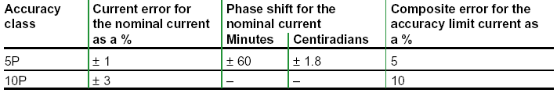
20 = the accuracy limit factor (ALF). The CT is guaranteed to operate within its accuracy class for a primary current magnitude up to I_{P} x ALF at the given accuracy load.
- I_{P} x ALF = 1000 A
- 190A. No, the current is bigger than the rated and actual ALFs.

4 – Understanding the effect of IDMT Relay settings

 | IDMT internal resistance, as seen by CT (ohms)
PS = 10 A | 0.03
PS = 5 A | 0.12
PS = 2.5 A | 0.5
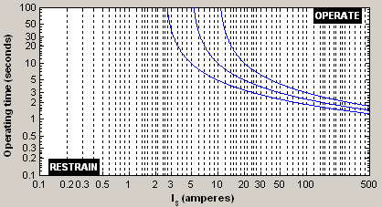
- The IDMT relay’s PS settings are physically implemented as a tapped winding inside the relay supplying magnetic flux that causes the Ferraris disc to move. The higher the PS setting, the smaller the number of windings required, and therefore the smaller the resistance of the relay as seen by the CT.
- 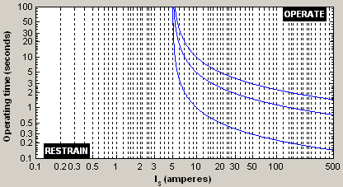
- 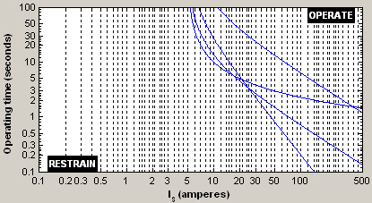
- 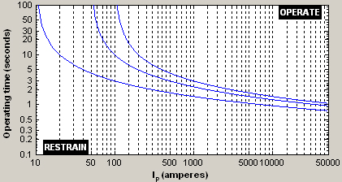

5 - The importance of CT and Relay burdens in CT configuration
- Assuming the CT magnetising current is negligible, the voltage V across the secondary CT winding is
V = I₂ ( R_{CT} + R_{line} + R_{IDMT} ) …(1)
At the accuracy limit of the CT, the secondary current is
I₂ = I_{Srated} ALF_{rated} – I_{M} = I_{Srated} ALF_{rated} …(2)
For the rated scenario R_{line} = 0 ohms.
Therefore, at the accuracy limit for the rated scenario, (1) can be written as
V_{accuracy_limit} = I_{Srated} ALF_{rated} ( R_{CT} + R_{IDMTRated} ) …(3)
For the real-life scenario where R_{line} is not zero and R_{IDMT} is a function of the relay’s PS setting, (3) can be written as
V_{accuracy_limit} = I_{Srated} ALF_{actual}( R_{CT} + R_{line} + R_{IDMTActual}) …(4)
Equating (3) and (4) lead to
ALF_{actual}= ALF_{rated} (R_{CT} + R_{IDMTRated} ) / (R_{CT} + R_{line} + R_{IDMTActual}) …(5)
The values of R_{IDMTRated} and R_{CT} can be found from the accuracy load (IDMT burden) and CT Burden at rated secondary current by using the following formulas:
R_{IDMTRated} = IDMT_{BurdenRated} / I_{Srated}² …(6)
R_{CT} = CT_{Burden} / I_{Srated}² …(7)
Therefore ALF_{Actual}= 20 (0.2 + 5/25) / (0.2 + 1 + 0.5) = 4.7
- The line length between the CT and the relay in most power system applications are much longer than in typical industry applications. A high 5 A secondary CT current through this line resistance will result in a much larger burden for the CT, thereby lowering its actual ALF compared to its rated ALF. 1 A secondary CT currents addresses this problem.
- The fault current forces the CT into operating above its accuracy limit, causing the CT to lose accuracy. To solve the problem select a CT with a higher VA rating.

6 – Tutorial exercises
- Ip = 800 A, therefore Is = 800 x 5 / 100 = 40 A.
t = 0.14 x TM / ((Is/PS)^0.02 - 1) = 0.14 x 0.2 / ( 40 / 4) ^ 0.02 – 1) = 0.594 seconds
- Ip = 800 A, therefore Is = 800 x 1 / 100 = 8 A.
t = 0.14 x TM / ((Is/PS)^0.02 - 1) = 0.14 x 0.2 / ( 8 / 4) ^ 0.02 – 1) = 2 seconds

This work is licenced under the Creative Commons Attribution-Non-Commercial 2.5 South Africa License. To view a copy of this licence, visit http://creativecommons.org/licenses/by-nc/2.5/za/ or send a letter to Creative Commons, 171 Second Street, Suite 300, San Francisco, California 94105, USA.

