Relay Grading - EEE4089F Practical

Due date: 12h00 Friday 4 May 2007

Please hand-in this completed practical sheet (one sheet per group) to Heskin or Taru, sitting in the office next to Chris in the Machines lab.

Student IDs of group members:

__________________________________________

__________________________________________

__________________________________________

__________________________________________

__________________________________________
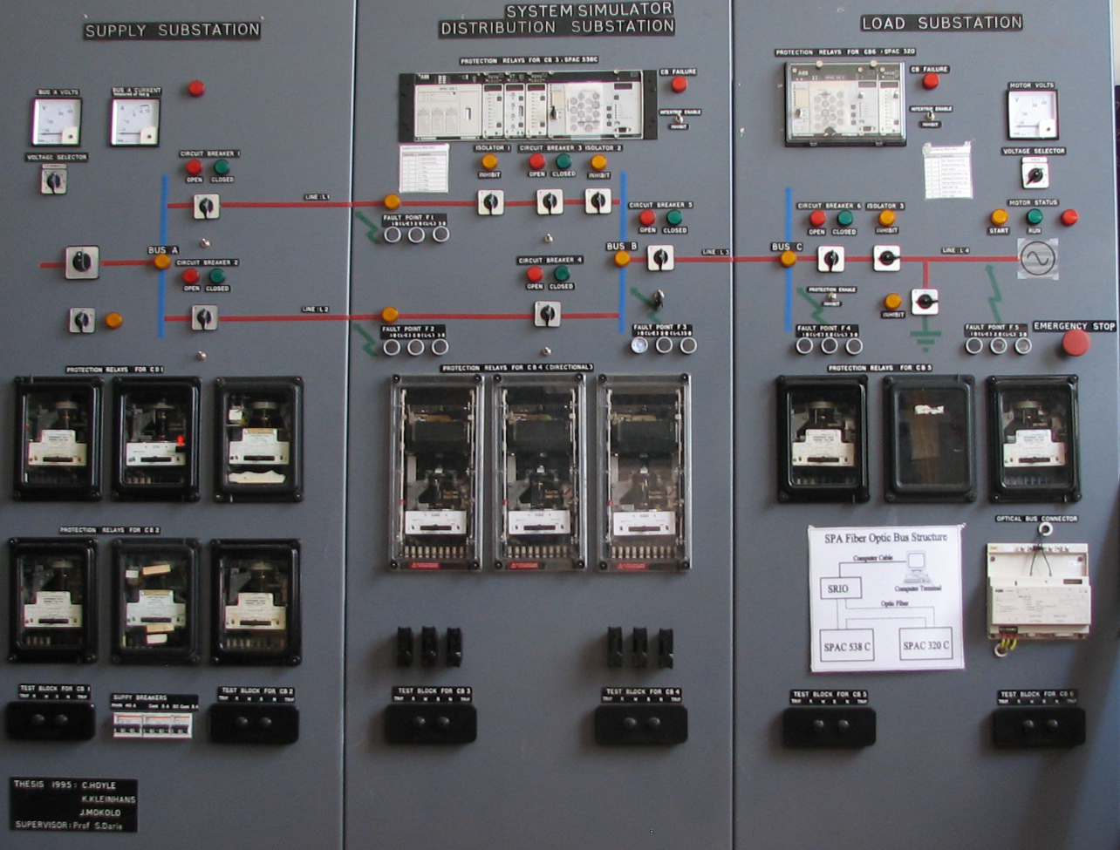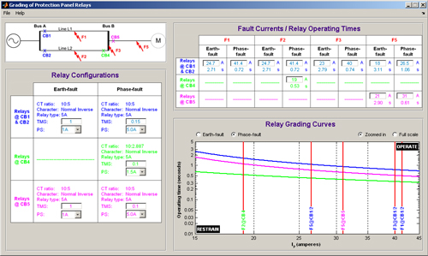
The protection panel in the Power Engineering Lab, shown above left, consists of circuits representing a feeder supplying a motor, together with current and voltage transformers and relays providing protection in the event of faults. 3 phases, phase-to-phase and phase-to-neutral faults can be applied to the feeders by pressing buttons.
The purpose of the practical is to configure the grading of the electro-mechanical over-current (OC) and directional over-current (DOC) relays on the panel, in order to protect the system with maximum discrimination and sensitivity, so that only the minimum part of the system is disconnected as fast as possible during a fault. The ProtectionPrac software, shown above on the right, can be used to assist in grading the relays.
The practical requires that you establish over-current and directional over-current relay settings for the relays connected to CB1, CB2, CB4 and CB5, to give fast, discriminatory protection for faults F1, F2, F3 and F5, and test the power system to demonstrate relay operation. The system can be analysed by measuring and recording the duration and magnitude of the input fault current. You will also be required to monitor voltage dips: the collapse of voltage when there is a fault on another part of the network. The voltage dip can be measured at the load end.

1 – Find the system layout through measurement
- Inhibit all relays, and close all circuit breakers on the protection panel.
- Switch on the supply but do not start the motor load.
- Zero both the phase-to-neutral voltage and source current meters on the protection panel to increase the accuracy of your measurements.
- Measure the phase-to-neutral supply voltage.
Supply Voltage | 232 V

- With both lines L1 and L2 connected, measure the source current for the three types of faults at F3. Now disconnect line L1 (open CB1) and measure the source current for the three types of faults at F3. Don’t allow fault currents in the protection panel to flow for longer than necessary to take accurate measurements.
 | ph-n fault at F3 | ph-ph fault at F3 | 3ph fault at F3
I_{S} (L1 and L2 connected) | 23 A | 35.5 A | 40 A
I_{S} (Only L2 connected) | 21.5 A | 31 A | 36 A

- Show how you’ve used the measurements in 1d. and 1e. above to calculate the per phase source resistance and line resistance of lines L1 and L2. Assume L1 and L2 have equal resistances. (Hint: you have two unknowns and two equations…)

V = I x (Rs + Rfln/ 2) …(1)
V = I x (Rs + Rln) …(2)
Therefore Rln = 1.407 ohms
and Rs = 9.38 ohms

- With both lines L1 and L2 connected, measure the source current for the three types of faults at F5. Do the same measurement with only L2 connected.
 | ph-n fault at F5 | ph-ph fault at F5 | 3ph fault at F5
I_{S} (L1 and L2 connected) | 21 A | 27 A | 31 A
I_{S} (Only L2 connected) | 18 A | 23 A | 26.5 A

- Show how you will calculate the per phase resistance of the feeder section between bus B and fault F5
V = I x Rtotal, therefore Rtotal = 11.05 ohms, therefore Rf = 0.964 ohms

2 – Find the fault currents to be used for relay grading
The electromechanical IDMT OC relays at CB1, CB2 and CB5 on the protection panel are wired as shown below [adapted from 1], while the directional IDMT OC relays at CB4 each monitor one phase, and will only operate for a current flowing from bus B to bus A.
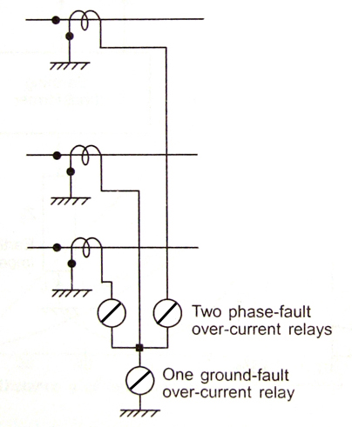
- Explain why you will use the three-phase and not the phase-to-phase fault currents to grade the phase-fault relays.
Although it makes sense to use the smallest fault current (i.e. ph-ph) to configure your OC relay for maximum sensitivity, for grading this might mean that there is not sufficient delay between the different relays for discrimination during larger 3ph fault currents, give the shape of the IDMT curve. Grading is therefore done using 3ph fault current values, which means that ph-ph faults will unfortunately take longer to clear.
- What size fault current flowing from bus B to bus A will you use to configure CB4’s directional relays: any current higher than zero, the ph-n, the ph-ph, or the 3ph fault current? Explain your answer.
You will use the lowest ph-n fault current, which represents the most sensitive fault current, as the directional relay will not be graded with any other relay, therefore 3ph fault current restriction in 2a) does not apply. Any current higher than zero is too sensitive; it might happen that bus B to A currents do flow during normal operation.

- Faults F1 and F2 can occur anywhere between buses A and B. At what location between buses A and B will the highest fault currents flow through CB2, and at what location will the lowest fault currents flow through CT4? What will the size of these currents be? Show all calculations.
If the fault is right next to bus A, the current through CB2 will be the highest, and the current through CB4 the lowest.
With a fault occurring near bus A, the 3ph current through CB2 can be approximated by (9.38+1.407) / 9.38 x 36A = 41.4 A
The ph-n current for the same scenario is 1.15 x 21.5A = 24.7 A
The smallest ph-n fault current through CB4 when the fault is next to bus A will be negligible while CB2 has not yet tripped, and I = V/R = 232 / (9.38+2x1.407) = 19.02 once CB2 has tripped: so choose 19A as the design fault current for the directional relays.

- With the results of the measurements and calculations above, you will now be able to complete the table below, which shows the fault currents that you will use to configure the relays at CB1, CB2, CB4 and CB5 for optimal grading. Assume that the relays at CB1 and CB2 will be configured in an identical way.
 | Fault at F1 |  | Fault at F2 |  | Fault at F3 |  | Fault at F5
 | Earth-fault | Phase fault | Earth-fault | Phase fault | Earth-fault | Phase fault | Earth-fault | Phase fault
Relays @ CB1, CB2 | 24.7 A | 41.4 A | 24.7 A | 41.4 A | 23 A | 40 A | 18 A | 26.5 A
Relays @ CB4 | ------------ | ------------ | ------------ | 19 A | ------------ | ------------ | ------------ | ------------
Relays @ CB5 | ------------ | ------------ | ------------ | ------------ | ------------ | ------------ | 21 A | 31 A

3 – Calculate the correct PS and TMS settings
- Calculate the TMS and PS values for the phase-fault relays at CB5, which should trip as quickly as possible. Assume a maximum load current of 10A, a IDMT normal inverse characteristic curve and a CT ratio of 10/5. Although the TMS value of a relay can be set to 0, in practice values smaller than 0.08 is not recommended, as the relay will be too sensitive, and might trip even for a small vibration.
As the max load current is 10A, choose a PS setting of 5A. Given a CT ratio of 10/5 the relay will never operate for 10A, but will operate for any value above it. Now choose a TMS value using the normal inverse formula, with phase fault current of 31A and a trip time as small as possible. For TMS=0.08 the trip time will be 0.48 seconds.

4 – Open the ProtectionPrac software
- Go to Vula, Resources, Tutorials and Tests, and download ‘Advanced Protection - software.exe’
- Run this program on your PC, and install into a new folder of your choice, e.g. c:\protection
- Open Matlab
- Change Matlab’s current directory to the folder that you installed into during step b.
- Run protectionprac.m in Matlab

5 – Calculate the relay settings for optimal grading
Use the ProtectionPrac Matlab software to calculate the protection panel relay settings for optimal grading. The ratios of the CTs used in the protection panel are build into the ProtectionPrac software.
- Select the ‘Phase-fault’ radio button in the ‘Relay Grading Curves’ section of ProtectionPrac, thereby showing the phase-fault relays’ curves in the graph window.
- Set the phase-fault relay @ CB5 in the ProtectionPrac software to the TMS and PS values that you have calculated in 3a., and the F5 phase-fault current @ CB5 (in the ‘Fault Currents / Relay Operating Times’ section) to the value used during the calculations in 3a. Note how the curve changes in response to a change in TMS and PS values.
- If you have done your calculations in 3a. correctly, the CB5 relay operating time for a F5 phase-fault (shown in the ‘Fault Currents / Relay Operating Times’ section) should be the same as what you have calculated. From the ‘Relay Grading Curves’ section, read from the magenta graph the highest load current through the CT @ CB5 for which the earth-fault relay @ CB5 will never operate. How does this value relate to the CT ratio and PS setting of the relay?
2A. The PS value represents the highest secondary current for which the relay definitely will not operate, in this case 1A. The CT ratio is 10:5, which translates into a primary current of 2A.

- Toggle between the ‘Zoomed in’ and ‘Full Scale’ radio buttons in the ‘Relay Grading Curves’ section. Note how the axes of the graph change between allowing a more detailed view of the intersections between the fault currents and the relay curves, or an overview of the curve shapes with less detail.
- Complete the ‘Fault currents / Relay Operating Times’ table in ProtectionPrac with the fault currents that you calculated in 2d.
- Now grade both the earth-fault and the phase-fault relays using ProtectionPrac. Assume that the protection panel load will never draw more than 10A during normal operating conditions, and that a current of up to 4A flowing backwards, from bus B to bus A, is considered normal. Allow at least 400 ms grading between relays. Complete the tables below with the operating times of the relays for each fault, and the relay settings that will result in these times. (Hint: to set up the direction relays, a PS setting of as close as possible to 50% of the normal load current, seen on the secondary side of the CT, is normally selected. Also keep in mind that TMS settings smaller than 0.08 is not wise…)
 | F1 |  | F2 |  | F3 |  | F5
 | Earth-fault | Phase- fault | Earth-fault | Phase- fault | Earth-fault | Phase-fault | Earth-fault | Phase- fault
Relays @ CB1 & CB2 | s | s | s | s | s | s | s | s
Relays @ CB4 | ------------ | ------------ | ------------ | s | ------------ | ------------ | ------------ | ------------
Relays @ CB5 | ------------ | ------------ | ------------ | ------------ | ------------ | ------------ | s | s
Operating times – simulated with ProtectionPrac
 | Earth-fault | Phase-fault
Relays @ CB1 & CB2 | TMS:  PS: | TMS:  PS:
Relays @ CB4 | ------------------------------------- | TMS:  PS:
Relays @ CB5 | TMS:  PS: | TMS:  PS:

6 – Test if the protection operate as designed
- Set the relays on the protection panel to the configuration that you’ve found in section 4 above. Be very careful when adjusting the relays – they are fragile instruments!
- With both feeders L1 and L2 connected, but without starting the motor load, measure the actual relay operating times for the all three faults and complete the table below. Note that the ‘operated’ flags on some of the relays are not working – this will not inhibit the functioning of the relay. Also note that the left-most relay @ CB4 behaves incorrectly during an earth-fault at F3. Can you think of a reason why?
Incorrect phase wiring at the back of the panel.

 | F1 |  | F2 |  | F3 |  | F5
 | Earth-fault | 3p and p-p faults | Earth-fault | 3p and p-p faults | Earth-fault | 3p and p-p faults | Earth-fault | 3p and p-p faults
Relays @ CB1 & CB2 | s | s | s | s | s | s | s | s
 |  | s |  | s |  | s |  | s
Relays @ CB4 | ------------ | ------------ | ------------ | s | ------------ | ------------ | ------------ | ------------
 |  |  |  | s
Relays @ CB5 | ------------ | ------------ | ------------ | ------------ | ------------ | ------------ | s | s
 |  |  |  |  |  |  |  | s
Operating times – measured
- Comment on the differences / similarities between the simulated and measured operating times.

7 – The impact of loads and faults on voltage levels
- Connect an oscilloscope to the motor load, configured to measure the voltage at the load.
- Connect the motor load.
- Switch on the system with both feeders connected. Close CB6 to start motor.
- Reproduce the resulting voltage levels below, indicating the soft-start period and the operating period.

- Now create a 3-phase fault at F2. Reproduce the resulting load voltage levels below.

- How can the voltage variations associated with motor start-up and faults be minimised?
Fast protection, and lower Z due to multiple lines.

This work is licenced under the Creative Commons Attribution-Non-Commercial 2.5 South Africa License. To view a copy of this licence, visit http://creativecommons.org/licenses/by-nc/2.5/za/ or send a letter to Creative Commons, 171 Second Street, Suite 300, San Francisco, California 94105, USA.

