**FACTORY GROUP 1 : CIBAPAC**

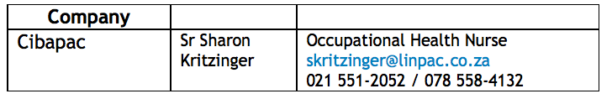

Amy

Hilko

Morgan

Jonny Myers

**FACTORY GROUP 2: INDIGO COSMETICS**

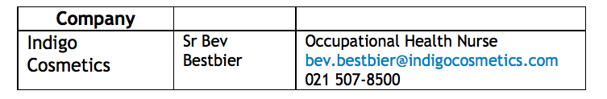

Ridwan

Indira

Joyce

Nazia

Jim TeWaterNaude

**FACTORY GROUP 3: TRANSWERK**

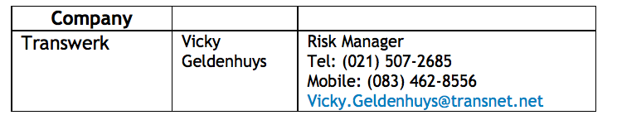

Astrid

Corne (not coming)

Muthei

Khalid

Mokgadi

Mohamed Jeebhay

**FACTORY GROUP 4: FINE CHEMICALS**

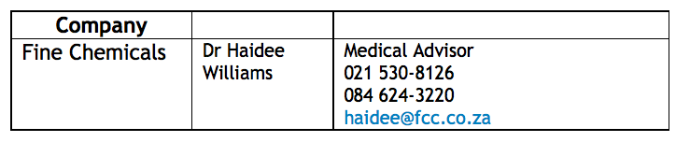

Gina

Bertie

Nobby

Andy

Haidee Williams