Environmental impact assessment
Introduction
EIA is defined as the process of evaluating the direct and indirect environmental, human health and social implications of a proposed development project. (for eg highway, or factory). The purpose of the assessment is to ensure that decision-makers consider environmental impacts before deciding whether to proceed with new projects.

The EIA process began in North America in the 1970s. Therefore, it has a long history and experience that can be useful for developing countries just beginning to establish EIA processes. Only, recently, few countries in eastern and southern Africa had an EIA policy. Now, most countries have such a policy and supporting legislation. Traditionally, EIA was designed to operate at the project level; that is to identify impacts and mitigation measures for an individual project. In the past
years however, the EIA process has gradually been extended to sectoral levels (for eg monitoring of CO₂ emmissions from fossil fuels in USA are performed in residential, commercial, industrial and transport sector, sectors in the evaluation of the impact of human activities on marine biodiversity in the EU includes fisheries and dumping, the evaluation of sustainable transport option in Mumbai, India were done in the four sectors namely the inland city, western suburbs, eastern suburbs, and rest of Mumbai Metropolitan region), strategic reviews of policy (for e.g. the impact of the US Federal Farm Bill on subsidies, nutrition, and air pollution), and even to the global level (for eg the impact of HFC emission in the UK on global warming).

An EIA is a flexible process and employs a large number of evaluation methods and techniques. EIA is increasingly part of standard pre-feasibility engineering and economic studies.

Project-level EIA has a number of weaknesses. Firstly, a single project-level EIA is usually cross-sectional in nature and has little leverage beyond the influence of the single project and has to be repeated for each sector or regional project. An EIA rarely influences which projects are selected before the assessment is carried out. As a result, project-level EIAs are mainly reactive, at a time when pro-action becomes increasingly necessary. In the worst cases, EIA does not begin until a fairly well defined project is proposed, then it is forced into reacting to a relatively rigid proposal. Ideally, EIAs should always include the outcome of the no-project alternative, emphasising that EIA is a public process rather than a single study. On the other hand, the no-project outcome must account for the costs of no project such as power outages, bad roads, ineffective schools, and inefficient or unsafe water supply. EIA should help decision-makers ascertain the when, where, how and cost of proposed projects as well as the no-project option.

EIA is often weak on indirect and synergistic impacts unless the EIA team is
unusually qualified and well funded. Some still think of EIA as a mandated document, rather than part of feasibility or as a valuable tool for project selection and design. Occasionally in the worst cases, an EIA becomes a post-project justification or mitigation exercise. In addition, project totally applying to environmental concerns is difficult to enforce.

The EIA Process

An EIA describes the impacts on the environment with and without the project. To do this systematically, different attempts to categorise the elements comprising the environment, also called attributes, have been made (Box 1 provides one example). Changes in the environmental attributes provide indicators of changes in the environment. The EIA describes, quantifies, then aggregates the effects of
project activities on these attributes.

Box 1: Environmental Attributes for Projects

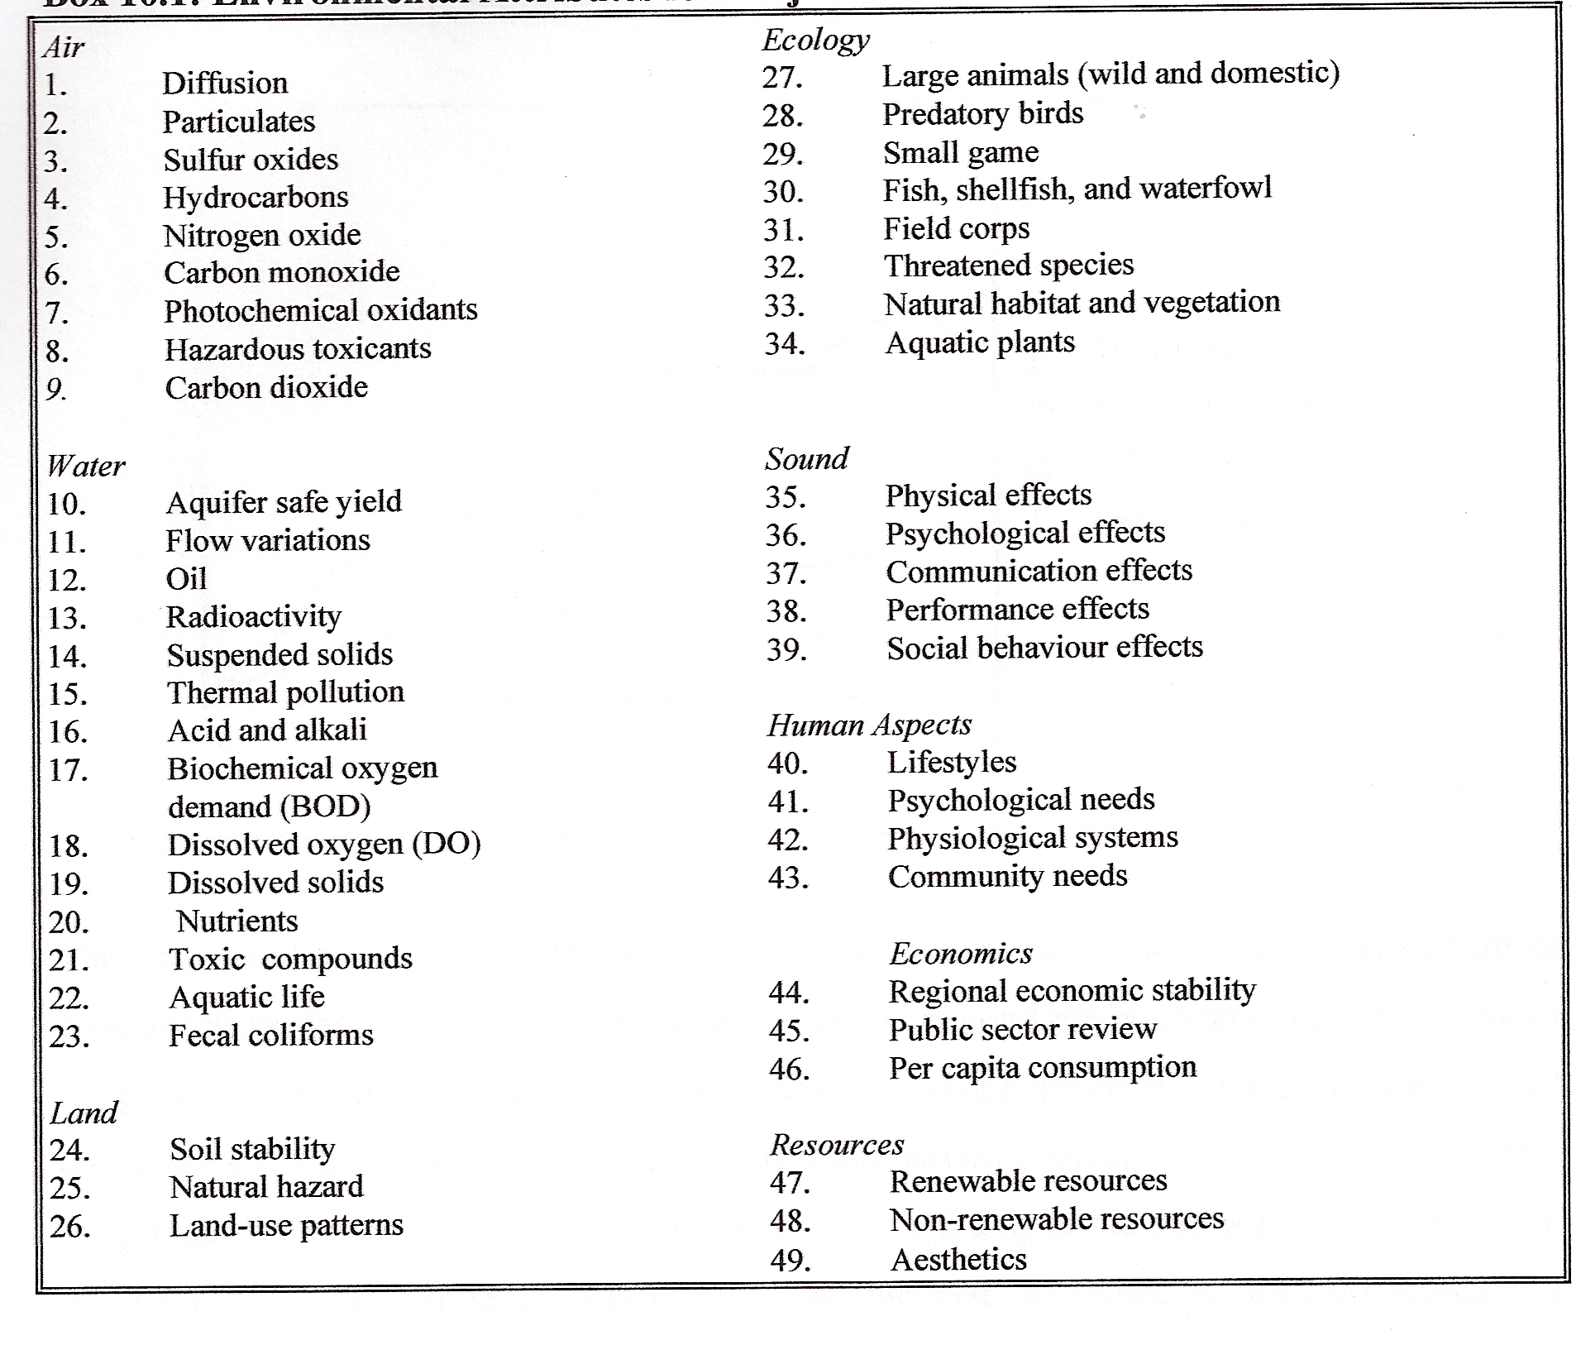
(Forum for Economics and Environment)

The EIA measures attributes with and without the project, or an activity within the project at given point in time. The measure of attributes may change over time without the activity. The impacts have to be measured in terms of the “net” changes in the attribute at a given point in time.

The main steps in an EIA are thus, (1) describe baseline the situation; (2) identify the potential impacts (3) estimate the impacts; (4) aggregate impacts on the environment; and (5) propose mitigation measures to minimise the environmental impacts which need to be monitored during the project.

The nature and importance of the impact is determined by the conditions of the environment without the project. The stressors may have impacts beyond the boundary and time frame of the project. Baseline analysis is more than making a statement on the initial environment of the proposed project. Because projections of future environmental conditions that may affect the project should also be made, it is necessary to adopt a dynamic and not static approach to the study of the environment. In effect, the baseline analysis should permit a comparison of project-induced environmental changes with other expected environmental changes in the noproject
situation. This dynamic approach may be more challenging, but will engender useful
additional studies and dialogues. It should take account of: (a) past trends in environmental quality over time, (b) community preferences or competing demands regarding resource utilisation, and (c) other current or proposed development programs and projects under study.

The quality of the analysis of baseline conditions establishes the viability of the appraisal of the impacts, and therefore of the EIA itself. Identifying impacts involves two aspects: the stressors, or sources of impacts i.e. what causes the impacts created by a project activity, and the receptors, or the attributes (Box 1). This identification is done through a screening followed up by a scoping procedure. The screening determines if a project needs a full EIA, a partial EIA or none. The scoping identifies the project’s main environmental impacts and the depth of the analysis required. The terms of reference of the EIA are often established at that point. The nature and importance of the impact is determined by the conditions of the environment without the project. The stressors may have impacts beyond the boundary and time frame of the project. For each type of potential important impact or environmental concern, the analysis should predict the nature and significance of the expected impacts, or explain why no significant impacts are anticipated. Some environmental effects are quantifiable, while others may need to be described qualitatively. Impacts should be quantified in terms of all effects on human health and welfare, and on ecosystems.

The impact of a stressor on a receptors, or environmental attributes, may be modelled by dose-response functions (for e.g. increase in cases with increasing exposure, decrease in crop yield with erosion). Such information is not often readily available and can be costly to gather. Often the dose-response function are transferred from other studies and modified for the difference in geography, duration of exposure and population specifics. Once all the impacts of a project have been identified and quantified as well as possible, one has to value the impacts and develop a new project cash flow integrating the environmental impacts. However, such an ideal situation in which a dose-response exists and can be valued and entered into a cash flow is often the exception. Attributes may have to be aggregated or compared to each other. Some type of ranking relying on expert judgement may have to be developed using a Delphi method for instance.

In an EIA, mitigation measures may be proposed to avoid or diminish environmental and social impacts. Then, new activity or production processes can be proposed. In an economic appraisal, the alternatives can then be compared in terms of the economic viability. If changing the project or introducing different activities or technologies is not possible, the analyst will evaluate if the negative components of a project or the project itself should not be eliminated altogether. If not, compensation can be sought which can be materials for reconstruction, prevention, or financial such as compensation for loss of property or some property right.

Detailed Project-level EIA Process

a) Screening

Screening is used to decide the nature and extent of the EIA to be carried out. The
environmental review process begins with environmental screening at the time a project is identified. In the screening, the nature and magnitude of the proposed project’s potential environmental and social impacts is determined, and the project is assigned to an environmental category. Box 2 gives the example of the categories that the World Bank applies. Most screening processes in eastern and southern Africa are similar in having three categories. The main difference is that in some countries, the order is reversed (category A does not require an EIA, while category
C does). The reason for initial screening is simple; not all projects have significant
environmental impacts and thus do not warrant a full-blown and expensive EIA.

Box 2: Classifying EIAs by World Bank Category
Category A: A full EIA is required. These projects are expected to have adverse impacts that may be severe, irreversible and diverse, with attributes such as direct pollutant discharges large enough to cause degradation of air, water or soil; large-scale physical disturbances of the site and/or surroundings; extraction, consumption or conversion of substantial amounts of forest and other natural resources; measurable modification of hydrological cycles; hazardous material in more than incidental quantities; and involuntary displacement of people and other significant social disturbances.

Category B: Although a full EIA is not required, some environmental analysis is necessary. Category B projects have impacts which are less significant, and not as sensitive, numerous, major or diverse. Few, if any of these impacts are irreversible, and remedial measures can be more easily designed. Typical Category B projects entail rehabilitation, maintenance or upgrading rather than new construction.

Category C: No EIA or other environmental analysis is required. Category C projects have negligible or minimal direct disturbance on the physical setting. Typical Category C projects focus on education, family planning, health and human resource development. Projects with multiple components are classified according to the component with the most significant adverse impact if there is a Category A component, the full project is classified as A.
(Forum for Economics and Environment)

b) Scoping

A scoping process is undertaken to identify key issues and develop the Terms of Reference (TOR) for the EIA once a project is categorised. It is essential to identify more specifically the likely environmental impacts and to define the project’s area of influence at this stage. As part of this process, information about the project and its likely environmental effects is disseminated to local affected communities and NGOs, followed by consultations with representatives of the same groups. The main purpose of these consultations is to focus the EIA on issues of concern at the local level.

c) EIA

The structure of the EIA is important. When a project is classified as Category A, a full-scale EIA is undertaken, and presented in an EIA report. Category B projects are subject to a more limited EIA, the nature and scope of which is determined on a case-by-case basis. What is important, is that the baseline without the project and the projected environmental impacts with the project are clearly reported. In South Africa, impact assessment should be according certain criteria including the nature of the impact (type of effect), extent (if effect is local, regional, national or international), duration) (short-term, long-term), intensity (destructive or benign), probability (the likelihood of the impact occurring) and overall significance. Mitigation measures should be proposed and the effect of these measures in reducing environmental impacts should be evaluated. Where applicable, some clear indicators of project alternatives should be provided. In South Africa, the project has to be divided into pre-construction phase, construction phase, operational phase and decommissioning phase in order to facilitate the identification of those activities which require certain management actions to mitigate the impacts arising from them.
The information should be easily translatable in an input-output schedule for an economic analysis. Once the draft EIA report is complete, the developer submits it to the responsible authority (local or national DEAT in SA) for review by environmental specialists. If the report is found satisfactory, the responsible authority project team is authorised to proceed to appraise the project. During appraisel, the responsible authority staff review the EIA procedures and other important aspects with the developer, resolve any outstanding issues, and assess the adequacy of the institutions responsible for environmental management in light of the findings. They also ensure that the mitigation plan is adequately budgeted, and determine if the EIA recommendations are properly addressed in project design and economic analysis. The developer is responsible for implementing the project according to agreements derived from the EIA process. The responsible authority supervises the implementation of environmental aspects as part of overall project supervision, using environmental specialists as necessary. An evaluation of the project and its EIA is carried out after the project ends. This information will allow the improvement of the broader environmental assessment at sectoral and global level and project ffectiveness of similar projects in the future.
Literature

Brent CA, Werner P. 2007. Environmental impact assessment during project execution phases: towards a stage-gate project management model for the raw materials processing industry of the energy sector. Impact Assessment and Project Appraisal 25(2): 111-122
Department of Environmental Affairs and Tourism. 1998. Regulations; Implementation of section 21, 22 and 26 of the Environmental Conservation Act, 1989. Guideline Document, Pretoria.

European Communities. 2001. Guidance on EIA Screening, Scoping and Review. Website:
http://europa.eu.int/comm/environment/eia/eia-support.htm.

Urban Environmental Management. Environmental Impact Asessment. Web: http://www.gdrc.org/uem/eia/impactassess.html

Wikipedia, The Free Encyclopaedia, The Wikemedia Foundation, San Francisco, California, Web: http://en.wikipedia.org/wiki/environmental_impact_assessment

World Bank. 1999 (revised 2004). World Bank Operational Manual – Bank Procedures. Environmental Assessment. Website: http://wbln0018.worldbank.org/Institutional/Manuals/OpManual.nsf/944eea1d5fb31d95852564a30060b223/9367a2a9d9daeed38525672c007d0972?

South African EIA Legislation

EIA REGULATIONS (http://www.environment.gov.za/PolLeg/GenPolicy/eia.htm)
INFORMATION DOCUMENT ON REQUIREMENTS WITH RESPECT
TO THE EIA REGULATIONS
Guidelines for the plan of a scoping study
Guideline on public participation
Guidelines for involving specialist in EIA process

EIA flawed

ARTICLE IN CAPE TIMES

EIA Exercise

EIA question
EIA Figure (Location of sites)

