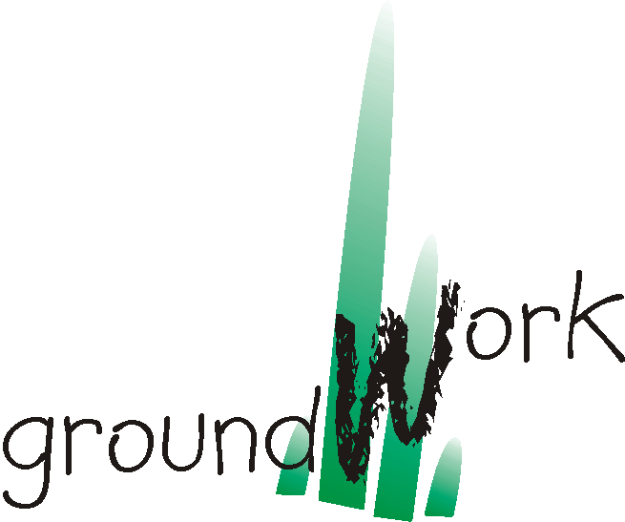
P.O. Box 2375
191c Burger Street
Pietermaritzburg, 3200
South Africa
Tel: +27 – 33 – 342 5662
Fax: +27 – 33 – 342 5665
team@groundwork.org.za

SUBMISSION ON:

THE NATIONAL ENVIRONMENTAL MANAGEMENT:AIR QUALITY DRAFT BILL
(Draft 1 April 2003)

Submitted by: groundWork
(see full list of organisations supporting this submission)
Address: 191c Burger Street, Pietermaritzburg, 3200
Tel: 0333425662
Fax: 0333425665
Email: team@groundwork.org.za

Date of submission: 29th May 2003

Contact person: Bobby Peek
Designation: Director
Telephone: 0824641383 / 0333425662
Email: bobby@groundwork.org.za
STRUCTURE OF SUBMISSION

This submission is structured in two parts. The first part is an overall comment on the strategic purpose and stated intention of the draft bill. This comment captures the view of a collective of communities living in pollution hotspots around the country. The second part is a detailed response to various sections of the legislation. We welcome any contact with the policymakers to clarify or discuss any aspect of this submission. We look forward to a second draft that reflects the public interest more strongly, as a result of this participatory process.

PART ONE: STRATEGIC COMMENTS FROM POLLUTION AFFECTED COMMUNITIES

- Introduction

Will this law protect people’s health and environment? Will it foster sustainable development?

The Bill attempts to deal with problems associated with air pollution. These problems are defined by civil society as:
- Poor health
- Poor quality of life
- Weakening development potential; and
- Negatively impacting upon job creation.

Some of these concerns are acknowledged in the Bill, however, the Bill is neutral in that it focuses on the management of air quality, rather than the protection and improvement of the health of South Africa’s citizens.

National government’s priority to grow the economy must be located within the context of Section 24 of the National Constitution (the right to an environment which is not harmful to health and well-being) and the National Environmental Management Act, if it is to uphold our national commitment to sustainable development.

The draft Bill indirectly allows industry to continue polluting as usual due to its failure to guarantee successful implementation. The continued operations of “dirty” industry, with its unsustainable levels of pollution, limits opportunities for the development of new industries. This, in turn, limits government’s ability to achieve job growth, push back the frontiers of poverty and will further impede the health of South Africa’s future and existing workforce.

- Standards

2.1 Provision must be made in the draft Bill for enforceable ambient and emission standards. Emission standards must be set nationally to ensure uniformity and a non-competitive environment across provinces. These standards have to be adjusted (made more stringent) in local areas, depending on the context. For example, in South-Durban where to industrial polluters operate in close proximity, the standards will be adjusted in consideration of the cumulative effect on the air quality in that area. The people who breathe in the air will breathe in the pollutants from both industries, thus experiencing double impact.
If the Minister does not develop these standards at a national level:
- government will be unable to hold industry accountable for their pollution,
- some provinces “might” set standards and others not, and therefore “dirty” industry will seek to move to provinces where there are no standards, or where there are weaker standards, therefore exploiting the environment in these areas; and
- development will occur in an uneven manner in South Africa, leading to more areas in South Africa been contaminated by poor air quality.
2.2 Technology standards must be a critical consideration when making decisions on license applications. Technology must be based on BAT(Best Available Technology)/BART (Best Available Retrofit Technology) principles .

2.3 Quality control measures must be applied to the testing equipment used during monitoring and a legal test must be used to monitor technology standards.

2.4 Finally, emission standards must be health – based in accordance with World Health Organisation (WHO) guidelines.

Case study:

Anglo Platinum, in Rustenburg is polluting the neighbourhood, and doctors in the area state that the incidence of sinus problems stands at 80% of the population. Government however cannot hold the company accountable because there are no standards, both ambient and emissions, to use as reference. This is why it is imperative for the Minister to be mandated to develop standards.

Health and Environmental Justice

3.1 The main purpose for the development of this Bill is the protection of people’s health. Yet, health is not mentioned in the objective of this Bill. While recognising that the “burden of health impacts” falls most heavily on the poor, the Bill is too vague to ensure that this burden, known as environmental injustice, is not perpetuated in a democratic South Africa.

The Bill must address:
- Environmental injustices where, for historical reasons, certain communities, especially fence line communities had polluting industries placed in their neighbourhoods;
- Workers and residents right to compensation for injury or illness as a result of the operations of dirty and dangerous industry;
- Government’s failure to deliver and promote cost effective energy to households dependent on coal;
- Determination of national air pollution standards that protect health,

3.2 The object of this Act should read: To protect, restore and enhance the quality of air in the republic through the promotion of participative, effective and enforceable air management strategies that place the needs of people first whilst recognising the need for sustainable development.”

Case study:

In south Durban, leukaemia rates are 24 times the national average and respiratory problems amongst learners are at 52%, whereas the world norm is below 20%. These trends have been linked to air pollution. These stats affect mainly the poor and disadvantaged, who have these industries within their neighbourhoods. It is for this reason that health and environmental justice must be given a strong focus in this Bill.

- Information and Monitoring

4.1 This is the cornerstone of the Bill. The need for information management systems has already been acknowledged in the White Paper on Environmental Management, July 28, 1997. However, the Bill does not take this process further to “optimise the capacity of government” (pg 36) and to provide guidance from the Department of Environmental Affairs and Tourism (DEAT) as to what systems should be used by polluters and government authorities. There are ample examples of good practice around the globe as to how information can be collected, such as the Pollution Release and Transfer Registry (PRTR) as well as the Toxic Release Inventory (TRI). The Bill must indicate how government is going to undertake this.

4.2 More alarmingly, it does not compel the Minister to develop standards for information management and leaves the onus on municipalities to undertake this information collection and monitoring. Without clear assistance from provinces and national government, this will be unachievable. Government must indicate how local and provincial authorities are going to be assisted if they cannot undertake this duty.

4.3 The public has no entitlement to enforce its constitutional rights by compelling performance. Community “right to know” and public involvement in monitoring and information gathering must be included in the Bill.

Case study:

Environmental information is a hotly contested arena in South Africa. Civil society started taking air pollution samples as far back as May 2000 in response to the lack of credible and reliable information being generated by government or industry. This has formed the basis of challenges, as in the south Durban basin. More importantly, with no standards on information collection, the apartheid legislation such as the National Key Points Act has been used by industry to deny both government and civil society access to information in south Durban.

- Capacity Constraints

The resources required of municipal and provincial government to manage air quality can be substantial not to mention the technical skills. By pushing air quality management to the most financially weak and poorly capacitated sectors, such as municipalities, it is doomed to fail. In the interim, (while the requisite regulations are being drafted) there must be clear guidelines for the reporting required by municipalities.

Case Study:

In Sasolburg, which possibly has the most concentrated heavy industrial complex in the country, there is only one health officer, responsible for the “exhaust fans from the local steakhouses to the very many complex chemical units” in Sasolburg. Civil society organisations have taken their own samples and provided technical information to government on EIA’s and reviews. In the Free State, provincial and local government has not acted against Sasol on any of its pollution problems – possibly due to a lack of understanding of the complexity of the industry.

- CONCLUSION

Air Quality cuts to the heart of every South African. Ultimately, whether we are policymakers, business operators or workers, we are all residents and we all desire to breathe clean air. International practice indicates that we can have a law that manages air quality in the interests of people, without real loss to business. Let us use the common factor that connects us all to seek a solution that is just.

