1. Introduction, p4:

Replace the para with:

A coherent and effective regulatory system (AQMS) would include the setting air quality standards, setting specific time-bound air quality objectives, and would be capable of gathering the necessary air quality information and using the permitting or licensing system and the necessary technical and legal resources to give effect to regulations.

2. Overview of main air pollutants

a) missing reference, Figure 2.2:

Remove ref. Superscript from text box, insert it as follows:

A highly simplified explanation of the mechanism of global warming is illustrated in the following diagram (Figure ..).

See, for example, http://www.cmdl.noaa.gov/climate.html

b) Paragraph above Table 2:

delete … (greater than CO2) …

3. The main air pollutants and their health effects

a) Para 2: The expected health effects depend on the .. replace [type of pollutant] .. with [pollutant] ..

b) Replace Figure 3.1 with:

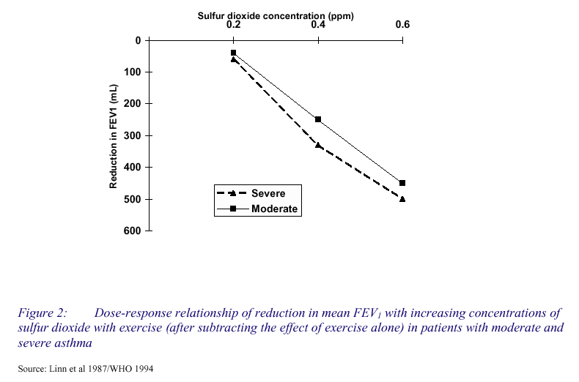
(this seems to be a graph of the same data)

c) Figures 3.6-3.8:
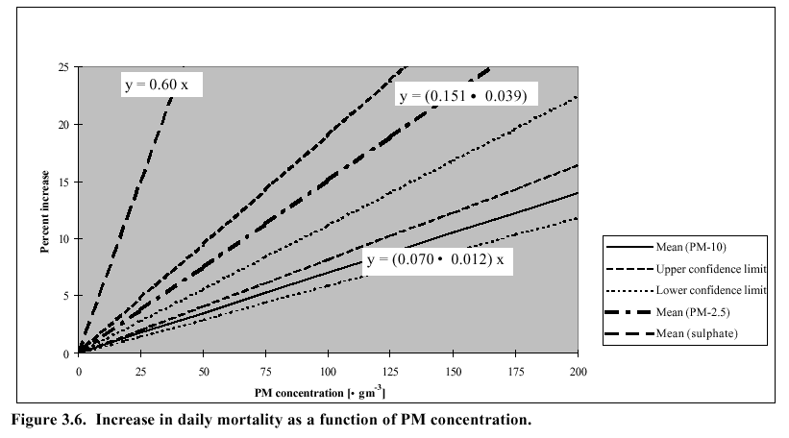

George, I believe the ( . ) should be the C.I. ( +- ).
Thus, for PM10, % increase in daily mortality (y) = (0.07 +- 0.012) x, where x is the concentration in μg/m3.
Check: at 100 μg/m3, CI = 7-1.2=5.8 to 7+1.2=8.2%. [seems to be about right for PM2.5 as well.]

Also, the . g should read μg. Same for following graphs.

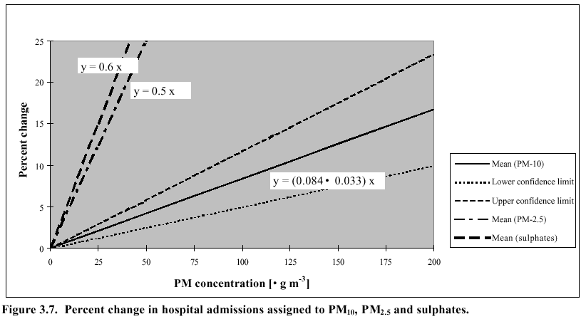
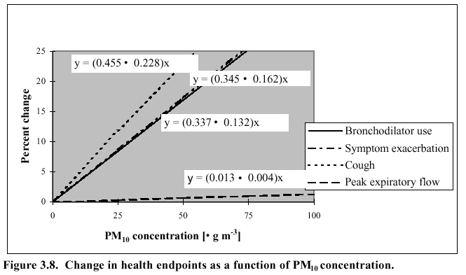

d) Table 1 (RR table) superscript:
- The relative risk estimates are based on Western European data only. The analysis was based on air quality and health endpoint data from 141 cities in 30 countries in Europe, with a total population of 78 million, 25% of the total urban population of the European Region of the WHO.^{iii}

Ch4. The Principle Sources of the …
a) After Figure 4.2, add:
The city-to-city variability of pollutant emission rates is illustrated by the following data, Table …. Note, for example, that the contribution of motor vehicles to total SO2 emissions ranges from 4% for Brisbane and Adelaide to 18% for Sydney. The relative contributions of various source types do not necessarily correspond to similar contributions to ambient concentration (or exposure) due to the different release characteristics of different sources.

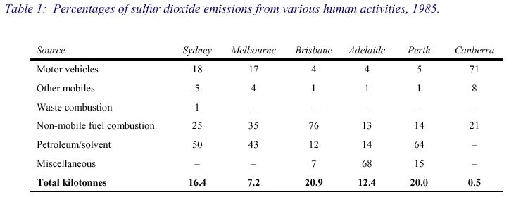

b) Mobile sources diagram:
Figure : Procedure for estimating mobile source emissions

CHARACTERISATION OF FACTORS AFFECTING
MOBILE SOURCES EMISSIONS

INPUT DATA: OUTPUT: INPUT DATA:
Small
Medium Petrol
Large
Passenger Cars
Small
Medium Diesel
Large

LDV Commercial
HDV Vehicles
Buses

2T Motorcycles
4T
…………………………………….
Vehicle Lifetime Function, Scrappage Rate

Fuel Composition(s)

Mode of Use (Urban, Rural, Highway)
Annual Mileage
Travel Speed
Fuel Consumption

Emission Factors: Variation with speed, age degradation factors, engine design

MOBILE SOURCE EMISSONS PROFILE

(SO₂, Pb, HC, NOx, CO)

Petrol and Diesel Consumption
Controls implemented:
Catalytic converters, ..
(Fuel Balance)
Total Emissions
Total Emissions
per Vehicle Class

Vehicle population by size and type
The car population is divided into three size classes:
- small cars have engine displacement below 1400 cc
- medium cars have engine displacement between 1400 cc and 2000 cc
- large cars have engine displacement above 2000 cc.

PDF version of diag:
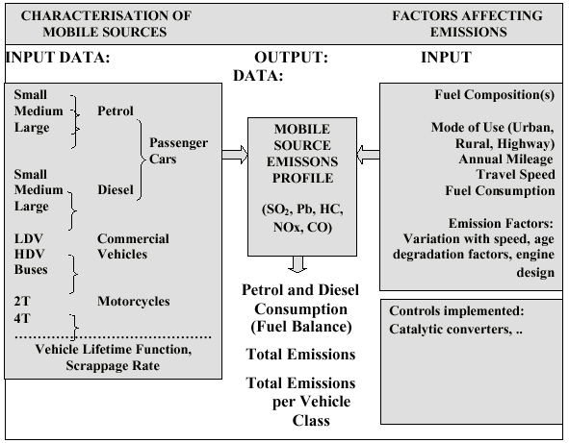
c) Table 4.4: Mobile source toxics …, delete the ‘and’

d) The N₂O column in Tables 4.5 etc is correct. (NO2 is included in NOx, the sum of NO2 and NO.) N2O is not significant from an env health perspective, but it is important from a global warming perspective because of its high global warming potential.

e) I need to reformulate and clarify all three case studies. Will work on this next week.

Eugene
06 Aug 04

See, for example, http://www.cmdl.noaa.gov/climate.html
Len Ferrari and Janet Salisbury, National Health Environmental Forum Monograph Air Series No. 4: Sulfur dioxide (1999)
Len Ferrari and Janet Salisbury, National Environmental Health Monographs Air Series No. 4: Sulfur Dioxide (1999) (Australia)

