Ch 6: Methods of assessing air quality; the use of air quality indices
(Reference: Monitoring ambient air quality for health impact assessment, WHO Regional Publications, European Series No. 85 (1999))

The methods of assessing air quality in a given (urban) area are complicated because air pollution concentrations vary in space (from place to place) and time across the area under consideration. This spatial and temporal variation in ambient air quality is due to several factors, including the location of pollutant emission sources, the height and temperature of release of the pollutants and meteorological conditions. For example, vehicle pollutant concentrations are emitted at ground level, and these concentrations are highest close (within 1 km) to heavy traffic roads. The exposure of the population in a given area is therefore a function of location within the area. Estimates of population exposure should ideally account for both the spatial and temporal variation of air quality and the population distribution across the area.

The most important methods of assessing air quality include:
  - ambient air quality monitoring,
  - modelling
  - the preparation of emission inventories,

Since each method has limitations, a comprehensive ambient air quality assessment requires the use of all three methods.

Indoor air quality may differ significantly from outdoor (ambient) air quality – concentrations may be lower or higher, and indoor and outdoor pollutants may be significantly different. Accurate assessments of individual exposure may require time-activity data.

It is useful to classify pollutant sources natural (e.g. volcanic eruptions, biogenic emissions from plants and forests) and ‘anthropogenic’ (the result of human activities).

Ambient air quality monitoring
An air quality monitoring system essentially measures ambient air concentrations at a number of fixed locations, for example across a city or within a region.

Continuous monitors (analysers) are instruments capable of measuring pollutant concentrations (for example, SO₂, NO₂, CO, PM) continuously and more or less instantaneously (in reality, measurements are averaged over very short periods of time). The ‘instantaneous’ values are not in themselves useful for assessing air quality. (‘Instantaneous’ values are subject to measurement ‘noise’. In addition, in the absence of instantaneous exposure-response relationships, ‘instantaneous’ measurements cannot provide a useful estimate of health impacts.) Thus these values may be averaged over time periods of 10 or 15 minutes, one hour, 3 hours, 8 hours, 24 hours or longer periods. The time-averaged values (time weighted averages) may be compared with air quality standards or guidelines, or may be used, in conjunction with known exposure-response relationships, to estimate the potential health impacts of the air pollutant concentrations.

Automatic analysers that are capable of measuring air pollutant concentrations continuously are comparatively expensive, and have to be housed in a protected and controlled environment, usually at a fixed site or in a mobile station or caravan. (A monitoring station capable of continuously measuring the concentrations of the five common air pollutants – SO₂, NO₂, ozone, CO and PM – costs about R1.0 million.) A typical monitoring system consists of a limited number of monitoring sites, each measuring a specific set of pollutants. For example, the City of Cape Town has the following monitoring network:

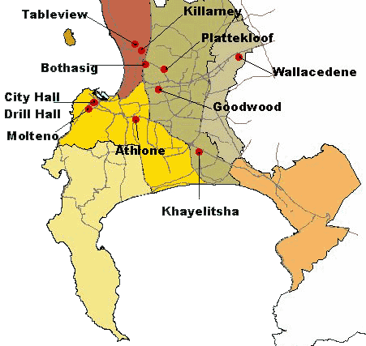
Figure 6.1: Cape Town Monitoring Sites

Not all the stations measure all the commons pollutants; additional measurements are done on an ad hoc basis, and a mobile station may be relocated to a new area.

The choice of location of monitoring sites should consider factors such as:
- the need to monitor major pollution sources
- the need to assess suspected areas of high concentration,
- the need to monitor exposure in areas with high population density and
- the need for data for a ‘control’ area remote from local pollution sources;
- the need for data on ‘background’ pollution levels, outside of the city’s expected area of impact.

Cape Town publishes monthly reports of the results obtained at its monitoring stations. (www.capetown.gov.za/airqual/reports/cmc_reports.asp) Ad hoc reports of ‘air pollution episodes’ – periods of unusually high concentrations – are published as well. The city of Durban (Ethekwini) had a fairly comprehensive monitoring network in the South Durban region. Durban’ system is currently being redesigned and upgraded. (See the available files of examples of monitoring reports for Cape Town and South Durban.)

Active and passive samplers are a lot cheaper than continuous automatic analysers, but they are only capable of periodic sampling over longer time averaging periods (usually several days), and are generally less sensitive than continuous monitors. Passive monitors are useful for initial surveys of air pollutant profiles.

Monitoring sites provide detailed information on concentrations of a particular set of pollutants at a specific site. For example, the Cape Town network provides data on 5 or 6 pollutants, at the 8 sites shown in Figure 1. However, pollutant concentrations vary continuously across the area; measurements at these sites cannot be assumed to represent conditions throughout the metropolitan area (an area of about 2 500 kms2), even if optimally located in relation to pollution sources and the exposed population. There is at present no standardised method of using monitored data to estimate average air quality or population exposure.

Very localised spatial and temporal variations in concentration may occur due to the proximity to point sources, major roads or the effect meteorology and terrain variations due to mountains, hills and buildings. Monitoring on its own does not therefore provide a coherent integrated picture of air quality. Most monitoring networks measure (continuously) the concentration of the five common pollutants. Although remote sensing instruments have been developed for monitoring volatile organic compounds, these instruments are not yet in widespread use.

In general, ambient air monitoring does not give an indication of the source of pollution. For example, sulphur dioxide and nitrogen oxides are both emitted from stationary combustion sources and vehicles, both petrol and diesel driven. Measurements at a particular location cannot readily be apportioned to one or other source on the basis of monitoring data alone. Thus if (health based) standards are exceeded, action cannot easily be taken to manage and control pollution sources.

Nonetheless, in spite of these limitations, monitoring is the most widely used method for assessing ambient air quality. Table 6.1 summarised the available air monitoring methods, together with their approximate costs, advantages and disadvantages.
Table 6.1 Summary of monitoring techniques
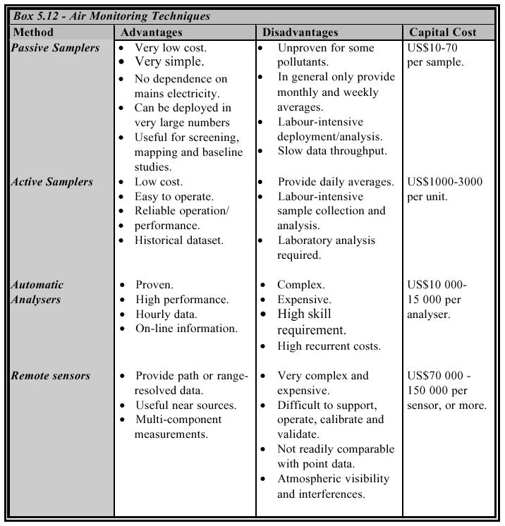

Air quality modelling
Air quality modelling, particularly dispersion modelling, is used to predict air pollution concentrations in the modelled region using data on pollutant emission sources and meteorology as inputs. There are several different types of atmospheric models, ranging from a simple input-output ‘box’ model to very complex models (and difficult to develop and use) that attempt to account for dispersion, atmospheric chemistry and local terrain variations. Statistical dispersion models are intermediate in complexity and ease of use, and the most widely used. Air quality models are mathematical procedures that combine emission data from one or several sources (some models are capable of handling several thousand sources, including stationary and mobile sources) and meteorological data to predict ambient concentrations of pollutants as a function of time and location. The output of all models should be validated, and calibrated if necessary, against data from appropriately located monitoring stations. Dispersion models are able to interpolate values between monitoring stations, and may be used to predict (forecast) near-term concentrations, providing a coherent integrated picture of the link between the sources of pollution and the ambient air quality. Atmospheric models are therefore as essential aspect of air quality assessment, but their limitations must understood and accounted for. The calibration and validation of models is essential.

A great value of air pollution modelling is that it can be used to evaluate the effectiveness of interventions such as the use of cleaner fuels, the us gas cleaning equipment on factory stacks or the emission reduction benefits of improving public transport and simultaneously reducing private vehicle use. Modelling may also be used to assess the likely impact of new industrial developments. Model results may thus be used to make air quality management decisions.

The validity of a dispersion model is dependent on the quality of pollutant source data. As in the case of an Emission Inventory, the necessary regulatory and administrative infrastructure for the periodic collection of source data is essential.

Air pollution modelling may also be used to study the potential impact of a single emission source, illustrated in the following example.

Consider the impact of a large industrial boiler, producing about 24 t/h of steam, using 3t/h coal containing 1% sulphur as a fuel source. The emission rate of SO2 would be about 16g/s (57kg/h). For modelling purposes, assume a stack height of 50m, a stack exit velocity of 6m/s and an exit gas temperature of 300 ºC. A dispersion model is able to predict concentrations in a specified area, for given meteorological conditions. (For illustrative purposes, a simplified statistical (Gaussian) model that does not account for stack temperature and exit velocity was used.)

Figures 6.2 and 6.3 illustrate the substantial differences in ambient concentrations as a function of downwind location, and the location of the point of highest concentration, that may occur due to differences in wind speed and atmospheric stability. (Stable or very stable conditions may occur at night, particular during winter, under conditions of low wind speed. Unstable conditions may occur during the day with strong insolation (heating by the sun) and moderate wind speed.) Under stable or poor dispersion conditions (Figure 6.2), maximum concentrations are high (about 130 ug/m3) and occur over a comparatively large area; under unstable conditions (good dispersion, Figure 6.3), maximum concentrations are lower (about 110 ug/m3) and occur over a smaller area. Note also that the point of maximum concentration is not at the source but is some distance downwind because the pollutants are discharged at a height of 50m. Note also that the location of the point of maximum concentration is substantially different for the two cases.

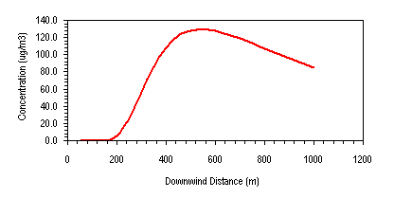

Figure 6.2: SO2 concentration vs downwind distance (Emission rate 16g/s, 50m stack, 10km/h wind, atmospheric stability class f )

Figure 6.3: SO2 concentration vs downwind distance (Emission rate 16g/s, 50m stack, 20 km/h wind, atmospheric stability class b)

The model also provides the ‘footprint’ of the pollution impact, as illustrated in Figures 6.4 and 6.5, again showing the substantial differences in impact that occurs under different meteorological conditions.

Source location
Figure 6.4: SO2 concentrations for Stability Class F, 10km/h wind speed

The change in ambient concentrations due to a change in meteorological conditions may be illustrated by modelling the same emission source under slightly unstable conditions:

Source location
Figure 6.4b: SO2 concentrations for Stability Class B, 20km/h wind speed)

The location of a receptor relative to the wind direction have an even greater significance with the respect to the exposure experienced – in both cases the concentrations upwind are essentially zero compared to the significant concentrations downwind of the source.

Basic dispersion models account for the influence of meteorology – wind strength and direction, cloud cover – and source strength and other characteristics such as release height, temperature and exit velocity. More complex models are needed to account for atmospheric chemistry and the influence of terrain on wind direction.

Air pollutant emission inventory
The third generally used method on assessing air quality in a given area is the preparation of an emission inventory. An emission inventory is a compilation of all significant pollutant emissions and emission sources. Emission data are consolidated into a national emission inventory database, using a standardised methodology of estimating emissions. In terms of the United Nations Framework Convention on Climate Change (UNFCCC), signatories are required to compile and maintain an emission inventory of greenhouse gases.

The following excerpt from the EMEP/CORINAIR Emission Inventory Guidebook - 3rd edition September 2003 UPDATE, Report 30 (http://reports.eea.eu.int/EMEPCORINAIR4/en/page002.html ) provides the motivation for the compilation of an EI, and an outline of the general methodology used.

(Introduction to: EMEP/CORINAIR Emission Inventory Guidebook - 3rd edition September 2003 UPDATE, Report 30, http://reports.eea.eu.int/EMEPCORINAIR4/en/page002.html)
EMISSIONS AND EMISSION INVENTORIES
Substances emitted into the atmosphere by human and natural activities are the cause of many current and potential environmental problems, including:
- acidification
- air quality degradation
- global warming/climate change
- damage and soiling of buildings and other structures
- stratospheric ozone depletion
- human and ecosystem exposure to hazardous substances.
It is necessary to have quantitative information on these emissions and their sources in order to help:
- inform the policy makers and the public
- define environmental priorities and identify the activities and actors responsible for the problems
- set explicit objectives and constraints
- assess the potential environmental impacts and implications of different strategies and plans
- evaluate the environmental costs and benefits of different policiesli>
- monitor the state of the environment to check that targets are being achieved
- monitor policy action to ensure that it is having the desired effects
- ensure that those responsible for implementing the policies are complying with their obligations.
There are many types of sources of atmospheric emissions and many examples (often millions) of each type, for example:
- power plants
- refineries
- incinerators
- factories
- domestic households
- cars and other vehicles
- animals and humans
- fossil fuel extraction and production sites
- offices and public buildings
- trees and other vegetation
- distribution pipelines
- fertilised land
- land with biological decay.

Air Quality or Air Pollution Indices (AQI or API)
It is not possible to measure emissions from all of the individual examples of these sources or, in the short term, from all the different source types. In practice, atmospheric emissions are estimated on the basis of measurements made at selected or representative samples of the (main) sources and source types.
The basic model for an emission estimate is the product of (at least) two variables, for example:
- an activity statistic and a typical average emission factor for the activity, or
- an emission measurement over a period of time and the number of such periods emissions occurred in the required estimation period.
For example, to estimate annual emissions of sulphur dioxide in grams per year from an oil-fired power plant you might use, either:
- annual fuel consumption (in tonnes fuel/year) and an emission factor (in grams SO₂ emitted/tonne fuel consumed), or
- measured SO₂ emissions (in grams per hour) and number of operating hours per year.
In practice, the calculations tend to more complicated but the principles remain the same.
Emission estimates are collected together into inventories or databases which usually also contain supporting data on, for example: the locations of the sources of emissions; emission measurements where available; emission factors; capacity, production or activity rates in the various source sectors; operating conditions; methods of measurement or estimation, etc.
Emission inventories may contain data on three types of source, namely point, area and line. However, in some inventories all of the data may be on area basis - region, country, sub-region etc.
- Point sources - emission estimates are provided on an individual plant or emission outlet (usually large) usually in conjunction with data on location, capacity or throughput, operating conditions etc. The tendency is for more sources to be provided as point sources as legislative requirements extend to more source types and pollutants as well as more openness provides more such relevant data.
- Area sources - smaller or more diffuse sources of pollution are provided on am area basis either for administrative areas, such as counties, regions etc, or for regular grids (for example the EMEP 50x50 km grid).
- Line sources - in some inventories, vehicle emissions from road transport, railways, inland navigation, shipping or aviation etc are provided for sections along the line of the road, railway-track, sea-lane etc.

Air Pollution Indices
The task of communicating the complex relationship between air pollutant exposure and ill health to the public in a manner that is both simple and accurate is an important albeit difficult aspect of an air pollution information system. An Air Pollution Index (API) (or Air Quality Index, AQI) is a numerical scale, usually colour coded, widely used to relate air pollution exposure data to the risk of short-term adverse health. In practice a subset of air pollutant exposures, consisting of the concentrations of the common air pollutants – sulphur dioxide (SO2), particulate matter (PM), nitrogen oxides (NOx), carbon monoxide (CO) and ozone (O₃) – is used to determine the API. The systems in current use are based on the calculation of an index value for each of the pollutants; in most cases, the API is then considered to be the highest of the individual pollutant index values.

The UK index system is:

Table 6.2: The UK Air Pollution Index Systemª
Band | Index | Ozone | Nitrogen Dioxide | Sulphur Dioxide | Carbon Monoxide | PM₁₀ Particles
Band | Index | 8 hourly or  hourly mean* | Hourly mean | 15 minute mean | 8 hour mean | 24 hour  mean
Band | Index | µg/m³ | µg/m³ | µg/m³ | mg/m³ | µg/m³
Low | 1 | 0-32 | 0-95 | 0-88 | 0-3.8 | 0-16
Low | 2 | 33-66 | 96-190 | 89-176 | 3.9-7.6 | 17-32
Low | 3 | 67-99 | 191-286 | 177-265 | 7.7-11.5 | 33-49

UK Air Quality Standards
Moderate | 4 | 100-126 | 287-381 | 266-354 | 11.6-13.4 | 50-57
Moderate | 5 | 127-152 | 382-476 | 355-442 | 13.5-15.4 | 58-66
Moderate | 6 | 153-179 | 478-572 | 443-531 | 15.5-17.3 | 67-74
High | 7 | 180-239 | 573-635 | 532-708 | 17.4-19.2 | 75-82
High | 8 | 240-299 | 636-700 | 709-886 | 19.3-21.2 | 83-91
High | 9 | 300-359 | 701-763 | 887-1063 | 21.3-23.1 | 92-99
Very High | 10 | 360 or more | 764 or more | 1064 or more | 23.2 or more | 100 or more
* For ozone, the maximum of the 8 hourly and hourly mean is used to calculate the index value.
- Adapted from the netcen (www.netcen.co.uk) data archive website:
http://www.airquality.co.uk/archive/standards.php#std

The United States operates a system similar in basic concept, but considerably different with respect to the detailed implementation of the system. Both systems use their Air Quality Standards as a basis for the numerical scale, and do not account for the reality of simultaneous multiple exposures to different air pollutants. The pollutant with the highest index value is assumed to characterise to air quality for the given location and period – the effect of all other pollutants is ignored.

The index system proposed for the DAPPS project, based on relative risk of excess daily mortality, is:

Table 6.3: The definition of the DAPPS Air Pollution Index (API) System
 | Pollutant exposure metric -> | PM10, 24h average [μg/m3] | PM2.5, 24h average [μg/m3] | SO2, 24h average [μg/m3] | Ozone, 8h maximum [μg/m3] | Ozone, 1h maximum [μg/m3] | NO2, 1h maximum [μg/m3] | CO, 8h rolling average [mg/m³]
Relative Risk | Index value | Concentration = (RR-1)/(Excess Risk Factor)
1 | 0 | 0 | 0 | 0 | 0 | 0 | 0 | 0.0
1.015 | 1 | 21 | 10 | 38 | 30 | 33 | 51 | 3.9
1.031 | 2 | 41 | 20 | 77 | 60 | 67 | 102 | 7.9
1.046 | 3 | 62 | 30 | 115 | 90 | 100 | 153 | 11.8
1.061 | 4 | 83 | 40 | 153 | 120 | 133 | 204 | 15.7
1.077 | 5 | 104 | 50 | 192 | 150 | 167 | 256 | 19.7
1.092 | 6 | 124 | 60 | 230 | 180 | 200 | 307 | 23.6
1.107 | 7 | 145 | 70 | 268 | 210 | 233 | 358 | 27.5
1.123 | 8 | 166 | 80 | 307 | 241 | 267 | 409 | 31.5
1.138 | 9 | 186 | 90 | 345 | 271 | 300 | 460 | 35.4
> 1.153 | 10 | >=207 | >=100 | >=383 | >=301 | >=333 | >=511 | >=39.3

The overall DAPPS index is the sum of the individual indices, normalised to the same 0 to 10 scale of values.

