Ch 5: The influence of the atmospheric processes
The three atmospheric processes that have a major effect on ambient level concentrations (and therefore health and environmental effects) are meteorology, chemical and physical transformations, and dispersion of the pollutants.

Meteorology (the study of weather patterns, including the variables wind speed and direction, atmospheric temperature and pressure, cloud cover, relative humidity and insolation) may be the dominant influence on the dispersion of pollutants as well as the rate of formation of pollutants such as ozone and secondary particulates.
(Insolation: the duration and intensity of solar radiation)

Wind, characterised by wind speed and direction, mainly influences the horizontal dispersion, and therefore the dilution, of air pollutants. It is the main mechanism for transporting pollutants downwind of sources. Surface roughness (obstructions such as trees and buildings) results in turbulent eddies and promotes dispersion.

The vertical movement of the air results in vertical dispersion of pollutants. Conversely, the absence of vertical dispersion results in increasing graound level concentrations and a larger area of impact. The main factor influencing the vertical stability (the tendency of a parcel of air to remain at ground level or to rise) of the air is the actual vertical temperature profile relative to the dry adiabatic lapse rate.

The dry adiabatic lapse rate is the rate of temperature decrease with height that would occur if a dry parcel of air rises adiabatically, that is, without losing or gain heat (energy). The dry adiabatic lapse rate is 9.8 ºC per 1000m or about 1 ºC per 100m. Due to the presence of water vapour in the atmosphere, the average adiabatic lapse rate is less, about 6.5 ºC

The vertical dispersion potential (the stability) of the atmosphere is determined by comparing the actual lapse rate (vertical temperature profile) against the adiabatic lapse rate, as in Figure 5.1.
Ground based temperature inversion
Dry adiabatic lapse rate
------ Actual (environmental) lapse rates
Super adiabatic lapse rates
Sub adiabatic lapse rates
Height
Temperature

Figure 5.1: Lapse rates (rates of temperature change with height, relative to the dry adiabatic lapse rate)

The influence of air stability on the potential to disperse pollutants may be summarised:
- Super-adiabatic conditions or a strong lapse rate – the air is unstable, good dispersion conditions
- Sub-adiabatic or weak lapse rate, the air is relatively stable – poor dispersion conditions
- Temperature inversion (the temperature increases rather than the ‘normal’ decrease with height) – stable atmosphere, very poor dispersion conditions

Figure 5.2 illustrates pollutant dispersion patterns under different atmospheric conditions.

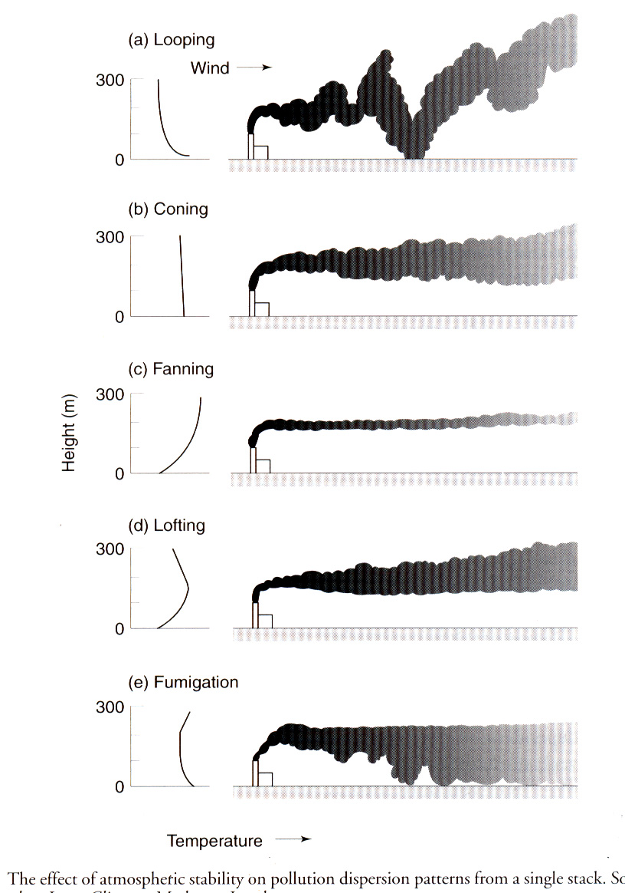

Super adiabatic conditions

Sub adiabatic conditions, neutral conditions

Stable conditions, very little vertical mixing

Discharge above the inversion layer

Discharge below the inversion layer

Figure 5.2: The effect of atmospheric stability on pollution dispersion patterns from a stack

Under cloudless conditions, ground cooling is rapid at night, resulting a tendency to stable or very stable conditions. Under cloudy conditions, the clouds trap the earth’s heat at night, reducing the tendency for the occurrence of temperature inversion conditions and therefore stable conditions.

In air pollution modeling, the complex interaction of meteorological factors are frequently grouped into one of 6 (A to F) ‘stability classes’, in accordance with the following scheme.

Surface  Windspeed |  | Daytime  Incoming Solar Radiation |  |  | Night-time  Cloud Cover
m/s | mi/hr | Strong | Moderate | Slight | > 50% | < 50%
<2 | <5 | A | A-B | B | E | F
2-3 | 5-7 | A-B | B | C | E | F
3-5 | 7-11 | B | B-C | C | D | E
5-6 | 11-13 | C | C-D | D | D | D
>6 | >13 | C | D | D | D | D
Note: Class D applies to heavily overcast skies, at any windspeed day or night.
Table 5.1: Pasquill stability classes A to F

In addition to dispersion, individual air pollutant species may undergo chemical reaction. Sulphur dioxide reacts with atmospheric oxygen and water vapour to form sulphuric acid (usually condensed as very fine droplets or mist); the sulphuric acid may in turn react with ammonia (emitted from farming activities) to form solid sulphate particles. NO₂ may be converted to nitric acid mist and ammonium nitrate particles. NO, NO₂ and organic compounds, under the influence of ultraviolet sunlight, interact in a complex series of reactions to form ozone. Sub-micro solid and liquid particles may grow through agglomeration or absorption of moisture.

Terrain features such as hills, valleys and mountains may create local air flows or may trap pollutants; the proximity of the sea may result in land – sea breezes and the recirculation of air pollutants.

Pollutants may be removed from the atmosphere through wet deposition – scrubbed out by rainfall, or dry deposition onto the surfaces of buildings and vegetation.

