Ch 5: The main sources of the common air pollutants; methods of estimating emission rates
Ambient air pollutant concentrations are the result of the interaction of pollutant emissions, chemical and physical transformations, dispersion of the pollutants and pollutant deposition
. There are natural and ‘anthropogenic’ (the result of human activities) sources of pollution. Dispersion of pollutants is greatly influenced by meteorology, mainly wind speed and direction, and vertical air movement. The oceans and surfaces of plants, the earth’s surface and buildings act as pollutant ‘sinks’
.

The sources of air pollution may be classified as stationary point sources (generally industrial in origin), diffuse or area sources and mobile sources (mainly cars and trucks). The stationary industrial sources are usually classified by process type or sub-type. Thus an oil refining plant also includes large industrial boilers as a sub-type. Small and medium scale plants such as garment or food processing plants may include industrial boilers, a common source of air pollution. The quality and type of fuel used for energy production are important determinants of the air pollution potential of a plant. Each type of plant or activity generally emits more than one pollutant, and the pollutant emission rate depends on the fuel type and quality, the design of the plant (and whether fitted with air pollution control devices or not), and the activity rate or rate of fuel use or production rate of the plant.

Table 3 lists some stationary sources and typical pollutants emitted by these sources. Depending on the classification system, stationary sources may be classified into 50 to 100 different categories. South African regulations, for example, list of about 70 ‘Scheduled Industries’.

Table 5.1: Examples of stationary sources and the main pollutants emitted
Source | Pollutants
Coal Fired Power Stations | SO2, NOx, PM, VOCs, …
Boilers, Combustion Plants | SO2, NOx, PM, VOCs, …
Oil refineries | SO2, NOx, PM, VOCs, …
Incinerators | Dioxins, SO2, NOx, PM, VOCs, …
Sulphuric Acid Plants | SO2, sulphuric acid mist, SO3
Nitric Acid Plants | NOx
Fertiliser Plants | PM (ammonium nitrate, phosphate rock, etc.
Glass manufacture | SO2, NOx, PM
Landfills | CH₄, H₂S, odourous gases
Mines and smelters | PM, NOx, SO₂, ..
Open burning of solid waste | Dioxins, PM, VOCs, …
VOC storage facilities, paintshops, dry cleaners etc…. | VOCs

The list of pollutants in Table 5.1 is by no means complete.

Source apportionment data
Ambient air quality in a given geographical region is influenced not only by the emission rates of various pollutants, by factors such a meteorology and local topography (mountains and other geographical features). The area influenced by local air pollution may be called an ‘airshed’. In order to develop an effective pollution reduction plan in a given region, a knowledge of the relative contribution of each source or group of sources to total emissions of a pollutant in the ‘airshed’ is required. A single pollutant (SO₂ for example) may have a number of sources, illustrated in the source apportionment graphic, Figure 5.1, below.
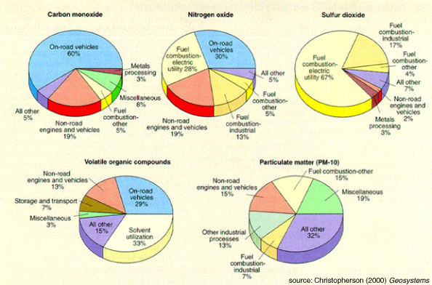
Figure 5.1: Source apportionment example for the common air pollutants

It is important to note that the relative contribution of different sources (the source apportionment) to the total emissions of a particular pollutant may vary considerably from city to city within a country, and from country to country. In the example above the major SO₂ source is an electric power station. But in a city or an urban area without a local power station (such as Durban) electric power generation would not be a significant SO₂ source.

In the South Durban region the main SO₂ sources are the two oil refineries – together they contribute more than 50% to the regional SO₂ inventory. The results (for SO2 emissions) of an emission inventory study in the South Durban Industrial Area are shown in Figure 5.2.
Figure 5.2: SO2 source apportionment, South Durban

tpa: tons per annum

Methods of estimating industrial point source emissions:
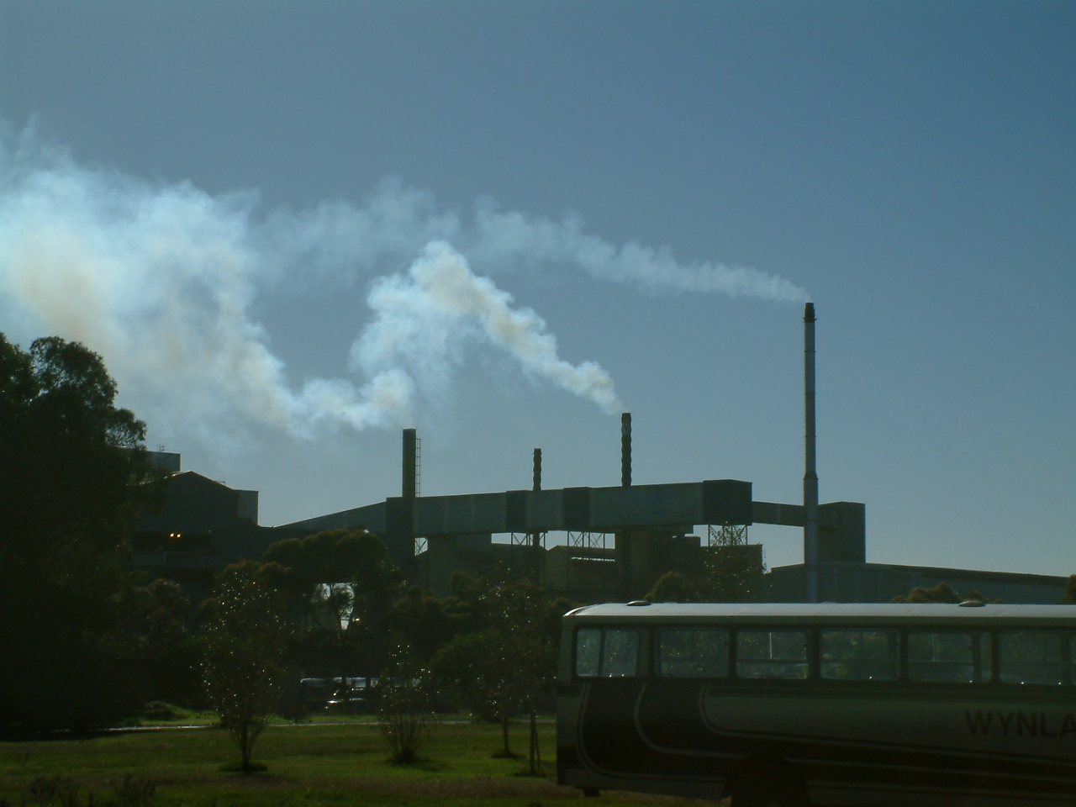
The process of identifying all significant emission sources and estimating or measuring the emission rates (units of g/s are frequently used) of pollutants from each point source are essential prerequisites to developing a point source emission inventory, a far from trivial task.
Figure 5.1 Stack emissions from Consol Glass< Sacks Circle, Bellville

Whilst continuous stack emission monitoring would yield a record of emission rates for each stack, this method is generally only used for large point sources, in countries where continuous emission monitoring (CEM) is mandatory (compulsory). In the absence of CEM, periodic stack measurements may be used to obtain an estimate of emission rates. However, these periodic emission rates should be used with caution – a measurement taken over a period of a few hours annually may not be representative of average operating conditions, and accurate measurements require considerable care.

A widely used alternative is the use of emission factors to estimate emission rates.

The general formula for estimating emission rates is:

Emission rate [g/s] = Activity rate [kg/s or l/s] * Emission factor [g/kg or g/l].

(Other consistent units may be used.)

The US EPA’s Compilation Of Air Pollutant Emission Factors (AP-42) is a widely used reference both of emission factors and methodology. Needless to say, due care should be taken to check that the AP-42 emission factors are applicable to the specific local source, for example by checking if the fuel used, the technology installed and the stack gas cleanup systems are sufficiently similar for the AP-42 emission factors to be applicable.

In general, the use of fossil fuels (coal, fuel oil or gas (LPG or LNG)) is a major source of pollutant emissions, and emissions of the greenhouse gas carbon dioxide (CO2). However, the pollutant profile of each of these fuel sources is markedly different, with gas being by far the least polluting.

Fuels may be compared for pollution potential on the basis of their emissions per kg or per litre, as illustrated in the Table 5.2.

Table 5.2: Emission Factors for different fuel types (CT Brown Haze Study)
 |  | Pollutant
Fuel | Units | SO2 | NOx | PM10 | VOCs
Coal | g/kg | 19 | 1.5 | 4.1 | 5.0
Paraffin | g/l | 8.5 | 1.5 | 0.2 | 0.09
LPG | g/l | 0.01 | 1.4 | 0.07 | 0.5
wood | g/kg | 0.75 | 5 | 17.3 | 22

Of the above fuels, LPG (liquefied petroleum gas) is the ‘cleanest’ – it produces far lower emissions of SO2, PM10 and VOCs compared with the other fuels, and NOx levels are similar.

Note that these emission factors are to some extent dependent on the individual fuel composition. For example, the SO2 emissions from coal and fuel oil are a direct function of the sulphur content of these fuels. Good design and the installation of emission control devices such as precipitators or baghouses (to reduce PM10 emissions), or stack gas scrubbers (for SO2 emissions) may reduce emissions of these pollutants by 70 to 90%.

The above emission factors may be compared to the US EPA AP-42 values.
Exercise: If 90% of the sulphur in coal is emitted through the boiler stack in the form of sulphur dioxide, calculate an approximate emission factor (kg SO2/ kg coal) for coal containing 0.9% sulphur.

A point source emission inventory is a database (usually electronic) of all point source emission rates (for each pollutant), together with relevant data on the location of each source, annual production rate or fuel consumption rate used as the basis for estimating the emission rate (or measured stack flow rates and concentrations) in a defined area. Questions of the completeness of the database (whether all significant sources have been included), the accuracy of the measured or estimated emission rates, and the activity pattern (whether the plant operates continuously or periodically) should be addressed in compiling the database.

An example of part of the South Durban emissions database is shown in Table 5.3 below.

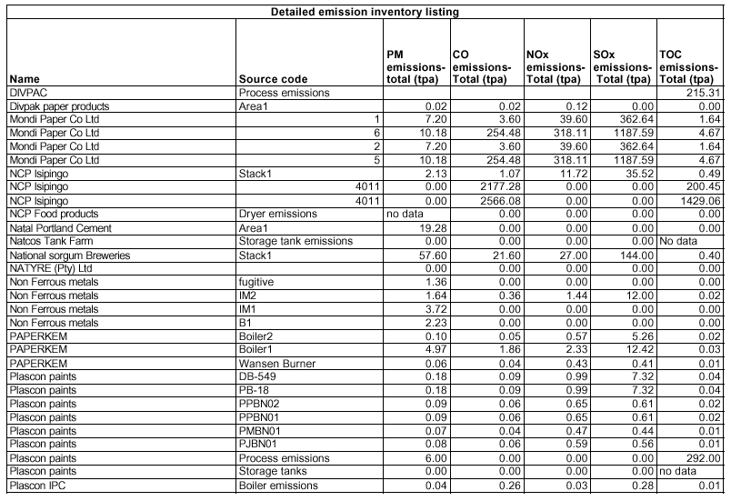
Table 5.3: Part of the South Durban Emission Inventory (1998 – 2000 data)
Estimating mobile source emissions
Mobile sources refer mainly to emissions from cars, trucks, minibuses and buses. The fuel source may be petrol or diesel, and emissions include exhaust emissions and fugitive emissions. The procedure is complex, as is illustrated in the diagram (Figure 5.3) below.
Figure 5.3: Procedure for estimating mobile source emissions

CHARACTERISATION OF FACTORS AFFECTING
MOBILE SOURCES EMISSIONS

INPUT DATA: OUTPUT: INPUT DATA:
Small
Medium Petrol
Large
Passenger Cars
Small
Medium Diesel
Large

LDV Commercial
HDV Vehicles
Buses

2T Motorcycles
4T
…………………………………….
Vehicle Lifetime Function, Scrappage Rate

Fuel Composition(s)

Mode of Use (Urban, Rural, Highway)
Annual Mileage
Travel Speed
Fuel Consumption

Emission Factors: Variation with speed, age degradation factors, engine design

MOBILE SOURCE EMISSONS PROFILE

(SO₂, Pb, HC, NOx, CO)

Petrol and Diesel Consumption

(Fuel Balance)
Total Emissions
Total Emissions
per Vehicle Class
(For details of the methodology, see the paper by Mert and Cairncross.)

Table 5.4 lists typical mobile source emissions in the United States.

Table 5.4: US EPA List of Mobile Source Air Toxics and

US EPA List of Mobile Source Air Toxics
Acetaldehyde  Acrolein  Arsenic Compounds  Benzene  1,3-Butadiene  Chromium Compounds  Dioxin/Furans | Diesel Exhaust  Ethylbenzene  Formaldehyde  n-hexane  Lead Compounds  Manganese Compounds  Mercury Compounds | MTBE  Naphthalene  Nickel Compounds  Polycyclic Aromatic Hydrocarbons (PAH)  Styrene  Toluene  Xylene

A number of these compounds are known or suspected carcinogens.

Vehicle emissions include SO₂, PM, NOx, VOCs and Pb.

Emissions per km travelled depend on vehicle type (petrol or diesel), size, speed, engine design and emission control technology. Tables 5.5 to 5.9 illustrate the differences in emissions per km with and without emission control devices.

Table 5.5: EU Auto-oil Vehicle Emission Factors (Petrol Cars):

Uncontrolled: Fuel Economy 11.2 l/100 km
 | NOx | CH4 | VOC | CO | N2O | CO2
Total g/km | 2.24 | 0.07 | 5.40 | 46.5 | 0.005 | 269
Exhaust | 2.24 | 0.07 | 4.03 | 46.5 | 0.005 | 269
Evaporative |  |  | 1.37
g/kg fuel | 26.6 | 0.83 | 64.0 | 551 | 0.059 | 3183
g/MJ | 0.610 | 0.019 | 1.47 | 12.7 | 0.001 | 73.2

Table 5.6: EU Auto-oil Vehicle Emission Factors (Petrol Cars):

Early non-catalyst controls: Fuel Economy 9.4 l/100 km
 | NOx | CH4 | VOC | CO | N2O | CO2
Total g/km | 2.05 | 0.08 | 5.31 | 28.6 | 0.005 | 225
Exhaust | 2.05 | 0.08 | 3.94 | 28.6 | 6.005 | 225
Evaporative |  |  | 1.37
g/kg fuel | 29 | 1.13 | 75.2 | 405 | 0.071 | 3183
g/MJ | 0.668 | 0.026 | 1.73 | 9.3 | 0.002 | 73.2

Table 5.7: EU Auto-oil Vehicle Emission Factors (Petrol Cars):
Non-catalyst controls: Fuel Economy 8.3 l/100 km
Total g/km | 2.3 | 0.07 | 4.58 | 18.7 | 0.005 | 199
Exhaust | 2.3 | 0.07 | 3.32 | 18.7 | 0.005 | 199
Evaporative |  |  | 1.37
g/kg fuel | 36.7 | 1.12 | 73.2 | 298 | 0.08 | 3183
g/MJ | 0.845 | 0.026 | 1.68 | 6.86 | 0.002 | 73.2

Table 5.8: EU Auto-oil Vehicle Emission Factors (Petrol Cars):
Oxidation catalyst: Fuel Economy 8.1 l/100 km
Total g/km | 1.35 | 0.07 | 1.51 | 7.52 | 0.005 | 193
Exhaust | 1.35 | 0.07 | 1.07 | 7.52 | 0.005 | 193
Evaporative |  |  | 0.44
g/kg fuel | 22.3 | 1.15 | 24.9 | 124 | 0.082 | 3183
g/MJ | 0.512 | 0.027 | 0.572 | 2.85 | 0.002 | 73.2

Table 5.9: EU Auto-oil Vehicle Emission Factors (Petrol Cars):
Three-way catalyst: Fuel Economy 8.5l/100 km
 | NOx | CH4 | VOC | CO | N2O | CO2
Total g/km | 0.52 | 0.02 | 0.47 | 2.86 | 0.05 | 203
Exhaust | 0.52 | 0.02 | 0.41 | 2.86 | 0.05 | 203
Evaporative |  |  | 0.06
g/kg fuel | 8.16 | 0.314 | 7.37 | 44.9 | 0.784 | 3183
g/MJ | 0.187 | 0.007 | 0.169 | 1.03 | 0.018 | 73.2
(Ref. EU Emission Inventory Guidebook, ROAD TRANSPORT rt070100 B710-14 1 September, 1999)

Note the progressive reduction in emissions (for example, NOx emissions decrease from 2.24 in Table 5.5 to 0.52 g/km in Table 5.9) with the improvement in emission control technology.

Total emissions in a given area may be estimated using the following general relationship:

Emission Rate = Emission Factor x Activity Rate

A complex example of the application of emission factors and other input data is the emission inventory that is currently being developed for the Cape Metropolitan Area, under the DAPPS project:

The role of an emission inventory
An emission inventory is a periodically updated database of pollutants emitted to the atmosphere, usually expressed as total annual emissions. In some countries, for example the USA, Canada, Mexico) the detailed emission inventory is publicly available (on the internet). Citizen’s groups are then able to access the data and to pressurise industries to reduce emissions. (See the annual emission inventory summary reports for the USA and Canada in the Materials folder. Else search for these on the Web.)

An emission inventory (usually expressed as g/s) may be used as input to an air pollution modelling study.

More recently, emission inventories include emissions to all media (air, water and soil), and transfers between media. (Alternate names: Toxic Release Inventory in the US, Pollutant Release and Transfer Registry (PRTR) by UNEP.) At a national level, emissions are estimated based on a common methodology. Total emissions are the sum of emissions from all sources, both stationary and mobile.

A typical emission inventory may include 150 to 200 substances. The list is based on an insight into the activities and processes that are likely to produce specific emissions, and the practicality of estimating and tracking the specific pollutants. Emissions may be estimated using emission factors (literature values, validated whenever possible through direct source emission measurements) and activity rates, with due allowance for emission control devices if applicable.

An appropriate emission factor for each compound may be derived through an analysis of all factors affecting vehicle emissions – fuel composition, vehicle characteristics, driving cycle, a profile of the different vehicles in the fleet, etc., - to obtain a factor that may be expressed as mg Pollutant per litre of fuel consumed, or mg/ km travelled. The factor is then applied to the activity rate (litres per annum or km per annum) to estimate total emissions. If an emission control device is fitted to a vehicle, the emission factor would be adjusted to account for the reducing achieved. Similarly, for stationary emission sources such as a refinery furnace, an appropriate emission factor is applied to the total fuel burnt per annum.

The compilation and maintenance of an emission inventory is a considerable task, although not particularly costly to maintain once the regulatory and administrative infrastructure has been established. Technical (and possibly financial) assistance for the establishment of a PRTR is available from several countries and the United Nations Environmental Program. (See the UNEP website.) The initial inventory may be a first approximation only, but successive annual inventories should reflect a progressive improvement in the quality and completeness of the data.

An emission inventory (or PRTR) cannot be established without regulations for the compulsory provision of input data. The legal framework for such regulations, and the necessary administrative infrastructure, are therefore prerequisites.

Public access to the PRTR data is imperative. The experience in a number of countries that have implemented a PRTR is that public access to the data enables affected communities to exercise their environmental rights, and results in a decrease in emissions, with or without regulatory intervention.

Case Studies: Estimating emission rates using emission factors
a) Consol Glass
Approximate data:
Fuel: HFO (heavy fuel oil); 30 000kl per annum;
sulphur content: 1.0 to 2.0%S
stack heights: 45 to 60m
What are the approximate SO2, PM10 and NOx emission rates? Stack gas concentrations?

b) Abnormal emissions example: Oil Refinery: flare at SAPREF (Durban)

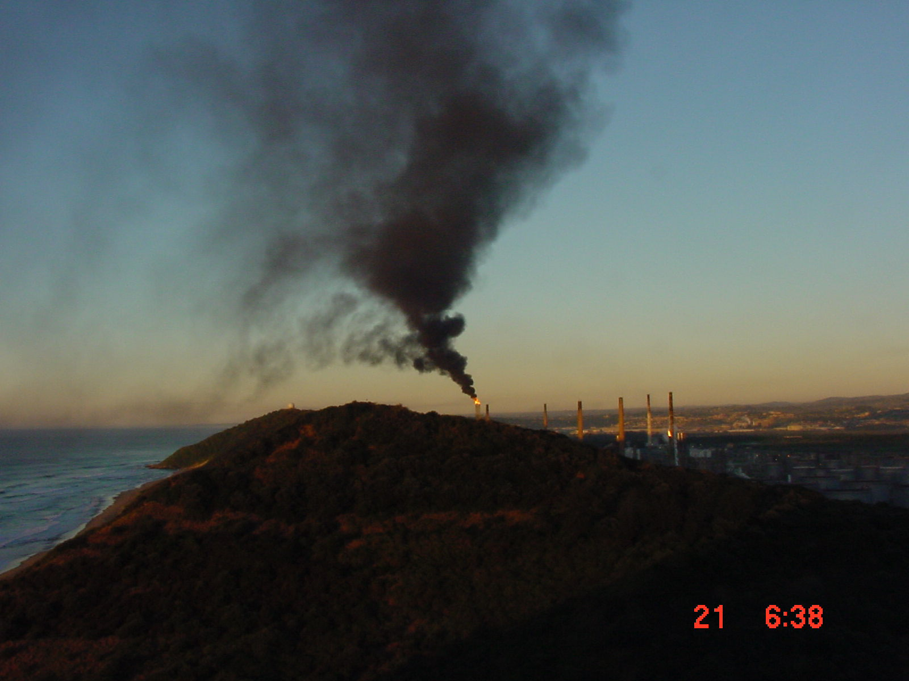

Vehicle emissions
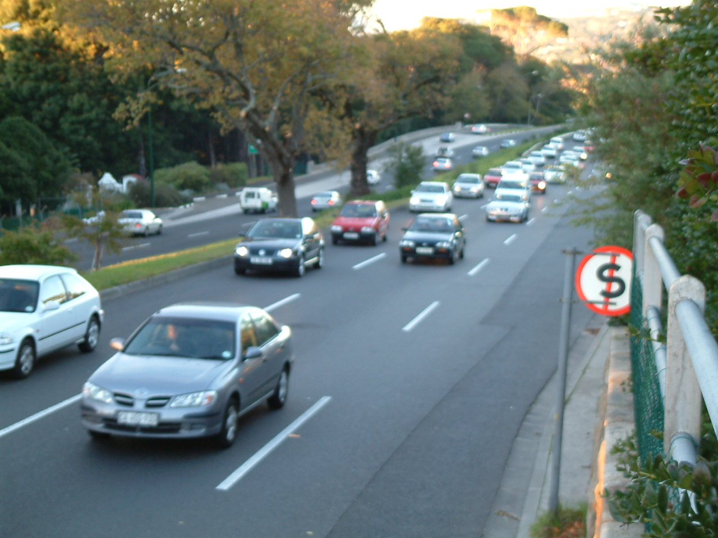

Problems and assignments

Emission Inventory for South Durban, Ecoserv (Pty)(Ltd), 2000

