Ch 3: The main air pollutants; their health impacts; exposure - response relationships

The Health and Environmental Effects of the Classical (Common) Air Pollutants
The classical (or common) air pollutants are SO2, NO2, CO, ozone and PM. The adverse health effects of these ambient air pollutants on exposed communities, demonstrated through many epidemiological studies (WHOa, 2002) include:
- reduced lung functioning
- provoking asthma attacks
- worsening of respiratory symptoms
- restricted physical activity
- increased medication use
- increased hospital admissions
- increased emergency room visits
- development of respiratory diseases
- premature death.

The expected health effects depend on the type of pollution, the level (pollutant concentration) and duration of exposure, and the personal susceptibility of an individual.

Summaries of the sources and the health and environmental effects of the common air pollutants are as follows. (More detailed descriptions of the health impacts of these pollutants are to be found in references 1 and 2 – WHOa and WHOb.)

SO2
Summary: Sulfur dioxide belongs to the family of gases called sulfur oxides (SOx ). These gases are formed when fuel containing sulfur (mainly coal and oil) is burned, and during metal smelting and other industrial processes. Vehicle fuels (petrol and diesel) contain significant levels of sulphur and hence contribute to the emission of SO2 and sulphate particulates. SO2 in the atmosphere is converted to sulphuric acid (H2SO4) and other sulphate particulates. Large scale emissions of SO2 from power stations contribute to acid rain.

Health and Environmental Effects: The major health concerns associated with exposure to high concentrations of SO₂ include effects on breathing (decreased lung function), respiratory illness, alterations in pulmonary defences, and aggravation of existing cardiovascular disease. Children, the elderly, and people with asthma, cardiovascular disease or chronic lung disease (such as bronchitis or emphysema), are most susceptible to adverse health effects associated with exposure to SO₂.

The following excerpts summarizing the exposure-response relationships of SO2, NO2, PM and CO have been extracted from reference 1 (WHOa, Chapter 3). For further details, references 1 and 2, and the scientific literature should be consulted.

WHO Exposure-response relationships for SO2:
Short-period exposures (less than 24 hours)
Most information on the acute effects of SO2 comes from controlled chamber experiments on volunteers exposed to SO₂ for periods ranging from a few minutes up to one hour (WHO 1999a). Acute responses occur within the first few minutes after commencement of inhalation. Further exposure does not increase effects. Effects include reductions in the mean forced expiratory volume over one second (FEV1), increases in specific airway resistance (sRAW), and symptoms such as wheezing or shortness of breath. These effects are enhanced by exercise that increases the volume of air inspired, as it allows SO₂ to penetrate further into the respiratory tract.

A wide range of sensitivity has been demonstrated, both among normal subjects and among those with asthma. People with asthma are the most sensitive group in the community. Continuous exposure-response relationships, without any clearly defined threshold, are evident. To develop a guideline value, the minimum concentrations associated with adverse effects in asthmatic patients exercising in chambers have been considered. An example of an exposure-response relationship for asthmatic patients is shown in Figure 3.1, expressed in terms of change in FEV1 after a 15-minute exposure.

Exposure over a 24-hour period
Information on the effects of exposure averaged over a 24-hour period is derived mainly from epidemiological studies in which the effects of SO₂, SPM and other associated pollutants are considered. Exacerbation of symptoms among panels of selected sensitive patients seems to arise in a consistent manner when the concentration of SO₂ exceeds 250 µg/m 3 in the presence of SPM. Several more recent studies in Europe have involved mixed industrial and vehicular emissions now common in ambient air. At low levels of exposure (mean annual levels below 50 µg/m 3 ; daily levels usually not exceeding 125 µg/m 3 ) effects on mortality (total, cardiovascular and respiratory) and on hospital emergency admissions for total respiratory causes and chronic obstructive pulmonary disease (COPD), have been consistently demonstrated. These results have been shown, in some instances, to persist when black smoke and SPM levels were controlled for, while in others no attempts have been made to separate the pollutant effects. In these studies no obvious threshold levels for SO₂ [emphasis added] has been identified.”

Long-term exposure
Earlier assessments examined findings on the prevalence of respiratory symptoms, respiratory illness frequencies, or differences in lung function values in localities with contrasting concentrations of SO2 and SPM, using data from the coal-burning era in Europe. The lowest-observed-adverse-effect level of SO2 was judged to be at an annual average of 100 µg/m 3 , when present with SPM. More recent studies related to industrial sources of SO2, or to the changed urban mixture of air pollutants, have shown adverse effects below this level. But a major difficulty in interpretation is that long-term effects are liable to be affected not only by current conditions, but also by the qualitatively and quantitatively different pollution of earlier years. However, cohort studies on differences in mortality between areas with contrasting pollution levels indicate that mortality is more closely associated with SPM, than with SO₂.

(Figure 3.1 is an example of a short-term (15-minute) exposure-response relationship for SO2.)
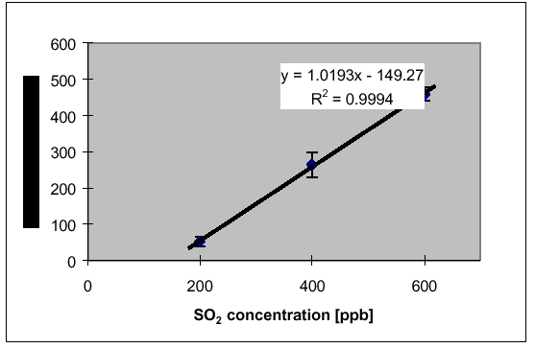
Figure 3.1 Mean change of FEV1 in asthmatics with changing SO2 concentrations
NOx
Summary: NOx consists of nitric oxide (NO) and nitrogen dioxide (NO2). Combustion processes are the main sources of NOx; about 90% of the NOx is released in the form of NO which is converted to NO2. Major sources are power stations (particularly coal fired power stations), vehicles (particularly if not fitted with catalytic converters) and certain industrial processes – mainly nitric acid manufacture. NO2 is a suffocating, brownish gas; nitrogen dioxide is a strong oxidizing agent that reacts in the air to form corrosive nitric acid, as well as toxic organic nitrates. It also plays a major role in the atmospheric reactions that produce ground-level ozone (or smog) and fine particulate matter (PM2.5) in the form of nitrates.
Health and Environmental Effects: Nitrogen dioxide can irritate the lungs and lower resistance to respiratory infections such as influenza. The effects of short-term exposure are still unclear, but continued or frequent exposure to concentrations that are typically much higher than those normally found in the ambient air may cause increased incidence of acute respiratory illness in children. EPA's health-based national air quality standard for NO₂ is 0.053 ppm (measured as an annual arithmetic mean concentration). Nitrogen oxides contribute to ozone formation and can have adverse effects on both terrestrial and aquatic ecosystems. Nitrogen oxides in the air can significantly contribute to a number of environmental effects such as acid rain and eutrophication in coastal waters like the Chesapeake Bay (USA). Eutrophication occurs when a body of water suffers an increase in nutrients that leads to a reduction in the amount of oxygen in the water, producing an environment that is destructive to fish and other animal life.
Nitrogen dioxide exposure-response relationships
Short-term exposure effects
Available data from animal toxicology experiments indicate that acute exposure to NO2
concentrations of less than 1880 µg/m 3 (1 ppm) rarely produce observable effects. Normal healthy humans, exposed at rest or with light exercise for less than two hours to concentrations above 4700 µg/m 3 (2.5 ppm), experience pronounced decreases in pulmonary function; generally, normal subjects are not affected by concentrations less than 1880 µg/m 3 (1.0 ppm).
One study showed that the lung function of subjects with chronic obstructive pulmonary disease is slightly affected by a 3.75-hour exposure to 560 µg/m 3 (0.3 ppm). A wide range of findings in asthmatics has been reported. Asthmatics are likely to be the most sensitive subjects, although uncertainties exist in the health database. The lowest concentration causing effects on pulmonary function was reported from two laboratories that exposed mild asthmatics for 30-110 minutes to 565 µg/m 3 (0.3ppm) NO2 during intermittent exercise. However, neither of these laboratories was able to replicate these responses with a larger group of asthmatic subjects. One of these studies indicated that NO2 can increase airway reactivity to cold air in asthmatic subjects. At lower concentrations, the pulmonary function of asthmatics was not changed significantly.

NO2 increases bronchial reactivity, as measured by the response of normal and asthmatic subjects following exposure to pharmacological bronchoconstrictor agents, even at levels that do not affect pulmonary function directly in the absence of a bronchoconstrictor. Some, but not all, studies show increased responsiveness to bronchoconstrictors at NO2 levels as low as 376-565 µg/m 3 (0.2 to 0.3 ppm); in other studies, higher levels had no such effect. Because the actual mechanisms of effect are not fully defined and NO2 studies with allergen challenges showed no effects at the lowest concentration tested (188 µg/m 3 ; 0.1 ppm), full evaluation of the health consequences of the increased responsiveness to bronchoconstrictors is not yet possible. Recent studies have shown an increased reactivity to natural allergens in the same concentration range. The results of repetitive exposures of such individuals, or the impact of single exposures on more severe asthmatics, are not known.”

CO
Summary: Carbon monoxide is a colorless, odorless, poisonous gas formed when carbon in fuels is not burned completely. It is a byproduct of highway vehicle exhaust, which contributes about 60 percent of all CO emissions. In cities, vehicle exhaust can cause as much as 95 percent of all CO emissions. These emissions can result in high concentrations of CO, particularly in local areas with heavy traffic congestion. Other sources of CO emissions include industrial processes and fuel combustion in sources such as boilers and incinerators.
Health and Environmental Effects:
Carbon monoxide enters the bloodstream and reduces oxygen delivery to the body's organs and tissues. The health threat from exposure to CO is most serious for those who suffer from cardiovascular disease. Healthy individuals are also affected, but only at higher levels of exposure. Exposure to elevated CO levels is associated with visual impairment, reduced work capacity, reduced manual dexterity, poor learning ability, and difficulty in performing complex tasks.
Carbon monoxide: Exposure-response relationships
CO diffuses rapidly across alveolar, capillary and placental membranes. Approximately 80-90% of the absorbed CO binds with hemoglobin to form carboxyhemoglobin (COHb), which is a specific biomarker of exposure in blood. The affinity of hemoglobin for CO is 200-250 times that for oxygen. During exposure to a fixed concentration of CO, the COHb concentration increases rapidly at the onset of exposure, starts to level off after 3 hours, and reaches a steady-state after 6-8 hours of exposure. It is noted that the elimination half-life in the fetus is much longer than in the pregnant mother.

The binding of CO with hemoglobin to form COHb reduces the oxygen-carrying capacity of the blood and impairs the release of oxygen from hemoglobin. These are the main causes of tissue hypoxia produced by CO at low exposure levels. At higher concentrations, the rest of the absorbed CO binds with other heme proteins such as myoglobin and with cytochrome oxidase and cytochrome P-450. The toxic effects of CO first become evident in organs and tissues with high oxygen consumption, such as the brain, heart, exercising skeletal muscle and the developing fetus.

Severe hypoxia due to acute CO poisoning may cause both reversible, short-lasting, neurological deficits and severe, often delayed, neurological damage. The neurobehavioural effects include impaired coordination, tracking, driving ability, vigilance and cognitive performance at COHb levels as low as 5.1-8.2%. In apparently healthy subjects, the maximal exercise performance decreases at COHb levels as low as 5%. The regression between the percentage decrease in maximal oxygen consumption and the percentage increase in COHb concentration appears to be linear, with a fall in oxygen consumption of approximately 1% for each 1% rise in COHb level above 4%.

In controlled studies involving patients with documented coronary artery disease, mean pre-exposure COHb levels of 2.9-5.9% (corresponding to post-exercise COHb levels of 2.0-5.2%) have been associated with a significant shortening in the time to onset of angina, with increased electrocardiographic changes and with impaired left ventricular function during exercise. In addition, ventricular arhythmias may be increased significantly at the higher range of mean post-exercise COHb levels. Epidemiological and clinical data indicate that CO from smoking and environmental or occupational exposures may contribute to cardiovascular mortality and to the early course of myocardial infarction. Current data from epidemiological studies and experimental animal studies indicate that common environmental exposures to CO in the developed world would not have atherogenic effects on humans (WHO 1999a).

During pregnancy, endogenous production of CO is increased so that maternal COHb levels are usually about 20% higher than the non-pregnant values. At steady-state, the fetal COHb levels are as much as 10-15% higher than the maternal COHb levels. There is a well-established and probably causal relationship between maternal smoking and low birth weight at fetal COHb levels of 2-10%. In addition, maternal smoking seems to be associated with a dose-dependent increase in perinatal deaths and with behavioural effects in infants and young children.

Ozone
Nature and Sources of the Pollutant: Ground-level ozone (the primary constituent of smog) is the most complex, difficult to control, and pervasive of the six principal air pollutants. Unlike other pollutants, ozone is not emitted directly into the air by specific sources. Ozone is created by sunlight acting on NOx and VOC in the air. There are thousands of types of sources of these gases. Some of the common sources include gasoline vapors, chemical solvents, combustion products of fuels, and consumer products. Emissions of NOx and VOC from motor vehicles and stationary sources can be carried hundreds of miles from their origins, and result in high ozone concentrations over very large regions.
Health and Environmental Effects: Scientific evidence indicates that ground-level ozone not only affects people with impaired respiratory systems (such as asthmatics), but healthy adults and children as well. Exposure to ozone for 6 to 7 hours, even at relatively low concentrations, significantly reduces lung function and induces respiratory inflammation in normal, healthy people during periods of moderate exercise. It can be accompanied by symptoms such as chest pain, coughing, nausea, and pulmonary congestion. Recent studies provide evidence of an association between elevated ozone levels and increases in hospital admissions for respiratory problems in several U.S. cities. Results from animal studies indicate that repeated exposure to high levels of ozone for several months or more can produce permanent structural damage in the lungs. Ozone damages crops and forest ecosystems.
Ozone and other photochemical oxidants
O₃ toxicity occurs in a continuum in which higher concentrations, longer exposure duration, and greater activity levels during exposure cause greater effects. Short-term acute effects include pulmonary function changes, increased airway responsiveness and airway inflammation, and other symptoms. These health effects are statistically significant at 160 µg/m3 (0.08 ppm) for 6.6 hour exposures in a group of healthy exercising adults, with the most sensitive subjects experiencing a more than 10% functional decrease within 4-5 hours. Controlled exposure of heavily exercising adults, or children to an O3 concentration of 240 µg/m 3 (0.l2 ppm) for 2 hours, also produced decreases in pulmonary function. There is no question that substantial acute adverse effects occur during exercise with one hour exposure to concentrations of 500 µg/m 3 or higher, particularly in susceptible individuals or subgroups.

Field studies in children, adolescents, and young adults have indicated that pulmonary function decrease can occur as a result of short term exposure to O3 concentrations in the range 120-240 µg/m 3 and higher. Mobile laboratory studies have observed changes in pulmonary function in children or asthmatics exposed to O3 concentrations of 280-340 µg/m 3 (0.14-0.17 ppm) for several hours. Respiratory symptoms, especially coughing, have been associated with O3 concentrations as low as 300 µg/m 3 (0.15 ppm). O3 exposure has also been reported to be associated with increased respiratory hospital admissions and exacerbation of asthma. The effects are observed with exposures to ambient O3 (and co-pollutants) and with controlled exposures to O3 alone. This demonstrates that the functional and symptomatic responses can be attributed primarily to O3.

A number of studies evaluating animals (rats and monkeys) exposed to O3 for a few hours or
days have shown alterations in the respiratory tract, in which the lowest-observed-effect levels were in the range of 160-400 µg/m 3 (0.08-0.2 ppm). These included the potentiation of bacterial lung infections, inflammation, morphological alterations in the lung, increases in the function of lung enzymes active in oxidant defenses, and increases in collagen content. Long-term exposure to O3 in the range of 240-500 µg/m 3 (0.12 to 0.25 ppm) causes morphological changes in the epithelium and interstitium of the centri-acinar region of the lung, including fibrotic changes.

Figures 3.2 [to] 3.5 summarize the O3 levels at which two representative adverse health outcomes, based on controlled exposure experiments, may be expected. The dose-response relationships in these figures represent expert judgment based on the collective evidence from numerous studies and linear extrapolation in a few cases where data were limited.

Interestingly, these dose-response relationships appear to be non linear.

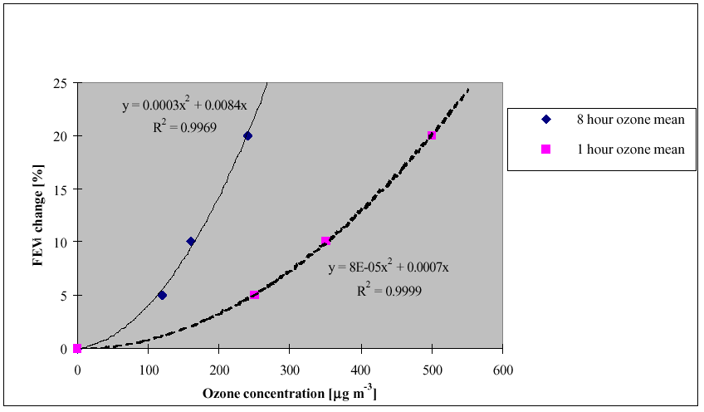
Figure 3.2. Change in FEV1 as a function of O3 concentration in the most sensitive 10% of
active young adults and children.
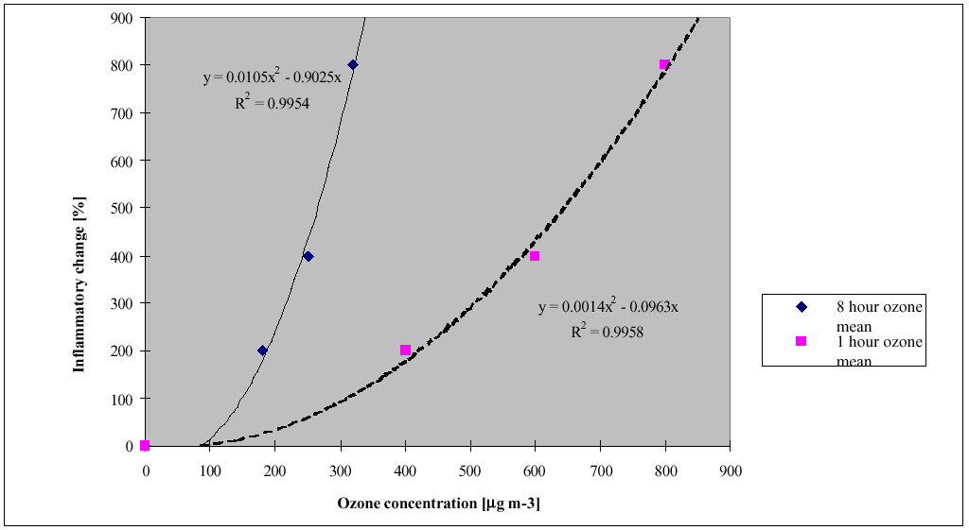
Figure 3.3. Inflammatory change (neutrophil influx in lungs of healthy young adults exercising
outdoors at more than 40l/min expiratory volume in the lung) as a function of O3 concentration.

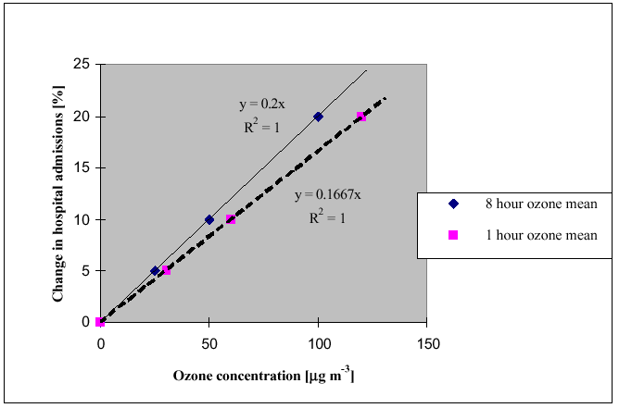
Figure 3.4. Increase in hospital admissions for respiratory conditions as a function of O3
concentration.

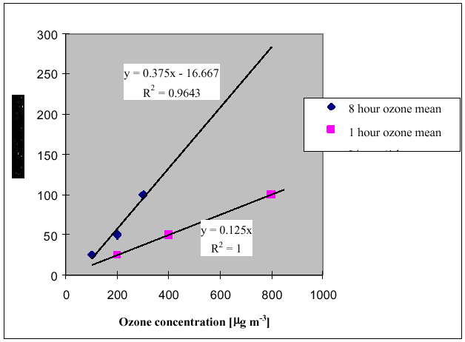
Figure 3.5. Change in symptom exacerbation among adults and asthmatics as a function of O3 concentration.

Particulate matter
The negative health impacts of exposure to suspended particulate matter are due to several complex factors that are still the subject of considerable research. These factors include the size range of the particles, the chemical composition of the particles and the concentration of the particles.

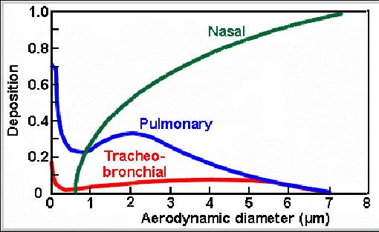
Figure 4.1: Fractional deposition of particulate matter in the lung, by particle size
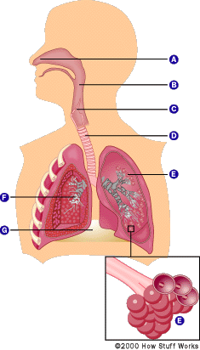

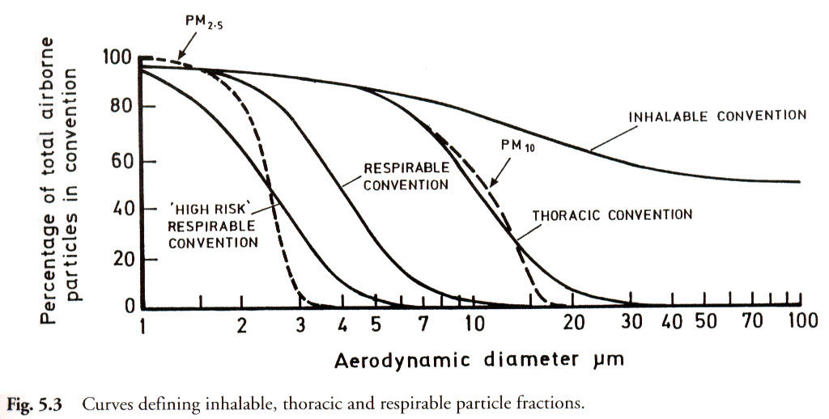
Figure 4.3: Curves defining inhalable, thoracic and respirable particles

Figure 4.2: The human lung

Note: PM10 and PM2.5 are the particle size fractions with median diameters of 10 and 2.5 microns (10⁻⁶m) respectively. The expected size distributions of these particle size fractions are shown in Figure 4.3.

PM10
Nature and Sources of the Pollutant: Particulate matter is the term for solid or liquid particles found in the air. Some particles are large or dark enough to be seen as soot or smoke. Others are so small they can be detected only with an electron microscope. Because particles originate from a variety of mobile and stationary sources (diesel trucks, woodstoves, power plants, etc.), their chemical and physical compositions vary widely. Particulate matter can be directly emitted or can be formed in the atmosphere when gaseous pollutants such as SO₂ and NOx react to form fine particles. Figure 2.1 show the very wide size range of ambient air particles – the largest particles are due to windblown dust, the smallest particles are formed as secondary pollutants, directly emitted (primary) particles are predominantly from combustion sources.
Health and Environmental Effects: The smaller particles that are likely responsible for adverse health effects because of their ability to reach the lower regions of the respiratory tract. The PM-10 standard includes particles with a diameter of 10 micrometers or less (one-seventh the width of a human hair). Major concerns for human health from exposure to PM-10 include: effects on breathing and respiratory systems, damage to lung tissue, cancer, and premature death. The elderly, children, and people with chronic lung disease, influenza, or asthma, are especially sensitive to the effects of particulate matter. Acidic PM-10 can also damage human-made materials and is a major cause of reduced visibility in many parts of the U.S. New scientific studies suggest that fine particles (smaller than 2.5 micrometers in diameter) may cause serious adverse health effects.

PM2.5 (Particulate Matter less than an aerodynamic diameter of 2.5 μm)
Comparatively recent data indicates that much of the health impact ascribed to PM10 is in fact caused by the PM2.5 size fraction, sometimes termed the ‘fine fraction’. The increased harm caused by PM2.5 (relative to its mass fraction) is ascribed to it penetrating deeper into the lungs compare with the coarse fraction (PM10 minus PM2.5), to its more harmful chemical composition (sulphates, nitrates and transition metals such as iron) and the far greater surface area per unit mass compared with the coarse fraction.

Exposure-response relationships of particulate matter:

Suspended particulate matter
Health effects of SPM in humans depend on particle size and concentration, and can fluctuate with daily fluctuations in PM10 or PM2.5 levels. They include acute effects such as increased daily mortality, increased rates of hospital admissions for exacerbation of respiratory disease, fluctuations in the prevalence of bronchodilator use and cough and peak flow reductions. Long-term effects of SPM refer also to mortality and respiratory morbidity, but only few studies on the long-term effects of SPM exist. Air pollution by particulate matter has been considered to be primarily an urban phenomenon, but it is now clear that in many areas of developed countries, urban-rural differences in PM10 are small or even absent, indicating that PM exposure is widespread. This is not to imply that exposure to primary, combustion-related PM may not be higher in urban areas.

A variety of methods exist to measure different fractions of particulate matter in air, with different health significance (see Section 2.1.1). This evaluation has tended to focus on studies in which PM exposure was expressed as PM10 and PM2.5. Health effect studies conducted with various TSP and BS as exposure indicators have provided valuable additional information. However, they are less suitable for deriving exposure-response relationships for PM because TSP includes particles that are too large to be inhaled, or because the health significance of particle opacity as measured by the Black Smoke method is uncertain. Methods for measuring particle concentrations are discussed in section 5.7.

The current time-series epidemiological studies are unable to define a threshold below which no effects occur. Recent studies suggest that even at low levels of PM (less than 100 µg/m 3 ), short-term exposure is associated with health effects. At low levels of PM10 (0 - 100 µg/m 3 ), the short-term exposure-response curve fits a straight line reasonably well (Figures 3.6 to 3.8). However, there are indications from several studies that at higher levels of exposure (several hundreds of µg/m 3 of PM10), at least for effects on mortality, the curve is flatter than at low levels of exposure. This is discussed later in this section.

Although many studies have obtained acute effect estimates for PM10 that are reasonably consistent, this does not imply that particle composition or size distribution within the PM10 fraction is unimportant. Limited evidence from studies on dust storms indicates that such PM10 particles are much less toxic than those associated with combustion sources. Recent studies in which PM10 size fractions and/or constituents have been measured suggest that the observed effects of PM10 are largely associated with fine particles and not with the coarse fraction (PM10 minus PM2.5). In some areas strong aerosol acidity or sulphate may be the cause of the effects associated with PM2.5.

Evidence is also emerging that long-term exposure to low concentrations of PM in air is associated with mortality and other chronic effects, such as increased rates of bronchitis and reduced lung function. Two cohort studies conducted in the U.S.A. suggest that life expectancy may be 2-3 years shorter in communities with high PM than in communities with low PM. This is consistent with earlier cross-sectional studies, which compared age-adjusted mortality rates across a range of long-term average PM concentrations. The results showed that long-term average exposures to low PM levels, starting at about 10 µg/m 3 of fine particulate matter, were associated with a reduction in life expectancy. Whilst such observations require further corroboration, preferably also from other areas in the world, these new studies suggest that the public health implications of PM exposure may be large.

Figures 3.6-3.8 show summary estimates of the relative increase in various health parameters as a function of PM concentration. These figures are based on data reported in studies in which PM10 and/or PM2.5 have been measured. They were not inferred from other measures such as Coefficient of Haze, Black Smoke or SPM. The database for parameters other than PM10 is still limited, so the evaluation of health effects, especially the short-term effects, is largely expressed in terms of PM10. However, future regulations and monitoring activities should give emphasis to the ultrafine and fine fractions in addition to, or even instead of, PM10.

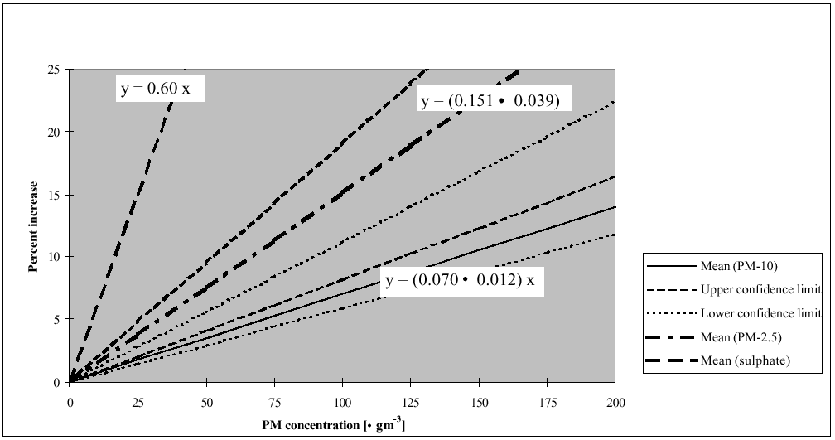
Figure 3.6. Increase in daily mortality as a function of PM concentration.
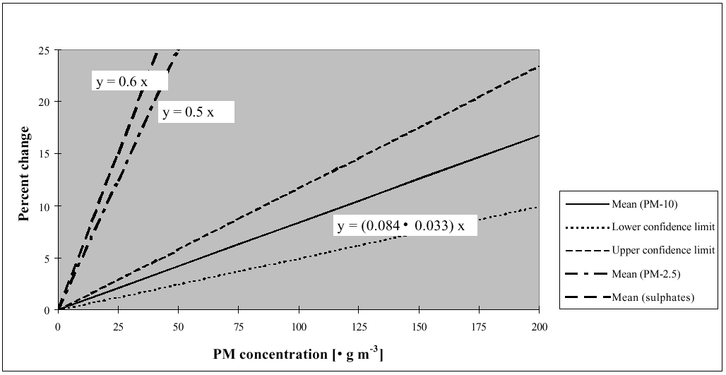
Figure 3.7. Percent change in hospital admissions assigned to PM10, PM2.5 and sulphates.

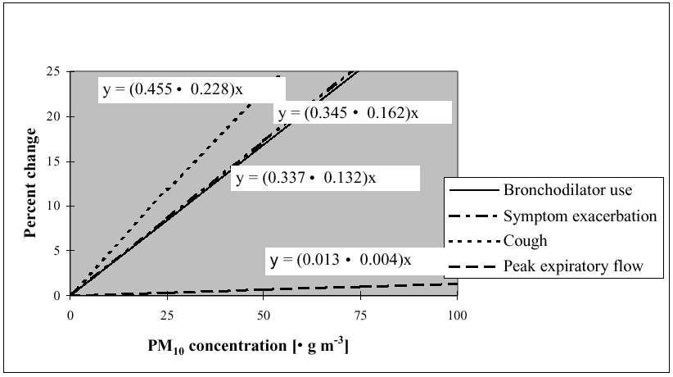
Figure 3.8. Change in health endpoints as a function of PM10 concentration.

The following issues should be considered when using these graphs:

(1) The graphs should not be used for PM10 concentrations below 20 mg/m 3 , or above 200
mg/m 3 ; or for PM2.5 concentrations below 10 mg/m 3 , or above 100 mg/m 3 . This caution
is required as mean 24-hour concentrations outside of the quoted ranges were not used
for the risk assessment, and extrapolations beyond them would be invalid.

(2) The areas close to the straight lines in Figures 3.6–3.8 should be considered as ‘shaded’
areas representing uncertainty, indicated by the 95% confidence intervals (CI).

(3) There is a fundamental difference between the guidelines for PM10 or PM2.5 and the
guideline values for respirable particulate matter derived in the WHO Air Quality
Guidelines for Europe (WHO 1987). The guidelines for PM10 and PM2.5 are
relationships between a health endpoint and the PM concentration. The percent change
is related to the risk of health effects occurring. In consequence, when deriving an air
quality standard for PM10 or PM2.5 using these relationships, it has to be decided which
curve should be used and the risk has to be fixed. This is a new situation with respect
to the derivation of air quality standard from an air quality guideline value, in which a
risk is assumed without it being explicitly stated.

(4) Figures 3.6-3.8 can be used with caution to estimate how many subjects would be
affected over a short period of time with increased PM levels, for a population of a
given size, mortality and morbidity characteristics. There is need for caution because
of variation in results between studies for some effects.

(5) With information on the average number of deaths and the average number of hospital
admissions due to respiratory illness in a particular population, the trendlines in Figures
3.6 and 3.7 allow an estimation of the number of subjects that would be affected by an
episode of PM10, or PM2.5. Similarly, with information on the number of asthmatics
using bronchodilators, or experiencing asthma symptoms on a particular day, the
trendlines in Figure 3.8 allow an estimate of the expected number of affected subjects.
An instructive example is explained in the Air Quality Guidelines for Europe (WHO
1999a).

(6) There is little current information to quantify the reduction in life expectancy associated
with daily mortality increases related to PM exposure. If effects are restricted to
subjects in poor health, effects on age at death may be relatively small.

Lead (Pb)
Pollutant: The main source of environmental lead is emissions from cars using leaded petrol. Smelters and battery plants are major sources of lead in the air in their immediate vicinity. The highest concentrations of lead may be found in the vicinity of nonferrous smelters and other stationary sources of lead emissions.
Health Effects: Exposure to lead mainly occurs through inhalation of air and ingestion of lead in food, paint, water, soil, or dust. Lead accumulates in the body in blood, bone, and soft tissue. Because it is not readily excreted, lead can also affect the kidneys, liver, nervous system, and other organs. Excessive exposure to lead may cause anemia, kidney disease, reproductive disorders, and neurological impairments such as seizures, mental retardation, and/or behavioral disorders. Even at low doses, lead exposure is associated with changes in fundamental enzymatic, energy transfer, and other processes in the body. Fetuses and children are especially susceptible to low doses of lead, often suffering central nervous system damage or slowed growth. Recent studies show that lead may be a factor in high blood pressure and subsequent heart disease in middle-aged males. Lead may also contribute to osteoporosis in post-menopausal women.

VOCs
Volatile Organic Compounds or VOCs are organic chemicals that easily vaporize at room temperature. They are called organic because they contain the element carbon in their molecular structures. VOCs have no colour, smell, or taste. VOCs include a very wide range of individual substances, such as hydrocarbons (for example benzene and toluene), halocarbons and oxygenates.
Hydrocarbon VOCs are usually grouped into methane and other non-methane VOCs. Methane is an important component of VOCs, its environmental impact principally related to its contribution to global warming and to the production of ground level or lower atmosphere ozone. Most methane is released to the atmosphere via the leakage of natural gas from distribution systems. Benzene, a non-methane hydrocarbon, is a colourless, clear liquid. It is fairly stable but highly volatile, readily evaporating at room temperature. Since 80% of man-made emissions come from petrol-fuelled vehicles, levels of benzene are higher in urban areas than rural areas. Benzene concentrations are highest along urban roadsides. Oxygenates arise in vehicle exhausts and via atmospheric chemical reactions. Evaporation of solvents, used for example in paints, cause a release of hydrocarbons, oxygenates and halocarbons to the atmosphere.
Some VOCs are quite harmful, including the carcinogens benzene, polycyclic aromatic hydrocarbons (PAHs) and 1,3 butadiene. Benzene may increase susceptibility to leukaemia, if exposure is maintained over a period of time. There are several hundred different forms of PAH, and sources can be both natural and man-made. PAHs can cause cancer. Sources of 1,3 butadiene include the manufacturing of synthetic rubbers, petrol driven vehicles and cigarette smoke. There is an apparent correlation between butadiene exposure and a higher risk of cancer.
In comparison to other pollutants, the monitoring of VOCs not yet well developed and there is no long term database of information.
Other air pollutants

Dioxins and furans are two groups of extremely harmful substances emitted from waste incinerators that are not equipped with the most sophisticated operational and emission control systems. This is one of the main reasons for communities’ opposition to the use of incineration as a means fro ‘disposal’ of solid waste. (Other reasons are – incineration discourages recycling and reuse of the ‘waste’ materials, and is wasteful of energy and other natural resources.

Dioxins and furans belong to a group of substances known as Persistent Organic Pollutants (POPs) or Persistent Toxic Substances (PTS). Particulate matter containing heavy metals (principally Pb) or persistent organic compounds (such as dioxins) contaminate soil and crops. Exposure to these types of contaminants occurs mainly through ingestion of contaminated food or soil rather than through inhalation of the polluted air.

Exposure-response relationships, including unit risk factors for cancer-inducing pollutants such as benzene and 1-3 butadiene, are discussed and summarised in references 1 and 2.

Exposure-response relationships expressed as (attributable) Relative Risks: WHO Relative Risk values, health endpoints and exposure-response relationships.
The question of the exposure-response relationship for each of the pollutants may be approached from one of two perspectives: a risk based approach or a ‘toxicological’ approach that assumes that there is a threshold below which no adverse effects occur. The vast scientific literature on the relationship between exposure to air pollution and health has been reviewed and summarised in a number of WHO publications, including Air Quality Guidelines (2000). Of the pollutants under consideration for the API (SO2, NO2, PM10, PM2.5, O3 and CO), the PM10, PM2.5 and ozone do not do not have an apparent threshold value below which the risk of adverse health effect is zero. Continuing research indicates that SO2 and NO2 may not have threshold values either. In other words, except for CO, exposure to these pollutants carries a finite risk of an adverse health effect.

The WHO has also published a technical report proposing a procedure for Health Impact Assessment in the EU (WHO HIA report), using Relative Risk factors for SO2, NO2, PM10, PM2.5 and O3 in relation to a range of health endpoints. The data and methodologies in these publications (and the relevant primary sources) are under evaluation for use for the development of the DAPPS APIs.

Table 1 has been adapted from Annex A of the WHO HIA report. This table illustrates the relative risks of respiratory and other diseases and health endpoints associated with increasing air pollution.

The health endpoint ‘Total mortality’ is the only one that is common to all the pollutants and time-averaged values under consideration in developing the DAPPS APIs. One approach under evaluation is to use a common increment of risk attributable to each pollutant/ time averaged value combination under a given exposure scenario to establish breakpoints for the APIs.

Table 1: Relative Risk (central estimate) of health outcome per 10 ug/m³ increase in pollutant concentrationsª
HEALTH ENDPOINT | Incidence | PM10 24h ave. | PM2.5 24h ave. | SO2 24h ave. | O3 8 hr max. | O3 1 hr max. | NO2 daily average | NO2 1 hr max.
 | Per 100 000 | RR | RR |  | RR | RR | RR | RR
MORTALITY
Total mortality | 1013 | 1.0074 | 1.015 | 1.004 | 1.0051 | 1.0046 |  | 1.003
CardiovascularMortality | 497 | 1.008 |  | 1.008 | 1.004 | 1.004 | 1.002 | 1.002
Respiratory Mortality | 66 | 1.012 |  | 1.01 | 1.0126 | 1.008
MORBIDITY
Hospital Admissions Respiratory Disease | 1260 | 1.008
Hospital Admissions Respiratory Dis<15 Yrs | 100
Hospital Admissions Respiratory Dis 15-64 yrs | 66 |  |  | 1.0018 | 1.0062 | 1.0038 | 1.002 | 1.0008
Hospital Admissions Respiratory Dis 65+ Years |  |  |  | 1.004 | 1.0076 | 1.0062 | 1.0038 | 1.001
Hospital Admissions Asthma <15 Years | 100 |  |  | 1.015 | 1 | 1.0012 | 1.0062 | 1.0024
Hospital Admissions Asthma >15-64 Years | 66 |  |  | 1 | 1.007 | 1.003 | 1.0058 | 1.0022
Hospital Admissions COPD | 101.4 |  |  | 1.0044 | 1.0086 | 1.0068 | 1.0038 | 1.0026
Hospital Admissions Cardiovascular Disease | 436 | 1.009
Hospital Admissions Congestive Heart Elderly | 122
Acute Myocardial Infarction | 132 |  |  | 1.0064 |  |  | 1.0036
Acute Bronchitis < 25 Yrs
Asthma Attacks Children |  | 1.051
Asthma Attacks Adults |  | 1.004

The proportion of the health impact (Total mortality, asthma attacks in children, etc.) attributable to a given exposure (pollutant-time combination) in a given population may be calculated using:

AP = SUM{[RR(c) – 1] * p(c)}/ SUM [RR(c)*p(c)] , (1)

where: RR(c) - relative risk for the health outcome in category c of exposure,
p(c) - proportion of the population in category c of the exposure and
AP - Attributable Proportion (of the health outcome to the given exposure).

The number of cases I_{E} attributable to exposure to air pollutants, for a baseline frequency I of the selected health outcome may be calculated from:

I_{E} = I*AP. (2)

The estimate of the number of cases (for a given pollution level) is thus clearly dependent on the baseline frequency and the relative risk factors; both these factors may vary from city to city or country to country.

The data given in Table 1 are based on studies in Europe. Baseline incidence and Relative Risk values may be different in regions and/ or different populations, and may be different in South African cities, and may be different within different areas of a city. Nevertheless, this approach to health impact assessment may provide a systematic method for estimating breakpoints for the different pollutant-averaging time combinations. These tables imply that the relative risk is constant for a constant increment (10ug/m3) in pollution levels.

The Plain English Guide To The Clean Air Act: The Common Air Pollutants (United States Environmental Protection Agency, US EPA) (http://www.epa.gov/oar/oaqps/peg_caa/pegcaa11.html).
Guidelines for Air Quality, WHO, Geneva, 2000
Guidelines for Air Quality, WHO, Geneva, 2000 (Chapter 3)
HEALTH IMPACT ASSESSMENT OF AIR POLLUTION IN THE WHO EOROPEAN REGION, WHO/Euro product no: 876.03.01 (50263446)(November 2001)

