Ch 2: An overview of the main air pollutants and their impacts

Table 1 contains some of the more common air pollutants, a characterisation of these pollutants as ‘primary’ or secondary’, and the type of effects that these pollutants may have.

Table 1: Common Urban Air Pollutants and their Effects
Pollutant | Primary(P) or Secondary (S) | Effects
Sulphur dioxide (SO₂) | P | Health, vegetation
Particulate Matter (PM10, PM2.5) | P and S | Health, visibility impairment
Nitrogen oxides (NOx) (NOx = NO + NO₂) | P and S | Health, vegetation, Global Warming
Volatile Organic Compounds (VOCs) | P and S | Health, ozone formation, smog
Ozone | S | Health, vegetation
Heavy metals, incl. Lead compounds (Br, Cl, oxide) | P | Health
Carbon monoxide (CO) | P | Health

Primary and secondary air pollutants:
Primary pollutants are released directly (from the source) into the atmosphere.
Secondary pollutants are formed through chemical transformations and physical processes.
Aerosols are particulates (liquid or solid) suspended in air.
SO₂, CO₂, CO, NO, NO2, Particulate Matter (PM) and VOCs are primary pollutants - they are released directly into the atmosphere.

Particulate matter (PM) may be liquid or solid particles. PM is characterised both by its chemical composition and its size range. The term ‘aerosol’ is used for PM suspended in air, size range less than about 50 μm (micrometers). PM10 refers to the size fraction less than 10μm; PM2.5, the ‘fine fraction’, to that less than 2.5 μm; the ‘coarse fraction to the size range (PM10-PM2.5).

Vehicle emissions and emissions from other combustion sources may be significant primary sources of fine fraction (PM2.5) particulate emissions. The combustion of hydrocarbons - fuel oil, diesel and petrol - produces elemental carbon as a primary particulate.

Windblown dust (the main constituent of the coarse fraction) is also a source of primary particulate matter.

Secondary pollutants are formed in the atmosphere through chemical reactions and physical processes. For example, SO₂ and NO₂ react with ammonia or other alkaline species, atmospheric oxygen and water vapour to form sulphates (ammonium bisulphate and /or sulphuric acid) and nitrates (ammonium nitrate, peroxyacetylnitrate (PAN) and/ or nitric acid). The nuclei that form when these substances condense may grow through the physical processes of deposition of the gaseous component vapour onto the particles, and the agglomeration of smaller particles to form larger particles.

Figure 2.1 illustrates the characteristic size distribution of particulate matter.

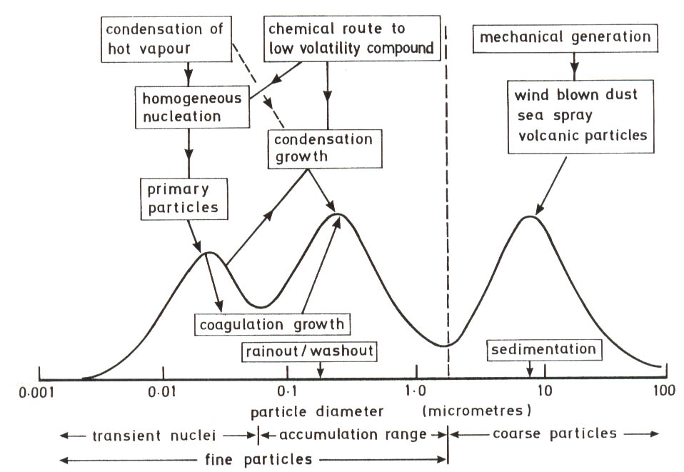
Figure 2.1: Size distribution of airborne particulate matter
(adapted from Holgate et al, Figure 5.2)

Nitric oxide (NO) is mainly produced by through combustion processes. NO is thus present in motor vehicle exhaust gases, stack emissions from stationary combustion sources such as coal, oil and diesel fired boilers and coal fired power stations, and waste incinerators. The negative environmental impacts of NO are not attributed to direct exposure to NO but to the atmospheric transformation products of NO.

Ozone is a secondary pollutant formed through a complex series of reactions between NOx (NO₂ and NO), volatile organic compounds and ultraviolet sunlight.

Carbon monoxide is formed due to the incomplete combustion of hydrocarbons – emissions from motor vehicles are the main source of ambient CO.

Carbon dioxide (CO₂) and other ‘Climate Change’ or ‘greenhouse’ gases that contribute to Global Warming.
Anthropogenic: Originating from human activities.
Non-anthropogenic or ‘Natural’ air pollution sources are those that do not arise from human activities.
The distinction between the two source types is not always clear-cut.
The focus of this module is the health impacts of anthropogenic air pollutants and their impacts on human health. CO₂ emissions from fossil fuel (coal, diesel, and petrol) combustion, and the resultant increase in atmospheric CO₂ concentrations do not have a direct health impact. Increasing methane and ozone levels also have significant global warming impacts. The (historically) rapid increase in the average earth temperature due to the increase in these ‘greenhouse gas’ concentrations are likely to have major large-scale impacts, including health impacts. These impacts are likely to include an increase in intense precipitation (rainfall) events, higher maximum temperatures and rising sea levels.

A highly simplified explanation of the mechanism of global warming is illustrated in the following diagram (Figure ..).

Figure 2.1: “Greenhouse gases in the atmosphere trap heat trying to escape to space, thereby raising the temperature of the Earth's lower atmosphere and surface. This is the greenhouse effect.”

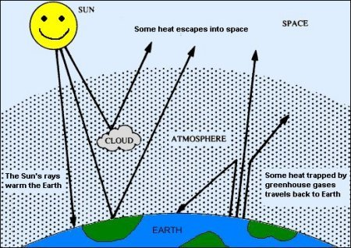
The main greenhouse gases:
Carbon dioxide (CO₂)
Methane (CH₄)
Nitrous oxide (N₂O)
Flourocarbons

Figures 2.2 and 2.3 illustrate long term CO₂ trends and more recent measurements, monitored at a location that is remote from anthropogenic sources, respectively.

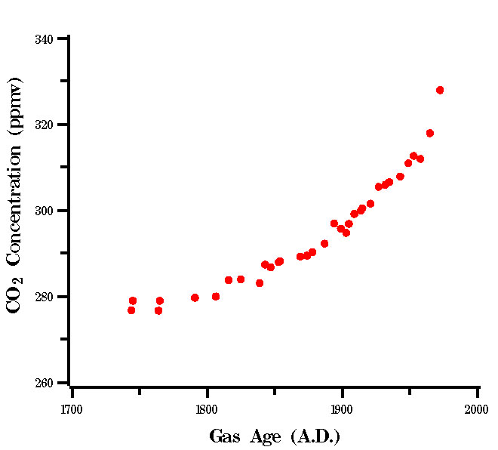
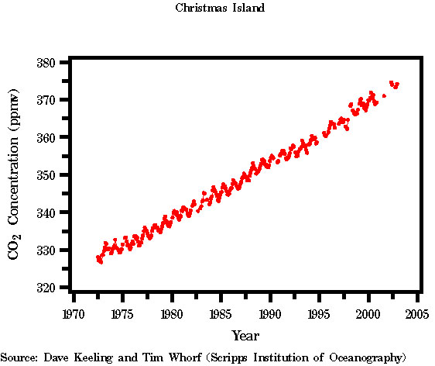
Figure 2.2 Long-term trend in atmospheric CO2 concentrations (ice core data)
Figure 2.3 Recent trend in atmospheric CO2 concentrations (measured at Christmas Island)

A perusal of Figures 2.2 and 2.3 show that CO₂ concentrations were about 280 ppm (by volume) in 1800 and have increased to about 380 ppmv. (The main GHGs are CO₂, CH₄ (methane), and N₂O (nitrous oxide). This historically rapid increase in Greenhouse Gas (GHG) concentrations has changed the Earth’s energy balance – the GHGs trap the long wavelength radiation from the earth causing a slow increase in the average temperature.

Of the greenhouse gas emissions, CO₂ emissions are by far the largest. But different gases have different (greater than CO₂) Global Warming Potentials, as shown in Table 2.3. The Global Warming Potential (GWP) is given relative to that of CO₂.
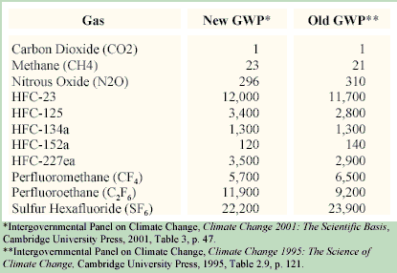
Table 2.3: Global Warming Potentials of the main Greenhouse Gases

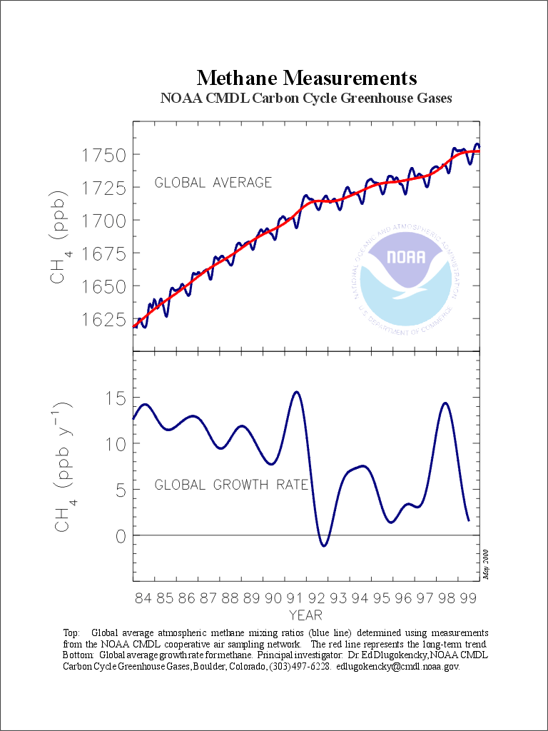

Note that the methane concentrations are given in ppb (parts per billion). Current levels are about 1800ppb or 1.8ppm, compared with the CO₂ concentrations of about 380ppm. But due to the much higher GWP of methane (23), this is equivalent to a CO₂ concentration of 23x1.8~40ppm.

Figure 2.4: Recent trend in methane concentrations

Deposition of pollutants takes place onto buildings, vegetation and other surfaces, and rain tends to scrub out pollutants from the atmosphere – the acidic pollutants, sulphuric acid and
nitric acid may form ‘acid rain’. The relationship between measured ambient pollutant levels and source emissions is therefore complex.

All pollutants undergo dispersion, chemical transformation and deposition in the lowest layer of the atmosphere – the troposphere. The troposphere extends to an altitude of about 16 to 18 km over the tropics, reducing to about 10 km over the poles and contains about 80% of the total air mass. All weather phenomena occur in this layer. Mixing between the troposphere and higher levels of the atmosphere (stratosphere and above) is negligible, therefore the dispersion of pollutants occurs almost exclusively within the troposphere.

What is clean air?

At locations that are remote from pollutant sources, air concentrations reach ‘background’ levels. ‘Background level’ concentrations refer to measurements done far from pollution sources. Due to the mixing and dispersion processes in the atmosphere, background levels may represent concentrations that are low but significantly different from the unpolluted air of pre-industrial periods. The distance from the source(s) required to reach ‘background’ levels depends on several factors, including the strength of the source, the rate of chemical transformation or deposition of the pollutant, and the prevailing meteorological conditions. The Cape Point monitoring station is regarded as a background station even though it is about 100km from the major sources of the City of Cape Town; in contrast, the pollution plumes from the large Eskom power stations (Mpumalanga Highlands) are measurable more than 1000 km from the sources.

Table 2 gives some ‘background level’ (Clean Air) concentrations compared to polluted air levels.

Table 2: Clean Air and Polluted Air
 |  | Concentration, ppb
Species | Units | Clean Troposphere | Polluted Air
SO₂ | ppb | 1 – 10 | 20 – 200
CO | ppb | 120 | 1000 – 10 000
NO₂ | ppb | 0.01 – 0.05 | 50 – 250
O₃ | ppb | 20 - 80 | 100 – 500
PM10 | μg/m³ | 0? | 30 -600?
VOCs | ppb | ? | 500 - 1200
Lead | μg/m³ | 0.0005 – 0.03 | 0.4 – 2.0+
ppb: parts per billion μg/m³ : microgrammes per metre³

The concentration of pollutants in urban air is one to three orders of magnitude (10x to 1000x) greater than levels in ‘background’ or unpolluted air.

For example, Cape Point ‘background’ concentrations (Figures 2.5 and 2.6) for ozone and CO may be compared with values within the City of Cape Town.

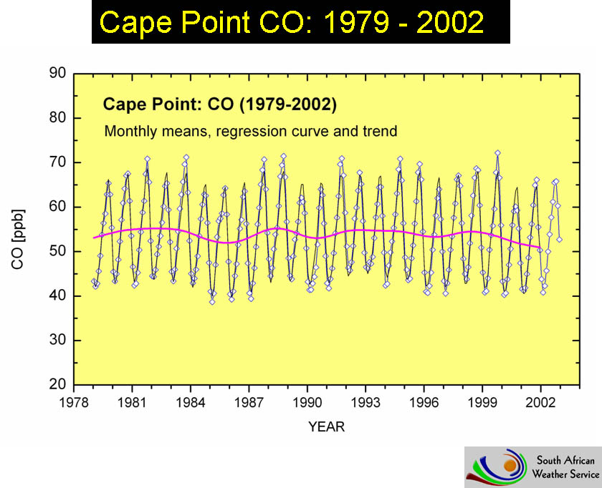
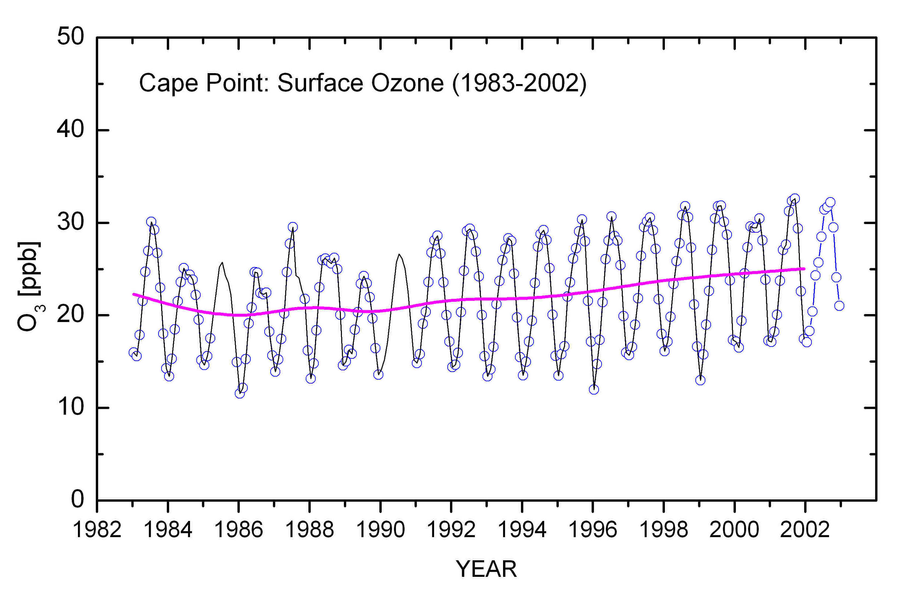
Figure 2.5 Background CO concentrations at Cape Point (Courtesy E Brunke)
Figure 2.6 Background ozone concentrations at Cape Point (Courtesy E Brunke)

By contrast, 24 hour average CO levels in at the Drill Hall monitoring stations are about 2000 ppb, compared with about 55 ppb at Cape Point (Figure 2.5); hourly average ozone concentrations in the City are 0 to 120ppb. Peak ozone levels in the City are about five times greater than at Cape Point. In some cities, peak ozone values of more than 200 ppb are not uncommon.

See, for example, http://www.cmdl.noaa.gov/climate.html

