Ch 11: Water and land pollution

The National Water Act (Act 36 of 1998) governs the use and protection of water resources in South Africa.

The draft policy document, Source Management in South Africa (Draft 3.2)(12 December 2003) sets out a policy framework for the management of water resources:

“The National Water Act, (Act 36 of 1998) was promulgated to provide for fundamental reform of the law relating to water resources, recognising that water is a scarce and unevenly distributed national resource that belongs to all people. The National Water Act acknowledges the National Government's overall responsibility for, and authority over, the nation's water resources and their use and that the ultimate aim of water resource management is to achieve the sustainable use of water for the benefit of all users. The Act also recognises the need for the integrated management of all aspects of water resources and, where appropriate, the delegation of management functions to a regional or catchment
level and that the protection of the quality of water resources is necessary to ensure sustainability of the nation's water resources.

The National Water Act provides the Department of Water Affairs and Forestry (the Department) with a mandate to protect, use, develop, conserve, manage and control South Africa’s water resources in an integrated manner. Such integrated management of the resource depends inter alia on effective management of water quality, which in turn relies on managing both the resource and sources of pollution that threaten the resource.
The Department has divided its water quality management functions into the key areas of resource, source and remediation management.”

“A situational assessment of water quality management and source management within South Africa,
together with interviews with key source management personnel within the Department, identified the
following critical problems and issues:
• there is an increasing level of economic development and urbanisation in South Africa, giving rise
to an increasing number and diversity of pollution sources; for example,
• there is a steady decline in the water quality of the country’s water resources; for example, Total
Dissolved Solids (TDS) in the Loskop dam in the Mpumulanga highveld have shown a steady
increase from about 170 mg/l in the early 1990’s to about 260 mg/l in 2002,
• although source management tools and instruments are available to the Department’s regional
personnel, there is a need for a national strategy that co-ordinates and focuses the use of these
instruments for effective source management,
• there is a need for effective co-governance to achieve integrated management of water resources,
in an arena where the mandates and responsibilities between government departments with regard
to water quality management require clarification,
• there is a limited human and financial resource base within the Department for the management of
sources,
• the National Water Act provides for promulgation of various regulations, such as General
Authorisations for water users, which would allow for a differentiated approach to water quality
management and assist in focussing the efforts of the limited resource base within the Department;
many of these regulations have however not been promulgated,
• the water use authorisation process that is currently in use within the Department is covered in a
guideline document that provides a comprehensive motivation for, and description of, the process.
The document is however difficult to use at an operational level as it lacks clear procedures and
programmes for licensing water users, and
• the National Water Act makes provision for the enforcement of the regulations and requirements of
the Act. These provisions have however not been devolved to operational procedures for use in the
enforcement of the Act b y the source managers.”

What is source classification
A source includes any anthropogenic or natural process that may impact or currently impacts, either
directly or indirectly, on the water resource. Source classification is defined as the categorising of
sources according to the level of threat or risk posed by the source to the water resource.

Appendix A.1 provides details of source classification at a national level. Five main sectors are
identified in Appendix A.1, namely a) mining, b) industry, c) agriculture, d) settlements (urban and
rural/dense) and e) national infrastructure.

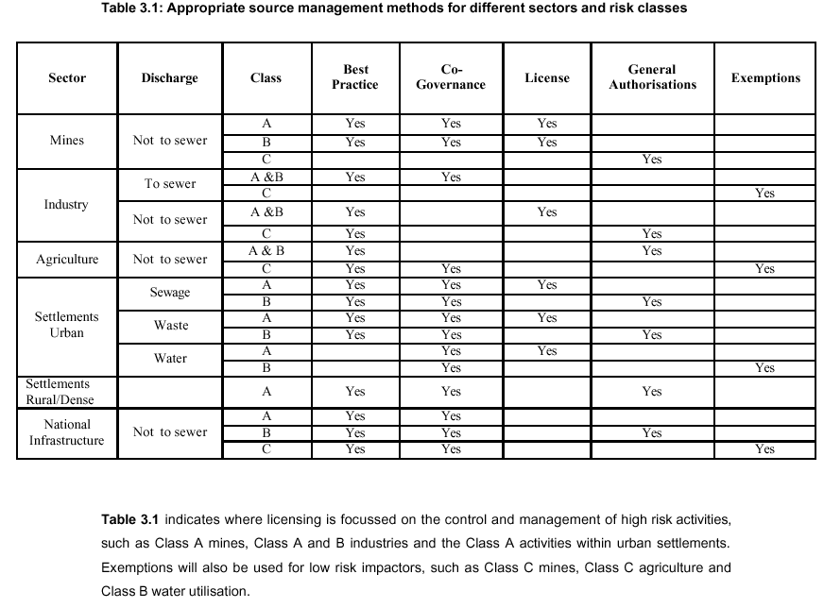

Department of Minerals and Energy (DME)
The DME acts as the lead agency for the licensing of water use for all classes of mines. No prospecting
or mining of minerals may be undertaken without a permit issued by the Regional Director of the DME.

Department of Environmental Affairs and Tourism (DEAT)
The Environmental Conservation Act (Act 73 of 1989) contains regulations in section 26 relating to the
Environmental Impact Assessment (EIA) process as well as provisions dealing with waste management
under section 20. The EIA regulations are aimed at controlling activities that may have a detrimental
effect on the environment, as prescribed in sub sections 21 and 22. These controlled activities are
referred to as controlled activities. These activities appear in Schedule 1 of Government Notice
Regulation 1182 (GG 5999) and Government Notice R670-Gazette No. 23401. The administration of the
regulations, including the granting or refusal of authorisations, has been delegated to the Provisional
Departments of Environmental Affairs (PDEA).
The DEAT, through the EIA process, acts as the lead agency for licensing of water use for:
• low risk (class C) industry that does not discharge to sewer,
• medium risk (class B) sewage treatment works and waste disposal sites in urban areas, and
• regional infrastructure that falls within the Government sector (class B).
The Departm ent has a review role at regional level. The approval of the EIA, under section 26 of the
Environmental Conservation Act, by the DEAT serves as the water use authorisation for these activities
in the risk classes provided above.

Department of Agriculture
The Department of Agriculture will be the lead agent for water use authorisations for low risk (class C)
agricultural activities. This delegation of responsibility to the Department of Agriculture will be covered by a Memorandum of Understanding. (MoU).

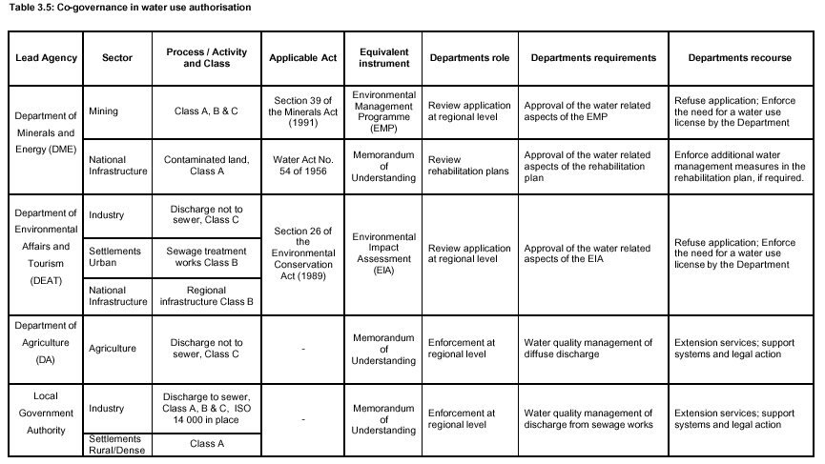

Level 1: Compliance assessment
Level 1 of the enforcement strategy involves policing by the Department of the regulated community and
reporting on the performance thereof. The Regional Office personnel will carry out the following tasks:
• assessment of environmental compliance according to discharge standards by comparing water
quality data captured to WMS to the Resource Water Quality Objectives (or, in their absence, the
Uniform Effluent Standards),
• routine monthly reporting on the performance of the regulated community: the regional staff will
prepare water quality reports for internal use within the Department and summarised reports for use
by the broader stake-holder community and
• identify out-of-compliance incidents through the programme of monitoring, compliance assessment
and reporting;

REGIONAL OFFICE
Position Role and Responsibility
Assistant Director: Planning • Identify and classify all processes, substances and activities into risk
classes.
• Plan, develop, review and finalise the Source Management Plan.
• Evaluate applicability and prepare General Authorisations.
Assistant Director: Water Use
Authorisation
• Co-ordinate all administrative tasks.
• Facilitate input from and manage technical experts.
• Review and evaluation of application.
Inspectors • Data collection and storage,
• Monitoring and compliance assessment,
• Preparation of water quality reports.
Co-governance • Liaison with other government departments.
Extension services • Providing an advisory service and assistance to the regulated
community.
Training • On-site training to meet local needs.

NATIONAL OFFICE
Position Role and responsibility
Deputy Director :
Source Control Policy
• Direct, co-ordinate and control the development, implementation and
consistent application of the source management controls and measures
identified in the Source Management Strategy,
• Supervise and co-ordinate the source management efforts of the Assistant
directors,
• Draft, review and sign Memorandum of Understanding with other government
departments,
• Co-ordinate source management inputs to resource directed measures and
remediation works.
Assistant Director:
Best Practice, Water Quality
Guidelines and National
Discharge Standards
• Develop and implement a methodology to prioritise the development of Best
Practice guidelines,
• Manage the process to prioritise the development of Best Practice guidelines,
• co-ordinate and manage the development of Best Practice guidelines.
Assistant Director:
Authorisations, Enforcement
and Controlled Activities
• Co-ordinate the National office input into the evaluation and reporting on water
use authorisation applications,
• Ensure conformity of evaluation (according to section 27 of the National Water
Act)
• Maintain National records on authorisations,
• Prepare recommendations on authorisations,
• Develop and implement procedures for enforcement, including directives and
legal action,
• Issue directives and prosecute offenders (as required),
Assistant Director:
Source Management Training
and Awareness
• Prepare a needs assessment which will focus on the particular training needs
of the personnel in the National and Regional offices with regard to source
management and water quality management,
• Co-ordinate programmes that will develop and implement new components of
the strategy’
• Co-ordinate training requirements for the Regional Offices,
• Plan and co-ordinate research and development
Assistant Director:
Source Directed Framework
and Policy Review
• Setting and reviewing national policies and strategies for water quality
management and source management,
• Develop the framework within which the water quality management policy and
the source management strategy will be designed and implemented
• Regular review and update of the framework to ensure that source
management programmes, procedures and processes are relevant,
informative and accurate, including legal, technical, social and environmental
aspects.
Assistant Director:
Management Information
Systems
• Co-ordinate the development, testing, implementation, training and use of a
management information system to support the licensing activities in the
Regional and National Offices

