Introduction
Economic development in the form of industrialisation has usually resulted in increasing concentrations of people in towns and cities (urban areas), and the increasing industrial, commercial and domestic activities associated with this historical process of industrial development. Industrial development may have undesirable environmental consequences, particularly an increase in air pollution in these growing urban areas. An increase in air pollution, and more generally environmental degradation, is frequently considered to be an undesirable but unavoidable result of ‘development’. Therefore the strict control and minimisation of environmental impacts is seen as being in conflict with ‘development’ and ‘progress’. But an understanding of the activities and factors that generate air pollution, the human health and environmental consequences of exposure to air pollutants and the available alternative approaches for the reduction or elimination of air pollution enables a different development scenario. Namely the management and avoidance of air pollution impacts within the development process by using concepts and approaches such as ‘Cleaner Production’, waste minimisation, recycling and reuse of ‘waste materials’ and the development of clean renewable energy sources.

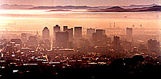
Air pollution cannot be confined. So the general public, including those who do not in any way benefit from the activity causing the pollution (such as a passing bus or a factory) may suffer the discomfort or disease burden of the air pollution. Section 24 of the South African Constitution says that we have the right to an environment that is not detrimental to our health and well-being. But the protection or enforcement of environmental rights in relation to air quality requires an insight into the relationship between the pollution source and the exposure of people or the environment to air pollutants, and the legal and regulatory framework that enables the enforcement of those environmental rights.

The link between poor air quality and ill-health has been suspected for more than 2000 years. The ancient Greeks attempted to control sources of odour such as rubbish; civil suits over smoke pollution were brought before the Roman courts. Air pollution and disease were linked in the (ancient) Islamic world. Urbanisation and the increased use of coal (rather than wood) for domestic heating and cooking during the 18th and 19th centuries, coupled with the development of highly polluting industrial processes such as sulphuric acid manufacture resulted in a rapid deterioration of air quality in towns and cities centres.

Two of the main air pollutants arising out of coal combustion are smoke (particulate matter) and sulphur dioxide (SO₂). The SO2 reacts with atmospheric water vapour and oxygen to form sulphuric acid droplets. The smoke and sulphuric acid droplets provide excellent nuclei for fog formation under weather conditions that tend to coincide with poor pollutant dispersion conditions. The link between air pollution, fog and ill health, observed since ancient times, may be ascribed to these factors.

The industrial revolution in 19th century England resulted in increased energy consumption and use of highly polluting coal. During the 19th century and through to the mid-20th century, the increased use of coal in English cities coincided with increased urban population densities. These factors, and winter weather (low level inversions, high humidity), combined to increase the number of pollution induced foggy days during this period resulted in elevated smoke (particulate matter) and sulphur dioxide (SO₂) concentrations in cities and towns.

Figure 1 uses coal usage rates (imports) into the city of London as a predictor of smoke concentration. The frequency of fog occurrences appears to correlate with the predicted smoke concentration. Between the late 19th century and 1950 coal usage and measured concentrations of sulphates (formed via the oxidation of SO2 in the atmosphere) and smoke decreased.

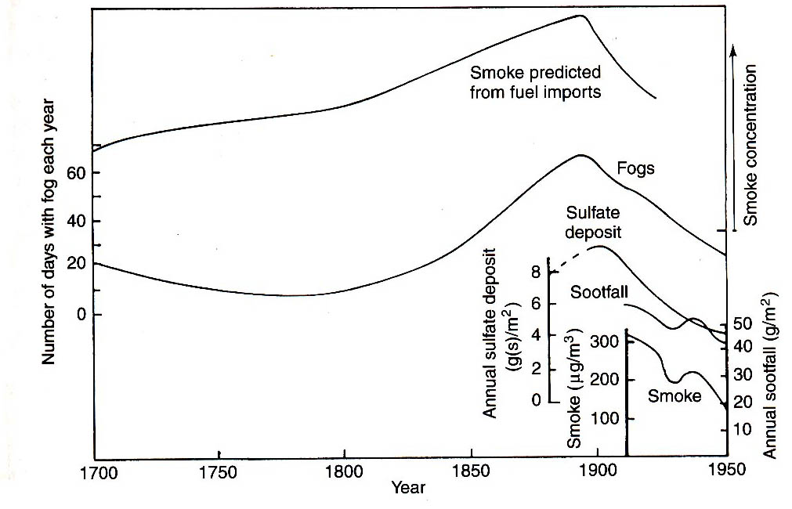
Ambient pollutant measurements
Figure 1: Air pollution in London since the 17th Century comparing predicted values with fog frequency, and later measurements

Data for London exemplify the phenomena of increasing urban populations and increasing urban population density during the period of industrialisation.

The increase in the total population, and the population density, of London during the 19th to mid 20th century are illustrated in Figures 2 and 3.
Figure 2: Population of London, 1800 to 2000
Figure 3: Population density of London,
1800 to 2000

By the early 20th century it was generally accepted that air pollution ‘caused’ ill health and an increase in mortality during severe pollution episodes. During the first half of the 20th century, detailed studies of particularly severe air pollution episodes (Meuse Valley, Belgium 1930; London 1952, 1956; The Ruhr Valley, 1962; Donora, PA, USA, 1948) yielded information on the effects of short duration exposure to high concentrations of suspended particulates and SO2.

The now famous Fog of London of 1952 demonstrated the health impact (about 4 000 excess deaths occurred during the 5-day period on the Fog) of these severe air pollution episodes, yielded considerable data (Figure 4) and spurred the development of more effective legislation to control air pollution.

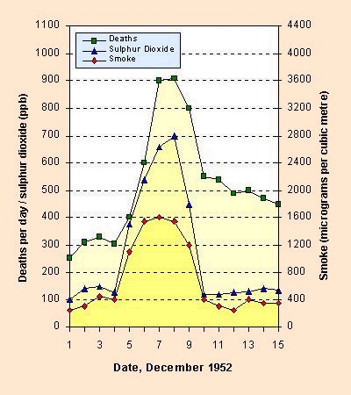
Figure 4: Death rates and pollutant concentrations during the ‘Fog of London’ (1952)
Figure 4 suggests an association between the increase in sulphur dioxide and smoke concentrations and mortality rates. The concentrations increased from about 130 g/m³ (SO₂) and 400 g/m³ (smoke) during 1 to 4 December 1952, to peaks of 700 g/m³ (SO₂) and 1600 g/m³ (smoke) on 7-8th December 1952.

During 7-8th December, the death rate peaked at about 900 per day compared with about 300 per day prior to the pollution episode.

The deaths were ascribed to pneumonia, asthma and bronchitis.

Over the last 50 years or so, a large number of studies demonstrated the cause-effect relationship between specific air pollutants and specific health endpoints; in many cases exposure-response relationships have been derived as well. The early studies focussed on the acute health effects (those occurring within days of exposure) of short-term exposure (exposure durations ranging from a few minutes to several days) to the ‘classical’ pollutants, namely sulphur dioxide (SO₂), particulate matter (PM), oxides of nitrogen (NOx), ozone (O₃), carbon monoxide (CO) and lead (Pb). In the USA, these six pollutants are called ‘criteria’ pollutants. These six pollutants, and volatile organic compounds (VOCs), are the main pollutants arising out of the combustion of fossil fuels (coal and oil products), and are generated in industrial power plants, petrol and diesel driven vehicles and by domestic cooking and heating appliances. The relative contribution (to ambient concentrations) of each of these three broad air pollution source categories varies from city to city.
VOCs: hydrocarbon compounds
NOx: nitrogen dioxide (NO₂) and nitric oxide (NO).
NOx is formed during combustion processes; about 90% of the NOx is release as NO which is converted to NO₂ in the atmosphere.
Sulphates: sulphuric acid (H2SO4) droplets, ammonium bisulphate, etc
Nitrates: The reaction of NO2 and O3 may produce nitric acid (HNO3) droplets and/ or peroxyacetyl nitrate (PAN)

An overall assessment of ambient pollutant concentrations (and their impacts) must include a consideration of secondary air pollutants – air pollutants that are not directly emitted but are formed through atmospheric chemical and physical processes. Ozone (in the troposphere, close to the earth’s surface) is formed through chemical reactions involving VOCs and NOx, under the influence of sunlight. Fine (PM2.5, particulate matter less than 2.5um diameter) particulate matter, mainly sulphates and nitrates, are formed due to the presence of SO2 and NOx as precursors.

The health impacts associated with ozone and PM2.5 are significant, and may have a greater contribution to specific health endpoints than that of the primary air pollutants.

In addition to the acute health impacts due to short-term exposure to air pollutants the health risks associated with prolonged exposure, including cancer and developmental risks, have to be considered as well. In the case of certain air pollutants, such as heavy metals (compounds of lead, chromium, etc.) and dioxins/ furans, the primary exposure path for people is not the direct inhalation of the polluted air, but through contaminated food or dust.

These persistent air pollutants (they do not break down into less toxic substances naturally, or break down very slowly) settle on crops or grass that is in turn eaten by livestock and subsequently by people. Water and sediments contaminated by persistent toxic substances result in the contamination of aquatic species and the food web, with attendant environmental and health risk consequences. Children may ingest contaminated dust – this is the main exposure pathway for leaded petrol emissions. A full assessment of the health risks associated with these substances requires a consideration of all pathways of exposure.
POPs: Persistent Organic Pollutants
PTS: Persistent Toxic Substances – includes POPs and metal compounds

In the absence of direct measures of the dose of the pollutants received (for example through measurement of biomarkers such as lead-in-blood levels), exposure-response relationships (frequently called dose-response relationships) may be used to estimate potential impacts on people and/or the environment. The World Health Organisation (WHO) reviewed summarised and published information on the exposure-response relationships for the most commonly encountered urban air pollutants as well as Air Quality Guidelines Values.

The accidental release of substantial quantities of air pollutants from industrial plants may occur relatively infrequently, but may have a significant impact on the surrounding communities. These industrial accidental may result in fires, explosions and /or the release of toxic substances, contributing to overall exposure and impact of these operations. The assessment of this type of health and safety risk requires additional risk assessment methodologies, including estimates of the probability of the occurrence of the accident, and the consequences (impacts), of a given accident scenario.
US EPA: United States’ Environmental Protection Agency
Both industrialised and semi-industrialised cities are subjected to a wide variety of sources of air pollution, and many more air pollutants – more than to 200. A number of countries compile and publish inventories of (annual) air pollutant emissions. The US EPA monitors and reports on six ‘Criteria’ pollutants (sulphur dioxide (SO₂), particulate matter (PM), oxides of nitrogen (NOx), ozone (O₃), carbon monoxide (CO) and lead (Pb)) and 189 ‘Hazardous Air Pollutants’. The latter list includes dioxins, furans and compounds of mercury, lead, chromium and a number of organic compounds. Canada, Mexico and a number of other countries compile similar air pollutant inventories. Industrial processes such as oil refining and waste incineration generate their own profile of pollutants. The complexity arising out of multiple sources of air pollution and the large number of pollutants that may be discharged from different sources means that it is usually difficult to unequivocally apportion ambient concentrations (and hence health impacts) at a particular location to specific sources.

Sources of air pollution may be characterized by factors such as the emission rates of specific pollutants, whether the source is stationary or mobile, the elevation of the source in relation to environmental receptors (people, crops, buildings etc.), and the gas exit velocity and temperature if the source is emitted from a stack. Stationary sources may be further characterized as point sources - chimneys or stacks - and area sources such as a landfill sites, or agricultural areas. Emissions from mobile sources, essentially emissions from petrol or diesel fuelled vehicles, depend on vehicle type and size, travelling speed, the fuel quality and total kilometres travelled. Different measurement and estimation techniques may be used to estimate pollutant emission rates from the different source types.
ppm: parts per million, by volume. That is, the ratio of the volume of gaseous pollutant to the volume of air in a mixture.
ppb: ppm/1000
Units of ppm and ppb are commonly used as expressions of concentration but they are dimensionless ratios.
Particulate Matter (PM) concentrations are always expressed in mass/ volume terms.

Several factors not directly related to pollution source characteristics influence the ‘instantaneous’ (in practice, measured over a short but finite time period of a few seconds to a few minutes) ambient concentration of air pollutants and the concentrations averaged over a given time period (the averaging times are usually 15 minutes up to a year) at a give location. These factors are mainly the meteorological conditions, distance from the source and the nature of the intervening terrain – whether urban, rural or a water body. The health and environmental impact of an air pollution source depends on several factors.

Human exposure may be defined as the contact of the (air) pollutant with a susceptible surface of the body, including the eyes, nose, mouth and throat, the skin, the airways and the lungs. Air pollution exposure is characterised by the concentration of the pollutant and the averaging period over which the concentration has been measured. Averaging periods in use are ‘instantaneous’ (in practice, a few seconds to a few minutes), 10 or 15 minutes, 1, 3 or 8 hours, 24 hours or 1 year. Seasonal (summer/ winter) averages are sometimes relevant. The pollutant concentration may be expressed as mass per unit volume of air (g or mg/ m3), or as a mixing ratio or volume ratio (ppm or ppb). An continuous concentration-time function provides a more complete measure (metric) of exposure; the cumulative exposure (the sum or integral of the concentration-time function over a given time period) may be the relevant measure of exposure for cumulative toxic substances such as lead.

The exposure of crops, vegetation, livestock and physical infrastructure (buildings, bridges, electricity pylons, etc.) to pollutants may result in economic losses due to a decrease in crop yields, corrosion of steel structures and the deterioration of paintwork; exposure of vegetation or the acidification of rivers, water bodies (lakes) and soil may lead to damage to natural fauna and flora; contamination of grazing and livestock fodder may lead to further human exposure to certain pollutants.

A complex set of factors relates the sources of air pollution to human exposure and to environmental degradation, including the atmospheric processes of dispersion, chemical and physical transformation, and deposition of pollutants onto surfaces. A basic understanding of these factors is necessary for the management and protection of the (urban) environment.

An effective management system requires a comprehensive Air Quality Management System and an effective legislative and regulatory environment. International treaties (Conventions) are becoming increasingly important to the safe management of hardous chemicals and hazardous wastes.

Global air pollution related burden of disease
The following two excerpts from WHOa indicate the overall burden of air pollution related disease:

“Achievements in air quality management underlie increased economic and social welfare in many developing countries. Sound air quality management is also a proven way of enhancing public health, since air pollution is associated with increases in outpatient visits due to respiratory and cardiovascular diseases, in hospital admissions and in daily mortality. Recent estimates of the increase in daily mortality show that on a global scale 4-8% of premature deaths are due to exposure to particulate matter in the ambient and indoor environment. Moreover, around 20- 30% of all respiratory diseases appear to be caused by ambient and indoor air pollution, with emphasis on the latter. It is suggested that without clean air, a sound economic development becomes virtually impossible and social conflicts inevitable. Although enormous progress has been made in developing clean air implementation plans for urban areas, especially in developed countries, a substantial number of people living in urban areas - around 1.5 billion, or 25 per cent of the global population - are still exposed to enhanced concentrations of gaseous and particle compounds in the air they breathe. And the use of open fires for indoor cooking and heating currently exposes about 2 billion people to quite substantial concentrations of suspended particulate matter, 10-20 times higher than ambient concentrations according to the limited measurements available. Other sources of air pollution include industrial and vehicular emissions, as well as vegetation fires. Furthermore, the rate of population growth continues to increase and is likely to peak around the year 2000, leading to
a doubling of the global population by the middle of the 21 st century. Most population growth will occur in low-income countries and will stress already inadequate infrastructures and technical and financial capacities. In parallel, the process of urbanisation will continue, such that the proportion of the global population living in cities will increase from around 45% to around 62% by the year 2025, creating dense centres of anthropogenic emissions.”

“There are three broad sources of air pollution from human activities: Stationary sources, Mobile sources, and Indoor sources. In developing countries, indoor air pollution from using open fires for cooking and heating may be a serious problem. It has been estimated that in developing countries, about 1.9 million people die annually due to exposure to high concentrations of suspended particulate matter in the indoor air environment of rural areas, while the excess mortality due to suspended particulate matter and sulphur dioxide in the ambient air amounts to about 500 000 people annually. Although the indoor air database is weak due to the scarcity of monitoring results, these estimates indicate that a serious indoor air problem may exist in developing countries.”

The South Africa database of air pollution exposures is weak and incomplete; in general, population exposure is poorly characterised with respect to both indoor and ambient concentrations, the number of people exposed and the vulnerability of the exposed population to air pollutants. However there are several areas of known high ambient air pollution concentration, particularly the heavily industrialised areas of the Vaal triangle and the South Durban Industrial Basin, and Cape Town is known to suffer from the ‘Brown Haze’ during the winter months. In all three areas, air pollution monitoring network data may provide a limited estimate of population exposures. The use of coal for cooking and heating is widespread in the townships of the inland cities, and biomass fuels continue to be used in rural areas. Paraffin is widely used for cooking and space heating. These factors suggest that the South Africa burden of air pollution related disease and mortality is likely to be significant, although as yet unquantified.

The essential elements of an Air Quality Management System
An air quality management system needs to address the complexity of the relationship between the sources of air pollution and the exposure of people, crops, vegetation, livestock and physical infrastructure to the air pollutants, and the human health and economic consequences of this exposure. A complex set of factors relates the sources of air pollution, characterised by factors such as the emission rate of each pollutant, and the height, temperature and exit velocity (if a stack) of the pollution plume, to the exposure (measured as time-averaged concentrations) of ‘receptors’ – people, buildings, crops and animals. These factors include the atmospheric processes of dispersion, chemical and physical transformation, and deposition of pollutants onto surfaces.

Key elements of an Air Quality Management System (AQMS) are
- the setting of Ambient Air Quality Standards,
- Source Emission Standards (or limits),
- the development of an Emission Inventory,
- Ambient Air Quality Monitoring,
- The gathering appropriate Meteorological Data and
- Air Quality Modelling.

A coherent and effective regulatory system (AQMS) would include the setting air quality standards, setting specific time-bound air quality objectives, and would be capable of gathering the necessary air quality information and using the permitting or licensing system and the necessary technical and legal resources to give effect to regulations .

Questions:
- Does Figure 1 ‘prove’ that air pollution (SO₂ and smoke) ‘causes’ an increase in daily mortality in the exposed population?
- Assuming that the population of London was 8.3 million in 1952, calculate the attributable daily mortality apparently due to increased SO₂ and smoke exposure during the 1952 episode.
- Is it possible to use this estimate of attributable risk to infer or estimate daily winter-time mortality for Soweto, 2004, assuming that the SO₂ and smoke exposures increase to 25% of the London 1952 values during winter?? What would the incremental daily mortality be if the risk factor is valid?

Holgate S. T., Samet J. M., Koren R. L. and Maynard R. L. (Eds.) Air Pollution and Health, Academic Press (1999), Chapter 2
http://www.kcl.ac.uk/humanities/cch/year1/numerical/problems/london/london-pop-table.html

