Health Risk Assessment
Standard Operating Procedure – Completion of WREPs

Table of Contents

1 INTRODUCTION 3
2 SCOPE 4
3 PURPOSE 4
4 METHODOLOGY 4
4.1 INTRODUCTION TO WREPS: 4
Relationship between OREPs and WREPs: 5
4.2 STEP-BY-STEP APPROACH TO A WALK-THROUGH HEALTH RISK ASSESSMENT 6
4.2.1 Preparatory Phase (before actually visiting the work place): 6
4.2.2 Action Phase (at the work place): 6
4.2.3 Data Collation Phase (back at the office / clinic): 8
4.3 APPENDIX 1: 10
4.4 APPENDIX 2: SUMMARY GUIDELINE FOR ALLOCATION OF SCORES 11

Table of Figures

Figure 1: The relationship between the WREP and Risk Assessment. 3
Figure 2: Relationship between OREPs and WREPs: 5
Figure 3: Constructing the Process-WREP: 7
Figure 4: Constructing the Location-WREP: 8

INTRODUCTION
Occupational Health is a preventive discipline, dedicated to reducing the likelihood of adverse events leading to injuries, illness or material losses. Central to this is the science of Risk Assessment. This is at the core of Occupational Health, from which every subsequent action is derived.
Occupational Health Risk Assessment is the systematic examination of activities and processes in the workplace, to determine the probability of harmful events, and the extent of the potential damage. This evaluation comprises a careful evaluation of the level of probability that the adverse event may occur, and the consequences of these events.
- The probability is a function of the estimated likelihood that the incident may occur, or of the degree of exposure of the target groups.
- These consequences quantify the degree and severity of harmfulness of the hazards.
Hence:
RISK = CONSEQUENCE X PROBABILITY

The Workplace Risk Exposure Profile (WREP) is the documented profile of risks for a targeted work area (i.e. a laboratory) or process (i.e. a production flow).
It comprises the following main groups of data:
- The hazards & their sources & impacts associated with the area, and their risks (consequences and probabilities)
- The processes and activities in the area
- Who the target employees are (those potentially exposed to the risks).
- Risk reduction controls (and their deficiencies).
Figure 1: The relationship between the WREP and Risk Assessment.
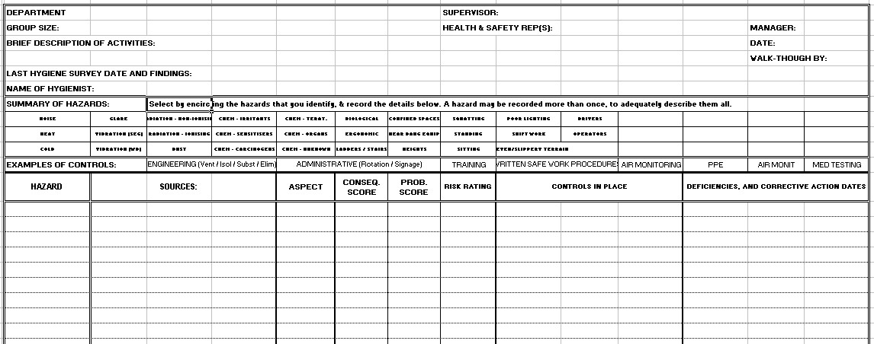
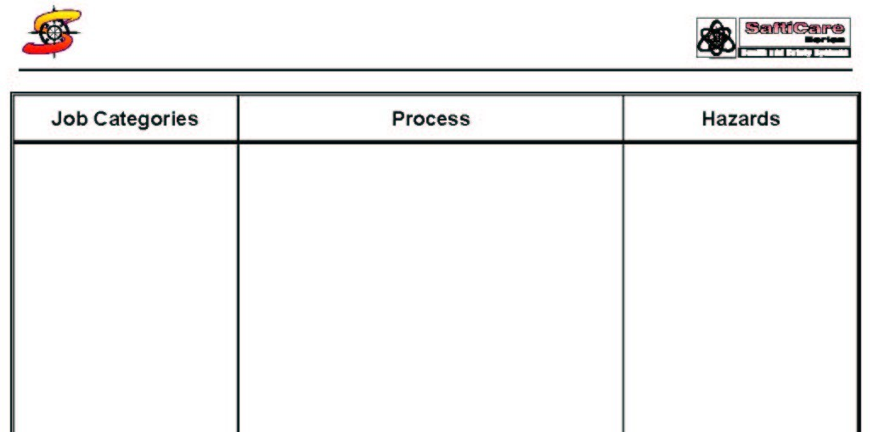
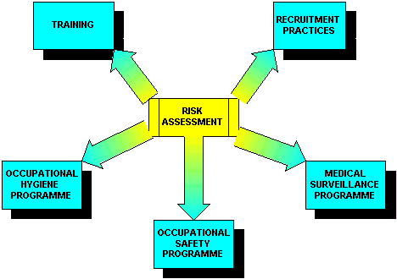
THE LOCATION WREP
THE PROCESS WREP

SCOPE
The Standard Operating Procedure is the method of choice for all programme users of the SaftiCare OH System.

PURPOSE
The Standard Operating Procedure provides detailed guidance regarding a workplace-based Health Risk Assessment (HRA), as compared with an occupation based HRA (the OREP).

METHODOLOGY

INTRODUCTION TO WREPS:
The Workplace Risk Exposure Profile (WREP) is the documented profile of risks for a specific work area.
The profile can be:
- Process-oriented (i.e. production flow) – “Process-WREPs”
- Location oriented (i.e. a laboratory) – “Location-WREPs”
Image of a Process-WREP | Process-WREPs comprise three main groups of data:  - Who the target employees are (those potentially exposed to the risks).  - The processes and activities in the area  - The hazards associated with the area
The manner in which these are developed is discussed later.
Image of a Location-WREP  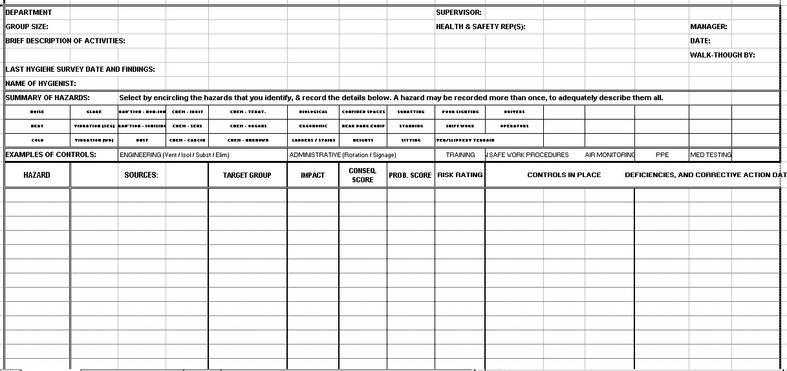 | Location-WREPs comprise six main groups of data:  - The hazards associated with the area  - The sources of the Hazards  - The Impacts of the Hazards ((Health & Safety, Environmental, Financial, and Public Image)  - The allocated scores: The Consequence Score, the Probability Score and the Risk Index.  - The Controls that are in place, to reduce exposure  - The Controls that are NOT in place, (deficiencies), with corrective action dates.
The manner in which these are developed is discussed later.
Special attention must be taken of control measures in place, noting conformance, partial conformance or non-conformance. Typical control measures are the following:
- Engineering controls (ventilation, isolation, elimination, substitution).
- Written standard operating procedures (“SOP’s”)
- Training
- Administrative Controls (Job rotation, warning signs)
- Air monitoring
- Personal Protective Equipment
- Biological monitoring as well as medical examinations
These are best recorded on the Location-WREPs.

Relationship between OREPs and WREPs:
A clear relationship can be seen between the Occupation-based OREPs and the Workplace-based WREPs. These act in synergy alongside one another, the one verifying the other.
Figure 2: Relationship between OREPs and WREPs:
Image of a blank OREP (Occupations)  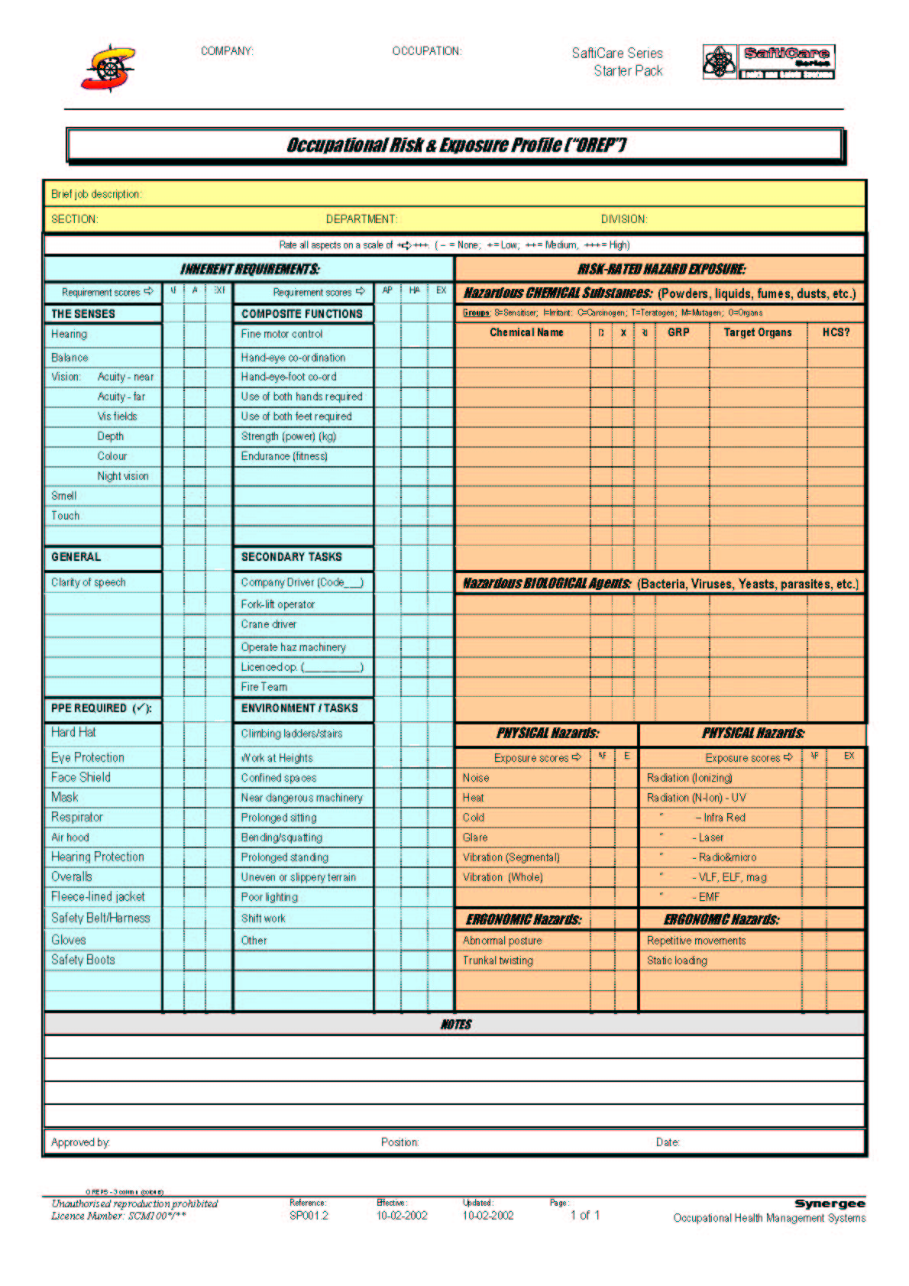  The OREPs represent a composite profile of the risks associated with the relevant occupation. These can be correlated with the hazards linked to the occupation in the Process Assessment Sheet (opposite). | Image of a blank Process-WREP  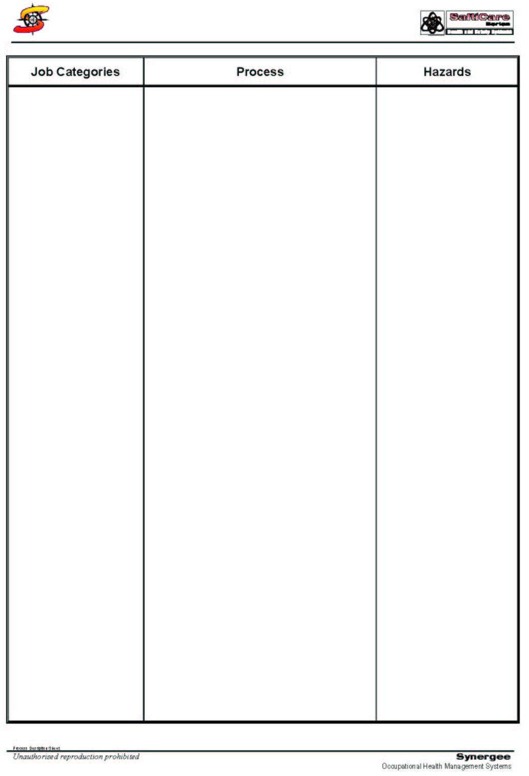  The Job Categories associated with the activities in this process sheet are recorded next to the relevant activities in the “Process” column. They are therefore associated with the hazards linked with these activities, which, in turn, can be cross-referenced with the hazards represented in the OREP (opposite).  The activities performed in this process are listed in the “Process” column.  The hazards associated with each activity are listed next to the activity in the “Hazards” column.

STEP-BY-STEP APPROACH TO A WALK-THROUGH HEALTH RISK ASSESSMENT

Preparatory Phase (before actually visiting the work place):
Step 1: Review all documents that refer to hazards in the area about to be visited. These include accident and illness statistics for that area, previous occupational hygiene measurements, medical surveillance findings and previous risk assessments.

Step 2: Establish a list all the job categories in the area that you are about to visit, and record these in a blank RISK Matrix worksheet, labelled with the area to be visited. Prepare blank OREPs for the occupations listed for that area, if these have not been created yet.

Step 3: Ask the supervisor of the area to provide a list of the chemicals that are in use in that area, and to indicate which job categories are exposed to which agents (ideally by using the standardised exposure score rating system of 1-5). List these in the OREPs that you have started, with their exposure scores. (Note – this is not necessary if OREPs have already been constructed.)

Step 4: Check that the chemicals listed for the work area are all represented in the company’s composite Chemical Toxicology Matrix. These can first be recorded on a blank toxicology capture sheet (see SOP on Chemical Toxicology Profiling), labelled with the name of the workplace, or alternatively they could be recorded directly into the Toxicology Matrix spreadsheet on the computer, flagging the relevant exposure groups in the spreadsheet (see SOP on Chemical Toxicology Profiling).

Step 5: Try to establish the toxicology of the chemicals in advance, using toxicology databases (cd-rom, DVD) if they are available, or the MSDS’s, if they are available (and of use!). The toxicology is summarised on the Toxicology Summary Forms, and then transferred into the Toxicology Matrix spreadsheet on the computer (see SOP on Chemical Toxicology Profiling).

Action Phase (at the work place):
Step 1: Collect all the necessary documents that have been created during the preparatory phase. These include:
- Control Check-list. (see later)
- Workplace Risk Exposure Profile (WREP) sheets (Process and Location).
- Pack of the current, already constructed OREP documents (if available), with whatever information they hold at the time of the walk-through.
- Blank notepaper.
- Blank RISK Matrix Capture form (bring a completed Matrix if one has already been constructed)

Step 2: Ask the supervisor to explain the work process in detail, and record this diagrammatically on the Process-WREP. Record the occupations at risk and the relevant hazards at the appropriate points along the diagram. These often occur more than once down the columns. Remember that drivers and operators of dangerous machinery are capability risks, and the moving machines are ergonomic risks.

Figure 3: Constructing the Process-WREP:
The Job Categories associated with the activities in this process sheet are recorded next to the relevant activities in the “Process” column. They are therefore associated with the hazards linked with these activities, which, in turn, can be cross-referenced with the hazards represented in the OREPs.
The activities performed in this process are listed in the “Process” column.
The hazards associated with each activity are listed next to the activity in the “Hazards” column.

Remember to note the following (the three “P’s”!):
- Product info: Raw materials, by-products, waste products, final products, their quantities and their movement around the worksite.
- Process info: Machinery, equipment, their quantities and their movement around the worksite.
- People info: Job categories, their numbers and their movement around the worksite.

Step 3: Fill in the Location-WREP for the area being visited. This is reasonably self-explanatory. See below. This would be a good time to review and update the relevant jobs’ OREPs.

Step 4: Once this is done, proceed with the walk-through, making supplementary annotations to the notes already made on the process or location WREP sheets.

Step 5: Before completing the walk-through, discuss the controls in place for each of the hazards identified. Use the controls listed in the Location-WREP as prompts.

Figure 4: Constructing the Location-WREP:
The Sources of the hazards listed are listed here, so that controls & deficiencies can be targeted.
The Impacts of the hazards identified are entered here (H&S, Enviro, Finance, Publicity).
The Controls that are in place should be recorded here (Engineering, Admin, PPE, etc.)
The Control Deficiencies that are evident should be recorded here (Engineering, Admin, PPE, etc.)
The Job Categories that are exposed are recorded here. They should be given an exposure score (1-4).

The Hazards that are associated with activities in this workplace are listed here.
Circle the hazards associated with this workplace. Useful as a quick reference
The Risk information that pertains to each hazard.
(Consequences & Probability)
Brief information regarding the Workplace under evaluation.

Data Collation Phase (back at the office / clinic):
Step 1: Ensure that the updated information from all the capture documents is transferred to three core documents:
- The OREPs (preferably typed)
- The Chemical Toxicology Matrix spreadsheet
- The RISK matrix spreadsheet
Step 2: The OREP information is used to update the company’s central OREPs, but this should be in consultation with all the relevant parties (Risk Management, Human Resources and Operations).
Step 3: The Chemical Toxicology information is used to update the Chemical Toxicology spreadsheet. Where possible, the appropriate MSDS should be stored on the computer’s hard drive, with a hypertext link between the MSDS and it’s record in the spreadsheet.
Step 4: The RISK Matrix on the computer should be updated with the new information, including the appropriate summarised medical surveillance strategy.
Step 5: Using the RISK Matrix, a short management report can be compiled, highlighting the important findings of the Health Risk Assessment (walk-through), and the relevant recommendations.

APPENDIX 1:
WALK-THROUGH ASSESSMENT – CHECKLIST CONTROL SHEET
CHECKLISTS: ☑ Ensure that you have covered the following:
- Previous risk assessments and occupational hygiene measurements at this workplace:
- Previous injuries, incidents and occupational diseases at this workplace
- List of Job Categories, and numbers of each – record in the RISK Matrix.
All Hazards, including:
- Physical hazards, such as noise, temperature (hot and cold), radiation (ionising & non-ionising), vibration, etc.
- Chemical Hazards handled at this workplace – list & record in the toxicology matrix, and the summary data in the RISK Matrix.
- Ergonomic hazards, such as repetitive movements, abnormal posture, glare, etc.
- Mechanical hazards, such as dangerous machinery, with moving parts, etc.
- Capability Hazards: Vocational Drivers and Operators of Dangerous Equipment
- Environmental hazards, such as darkness, uneven or slippery terrain, work at heights, hot working surfaces, fires, high voltage electricity.
- Psychosocial hazards, such as shift patterns, organisational stresses.
- Biological hazards, such as viruses, bacteria, fungi, etc. – record in the toxicology matrix and the summary data in the RISK Matrix.
Typical control measures, such as:
- Engineering controls (ventilation, isolation, substitution, elimination)  Personal Protective Equipment
- Training  Written safe operating procedures
- Air monitoring  Biological monitoring & Medical examinations.

APPENDIX 2: SUMMARY GUIDELINE FOR ALLOCATION OF SCORES
