Dermatology Assignment

Please answer all 4 cases
Each question will be marked out of 25 for a total of 100

Hope you enjoyed your brief exposure to Dermatology
Good luck

We are always available to help out with occupational skin problems.
I can always be contacted on the following e-mail addresses:
gail.todd@uct.ac.za
dermatol@uctgsh1.uct.ac.za

Case 3

A 45 year old fitter and turner doing maintenance work in a pharmaceutical factory was referred by a colleague for phototherapy of progressive skin depigmentation diagnosed as idiopathic vitiligo (Figure 5).
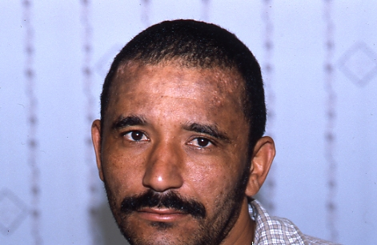
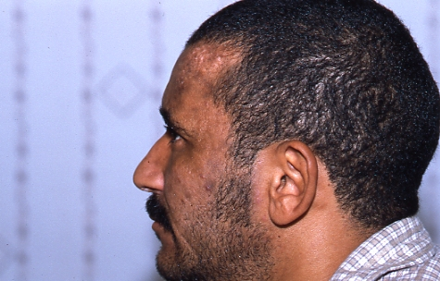
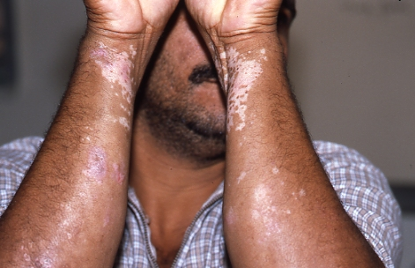
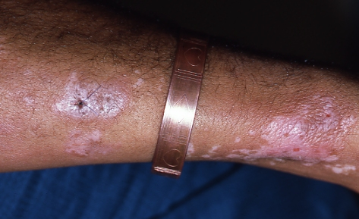
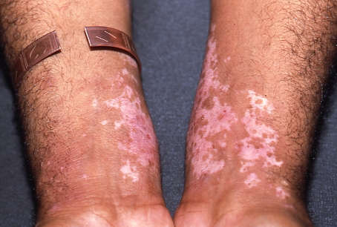

Figure 5

History revealed numerous chemical exposures at home and in the work place. The worker related the condition to maintenance work done on the azathioprine manufacturing line.

He responded to topical steroids and contact avoidance, his skin gradually regaining pigment.

Questions for Case 3

1. Can vitiligo be considered an occupational disease?
2. What products/chemical exposures would you look for that are known to cause vitiligo?
3. Is the diagnosis of idiopathic vitiligo correct and if not why?
4. What other conditions would you consider?
5. Considering that azathioprine is a drug – could this worker be experiencing an adverse drug reaction?
6. Could this worker benefit from PPE? If so, provide a pragmatic solution.

