Dermatology Assignment

Please answer all 4 cases
Each question will be marked out of 25 for a total of 100

Hope you enjoyed your brief exposure to Dermatology
Good luck

We are always available to help out with occupational skin problems.
I can always be contacted on the following e-mail addresses:
gail.todd@uct.ac.za
dermatol@uctgsh1.uct.ac.za

Case 2

A 45 year old indigenous flower picker presented with itchy, swollen, thickened skin of her hands, the left more affected than the right (Figure 3). Treatment with oral and topical steroids provided initial relief but she relapsed and the condition gradually became chronic and unresponsive to the above measures. The worker was sent for evaluation pending boarding.

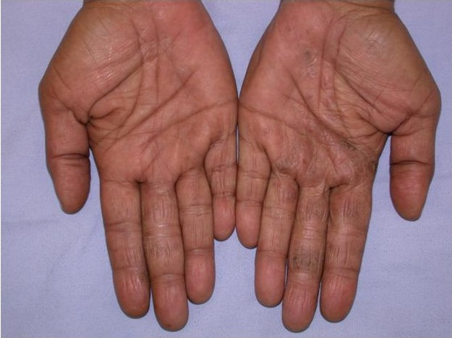
Figure 3

Her daily activities involved picking and packaging flower in assorted bunches for sale at the airports (Figure 4). She did not use any specific personal protective wear and hand care was soap and water. She could not identify any particular specific new task or product that she could relate to her skin problem.

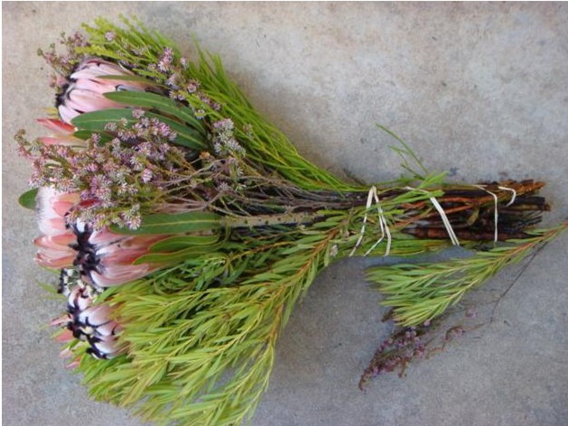
Figure 4

A patch test showed 2+ positive reactions to thiuram mix and mercapto mix.

Questions for Case 2

1. What are the implications of positive reactions to thiuram mix and mercapto mix?
2. What work place exposures could be implicated?
3. Are the patch test findings relevant in this patient and why?
4. Do you think the worker had been appropriately managed prior to referral and why?
5. Can she continue in her job and what advice would you give to the patient to prevent further problems?

