Dermatology Assignment

Please answer all 4 cases
Each question will be marked out of 25 for a total of 100

Hope you enjoyed your brief exposure to Dermatology
Good luck

We are always available to help out with occupational skin problems.
I can always be contacted on the following e-mail addresses:
gail.todd@uct.ac.za
dermatol@uctgsh1.uct.ac.za

Case 1

A 28 year pathology registrar in her final year of training presented with intermittently painful, swollen, red fingers of both hands (Figure 1). This was associated with cut-ups, especially after handling gut and breast specimens. The lesions gradually healed with desquamation of skin after using topical steroids. She used double latex gloves for the cut-ups. Specimens were fixed in formaldehyde buffered saline. Routine surgical equipment was used for dissection.

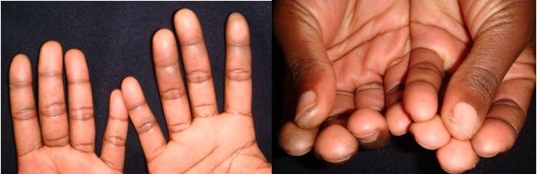
Figure 1

A diagnosis of latex allergy was assumed and she changed to nitrile gloves which initially seemed to help but, following the introduction of a new make, the problem recurred. A career change was contemplated because of the discomfort and interference with the ability to do her work.

A work place visit was done (Figure 2). The offending substance was identified following careful observation of the registrar while doing cut-ups. Suitable avoidance measures (not gloves!) have meant that the registrar has been able to pursue her career with no further problems.

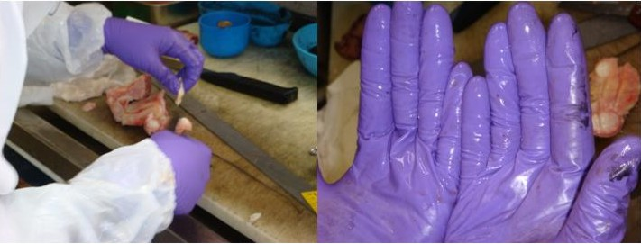
Figure 2

Questions for Case 1

1. What conditions would you consider from the above description?
2. Was latex allergy the correct diagnosis?
3. What work place exposures could be implicated?
4. What advice would you give to the patient?

