Health Risk Assessment
Guidelines – Developing a Chemical Toxicology Profile

Table of Contents

1 INTRODUCTION 4
1.1 GLOSSARY OF IMPORTANT TERMS 4
1.2 MATERIAL SAFETY DATA SHEETS (MSDSs) 7
1.3 INTRODUCTION TO HAZARDOUS CHEMICAL SUBSTANCE (HCS) SUMMARY SHEET. 9
2 SCOPE 9
3 PURPOSE 9
4 METHODOLOGY 9
4.1 HOW TO COMPLETE THE CHEMICAL TOXICOLOGY PROFILE: 9
4.1.1 Step 1: How to gather the toxicology Information. 9
4.1.2 Step 2: How to capture the toxicology information. 10
4.2 INTRODUCTION TO CHEMICAL TOXICOLOGY PROFILES: 10
4.3 HOW TO COMPLETE THE CHEMICAL TOXICOLOGY PROFILE: 12
4.3.1 Step 1: How to enter the toxicology information into the Chemical Toxicology Profile. 12
4.3.2 Step 2: How to link the toxicology information to Exposure Groups / Places 13
4.3.3 Step 3: How to link the chemicals to electronic toxicology MSDS’s 13
4.4 HOW TO USE THE CHEMICAL TOXICOLOGY PROFILE: 13
5 APPENDICES 13
5.1 APPENDIX 1: THE ALLOCATION OF TOXICITY SCORES 14
5.2 APPENDIX 2: THE ALLOCATION OF LIKELIHOOD SCORES 15
5.3 APPENDIX 3: THE ALLOCATION OF EXPOSURE SCORES 16
5.4 APPENDIX 4: INTERNET-BASED RESOURCES FOR TOXICOLOGY INFORMATION 17

Index of Figures

Figure 1: Image of an HCS Summary Sheet. 10
Figure 2: Image of a Chemical Toxicology Profile - 1. 11
Figure 3: Image of a Chemical Toxicology Profile - 2. 11

Index of Tables

Table 1: Scoring short-term (“acute”) Toxicity. 14
Table 2: Scoring long-term (“chronic”) Toxicity. 14
Table 3: Scoring “Effect Exposure”: Summary 16

INTRODUCTION
Occupational Health is a preventive discipline, dedicated to reducing the likelihood of adverse events leading to injuries, illness or material losses. Central to this is the science of Risk Assessment. This is at the core of Occupational Health, from which every subsequent action is derived.
Occupational Health Risk Assessment is the systematic examination of activities and processes in the workplace, to determine the probability of harmful events, and the extent of the potential damage. This evaluation comprises a careful evaluation of the degree of exposure of the target groups, and the consequences of this exposure. These consequences are comprised of the harmfulness of the hazards, and the likelihood that the events may occur).
Hence:
RISK = CONSEQUENCE X EXPOSURE
OR
RISK = (HARMFULNESS X LIKELIHOOD) X EXPOSURE

Toxicology is the study of what occurs to substances when they enter the body, including their toxicokinetics (absorption, distribution, metabolism and excretion), and toxicodynamics (adverse effects on target organs). Most particularly, it is interested in the details of the adverse health effects of the exposure. Whilst this is theoretically available in Material Safety Data Sheets (MSDS’s), this information is usually hopelessly inadequate in these documents.

GLOSSARY OF IMPORTANT TERMS
Chemical Risk Assessment is a complex process, and is regrettably burdened with many technical terms, which have to be learned by the Risk Assessors. Some of these include the following:
Term | Explanation
Time intervals  - Acute  - Sub-Acute  - Chronic | These refer to time intervals; – the time over which the condition evolves, or the duration of the condition.  Acute events are those that take place after (or over) a short time interval (seconds – hours). For example: burns following exposure to concentrated acids.  Sub-acute events are those that take place after (or over) a medium time interval (days – weeks). For example: contact dermatitis following exposure to solvents.  Chronic events are those that take place after (or over) a long time interval (months – years). For example: asthma following isocyanates
Chemical Identity Numbers  - CAS Number  - UN Number | CAS number  There is an international registration system for each and every chemical. Unfortunately not every single chemical is registered through this registration system, but this is as close to an “ID number” for chemicals that one can get. A powerful advantage of the CAS number is that it can be used as a search parameter, when hunting for toxicological information on databases. Searching databases by chemical names is hamstrung by the fact that all chemicals have synonyms (different names); hence the search may fail to find the chemical simply because it is listed under a different synonym.  For example: The CAS number for hydrochloric acid is 7647-01-0.  The UN numbering system is similar, but the numbers are different.
Synonym | Chemicals may have a number of different names, or synonyms. This is because chemicals are often named according to their chemical atomic structure. Unfortunately, the atomic structure can be named in various ways, producing different names (synonyms) for the identical chemical substance.  For example: hydrochloric acid has a synonym, hydrogen chloride
HCS | Hazardous Chemical Substance. This is a chemical substance that has the potential to cause harm. Often when one sees a reference to an “HCS”, this may mean a chemical that is listed in the tables published in the Regulations for Hazardous Chemical Substances of the Occupational Health and Safety Act.
Mucus membranes | This term refers to the epithelial lining of certain internal body surfaces, such as the nose, mouth, throat, lungs, eyes, etc. This is the body surface most vulnerable to chemical exposure.
Irritant  (IRR) | This term refers to a direct toxic effect, or “burn”. Corrosive is a synonym for irritant. The more corrosive the irritant, the greater the intensity of the irritation and the greater the damage on contact. The exposed body surfaces are most affected by irritants, such as the skin and mucus membranes of the eyes and upper respiratory tract.  For example: Acids and alkalis are irritants. The more concentrated they are, the more corrosive.
Sensitiser  (SEN) | This term refers to substances the have the potential to cause exposed people to become sensitised (allergic) to the substance. This is significant, as even minimal exposures can trigger a reaction in sensitised individuals (no “safe” low dose). Outcomes include eczematous skin reactions and asthma.  For example: isocyanates
Carcinogen  (CAR) | This term refers to substances the have the potential to cause cancer in exposed people.  For example: asbestos fibres.  Various agencies exist around the world, which analyse and categorise chemicals by their degrees of carcinogenicity. These include:  IARC (International Agency for Research on Cancer) (World Health Organisation)  - 1: Known human carcinogen  - 2A: Probably carcinogenic – degree of evidence almost sufficient to be classified as carcinogenic.  - 2B: Possibly carcinogenic – no human data, but experimental evidence of carcinogenicity.  - 3: Suspected carcinogen, but not classifiable.  - 4: Probably not carcinogenic to humans.  NTP (National Toxicology Programme, of U.S. Public Health Service)  - K: Known human carcinogen  - N: Not known to be a human carcinogen.  - A: Associated (Suspected) human carcinogen.  OSHA (Occupational Safety and Health Administration, USA)  - Y: Yes - known human carcinogen  - N: No – not a human carcinogen.  NIOSH (National Institute for Occupational Health & Safety, USA)  - “Listed” carcinogens, without differentiation between “possible” or “probable” carcinogens.  ACGIH (American Conference for Governmental Hygienists)  - A1: Known Human Carcinogen  - A2: Suspected Human Carcinogen  - A3: Confirmed animal carcinogen, with unknown relevance to Humans  - A4: Not classifiable as a human carcinogen (there is a concern, but inadequate evidence)  - A5: Not suspected to be a human carcinogen
Teratogen  (TER) | This term refers to substances the have the potential to exert adverse effects on the developing foetus in exposed pregnant people, causing abnormalities in the unborn child.  For example: ethanol, phenytoin.
Mutagen  (MUT) | This term refers to substances the have the potential to induce changes (usually damaging) to the genetic material of the sex organs, leading to an increased likelihood of passing on defective chromosomes to future generations.  For example: radionucleides (³²P, ¹⁴C, ³⁵S, ⁴⁵Ca)
Organ effects  (ORG) | This term refers to substances the have the potential to interfere with normal metabolic pathways leading to organ system (bone marrow, liver, kidney, nervous system, etc) malfunction and disease.  These are listed in the Chemical Toxicology Profile as follows:  CNS – Central Nervous System  PNS – Nerves of the body  HEP – Liver  HAEM – Bone marrow and blood forming organs  REP – Reproductive organs  REN – Kidneys  GIT – Gastro-intestinal Tract  ENDO – Endocrine system (the hormones)  CVS – The heart and blood vessels  RES – The lungs and airways  EYES – The eyes and the tracts that take the visual messages to the brain.  EARS – The ears and the cranial nerves that go to the organs of hearing and balance.  OTH – Anything that doesn’t fit with the other headings
  CNS | PNS | HEP | HAEM | REP | REN | GIT | ENDO | CVS | RESP | EYES | EARS | OTH
OEL | This stands for “Occupational Exposure Limit”. It is a statutory limit for the maximum allowable level of airborne (safe) exposure to a chemical substance. These allowable maximum limits are published in the Regulations for Hazardous Chemical Substances of the Occupational Health and Safety Act. Similar allowable limits are published for many countries all over the world. These include ACGIH (“TLVs” (Threshold Limit Values), OSHA, NIOSH, HSE.
Organisations commonly cited (referred to). | WHO World Health Organisation (Geneva)  ILO International Labour Office (Organisation) (Geneva)  ACGIH American Conference for Governmental Hygienists (USA)  OSHA Occupational Safety and Health Administration (USA)  NIOSH National Institute for Occupational Safety and Health (USA)  HSE Health and Safety Executive (British)  NCOH National Centre for Occupational Health (RSA)
Physical properties of Chemicals | Reactivity: the propensity to react on contact with other chemicals.  Flammability: the propensity to burn (burst into flame)  Explosion: the propensity to explode  These physical properties are often recorded as an index (out of 1-4) in MSDS documents. Hence “reactivity index” and ”flammability index”.
Indices of toxicity | Various agencies around the world analyse and categorise chemicals by their potential to cause harm. These are recorded as a “toxicity index”, just as for the indices of reactivity and flammability. These agencies include:  NFPA: National Fire Protection Agency (score of 1-4, from mild to very severe)  WHIMS: World Health Information Management System (score of 1-4, from mild to very severe)  Another method for recording toxicity is by the “Lethal Dose” score:  LD₅₀ The dose required to cause death to 50% of exposed experimental animals.
Synergee scores (indices) of toxicity | Acute Toxicity: This refers to the harmfulness of the chemical, out of a score of 1 to 4, with a time reference of “acute”.  Chronic Toxicity: This refers to the harmfulness of the chemical, out of a score of 1 to 4, with a time reference of “chronic”.  These scores are allocated according to the tables in the appendix.

MATERIAL SAFETY DATA SHEETS (MSDSs)
The MSDS is an internationally used method for communicating the hazards associated with hazardous chemical substances, to users in general. Their wide target audience necessitates readability and brevity without exclusion of critical safety information.
The General Administrative Regulations (Gazette No. 17403, 6 September 1996) of the Occupational Health and Safety Act prescribe the manner in which these MSDS’s are to be presented. The format should include the following 16 headings:
- Brief information regarding the Product and the manufacturing Company
- Composition
- Hazards Identification
- First Aid Treatment
- Fire Fighting Measures
- Accidental Release Measures
- Handling and Storage
- Exposure Controls
- Physical and Chemical Properties
- Stability and Reactivity
- Toxicological Information
- Ecological Information
- Disposal Considerations
- Transport Information
- Regulatory Information
- Other Information
For the purposes of this SOP, the sections 3 (Hazards Identification) and 11 (Toxicological Information) are the most important.
Section 3 is further subdivided as follows:
- Main hazard
- Flammability
- Chemical Hazard
- Biological Hazard
- Reproductive Hazard
- Health Effects: eyes
- Health Effects: skin
- Health Effects: ingestion
- Health Effects: inhalation
- Carcinogenicity
- Mutagenicity
- Neurotoxicity

Section 11 is further subdivided as follows:
- Acute Toxicity
- Skin and Eye Contact
- Chronic Toxicity
- Carcinogenicity
- Mutagenicity
- Reproductive hazards

According to South African Law, any company manufacturing or selling a hazardous chemical substance is obliged to provide the purchaser with an MSDS that meets with these requirements.

INTRODUCTION TO HAZARDOUS CHEMICAL SUBSTANCE (HCS) SUMMARY SHEET.
The Hazardous Chemical Substance Summary Sheet is the arrangement of toxicological characteristics of every chemical substance on site. It may be for pure chemicals (single ingredient) or for composites (multiple ingredients). It comprises a descriptive summary of all the key information about each chemical substance, drawn directly from toxicology databases, or MSDS’s.
An image of the HCS summary sheet is printed in Figure 1, later.

SCOPE
This Standard Operating Procedure is the method of choice for all programme users of the SaftiCare OH System.

PURPOSE
This Standard Operating Procedure provides detailed guidance for developing Chemical Toxicology Profiles, being an integral part of the process of Health Risk Assessment (HRA).

METHODOLOGY

HOW TO COMPLETE THE CHEMICAL TOXICOLOGY PROFILE:
The following steps are required:
Step 1: Gather the toxicology Information.
Step 2: Capture the toxicology information onto the HCS Summary Sheets.

Step 1: How to gather the toxicology Information.
Whilst the first resource for developing our Chemical Toxicology Profiles is through Material Safety Data Sheets (MSDS’s), this information is usually hopelessly inadequate in these documents. Therefore we also require access to more comprehensive sources of toxicology information. Synergee makes use of a variety of cd-rom based chemical toxicology databases, including the Canadian Centre for Occupational Health & Safety (CCOHS) databases (CC-INFO), NIOSH databases, and databases on the internet (see Appendices). This information is printed and kept on file.
It is not feasible to include step-by step details regarding methods of retrieval of information from these resources, in this document.

Step 2: How to capture the toxicology information.
The input sheet for gathering toxicology information is the HCS Summary sheet. The information is taken off the MSDS or from the Toxicology Datasheet.
Figure 1: Image of an HCS Summary Sheet.
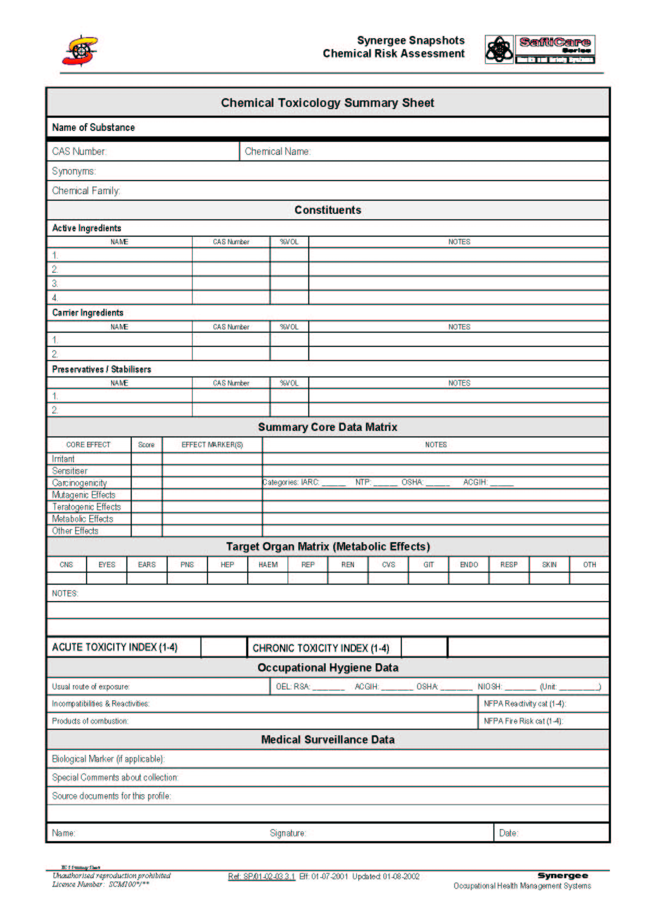

INTRODUCTION TO CHEMICAL TOXICOLOGY PROFILES:
The Chemical Toxicology Profile is the arrangement of toxicological characteristics of the company’s various hazardous chemical substances, in a manner that enables rapid data retrieval and analysis. It comprises a summarised dataset of all the key information about the chemicals in the company:
- Down the left (vertical) axis, is a list all the relevant chemicals, with their parent (product) chemicals and other group associations (such as chemical family).
- Along the top (horizontal) axis is a list all the various characteristics, including toxicological, exposure and medical surveillance information.
The relevant fields are populated by risk-related data, in an easy to see format (“blank” means not applicable, and stars from * to ****, indicate risk from low to extreme).
Analysis is by filtering tools that extract lists by any of the fields, or combinations.
For example, one can extract all the chemicals that can cause a particular health outcome, such as cancer, or asthma, etc. These can be listed by exposure groups (OREPs), or by workplaces (WREPs).
Figure 2: Image of a Chemical Toxicology Profile - 1.
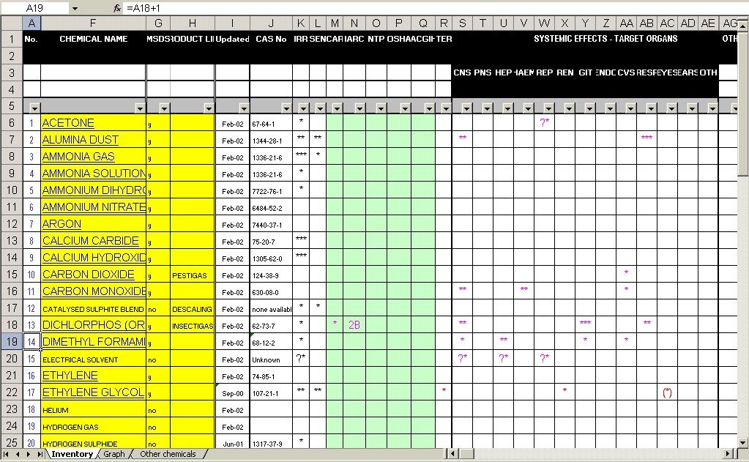
Info about the chemicals, such as chemical names, chemical family and the products in which the “parent” chemicals are found.
Date when the records were last updated
Toxicology information for each chemical, in summarised format
This field flags whether or not an MSDS is available for the chemical.
CAS Number
Figure 3: Image of a Chemical Toxicology Profile - 2.
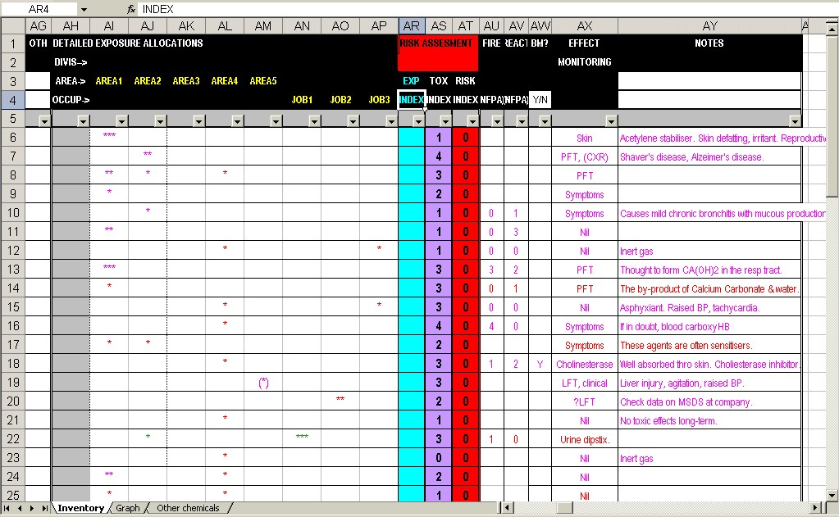
Fields for flagging the places and jobs which are exposed to the listed chemicals. These flags can be recorded as stars (asterisks), or as numerals (1-4).
Risk Assessment Indices (Scores). These include exposure score, toxicity score and risk index.
Flammability and Reactivity scores
Biological Monitoring – required “Yes”, or “No”.
Biological Effect Monitoring – what tests will be required?
Notes and comments about the chemical or product.

The structure of the Chemical Toxicology Profile.
- The first section comprises information pertaining the chemical itself, including it’s chemical name, chemical family and the product in which it is to be found (at this company). There is a column to register whether or not an MSDS is available for the chemical (“Y”=yes; “N”=no). The CAS number is recorded here. The date field is to register when the chemical was entered, or last worked on. Other process information could be included optionally, such as whether this is a raw material, an intermediate or a final product.
- The section to the right side of the CAS number is where the toxicity scores are recorded. This is the main component of the profile. It comprises the key information necessary to describe the adverse effects the chemicals could have on the body. These are described further below.
- To the right of these are the columns where exposure scores are recorded.
- To the right of this, is the Risk Assessment area, where the exposure and the toxicity values are multiplied, yielding the Risk Indices.
- Next to this lie two columns reflecting the degree of reactivity and flammability of the chemical. These are taken directly from the MSDS where they are given values out of 4. These are taken from the US-based “National Fire Protection Agency” (NFPA) databases.
- Next to these is a column in which the main suggested medical surveillance tests appropriate to the HCS are recorded, based upon the HCS’s profile.

HOW TO COMPLETE THE CHEMICAL TOXICOLOGY PROFILE:
The following steps are required:
Step 1: Enter the required chemical information into the Datasheet (spreadsheet or database).
Step 2: Flag the relevant fields which link the chemical information to the relevant work areas or occupations, by means of Exposure Scores (using asterisks (* to ****) or numerals (1 to 4)).
Step 3: Link the chemicals to electronic toxicology information sheets or MSDS’s.

Step 1: How to enter the toxicology information into the Chemical Toxicology Profile.
The data is entered as illustrated - the explanations for these fields are in figures 1 and 2. The content is taken directly from the HCS Summary Sheets, or from the toxicology database.
Some fields are provided with text; others are simply flagged by means of an asterisk:
- * = relevant, but minor effect / exposure
- ** = moderate effect / exposure
- *** = substantial effect / exposure
- **** = severe / exposure
Variations on this theme can be applied, for specific purposes; for example, (*) (asterisk held in brackets) could mean “possible” / “borderline”. A blank field indicates “Not Applicable”.
The determination of these Toxicology and Exposure scores (1-4) is described in the Appendix.

Step 2: How to link the toxicology information to Exposure Groups / Places
To accomplish this, the flags (“*” – “****”) are simply applied to the relevant exposure areas / occupations in the columns to the right of the columns carrying the toxicology information. In this way, using the drop-down filters in these columns will extract lists of chemicals as they pertain to the extracted areas.

Step 3: How to link the chemicals to electronic toxicology MSDS’s
The default software for the Synergee datasets is Microsoft Excel, but the same methodology can be applied to the Profile in other formats (Quattro).
This step requires the relevant toxicology data be converted to electronic format (saved from an electronic copy from a toxicology database, or scanned in from a “hard copy”), and stored in a readily accessible place on the computer. A hyperlink is then established between the listed chemicals in the Chemical Toxicology Dataset and their “parent” toxicology document, so that the “parent” toxicology document is called up when the mouse pointer touches the chemical name in the Chemical Toxicology Dataset.
This document will not attempt to provide the details as to how to allocate a hyperlink. This will be explained during training.

HOW TO USE THE CHEMICAL TOXICOLOGY PROFILE:
The Chemical Toxicology Profile is a living risk evaluation instrument, which can be used to analyse the chemical toxicology information in numerous ways. By using the drop-down menus available in each column, filters are applied that extract from the dataset only those chemicals that are requested.
For example, one can extract all the chemicals that can cause a particular health outcome, such as cancer, or asthma, etc., or by a particular exposure group, or by a risk area (workplace).

APPENDICES
The following appendices are included in the pages that follow:
- Method for allocating toxicology scores
- Method for allocating probability sores.
- Risk Matrix Table for allocating Risk Categories
- Internet-based resources for toxicology information.

APPENDIX 1: THE ALLOCATION OF TOXICITY SCORES
There are two methods for the evaluation of toxicity:
- Indirect measurement by estimation of potential outcome (qualitative)
- Direct measurement of “lethal dose” (LD₅₀) (quantitative).
The indirect measures are suitable for providing scores for all the “chronic toxicity” parameters, such as sensitisation, teratogenesis, mutagenesis, carcinogenesis, etc.
The direct measure (LD₅₀) is only suitable for scoring “acute toxicity”.
These elements are each examined for the agent under evaluation. The suggested scores (weightings) for each of the elements are as listed in the following tables. Note that these are guidelines only - the user is required to apply the best-suited category.

Table 1: Scoring short-term (“acute”) Toxicity.
Component | 1 (Low) | 2 (Med) | 3 (High) | 4 (Extreme) | Final (Highest)
IRRITANT | Transient & mild eye, skin & respiratory irritation. | Moderate eye, skin & respiratory burns. | Serious eye, skin & respiratory burns. | Life-threatening.
SENSITISER | Transient mild allergy.  (Skin only) | More severe allergy.  (Skin, eyes & upper respiratory tract only) | More severe allergy.  (Respiratory tract) | Life-threatening allergy (Respiratory & systemic organs).
ORGAN | Reversible mild or transient effects.  (eg. raised enzymes).  Significant volume required (ingestion)  LC₅₀ > 1000ppm (or equiv)  LD₅₀ > 500mg/kg | Reversible significant effects  (eg. blindness, anaemia)  Ingestion (even low volume).  LC₅₀ 100 – 1000ppm (or equiv)  LD₅₀ 250 - 500mg/kg | Irreversible (even potentially) significant effects  (eg. asthma)  Inhalation route.  LC₅₀ 10 – 100ppm (or equiv)  LD₅₀ 50- 250mg/kg | Life-threatening. Impaired fertility.  (eg. aplastic anaemia, agranulocytosis.  Skin absorption.  LC₅₀ <10ppm (or equiv)  LD₅₀ < 50mg/kg
For this table, the highest score from the sub-components is carried forward as the Acute Toxicity Score.

Table 2: Scoring long-term (“chronic”) Toxicity.
Component | 1 (Low) | 2 (Med) | 3 (High) | 4 (Extreme) | Final (Highest)
IRRITANT | Transient & mild eye, skin & respiratory irritation. | Moderate eye, skin & respiratory burns. | Serious eye, skin & respiratory burns. | Life-threatening.
SENSITISER | Transient mild allergy.  (Skin only) | More severe allergy.  (Skin, eyes & upper respiratory tract only) | More severe allergy.  (Respiratory tract) | Life-threatening allergy (Respiratory & systemic organs).
TERATOGEN | Suspected.  (Animal studies only) | Suspected.  (Laboratory only) | Known.  (Human studies) | Known.  (Case studies exist).
MUTAGEN | Suspected.  (Animal studies only) | Suspected.  (Laboratory only) | Known.  (Human studies) | Known.  (Case studies exist).
CARCINOGEN | Suspected.  (Animal studies only) | Suspected.  (Laboratory only) | Known.  (Human studies) | Known.  (Case studies exist).
ORGAN | Reversible mild or transient effects.  (eg. raised enzymes). | Reversible significant effects  (eg. blindness, anaemia) | Irreversible (even potentially) significant effects  (eg. asthma)  Skin absorption possible. | Life-threatening. Impaired fertility.  (eg. aplastic anaemia, agranulocytosis.  Easily absorbed thro’ skin
For this table, the highest score from the sub-components is carried forward as the Toxicity Score.

APPENDIX 2: THE ALLOCATION OF PROBABILITY SCORES
Remember that “Probability” is a function of the LIKELIHOOD of the adverse event taking place and the degree of EXPOSURE to the hazard.
From the table below it can be seen that 4 factors influence the allocation of a Probability Score. One is a Likelihood factor, and three are Exposure factors.
The Probability Score is simply taken as the average of these 4 factors.
Table 3: Calculating Probability Scores
LIKELIHOOD (INCIDENT FREQUENCY) | Score value (Table 4)
EXPOSURE FREQUENCY | Score value (Table 5)
EXPOSURE DURATION | Score value (Table 5)
EXPOSURE INTENSITY | Score value (Table 5)
PROBABILITY SCORE | TOTAL SCORE DIVIDED BY 4.

This value provides the vertical intersect that is used to allocate the relevant Risk Category from the table in Appendix 3.
Table 4: Calculating Likelihood (Incidence Frequency) Scores
1 (Minimal) | 2 (Low) | 3 (Med) | 4 (High) | 5 (Extreme)
Unlikely Ever. | 1 Incident / 10Years | 1 Incident / Year | 1 Incident / Month | 1 Incident / Week

Table 5: Calculating Exposure Scores
Sub-Component | 1 (Minimal) | 2 (Low) | 3 (Med) | 4 (High) | 5 (Extreme)
Frequency | Once /Year. | Quarterly. | Monthly | Weekly | Daily
Duration  (Hours per “average” work week) | < 1 Hours / Week (<10%) | 1-5 Hours / Week (10%) | 5-19 Hours / Week (10-50%) | 20-40 Hours / Week (50-100%) | >40 Hours / Week (>100%)
Intensity  (Where known) | As Per Table, Or  < 50%* Of Prescribed Limits  (Enclosed/ Sealed Process) | As Per Table,  Or  50-75% Of Prescribed Limits  (Manual Work With Local Exhaust) | As Per Table,  Or  75-100% Of Prescribed Limits  (Semi-Enclosed Process) | As Per Table,  Or  101-200% Of Prescribed Limits  (Manual Application, Protected (PPE)) | As Per Table,  Or  >200% Of Prescribed Limits  (Manual Application, Unprotected)

Appendix 3: Summary Guideline for allocation of Scores
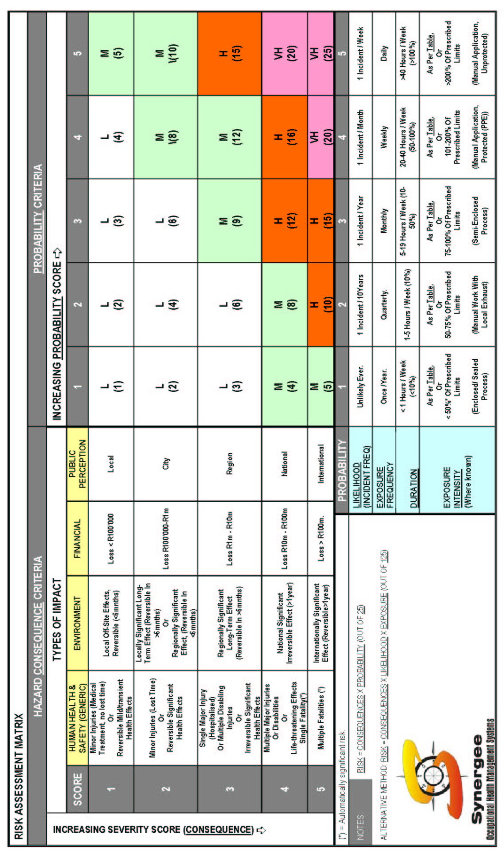

APPENDIX 4: INTERNET-BASED RESOURCES FOR TOXICOLOGY INFORMATION

- http://www.msdssearch.com MSDS search engine
- http://www.wiley.com/legacy/college/webercises/
- httP://www.jtbaker/safety/index.htm
- http://www.pp.okstate/edu/ehs/links/MSDS.htm
- http://www.ehs.ucr.edu/links/all_links.asp
- http://www.siri.org
- http://www.inchem.org
- http://www.physchem.ox.ac.uk/MSDS/#MSDS MSDS from Oxford University

