Health Risk Assessment
Policy Document

Table of Contents

1 INTRODUCTION 3
2 SCOPE 4
3 PURPOSE 4
4 OBJECTIVES 4
5 DEFINITIONS 4
6 REFERENCES 7
7 STANDARDS 7
8 FUNCTIONS OF THE HEALTH RISK ASSESSMENT 7
9 RESPONSIBILITIES 8
10 PROCEDURE 10
11 THE APPENDICES 12

Table of Figures

Figure 1: Hierarchy of Programmes, with underlying data flow. 3
Figure 2: The information beneficiaries of a Health Risk Assessment: 8
Figure 3: The structure of the data flow of the Health Risk Assessment: 11
Figure 4: The OREP and WREP: 12
Figure 5: Sample image of a Risk Matrix: 12
Figure 6: Image of 2 types of Workplace Risk Exposure Profile (WREP): 13

INTRODUCTION
Occupational Health is a preventive discipline, dedicated to reducing the likelihood of adverse events leading to injuries, illness or material losses. Central to this is the science of Risk Assessment. This is the core of Occupational Health, from which every subsequent action is derived.
Figure 1: Hierarchy of Programmes, with underlying data flow.
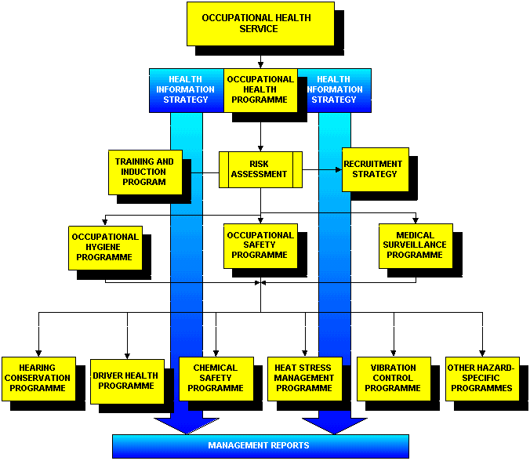

Occupational Health Risk Assessment is the systematic examination of activities and processes in the workplace, to determine the probability of harmful events, and the extent of the potential damage. This evaluation comprises a careful evaluation of the level of probability that the adverse event may occur, and the consequences of these events.
- The probability is a function of the estimated likelihood that the incident may occur, or of the degree of exposure of the target groups.
- These consequences quantify the degree and severity of harmfulness of the hazards.
Hence:
RISK = CONSEQUENCE X PROBABILITY

Risk Assessment can be conducted:
- By an occupational exposure group (such as a job category)
- By a particular physical location (such as a laboratory or workshop),
- By a process (such as a manufacturing process),
- By a particular activity

SCOPE
The Health Risk Assessment includes the evaluation of Health and Safety Risks, (with a lesser focus on Safety Risks), to employees of the company, as well as the risks to non-employees.

PURPOSE
The purpose of Health Risk Assessment is to evaluate all health hazards, and their exposures, in order to establish an effective risk reduction strategy.
This must comply with legal requirements, and follow a structured approach, such that the risks can be measured in a reproducible manner, and analysed to enable appropriate risk reduction strategies.

OBJECTIVES
- To recognise, quantify and analyse the hazards present at this company (their capacity to do harm, and the degrees to which exposure exists).
- To calculate Risk Indices for workplaces and occupations (job categories). These indices will allow ranking of the risks associated with each workplace and each occupation.
- To determine the actions that must be taken, if any, to reduce risk. These include:
- Occupational Hygiene Programmes such as air monitoring and engineering control measures.
- Occupational Safety Programmes, such as written safe working procedures and training.
- Medical Surveillance Programmes such as medical testing and biological monitoring.
- Training programmes that ensure that employees are fully conversant with the hazards that are inherent to their work.
- Recruitment strategies that ensure that employees are appropriately matched to their occupations, without unfair discrimination.

DEFINITIONS
- The term “HAZARD” refers to the agencies in the workplace that have a capacity to do harm.
The main forms of hazard of interest to occupational health programmes are:
- Physical, such as noise, temperature, radiation, etc.
- Chemical, such as liquids, fumes, gases, dusts, etc.
- Biological, such as viruses, bacteria, fungi, etc.
- Ergonomic, such as repetitive movements, abnormal posture, etc.
- Psychosocial, such as shift patterns, organisational stresses.
- Behavioural, such as non-compliance to standards, lack of skills.
- Mechanical, such as dangerous machinery, with moving parts, etc.
- Environmental, such as darkness, uneven or slippery terrain, work at heights, hot working surfaces, fires, high voltage electricity.
These are all described more fully in the Health Risk Assessment Guideline.
The hazards each have inherent degrees of “harmfulness”, or “toxicities”, which are determined by the inherent characteristics of the hazards. The degree to which they are harmful can be expressed by potential outcome of exposure, as follows:
- What degree of human injury could occur (in numbers of people, as well as injury severity)
- What degree of material damage could take place
- What degree of a public outcry may take place

- The term “EXPOSURE” refers to the degree to which the relevant groups of people are exposed to the hazards.
This includes the length of time of the exposure, as well as the intensity of the exposure. Hence the components of exposure include:
- time components
  - frequency (how often does this take place in a given period of time, such as a year)
  - duration (what is the length of time during which the exposure takes place)
- intensity components (the degree of the exposure)
  - the concentration of the agent in the air
  - the degree of contact with the agent (direct, indirect, body is completely covered, etc.)
Various techniques can be used to quantify this exposure. These are described in the Health Risk Assessment Procedures.

- The term “RISK” introduces an element of likelihood or possibility that a harmful event may occur. It is directly proportional to:
- the degree to which the agent is hazardous (the “consequences”)
- the degree to, or likelihood of, which the target group is exposed (the “probability”)
Hence:

RISK = HAZARD x LIKELIHOOD x EXPOSURE

- The Occupational Risk and Exposure Profile (OREP) is the formal documentation of the results of a Risk Assessment, for a single occupational exposure group (i.e. a job category). It comprises two main groups of data, all on one page:
- Capability requirements data, with scores of degrees of harmfulness, exposure and risk.
- Hazard related data, also with scores indicating the degrees of harmfulness, exposure and risk.
This document is the cornerstone of future action, providing key information for subsequent risk reduction strategies, such as Training, Occupational Safety interventions, Occupational Hygiene practices, Occupational Medicine programmes and Recruitment Policy.
 Illustrative images of an OREP are presented in the Tables in the Appendix.

- The Workplace Risk Exposure Profile (WREP) is the documented profile of risks for a targeted work area (i.e. a laboratory) or process (i.e. a production flow). It comprises three main groups of data:
- Who the target employees are (those potentially exposed to the risks).
- The processes and activities in the area
- The hazards associated with the area
 Illustrative images of an OREP are presented in the Tables in the Appendix.

- The Risk Matrix is the formal documentation of the results of a Risk Assessment, listing all the elements of the assessment in a single record, including location and exposure group. It comprises a matrix of the following:
- Down the left (vertical) axis, is a list all the occupations, grouped by their departments and other relevant demographics, (such as cost centre). The choice of demographic data included is limited only by the needs of the programme co-ordinator.
- Along the top (horizontal) axis is a list all the various possible hazards, recorded in the OREPs.
The relevant fields are populated by risk-related data, in an easy to see format (“blank” means not applicable, and asterisks from * - ****, indicating degrees harmfulness, exposure or risk, from low (*) to extreme (****)). Instead of asterisks (*), numbers from 1-4 can be used.
 Illustrative images of a Risk Matrix are presented in the Tables in the Appendix.
Analysis of this data enables easy evaluation of the risks (high or low) associated with various workplaces, departments and occupations, for every conceivable hazard. Inter-departmental and cross-occupational comparisons are therefore easy. Furthermore, subsequent risk reduction interventions are used to update the matrix, thereby enabling trends downwards, or upwards.
This enables rapid comparative analysis of relative risk, across the organisation. It is also a powerful tool for planning and organising proposed risk reduction strategies, and measuring the effects of these strategies.
The details regarding how to set up a Risk matrix are covered under the Risk Matrix SOP.

- The Worker-Allocated Surveillance Programme (WASP) is the formal documentation of the Medical Surveillance Strategy, accounting for the information made available from the Risk Assessment, and an understanding of appropriate test selection. The method for design of the WASPs for each exposure group is described in the Medical Surveillance Policy, Guidelines and Procedures.

REFERENCES
- Occupational Health and Safety Act (OHSA), No 85 of 1993 and Regulations.
- Institute of Occupational Hygienists of Southern Africa Guideline: “A guide to conducting an Occupational Health Risk Assessment”.
- The Mines Health and Safety Act (MHSA), No. 29 of 1996 and Codes of Practice.

STANDARDS
- The minimum standard will be the statutory requirements of the Occupational Health and Safety Act and its regulations. Where applicable, other standards will be applied, such as OHSAS 18001 (Standards for Occupational Health and Safety Programmes).
- A Health Risk Assessment should be repeated at least every two years. Should any new physical, chemical, biological or ergonomic stresses/risks be introduced during the periods between assessments, the new risks should be evaluated immediately.
- Wherever possible, a standardised approach should be used when establishing the scores to the hazards and their exposures. This is described in the OREP SOP.
- All measurement results generated during the process must be kept indefinitely (minimum of 30 years), and an exposure record thus generated included in employee medical records.

FUNCTIONS OF THE HEALTH RISK ASSESSMENT
The Health Risk Assessment functions as the cornerstone of the Occupational Health Programme. All subsequent occupational health activities are dependent upon the information yielded by the Health Risk Assessment.
Key functions include:
- The provision of carefully considered capability requirements (recruitment standards) for every occupation in the company. This is essential information for the development of Human Resource recruitment strategy.
- The provision of readily available information regarding the potential adverse health effects of exposure to the various hazards present in the workplace. This is essential for designing relevant health and safety training programmes, required by law.
- The provision of information pertaining to the risk of potential adverse health outcomes for all target groups, and also the capability standards that determine fitness requirements for all occupations. Both of these are essential for the design and implementation of effective medical surveillance programmes.
- The provision of a stratified, prioritised database of risks, their sources and their targets, that enable structured and appropriate safety intervention initiatives for risk-reduction.
- The provision of information that directs occupational hygiene measurement strategies, maximising outputs at optimal cost.
Figure 2: The information beneficiaries of a Health Risk Assessment:
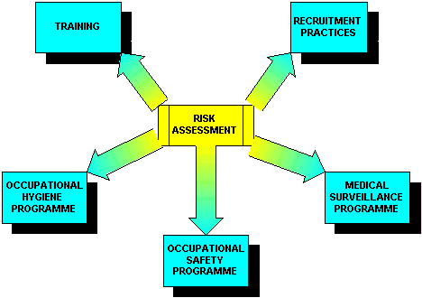

RESPONSIBILITIES
The overall responsibility for the Health Risk Assessment lies with the Risk Management team. However, they will require specific contributions as follows:
Safety, Health and Environment (SHE/Risk Management) Department Staff:
The SHE Staff will:
- Train the operational staff on how to complete the OREP documents, providing them with an understanding of the scores for hazard related data as well as the capability related data. This may require input from the medical team.
- Liase with operational staff and provide the exposure scores, for each occupation, for the chemicals listed by the operational staff.
- Assist in the acquisition of the relevant MSDS documents for the chemicals listed by the operational staff.
- Review the completed OREP documents, with the medical team, to ensure consistency and accuracy.
- Conduct facility inspections and walk-throughs, compiling location-oriented and process-oriented Health Risk Assessments.

Medical Department:
The Medical Department will:
- Establish the toxicity profiles of the hazardous chemical agents listed for the company. These are determined by reviewing the MSDS information acquired from the Risk Management Team. Alternative sources of toxicology information are likely to be necessary, given the inadequacy of most MSDS documents. These alternative sources include toxicology databases on the Internet, as well as commercially available databases on CD Rom.
- This toxicology is then summarised in the Chemical Toxicology Profile Spreadsheet. The agents of highest risk (a function of exposure and harmfulness), per job category, are transferred to the relevant OREPs.
- Review and standardise the toxicity (harmfulness) values of all the various hazards applicable to the facility under evaluation. The guidelines in the OREP SOP document can be used as a starting point.

Operations:
The Operational Staff will:
- Make lists of the hazardous chemical substances in use in their sections, and to allocate numerical scores representing exposures per job category.
- Liase with Risk Management to acquire the relevant MSDS documents for these chemicals.
- Complete the OREP documents; by recording the scores for hazard related data as well as the capability related data. Supervisors are best suited to this, in consultation with their staff. The department heads will be responsible for the verification of the final scores. The Completed OREPs are forwarded to Risk Management or the Medical Team.

Shop Stewards:
The Shop Stewards will:
- Carefully consider the completed OREPs, with a special reference to the inherent requirements of the occupations. Whilst the final decision regarding capability standards lies with management, the participation of employee representation in establishing these will go a long way to prevent future Industrial Relations disputes over fitness to work or grounds for fair dismissal.

Human Resources:
The Human Resources personnel will:
- Be conversant with the defined inherent requirements of the occupations (standards of fitness), as established in the OREPs.
- Develop and implement training programmes relevant to the risks associated with each job category, ensuring legal compliance.
- Establish an induction programme for new recruits, which should include specific health and safety training as well as a pre-employment medical, if relevant.
- Establish a termination of employment procedure, ensuring that employees leaving the company are first cleared by the medical department.

PROCEDURE
The guidelines for conducting Health Risk Assessment are recorded in a separate “Procedure Guideline” document. Associated with these guidelines, are standard operating procedures (“SOP’s”), which provide detailed instruction for implementation. These specific guidelines cover matters such as:
- Constructing Occupational Risk Exposure Profiles
- Constructing Workplace Risk Exposure Profiles and conducting a facility walk-through evaluation
- Compiling a Hazard-specific Risk Profiles, including:
- Hazardous Chemical Substances (HCS) Risk Profile, and interpreting Material Safety Data Sheets
- Hazardous Biological Agents (HBA) Profile
- Constructing the Risk Matrix.
The overall process of Health Risk Assessment is directed at assembling the key information in such a way as to enable the identification of areas of unacceptable risk, thereby predicting potential adverse health outcomes, and enabling effective risk reduction interventions. The following diagram outlines the key data routes that govern the process.

Figure 3: The structure of the data flow of the Health Risk Assessment:
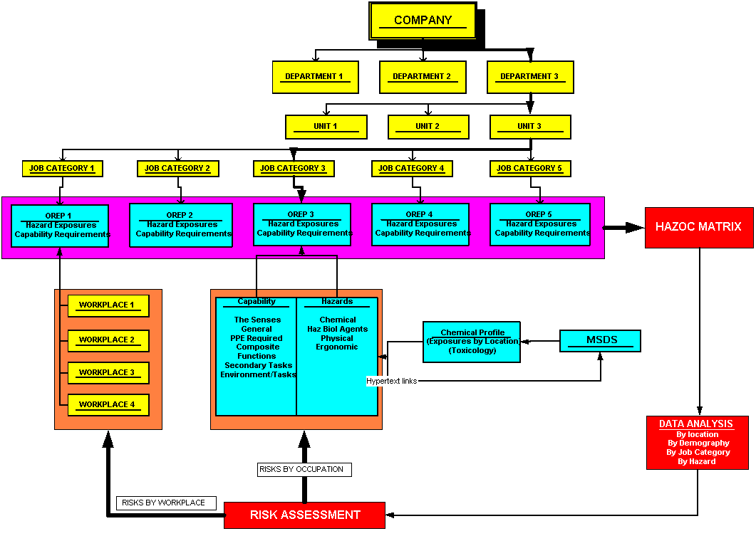
The Risk Matrix is where all the Risk Data is centralised, and compiled in a manner that enables analysis by any chosen parameter.
This area describes the position of the Job Category (& OREP) in the company organogram. This data enables future multi-level analysis.
The Health Risk Assessment can be conducted by Occupation (OREP), or by Location (& Process).
A single OREP includes the Risk Profiles of all the workplaces relevant to the OREP.
Chemical Risk Assessment. enabling population of the “Chemicals” fields in the OREP.
Each OREP represents the Risk Profile of a group of people with similar exposures

THE APPENDICES
This is where Health Risk Assessment begins; by location (or process), or by occupation.
Sample documents.
Figure 4: The OREP and WREP:
Image of a blank OREP  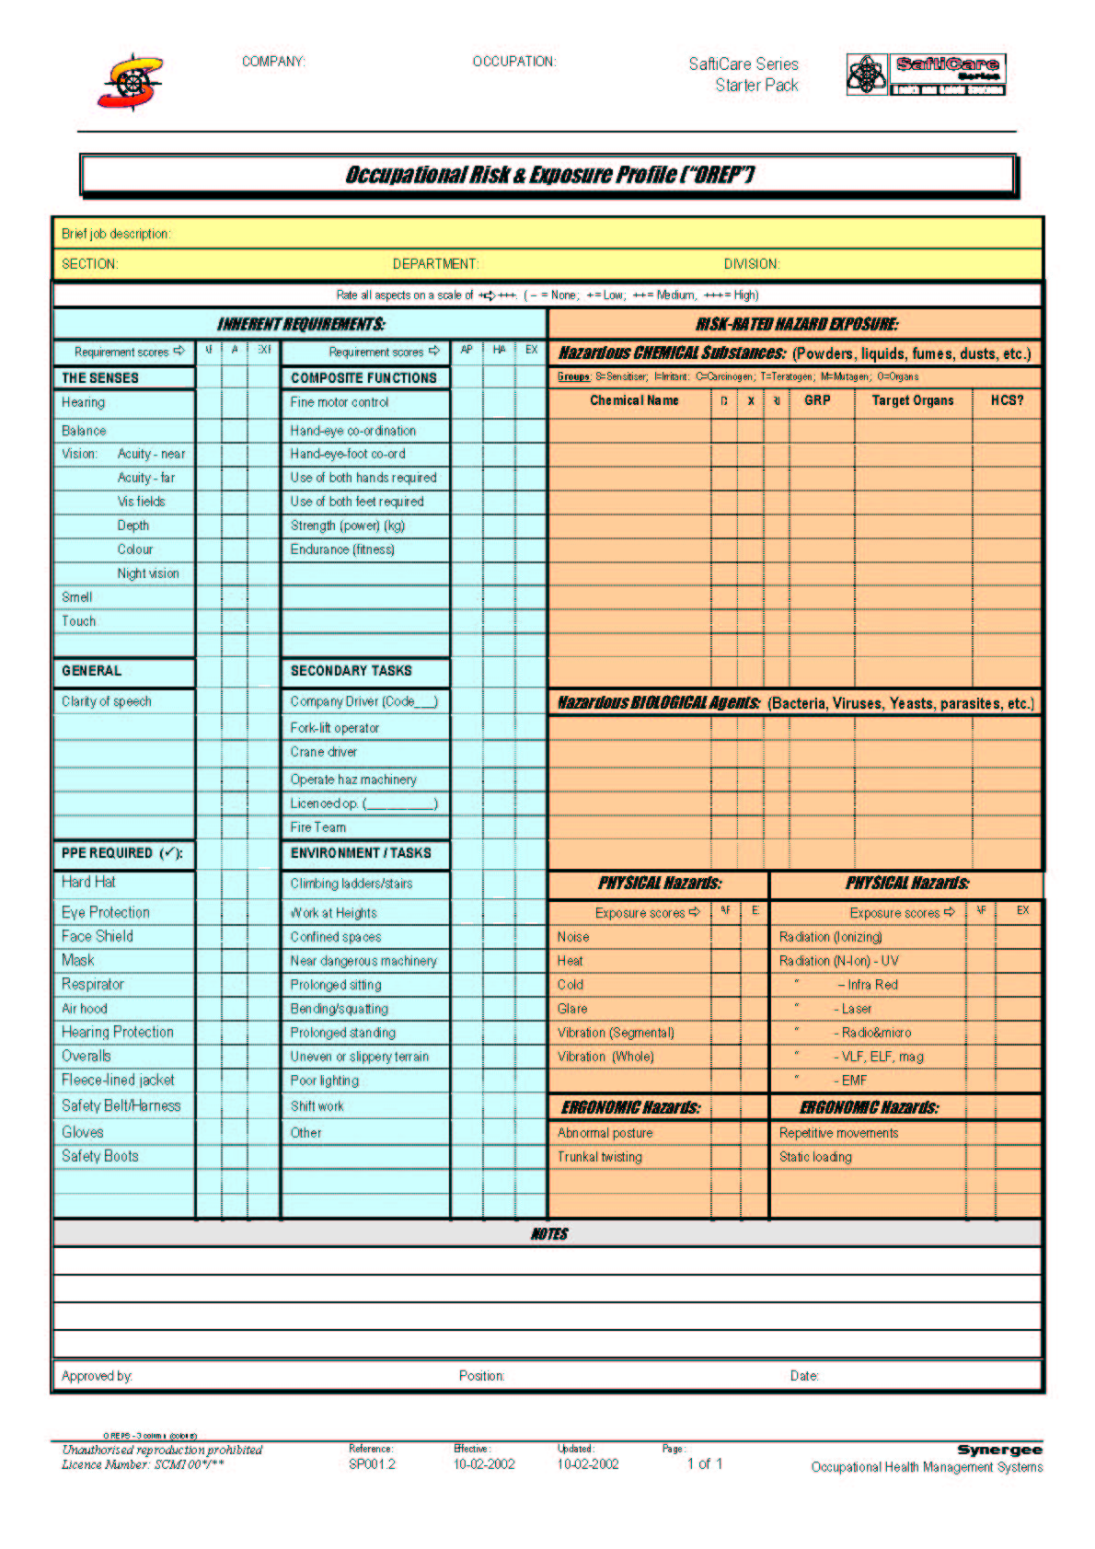  The OREPs represent a composite profile of the risks associated with the relevant occupation. These can be correlated with the hazards linked to the occupation in the Process Assessment Sheet (opposite). | Image of a blank WREP    The Job Categories associated with the activities in this process sheet are recorded next to the relevant activities in the “Process” column. They are therefore associated with the hazards linked with these activities, which, in turn, can be cross-referenced with the hazards represented in the OREP (opposite).  The activities performed in this process are listed in the “Process” column.  The hazards associated with each activity are listed next to the activity in the “Hazards” column.

Figure 5: Sample image of a Risk Matrix:
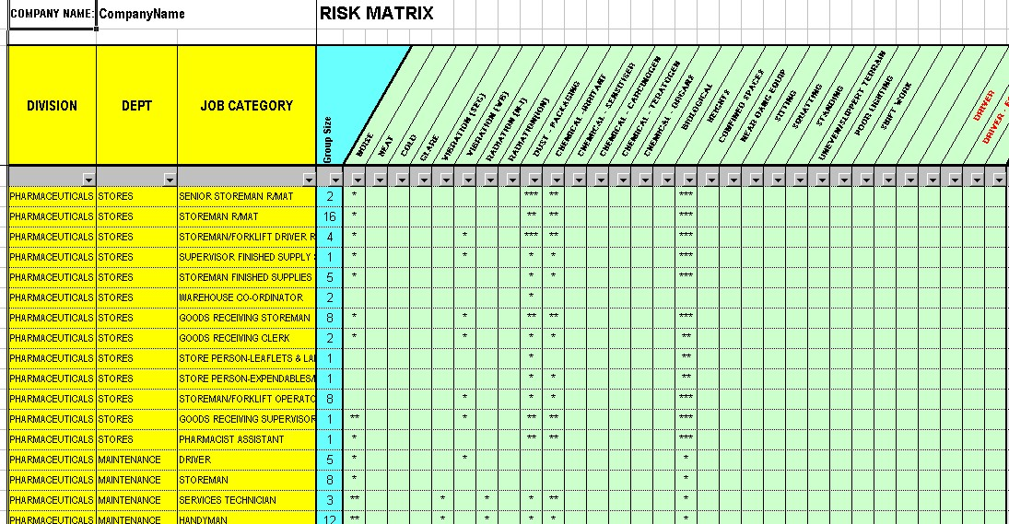
Figure 6: Image of 2 types of Workplace Risk Exposure Profile (WREP):
By Process | By Location  