Health Risk Assessment
Procedure Guidelines

Table of Contents
1 INTRODUCTION TO RISK ASSESSMENT 4
2 DEFINITIONS 6
2.1 The Baseline Risk Assessment: 8
2.2 The Issue-Based Risk Assessment: 8
2.3 The Continuous Risk Assessment: 8
3 TYPES OF “RISK” RELEVANT TO MEDICAL SURVEILLANCE 9
3.1 Effect Risk 9
3.2 Capability Risk 9
4 SCOPE 11
5 PURPOSE 11
6 OBJECTIVES 11
7 GENERAL APPROACH TO HEALTH RISK ASSESSMENT 11
7.1 Hazard Identification Phase: 12
7.2 Exposure Evaluation Phase: 13
7.3 Risk Prioritisation Phase: 14
7.3.1 Risk Categories (5x5) technique: 14
7.3.2 Numerical Risk calculation technique: 14
7.3.3 The Risk Matrix: 15
7.4 Actions Following Risk Assessment – Risk Management 16
8 THE OCCUPATIONAL RISK & EXPOSURE PROFILE (“OREP”) 17
8.1 Introduction To OREPs: 17
9 THE WORKPLACE RISK EXPOSURE PROFILE (“WREP”) 18
9.1 Introduction To WREPs: 18
10 THE HCS TOXICOLOGY PROFILE 20
10.1 Introduction to the HCS Toxicology Profile: 20
11 THE HBA RISK PROFILE 21
11.1 Introduction to the HBA Risk Profile: 21
12 THE RISK MATRIX 22
12.1 Introduction To The Risk Matrix: 22
13 THE APPENDICES 23
Appendix 1: Summary of types of Health and Safety Hazards 24
13.1 Appendix 2: Approach to the Allocation of Consequence Scores 25
13.1.1 The Concept of “Consequence” Score 25
13.2 Appendix 3: Approach to the Allocation of Probability Scores 27
13.2.1 The Concept of “Likelihood” (“Incident Frequency”) Score 27
13.2.2 The Concept of “Exposure” Score. 27
13.3 Appendix 4: Summary Guideline for allocation of Scores 30

Index of Tables
Table 1: Summary List of Types of Hazard 6
Table 2: Summary List of Types of Consequence (“Impacts”) 7
Table 3: Summary of Types of Risk Assessment 8
Table 4: Summary of Risk Factor Classification (5x5 technique): 15
Table 5: Scoring HBA virulence. 21
Table 6: Calculating Probability Scores 27
Table 7: Calculating Likelihood (Incidence Frequency) Scores 27
Table 8: Calculating Exposure Scores 28
Table 9: Scoring “Effect Exposure” Intensity: Guidelines for Physical & Environmental Hazards 28

Index of Figures
Figure 1: The two axes of Occupations and Risk. 10
Figure 2: The structure of the data collection: 16
Figure 3: Image of a blank OREP: 17
Figure 4: Image of part of the Process-Oriented Workplace Risk Exposure Profile (WREP): 18
Figure 5: Image of part of the Location-Oriented Workplace Risk Exposure Profile (WREP): 19
Figure 6: Relationship between OREPs and WREPs: 19
Figure 7: Image of a Toxicology Profile. 20
Figure 8: Image of part of a Risk Matrix. 23
Figure 9: Summary Guideline for the allocation of scores. 30

INTRODUCTION TO RISK ASSESSMENT
Occupational Health is a preventive discipline, dedicated to reducing the likelihood of adverse events leading to injuries, illness or material losses. Central to this is the science of Risk Assessment. This is at the core of Occupational Health, from which every subsequent action is derived.
Occupational Health Risk Assessment is the systematic examination of activities and processes in the workplace, to determine the probability of harmful events, and the extent of the potential damage. This evaluation comprises a careful evaluation of the level of probability that the adverse event may occur, and the consequences of these events.
- The probability is a function of the estimated likelihood that the incident may occur, or of the degree of exposure of the target groups.
- These consequences quantify the degree and severity of harmfulness of the hazards.
Hence:
RISK = CONSEQUENCE X PROBABILITY

It is understood that “Risk” is
- a qualitative term (measured in terms such as “low”, “medium”, and “high”, using industry norms as references for these standards)
- and a semi-quantitative term (measured by allocating values to the qualitative terms above (low = 1, medium = 2 high = 3, etc.), so that the relative risks can be compared.
- also expressed in epidemiological terms, using the tools of biostatistics to measure with greater precision, the relative risk of an effect resulting from exposure.
Point to Note: Occupational Risk Assessment and Epidemiology
Epidemiology is the study of the occurrence of adverse health events in given populations, over time. It is a complex discipline, which makes use of mathematical models of risk evaluation, biostatistics, and various techniques to verify the integrity of the findings. It is the “gold standard” of risk assessment. However, it has a number of drawbacks, severely limiting its application in daily Occupational Health practice. These include:
Time: Epidemiological studies often take time to establish, run, and to draw a conclusion, which is not available to conventional occupational health practice.
Controls: The absence of easily available control groups, against which to make comparative analyses.
Complexity: Whilst biostatistical analysis is not always complicated, many of the questions that require statistical answers demand a superior knowledge of the field.
Nevertheless, epidemiology remains central to occupational health practice – but not directly. Rather, the results of epidemiological investigations, which are published in the medical literature, are used as supportive data. In other words, the published literature is full of valuable studies with epidemiological findings, which can be used to the benefit of our own programmes. This is reflected in the Synergee approach to Health Risk Assessment, where literature review forms the very first step in the procedure.

Therefore, Health Risk Assessment can be conducted:
- By an occupational exposure group (such as a job category)
- By a particular physical location (such as a laboratory or workshop),
- By a process (the product’s “life cycle”),
- By a particular activity

Processes within the product’s life cycle include:
- Research and development  - Design of facilities  - Procurement of resources  - Transportation of materials  - Manufacture and packaging of product | - Sales  - Distribution of product  - Product use  - Product recycling and disposal

Activities that should be considered for risk assessment include:
- Logistical Activities | - Receiving (raw materials or intermediates)  - Storage  - Product distribution  - Fleet maintenance
- Production Activities | - Product manufacture: Mixing, blending, grinding, etc.  - Product packaging.
- Ancillary Services & functions | - Engineering  - Building maintenance, construction & demolition  - Grounds and gardening  - Waste management  - Canteen  - Health & Safety  - Laboratories  - Admin (offices, sales, procurement)
- Other Activities | - Travel (business, or even between home & work)  - Off-site business-related activities  - Volunteer community service  - Hobbies

Note that the Health Risk Assessment should consider different operating conditions, namely:
- Normal operating conditions
- Abnormal operating conditions (at start-up, shut-down, planned maintenance and shut-down)
- Reasonably foreseeable emergency situations (major spills, fire)

DEFINITIONS
- The term “HAZARD” refers to the workplace circumstances that have a capacity to do harm.
The main forms of hazard of interest to occupational health programmes are listed in Appendix 1.
Broadly, these are grouped as follows:
Table 1: Summary List of Types of Hazard
- Health Hazards, which include:  - Hazardous Agents: (Chemical, Biological, and Physical)  - Workplace Health Hazards: (Ergonomic, Psychosocial) | SUITABLE FOR MEDICAL SURVEILLANCE
- Safety Hazards, which include:  - Worker Capability: | SUITABLE FOR MEDICAL SURVEILLANCE
- Mechanical (work equipment):  - Fire & Explosion:  - Gravity:  - Environmental:  - Electricity:  - Behavioural:  - Miscellaneous | NOT SUITABLE FOR MEDICAL SURVEILLANCE

The hazards each have inherent degrees of “harmfulness”, “consequences”, or “toxicities”, which are determined by the inherent characteristics of the hazards. For the purposes of Risk Assessment, the effects of exposure to these hazards are known as “CONSEQUENCES”. The are various types of consequences, each which bring their own unique risks to the company’s sustainability. These are known as “IMPACTS”.
- The term “IMPACT” refers to the types of consequences that potentially occur as a result of exposure to hazards.
Broadly, these are grouped as follows:
Table 2: Summary List of Types of Consequence (“Impacts”)
- The degree of human injury or illness that could occur
- The degree of environmental damage that could occur
- The degree of financial loss (material damage, business down-time)
- The degree of negative public perception is caused by the incident

Various techniques can be used to quantify these consequence scores. These are described in Appendix 2.

- The term “PROBABILITY” refers to the degree to which the hazards are likely to exert the harmful effect, given occupational circumstances and knowledge of the agent. This is determined by:
- The predicted frequency with which the incident may be expected to occur, given the exposures in the workplace. This is known as the likelihood: ie. rarely occurs  known to occur frequently.
- The degree to which the employees are exposed. This can be expressed as follows:
  - The duration of the exposure
  - The frequency with which the exposure takes place over a given time period
  - The intensity with which the exposure takes place.
Various techniques can be used to quantify this exposure. This is described in Appendix 3.
Hence:
PROBABILITY = LIKELIHOOD X EXPOSURE

- The term “RISK” therefore incorporates the impact, the severity as well as the degree of probability that a harmful event may occur. For every type of impact, the risk is directly proportional to:
- the consequence of the exposure
- the degree of probability that the harmful event may take place
Hence:
RISK = CONSEQUENCE X PROBABILITY
Or
RISK = CONSEQUENCE X LIKELIHOOD X EXPOSURE

The various instruments used to gather risk information (OREP’s, WREP’s, etc., all use this format. The Risk Calculation Matrix provides a useful tool for calculating the risk. This is described in Appendix 4.

Table 3: Summary of Types of Risk Assessment

The Baseline Risk Assessment:
This process provides a “current status” review of the complete business, highlighting the risks in all business processes and activities. It is wide-ranging, aims at producing a broad overview. Areas covered include:
- Occupational Risk Assessment (“OREP’s”)
- Workplace Risk Assessment (“WREP’s”) (by process, location or by activity)
- Specific Hazardous Agent Assessment:
  - Hazardous Chemical Substances
  - Hazardous Biological Agents
  - Other, as relevant (Ergonomics).

The Issue-Based Risk Assessment:
This process provides a detailed assessment of specific risks associated with particular hazards, including:
- A new machine is introduced into a factory;
- A system of work is altered or operations change;
- An accident or a "near miss" has occurred;
- New production methods are implemented;
- Contractors carry out a capital/turnkey project.

The Continuous Risk Assessment:
This process provides a mechanism for continued monitoring and maintenance of the risks at an acceptable level. This may be by regular scheduled and periodic reviews to verify that the workplace conditions have remained the same. Examples include:
- Planned job observations
- Critical task analysis
- Critical parts analysis
- Planned workplace inspection
- General hazard suggestion schemes

TYPES OF “RISK” RELEVANT TO MEDICAL SURVEILLANCE
In occupational health, there are two core types of “risk” that are of direct relevance to medical surveillance:
The risk of injury or illness associated with exposure to a particular health hazard (hazardous agents and environmental hazards) – for the purposes of this programme, this shall be known as “EFFECT RISK”
This risk of injury or illness associated with work being conducted by employees who do not meet the inherent capability requirements commensurate with that work (capability hazards) – for the purposes of this programme, this shall be known as “CAPABILITY RISK”

These two terms require further definition and clarification:

Effect Risk
This refers to risk of employee injury or illness but, indirectly, it also refers to the risk of property or asset damage, as all share the same sources of risk. Besides the risks of injury and illness, the consequences of excessive exposures to hazardous workplace environments include losses in productivity, direct financial losses and industrial relations problems. The risks of litigation from non-employees (the public, customers, etc.) should also be borne in mind.
Given that [Risk = Consequences x Probability], the quantity of the Effect Risk is a function of the degree of harmfulness of the hazards associated with the occupation, the likelihood that the event may occur, and the extent of the exposures to the hazards.
Effect risk can be magnified by certain factors, including the intensity with which work is being conducted, (high work rates) and individual employee vulnerability. The effects of employee vulnerability on Effect Risk are reduced by establishing minimum standards of fitness for the tasks, and ensuring that these standards of fitness are applied and maintained, by means of a medical surveillance programme.

Capability Risk
This refers to the risk associated with the placement of an employee who does not meet the occupation’s capability requirements, thereby raising the likelihood of an accident or illness, involving themselves or others. This raises employer liability for claims from both outside and inside the company (accidents caused by employees physically inadequately equipped for the job).
Given that [Risk = Consequences x Probability], the quantity of the Capability Risk is a function of the degree of harm that could be caused by operator error in the activity, the likelihood that the event may occur and the time spent engaged in the activity.
As for “Effect Risk”, operator error (and, thereby, Capability Risk) is reduced by establishing minimum standards of fitness for the tasks, and ensuring that these standards of fitness are applied and maintained, by means of a medical surveillance programme.

Point to Note:
The Capability Requirements and Hazard Exposures for the company’s occupations are established during Health Risk Assessment, whereas the Standards of Fitness for the company’s occupations are established during the design phase of the Medical Surveillance Programme.

Figure 1: The two axes of Occupations and Risk.

Capability Risk
Effect Risk

This illustrates the two basic axes of risk – the vertical axis represents increasing health requirements and the horizontal axis represents increasing potential exposure to hazards.
This leads to four main “risk-groups” of occupations:
- Those with high health requirements, but low hazard exposure – the “liable occupations”. (eg. bulk truck drivers, heavy passenger vehicle drivers)
- Those with high health requirements, and high hazard exposure – the “critical occupations”. (eg. crane operators, forklift drivers, certain machine operators).
- Those with low health requirements, but high hazard exposure – the “hazardous occupations”. (eg. welding, maintenance, or any work entailing exposure to significant hazards).
- Those with low health requirements, and low hazard exposure – the “general occupations”. (eg. general workers, office and admin staff, etc.).

This model shows the dual requirement of the Medical Surveillance Programme to evaluate employees for both of these axes of risk. It should ensure that minimum medical requirements are met and that any adverse health effects from the exposure to hazards in the workplace are detected at an early stage, enabling effective remedial action to be taken.

SCOPE
The scope of the Health Risk Assessment Guideline is to provide an overview of the important concepts of relevance to Risk Assessment. Note that the emphasis is on Health and Safety Risks, with a lesser focus on Safety, Environmental, Financial and “Public Perception” Risks.
The scope of the Risk Assessment can vary as follows:
- Baseline Risk Assessment
- Issue-based Assessment
- Continuous Assessment
These are described in Table 3.

PURPOSE
The purpose of the Health Risk Assessment Guideline is to assist effective implementation of the Health Risk Assessment (HRA).
The purpose of the Health Risk Assessment is to ensure that health risks are identified and assessed, so that appropriate measures can be initiated to manage these risks, and that resources are targeted where they will produce greatest benefit.

OBJECTIVES
- Establish which type of assessment is required – “Baseline”, “Issue-Based”, or “Continuous”. Usually the initial approach is a combination comprising the following components:
- Completion of Baseline Occupational Risk Exposure Profiles (OREPs).
- Completion of Baseline Workplace Risk Exposure Profiles (WREPs).
- Completion of specific “Issue-Based” assessments by hazardous agent, where relevant, including:
  - HCS (Hazardous Chemical Substance) risk profile
  - HBA (Hazardous Biological Agent) risk profile
- By combining the knowledge of the harmfulness and exposure of the various hazards, compile a Risk Matrix enabling detailed analysis of the Risks.
- Compile a management report, indication areas of priority, and providing recommendations for risk reduction.

GENERAL APPROACH TO HEALTH RISK ASSESSMENT
Three main steps are involved, which are remembered by their phonic similarity:
HEALTH RISK ASSESSMENT | HEALTH RISK MANAGEMENT
- Step 1: Hazard Identification (“Enumerate”)  - Step 2: Exposure Evaluation (“Evaluate”)  - Step 3: Risk Prioritisation (“Risk Rate”) | “ERADICATE”
Hazard Identification and Exposure Evaluation can occur simultaneously.

Hazard Identification Phase:
Objective: Provide an overview of the hazards associated with the workplace, thereby appropriately directing the more detailed risk evaluation phase.
Input: The various data collection sheets and resources described below.
Outputs: “Occupational Risk Exposure Profiles” (“OREP”).
“Workplace Risk Assessment Profiles” (“WREP”)
The OREPs focus on the risks of Occupations, whereas the WREPs focus on the risks of Workplaces.

“Hazard Identification”
This phase comprises data gathering that “scopes” the hazards of relevance at the facility. These hazards are firstly identified, then allocated “harmfulness” scores in accordance with the tables provided.
Important data gathering resources include:
- Literature reviews: journals, the Internet, encyclopaedias, assessments at other (similar) sites, etc.
- Company data review: previous assessments, accident records, chemical inventories, purchasing inventories, absenteeism records.
- Hazard scan: walk-through inspections, interviews with workers, supervisors, company experts, such as laboratory staff, etc.

Point to Note:
The data is recorded by workplace, or by occupation. The advantages of collecting the data by occupation, are as follows:
- The data collected is immediately structured according to the risks associated with “homogenous exposure groups” (HEG’s), which is the universal requirement of Risk Management programmes. Homogenous exposure groups are simply employee groups that have identical OREP’s. These are usually in the form of Job Categories, or derivatives of these.
- Accurate analysis of the risks associated with the various workplaces is available through evaluation of the data collected from the OREPs. This is via a data management tool called the HAZOC (“Hazards & Occupations”) matrix. This is currently in the form of a purpose-designed analytical spreadsheet that has built-in filters, sorts and search tools that enable accomplishment of these comparisons with ease.
- The data is collected in a way that enables the rapid design of targeted Medical Surveillance Programmes, in a standardised manner. This advantage should not be under-emphasised. Without a careful and well-considered design strategy, these surveillance programmes are fraught with ad-hoc decisions, with potentially adverse industrial relations consequences, should they be implemented without relevance to the overall programme. This is especially important in the presence of the stringent requirements of current South African labour law.
- The data is presented in such a way that all the beneficiaries of the Health Risk Assessment process are well placed to receive the information they require for immediate programme implementation. The beneficiaries are depicted graphically in the section on OREPs.
- The data collection process requires the input of the employees, which improves the precision of the collective information, by avoiding “blanket” risk allocation to entire workplaces. Whilst it may be true that the composite sum of the hazard exposure data for a group of employees in a workplace may be a true reflection of the hazards in that workplace, it is rarely true for the converse.
- The “snap-shot bias” of interval workplace assessments is avoided by the gathering of data that is time-sensitive. OREPs carry greater precision regarding the actual risk, rather than the assumed risk. (“Snapshot” bias refers to the error that occurs with evaluations based in single visits by outside experts. This includes over-emphasis of hazards that happened to be prominent at the time of the inspection, and under-emphasis of hazards that were not visible at the time of the inspection.)

Synergee provides various tools for data collection during the Hazard Scan. Note that the Hazard Scan can be conducted by Occupation or by Location / Process. These two compliment each other, as they look at the same issues from two different points of view.
- For the purposes of Occupational hazard evaluation, the OREP is used as a data collection tool.
- For the purposes of Process / Workplace hazard evaluation, the WREP is used as a data collection tool.
Instructions regarding the use of these tools are in the following sections, and in detailed guideline documents of their own.
A summary of guideline scores, by type of Impact, is provided in Appendix 4.

Exposure Evaluation Phase:
Objective: Provide the exposure values to the identified hazards, and record the findings.
Inputs: The various data collection sheets.
Output: “Occupational Risk and Exposure Profiles” (“OREP”).
“Workplace Risk Assessment Profiles” (“WREP”)
This phase comprises an assessment of the exposures associated with the hazards – by job category, location, or business process. These are scored similarly to the hazard scores above.
This includes the length of time of the exposure, as well as the intensity of the exposure. Hence the components of exposure include:
- time components
  - frequency (how often does this take place in a given period of time, such as a year)
  - duration (what is the length of time during which the exposure takes place)
- intensity components (the degree of the exposure)
  - the concentration of the agent in the air
  - the degree of contact with the agent (direct, indirect, body is completely covered, etc.)
A summary of guideline scores, by type of Impact, is provided in Appendix 3.

Risk Prioritisation Phase:
Objective: Analysis of the hazards and their exposure values, to identify high-risk occupations and workplaces (“Risk ranking”).
Inputs: All Risk Assessment instruments (OREP’s, WREP’s, Hazardous Agent assessments).
Output: The Risk Matrix, in Management reports.

This phase comprises an analysis of the Risks. Remember that “Risk” is the product of:
- “Consequence”, (the “harmfulness profile”, or “Impact” that is unique to every hazard)
- “Probability”, (which varies with differing occupations or workplaces)

Once this point is reached in the Risk Assessment, there are two alternative approaches the Risk Ranking technique:

Risk Categories (5x5) technique:
Using the table illustrated in Appendix 4, the risks are allocated to a Risk Category by simply choosing the category that intersects the lines from the selected Consequence Score and Probability Score. The resultant Risk Category is expressed as a category: Low ⬇ Medium ⬇ High ⬇ Very High.
Given that each score is out of 5, a minimum score is always 1 (1x1), and a maximum score is always out of 25 (5x5).

Numerical Risk calculation technique:
This technique attempts to add a little more precision to the final Risk Score.
Probability is a function of the likelihood of the adverse event taking place and the exposure to the hazard.
Now if: RISK = CONSEQUENCE SCORE X PROBABILITY
And: PROBABILITY = LIKELIHOOD SCORE X EXPOSURE SCORE
Then: RISK = CONSEQUENCE SCORE X LIKELIHOOD SCORE* X EXPOSURE SCORE
*: The “Likelihood Score” is listed in the score allocation table as the “Incident Frequency”.
Given that each score is out of 5, a minimum score is always 1 (1x1x1), and a maximum score is always out of 125 (5x5x5).

The Risk Matrix:
For each and every hazard identified, whether during compiling OREP’s, WREP’s or any other assessment, the hazards are allocated a Consequence Score and a Probability Score, in accordance with the guideline in Appendix 4. This data is captured directly into the relevant input documents at the time of the assessment. This is subsequently computerised, which enables more detailed analysis.
Therefore the final step is to construct a Risk Matrix in which the Items to be risk ranked (the Occupations, Activities, Workplaces, etc), are listed down the left margin, and their main hazards are flagged by their scores. Ideally, all the scores (Consequence, Probability and Risk Scores) should be accessible for analysis. High-risk groups or areas are identified and intervention measures can be planned.
Table 4: Summary of Risk Factor Classification (5x5 technique):
The Risk Factors are classified as follows:
- Very High Risk scores from 20 to 25. Immediate action is required (discontinue?)
- High Risk scores from 14, but less than 20. Medium term action is required
- Medium Risk score from 7, but less than 14. Long-term action is required
- Low Risk scores of less than 7. Careful incident monitoring only.

Figure 2: The structure of the data collection:
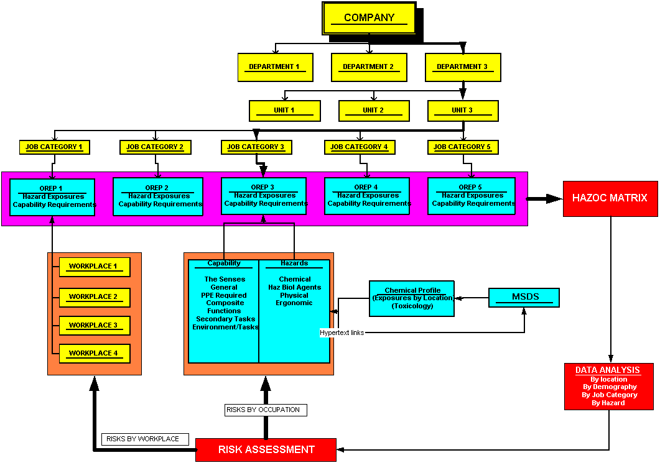
The HAZOC Matrix is where all the Risk Data is centralised, and compiled in a manner that enables analysis by any chosen parameter.
This area describes the position of the Job Category (& OREP) in the company organogram. This data enables future multi-level analysis.
The Health Risk Assessment can be conducted by Occupation (OREP), or by Location (& Process).
A single OREP includes the Risk Profiles of all the workplaces relevant to the OREP.
Chemical Risk Assessment. enabling population of the “Chemicals” fields in the OREP.
Each OREP represents the Risk Profile of a group of people with similar exposures

Actions Following Risk Assessment – Risk Management
On obtaining the Risk Indices, the risk assessment team can recommend the required risk reduction initiatives, giving remedial actions required to reduce or eliminate the risk. Risk Officers, occupational health sisters and doctors, industrial hygienist and management should plan and execute remedial actions, additional measurements/biological monitoring and medical surveillance as required.
A summary of the Risk Management interventions includes:
- Health and Safety Training
- Occupational Safety
- Occupational Hygiene
- Occupational Medicine
- Recruitment Practices
A more detailed description of these is provided in the Health Risk Management Guideline.

THE OCCUPATIONAL RISK & EXPOSURE PROFILE (“OREP”)

Introduction To OREPs:
The Occupational Risk and Exposure Profile (OREP) is the formal documentation of the results of a Risk Assessment, for a single occupational exposure group (i.e. a job category). It comprises two main groups of data, all on one page:
- Data that defines the inherent capability requirements of the occupation are listed. Failure to meet these requirements increases the company’s liability by increasing the risk of an accident.
- Data pertaining to the hazardous exposures unique to each occupational category

This document is the cornerstone of future action, providing key information for subsequent risk reduction strategies, Education and Training, Occupational Safety, Occupational Hygiene, Occupational Medicine and Recruitment Policy.

Figure 3: Image of a blank OREP:  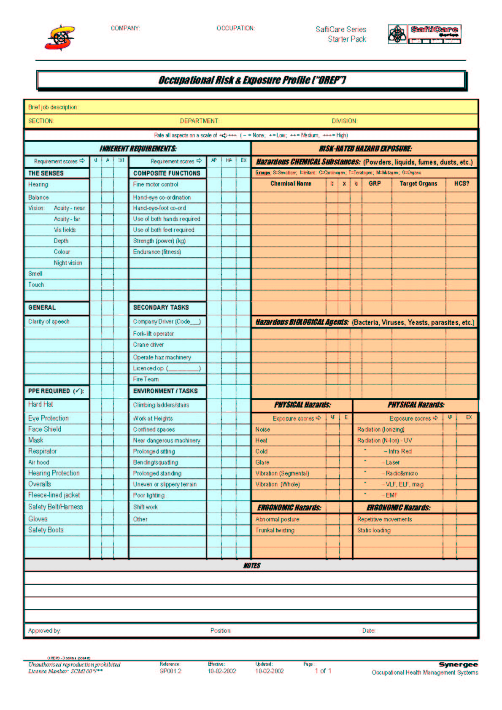 | The information directs the components of the Occupational Health Programme by:  - Ensuring that hazard exposure information is available to all parties (“Risk Assessment beneficiaries”)  - Minimum health requirements are agreed in advance.  - The information directs any training needs, as prescribed by the Hazardous Chemicals Substances regulations.  - The information determines placement requirements for the various occupations, improving the effectiveness of the Human Resources personnel. This provides protection from the Labour Relations and Employee Equity Acts, which require rational and defendable approaches to employment/placement strategies AND incapacity management.  - Presenting the required data for all the beneficiaries of the Risk assessment in a manner that enables rapid implementation

THE WORKPLACE RISK EXPOSURE PROFILE (“WREP”)

Introduction To WREPs:
The Workplace Risk Exposure Profile (WREP) is the documented profile of risks for a targeted work area (i.e. a laboratory) or process (i.e. a production flow).
It comprises the following main groups of data:
- The hazards & their sources & impacts associated with the area, and their risks (consequences and probabilities)
- The processes and activities in the area
- Who the target employees are (those potentially exposed to the risks).
- Risk reduction controls (and their deficiencies).
When conducting a process-oriented Health Risk Assessment, it is useful to draw a schematic process flow diagram (often these are already available from the company, but if not available, draw one on the blank WRAP sheet, as found in the SOP on Facility Walk-through evaluation), noting the following (the three “P’s”!):
- Product info: Raw materials, by-products, waste products, final products, their quantities and their movement around the worksite.
- Process info: Machinery, equipment, their quantities and their movement around the worksite.
- People info: Job categories, their numbers and their movement around the worksite.

Figure 4: Image of part of the Process-Oriented Workplace Risk Exposure Profile (WREP):
The Job Categories associated with the activities in this process sheet are recorded next to the relevant activities in the “Process” column. They are therefore associated with the hazards linked with these activities, which, in turn, can be cross-referenced with the hazards represented in the OREPs.
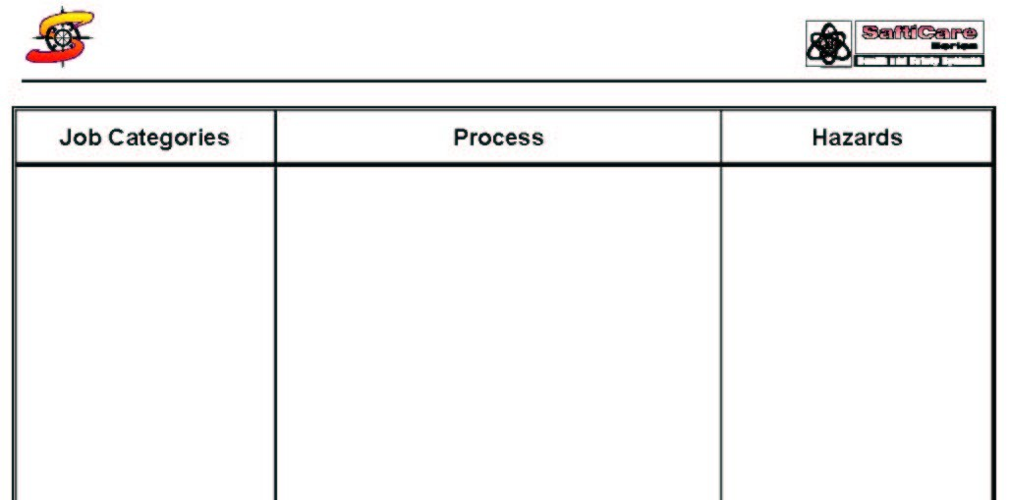
The hazards associated with each activity are listed next to the activity in the “Hazards” column.
The activities performed in this process are listed in the “Process” column.

The WREPs provided can also be used, to collect information in a more structured way per location.
When conducting a location-oriented Health Risk Assessment, it is useful to use pre-designed checklists that assist in the gathering of information:
Figure 5: Image of part of the Location-Oriented Workplace Risk Exposure Profile (WREP):
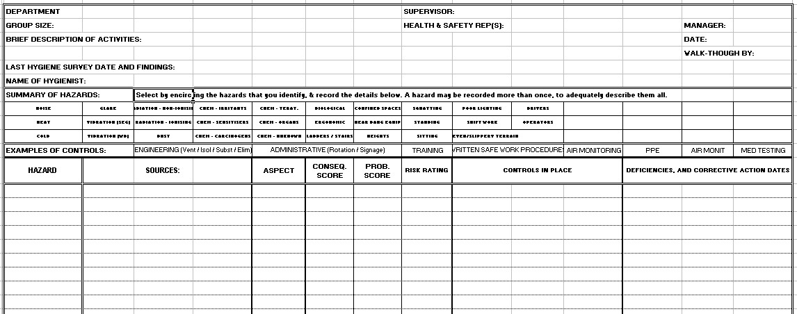

Special attention must be taken of control measures in place, noting conformance, partial conformance or non-conformance. Typical control measures are the following:
- Engineering controls (ventilation, isolation, elimination, substitution).
- Written standard operating procedures (“SOP’s”)
- Training
- Administrative Controls (Job rotation, warning signs)
- Air monitoring
- Personal Protective Equipment
- Biological monitoring as well as medical examinations

Point to Note:
Given that the favoured method for initial data collection is by job category, the simplest manner for data collection is by using the Occupational Risk and Exposure Profiles (OREPs) as data collection sheets. The data collected is stored in the OREPs, and transferred to the computerised HAZOC Matrix.
The WREP is used as a mechanism for supplementing and verifying the recorded information in the OREPS.

Figure 6: Relationship between OREPs and WREPs:
Image of a blank OREP  The OREPs represent a composite profile of the risks associated with the relevant occupation. These can be correlated with the hazards linked to the occupation in the Process Assessment Sheet (opposite). | Image of a blank WREP    The Job Categories associated with the activities in this process sheet are recorded next to the relevant activities in the “Process” column. They are therefore associated with the hazards linked with these activities, which, in turn, can be cross-referenced with the hazards represented in the OREP (opposite).  The activities performed in this process are listed in the “Process” column.  The hazards associated with each activity are listed next to the activity in the “Hazards” column.

The key Steps to be followed for the HRA Walk-through Evaluation are as described in the relevant SOP.

THE HCS TOXICOLOGY PROFILE

Introduction to the HCS Toxicology Profile:
The Hazardous Chemical Substance (HCS) Toxicology Profile is the arrangement of toxicological characteristics of the various hazardous chemical substances in a manner that enables rapid data retrieval and analysis. It comprises all the key information about the chemicals in the company, all in one dataset:.
- Down the left (vertical) axis, is a list all the chemicals, with their parent (product) chemicals and other group associations.
- Along the top (horizontal) axis is a list all the various characteristics, including toxicological, exposure and medical surveillance information.
The relevant fields are populated by risk-related data, in an easy to see format (“blank” means not applicable, and stars from * - ****, indicate risk from low to extreme).
Analysis is by filtering tools that extract lists by any of the fields, or combinations.
For example, one can extract all the chemicals that can cause a particular health outcome, such as cancer, or asthma, etc. These can be listed by exposure groups (OREPs), or by workplaces (WREPs).
This is one of the core activities of health risk assessment, as the results of this risk assessment are required for the completion of all other assessments (OREPs, WREPs, issue-based, etc.).
Figure 7: Image of a Toxicology Profile.
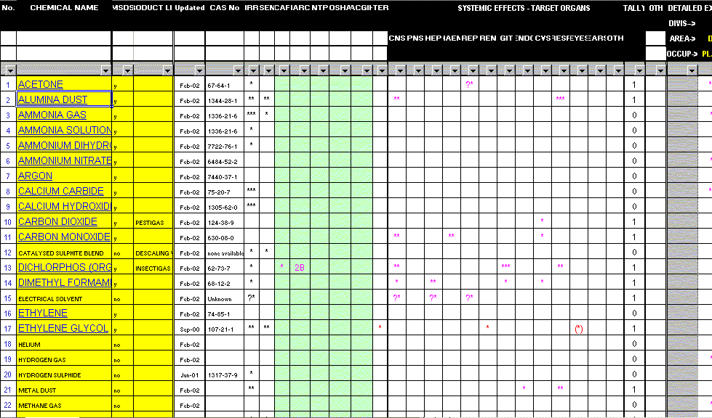

The construction of the Chemical Toxicology Profiles is discussed in the SOP.

THE HBA RISK PROFILE

Introduction to the HBA Risk Profile:
The Hazardous Biological Agent (HBA) risk profile is the arrangement of hazardous characteristics of the listed hazardous biological agents in a manner that enables rapid data retrieval and analysis. It comprises all the key information about the biological agents in the company, all in one dataset:
Down the left (vertical) axis, is a list all the biological agents, with their group associations.
Along the top (horizontal) axis is a list all the various characteristics, including hazard, containment category, exposure and other information.
The relevant fields are populated by risk-related data, in an easy to see format (“blank” means not applicable, and stars from * - ****, indicate risk from low to extreme).
Analysis is by filtering tools that extract lists by any of the fields, or combinations.
For example, one can extract all the chemicals that can cause a particular health outcome, such as cancer, or asthma, etc. These can be listed by exposure groups (OREPs), or by workplaces (WREPs).
Table for the allocation of Consequence Scores for HBA’s.
Table 5: Scoring HBA virulence.
Component | 1 (Low) | 2 (Med) | 3 (High) | 4 (Extreme) | Final (Highest)
CATEGORY | 1 | 2 | 3 | 4
LIKELIHOOD FOR CAUSING HUMAN DISEASE | UNLIKELY | YES  HEALTH RISK PRESENT | YES  SERIOUS HEALTH RISK | YES  SERIOUS HEALTH RISK
LIKELIHOOD TO SPREAD INTO COMMUNITY | NO | UNLIKELY | YES - MAY | YES – HIGH RISK
PROPHYLLAXIS & TREATMENT AVAILABLE | YES | YES | YES | NO
For this table, the highest score from the sub-components is carried forward as the HBA Consequence Score.

THE RISK MATRIX

Introduction To The Risk Matrix:
The Risk Matrix is the arrangement of the results of the Risk Assessment, for all the job categories, by their locations and organisational hierarchy. It comprises two main groups of data, all on one page:
Down the left (vertical) axis, is a list all the occupations, grouped by their departments and other relevant demographics, (such as cost centre). The choice of demographic data included is only limited by the needs of the programme designer. Note that even locations can be listed, as well as occupations, enabling direct analysis of all the company’s workplaces, too.
Along the top (horizontal) axis is a list all the various possible hazards, as made available in the OREPs.
The relevant fields are populated by risk-related data, in an easy to see format (“blank” means not applicable, and stars from * - ****, indicate risk from low to extreme).
Analysis of this data enables easy evaluation of the risks (high or low) associated with various workplaces, departments and occupations, for every conceivable hazard. Inter-departmental and cross-occupational comparisons are therefore easy. Furthermore, subsequent risk reduction interventions are used to update the matrix, thereby enabling trends downwards, or upwards.
This enables rapid comparative analysis of relative risk, across the organisation. It is also a powerful tool for planning and organising proposed risk reduction strategies, and measuring the effects of these strategies.

Figure 8: Image of part of a Risk Matrix.
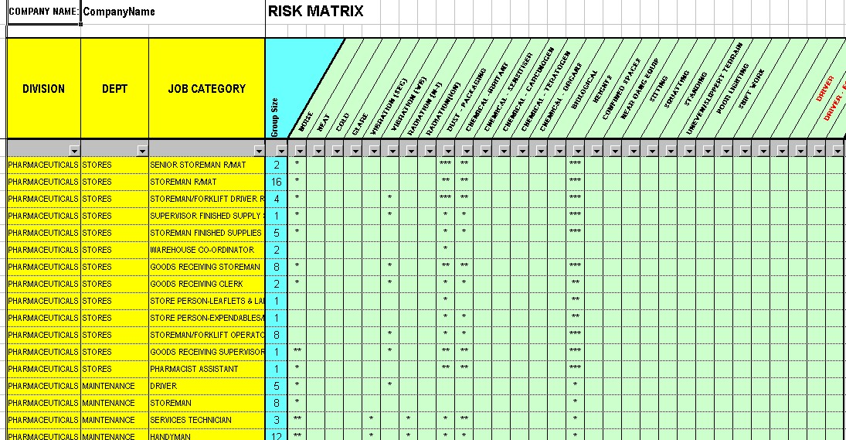

THE APPENDICES
The appendices attached to this document are:
- Summary of Health and Safety Hazards
- Approach to the allocation of Hazard Scores
- Approach to the allocation of Exposure Scores
- Step-wise approach to Health Risk Assessment

Appendix 1: Summary of types of Health and Safety Hazards
Health Hazards include:
Hazardous Agents: | Workplace Health Hazards:
- Chemical (HCS): (Liquids, fumes, gases, dusts, etc.)  - Irritants, Sensitisers, Carcinogens, Teratogens, Mutagens, Target Organ effects.  - Raw materials, active / inactive ingredients, intermediates, final products.  - Laboratory chemicals.  - Welding fumes, Building materials.  - Animal and plant products.  - Workplace smoking  - Biological (HBA):  - Viruses, bacteria, fungi, etc.  - Physical:  - Noise  - Temperature (hot & cold)  - Radiation  - Ionising (x-rays, γ-rays, α&β emitters)  - Non-ionising (bright light, UV & infrared, electromagnetic fields (EMF), microwaves & radio frequency, lasers.). | - Ergonomic  - Repetitive movements  - Vibration  - Abnormal posture.  - Material & equipment handling (lifting, pulling, etc.)  - Illumination (lighting) (dark & light)  - Humidity & air quality.  - Psychosocial  - Shift patterns  - Organisational stress.
Safety Hazards include:
- Worker Capability:  - Non-compliance with medical standards.  - Lack of required skills/competencies.  - Mechanical (work equipment):  - Dangerous machinery, (moving parts, etc.)  - Sharp edges  - Releases (sparks, chips, fume, dust)  - Pressurised vessels (air, gas, hydraulics)  - Failure or collapse of parts  - Overturning of machine or object  - Transport hazards (overhead cranes, forklifts, pallet trucks, vehicles).  - Fire & Explosion:  - Flammable gases, vapours, liquids.  - Combustible dusts or solids.  - Chemical reaction  - Hot work, flame or spark.  - Access and egress  - Gravity:  - Work at heights (ladders, scaffolding)  - Falling materials or objects (incl. stacking) | - Environmental:  - Uneven or slippery terrain.  - Sharp edges  - Extreme weather conditions  - Hot surfaces, liquids, steam.  - Oxygen deficiency (asphyxiation)  - Electricity:  - High voltage electricity.  - Static electricity.  - Exposed conductors.  - Defective wiring / plugs.  - Overloaded circuits.  - Behavioural:  - Non-compliance to safe work standards  - Violent behaviour  - Lone working conditions  - Miscellaneous:  - Inadequate safety equipment  - Animals (bites, stings, kicks, etc)  - Construction & demolition.

Appendix 2: Approach to the Allocation of Consequence Scores

The Concept of “Consequence” Score
The establishment of a reliable and consistent scoring mechanism for allocation of harmfulness is difficult. This is because “harmfulness” is partly linked to the intensity of exposure, yet “exposure” is the other variable used for calculating “Risk”! Hence, with increasing intensity of exposure, there is an increase in the harmfulness of the hazard. For example, heat is harmful to the human body, and has a characteristic target organ profile. However, with increasing intensity of exposure, the more harmful the heat becomes, migrating from a cause for simple dehydration, to heat exhaustion, to heat stroke. The heat stroke is certainly more harmful than the dehydration. To complicate things even more, the work rates of the occupations exposed to the given heat exposure magnify the risk of heat stroke, as do inherent vulnerabilities in the exposed employees (medical conditions that place them at increased risk)! What “harmfulness score” does one then allocate to heat as a hazard? What does one do with these “magnifiers” of risk?
The answer is not simple, but guidance can be found in keeping focussed on the intended outcome of the Health Risk Assessment process, which is a living database of activities and occupations, reliably ranked by health risk.

Hence:
The hazard (harmfulness) component is scored according to a scale that best represents the harmfulness of the hazard for the occupation under evaluation, on an agreed scale
Inherent employee vulnerabilities cannot be accounted for in the health Risk Assessment – instead, they are identified and listed as exclusions (“relative” or “absolute”) for the relevant occupations, in accordance with the exposure profiles. These are dealt with in the procedure covering Medical Surveillance. The risk reduction strategy here is the identification of those at risk (medical surveillance), and treating or removing employees who at unacceptable risk of harm.

Hence, by analysing the risks recorded in the database, risk reduction initiatives can be contemplated, either by exposure reduction or by altering the harmfulness of the hazard directly.

Point to Note:
From the preceding text, discussing the two types of risks that influence the planning of medical surveillance, these can be summarised as:
“EFFECT HAZARDS”: These have harmful effects on exposed individuals.
These are derived from the listed “Hazardous Agents”, and Environmental Hazards” (Appendix 1)
- Chemical, such as liquids, fumes, gases, dusts, etc.
- Biological, such as viruses, bacteria, fungi, etc.
- Physical, such as noise, temperature (hot and cold), radiation (ionising & non-ionising), vibration, etc.
- Ergonomic, such as repetitive movements, abnormal posture, glare, etc.
- Psychosocial, such as shift patterns, organisational stresses.

“CAPABILITIES HAZARDS”: These have harmful effects on the workplace, consequent of an employee working in an occupation for which he (she) does not have the required capabilities.
These are derived from the listed “Worker Capability Hazards” (Appendix 1)
- Non-compliance to medical standards, such as for vocational drivers & operators of dangerous equipment, such as cranes, excavation equipment and forklifts.

Hence the two different types of “Harmfulness” are:
“Capability Harmfulness”, which reflect the potential damage that could take place, should something go wrong as a result of operator error, should the employee’s capability not meet the requirements of the occupation. The types of potential damage are relevant to the all the types of impacts (Health & Safety, Environmental, Financial, and Public Perception) (see below).

“Effect harmfulness”, which reflect the potential health impacts that could take place, should sufficient exposure to hazardous agents take place, given the nature of the occupation. Quantifying the harmfulness of a hazardous agent is a complex task.
The allocation of these Consequence Scores is as per the following table.
HAZARD CONSEQUENCE CRITERIA
INCREASING SEVERITY SCORE (CONS) ⬇ | TYPES OF IMPACT
INCREASING SEVERITY SCORE (CONS) ⬇ | SCORE | HUMAN HEALTH & SAFETY (GENERIC) | ENVIRONMENT | FINANCIAL | PUBLIC PERCEPTION
INCREASING SEVERITY SCORE (CONS) ⬇ | 1 | Minor Injuries (Medical Treatment, no lost time)  Or  Reversible Mild/transient Health Effects | Local Off-Site Effects, Reversible (<6mnths) | Loss < R100’000 | Local
INCREASING SEVERITY SCORE (CONS) ⬇ | 2 | Minor Injuries (Lost Time)  Or  Reversible Significant Health Effects | Locally Significant Long-Term Effect (Reversible In >6mnths)  Or  Regionally Significant Effect, (Reversible In <6mnths) | Loss R100’000-R1m | City
INCREASING SEVERITY SCORE (CONS) ⬇ | 3 | Single Major Injury (Hospitalised)  Or Multiple Disabling Injuries  Or  Irreversible Significant Health Effects | Regionally Significant Long-Term Effect (Reversible In >6mnths) | Loss R1m - R10m | Region
INCREASING SEVERITY SCORE (CONS) ⬇ | 4 | Multiple Major Injuries  Or Disabilities  Or  Life-threatening Effects  Single Fatality(*) | National Significant Irreversible Effect (>1year) | Loss R10m - R100m | National
INCREASING SEVERITY SCORE (CONS) ⬇ | 5 | Multiple Fatalities (*) | Internationally Significant Effect (Reversible>1year) | Loss > R100m. | International

More detailed guidance for the allocation of Health and Safety Consequence Scores for Hazardous Chemical Substances (HCS) and Hazardous Biological Agents (HBA) are recorded in these SOP’s.

Appendix 3: Approach to the Allocation of Probability Scores
Remember that “Probability” is a function of the LIKELIHOOD of the adverse event taking place and the degree of EXPOSURE to the hazard.
From the table in Appendix 4 it can be seen that 4 factors influence the allocation of a Probability Score. One is a Likelihood factor, and three are Exposure factors.
The Probability Score is simply taken as the average of the cumulative scores of these 4 factors.

Hence the probability score is calculated as follows:
Table 6: Calculating Probability Scores
LIKELIHOOD (INCIDENT FREQUENCY) | Score value (Table 6)
EXPOSURE FREQUENCY | Score value (Table 7)
EXPOSURE DURATION | Score value (Table 7)
EXPOSURE INTENSITY | Score value (Table 7)
PROBABILITY SCORE | TOTAL SCORE DIVIDED BY 4.

This value provides the vertical intersect that is used to allocate the relevant Risk Category from the table in Appendix 4.

The Concept of “Likelihood” (“Incident Frequency”) Score
This value is simply a score that, from past experience or from professional judgement, is given a value as follows:
Table 7: Calculating Likelihood (Incidence Frequency) Scores
1 (Minimal) | 2 (Low) | 3 (Med) | 4 (High) | 5 (Extreme)
Unlikely Ever. | 1 Incident / 10Years | 1 Incident / Year | 1 Incident / Month | 1 Incident / Week

The Concept of “Exposure” Score.
The establishment of a reliable and consistent scoring mechanism for allocation of not as complex as for harmfulness but is also not without it’s difficulties.
One’s intuitive thought is that the exposure can be measured, and therefore the exposure scoring should be easy. The reason why this is not the solution to scoring is that:
- Measurements do not always represent the exposure over an extended period of time, such as a year. They are usually “snap shots”, that describe the exposure as it was at the time of the measurement. A more complete picture of exposure has to account for this “snap-shot” bias”. Exposures need account for the frequency (periodicity) of the exposures, the duration of the exposures, and the intensity of the exposures. Measurement is best at estimating the extent of the exposures.
- Not all agents are suitable for measurement, and nor is it feasible to measure every hazard. An alternative assessment of exposure is required. In fact, the non-measured estimation of exposure is applied far more frequently than the measured.
When compiling OREPs, note that “exposure” is applied to “Effect Risk” as well as for “Capability Risk”.

Table 8: Calculating Exposure Scores
Sub-Component | 1 (Minimal) | 2 (Low) | 3 (Med) | 4 (High) | 5 (Extreme)
Frequency | Once /Year. | Quarterly. | Monthly | Weekly | Daily
Duration  (Hours per “average” work week) | < 1 Hours / Week (<10%) | 1-5 Hours / Week (10%) | 5-19 Hours / Week (10-50%) | 20-40 Hours / Week (50-100%) | >40 Hours / Week (>100%)
Intensity  (Where known) | As Per Table, Or  < 50%* Of Prescribed Limits  (Enclosed/ Sealed Process) | As Per Table,  Or  50-75% Of Prescribed Limits  (Manual Work With Local Exhaust) | As Per Table,  Or  75-100% Of Prescribed Limits  (Semi-Enclosed Process) | As Per Table,  Or  101-200% Of Prescribed Limits  (Manual Application, Protected (PPE)) | As Per Table,  Or  >200% Of Prescribed Limits  (Manual Application, Unprotected)

Table 9: Scoring “Effect Exposure” Intensity: Guidelines for Physical & Environmental Hazards
This information is used in the preceding table, to determine the intensity of exposure to the following Hazardous Agents.
HAZARD | 1 (Low)  + | 2 (Med)  ++ | 3 (High)  +++ | 4 (V-High)  ++++ | 5 (Extreme)  ++++ | Aggravating Factors
Noise | 75-85dB(A) (TWA – 8hrs) | 85 – 90dB(A) (TWA – 8hrs) | 91 – 95dB(A) (TWA – 8hrs) | 96 – 105dB(A) (TWA – 8hrs) | over 105dB(A) (TWA – 8hrs) | Percussion / Impact Noise
Heat | WBGT index exceeds 25. | WBGT index exceeds 27.5. | WBGT index exceeds 30.0. | WBGT index exceeds 32.5. | WBGT index exceeds 35.0. | Heavy work rates
Cold | Dry bulb temp +5 to 0ºC  (OEL = no limit) | Dry bulb temp 0 to –18ºC  (OEL = no limit) | Dry bulb temp –18 to –34ºC  (OEL = 50 min / hour) | Dry bulb temp –34 to –57ºC  (OEL = 60min / day) | Dry bulb temp < –57ºC  (OEL = 5min / 8hr period) | Wetness, wind, lack of cover.
Glare | Mild degree of glare  Eg. Reflected light from computer screen, indoors. | Mod degree of glare  Eg. Reflected bright sunlight, outside. | Mod-high degree of glare  Eg. Reflected bright sunlight off sea. | Severe degree of glare  Eg. Furnaces, welding |  | UV and/or infrared light
Vibration  (Segmental) | 50-75% of prescribed limits  Low amplitude, high frequency (>2kHz)  Eg. Hand-held electric percussion drill. | 75-100% of prescribed limits  Moderate amplitude, moderate frequency (1-2kHz)  Eg. | 101-200% of prescribed limits  High amplitude, low frequency (<1kHz)  Eg. Pneumatic drilling machine. | >200% of prescribed limits |  | Cold exposure.
Vibration  (Whole body) | 50-75% of prescribed limits  Low amplitude, high frequency (>2kHz)  Eg. Electric motors. | 75-100% of prescribed limits  Moderate amplitude, moderate frequency (1-2kHz)  Eg. Diesel engines. | 101-200% of prescribed limits  High amplitude, low frequency (<1kHz)  Eg. Vibrating platform on a rig. | >200% of prescribed limits
Radiation  (Ionising) | 25-50% of prescribed limits | 50-75% of prescribed limits | 75-100% of prescribed limits | 101-200% of prescribed limits | >200% of prescribed limits
Radiation  (Non-ionising) | 25-50% of prescribed limits (TLV)* | 50-75% of prescribed limits (TLV)* | 75-100% of prescribed limits (TLV)* | 101-200% of prescribed limits (TLV)* | >200% of prescribed limits (TLV)*
Ergonomic | Low demand  (Work rate/rest periods) | Moderate demand  (Work rate/rest periods) | Moderate – High demand  (Work rate/rest periods) | High demand  (Work rate/rest periods) | Extreme demand  (Work rate/rest periods)

*: The “TLV” (Threshold Limit Value) is quoted here because these limits are published by the American Conference of Governmental Hygienists (ACGH), and are easily available in the ACGIH publications. South African Standards (“OEL’s”) are to be used as these are gazetted.

Appendix 4: Summary Guideline for allocation of Scores
Figure 9: Summary Guideline for the allocation of scores.
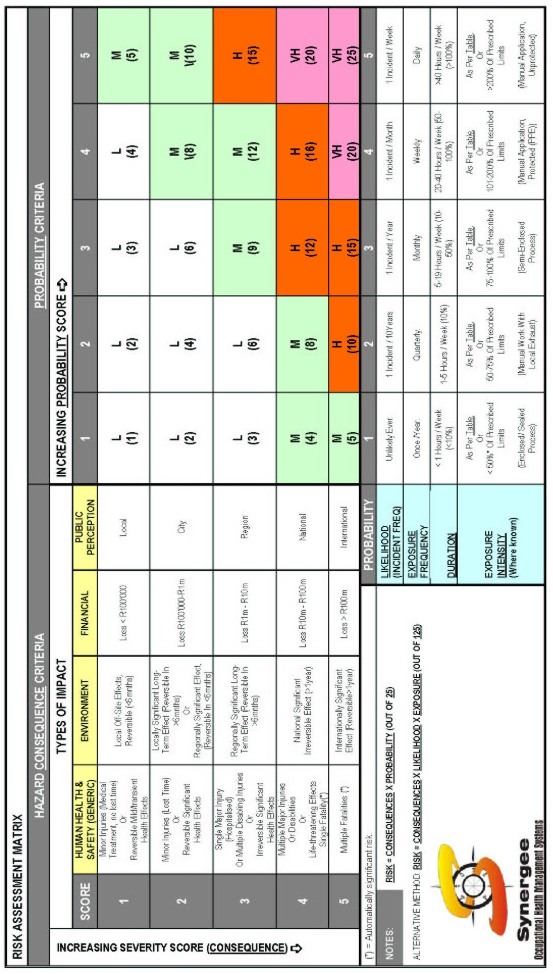
Appendix:5: Step-wise approach to Health Risk Assessment (Summary).
Step 1: Construct the OREPs.  This is conducted by the line staff, after receiving the appropriate training. Instructions are given in the SOP.  DATA FLOW  DATA FLOW | The Chemical data collected for the Chemical Toxicology Profile (SOP on Chemical Toxicology Profiling), is used in the OREP’s.  The Biological Hazard data collected for the Biological Hazards Profile (SOP on Biological Toxicity Profiling), is used in the OREP’s. | Step 2: Construct the HCS & HBA Risk Profiles.  Use this information to populate the toxicology elements in the chemical exposure and biological hazards sections of the OREPs. The toxicology information is used to provide the contents of the section on chemical exposures in the OREPs. Instructions are given in the SOP.
Step 3: Conduct Facility Walk-through’s.  Examine the processes, hazards and target groups by visiting the workplaces throughout the Company in a structured and systematic way. This information uses the information obtained in the OREPs, and verifies their validity. Instructions are given in the SOP.  DATA FLOW  DATA FLOW |  | Step 4: Construct the Risk Matrix:  The final HAZOC Matrix provides all the information to enable analysis and planning. This includes the following:  Hazard exposures, by occupations and Risk Areas  Group sizes, intended surveillance, etc.

