OH Programme Implementation Plan
Guideline Document
Table of Contents

1 INTRODUCTION 3
2 SCOPE 4
3 PURPOSE 4
4 OBJECTIVES (Steps) 4
4.1 Risk Assessment (Objective 1) 4
4.2 Programme Design: Occupational Hygiene (Objective 2) 5
4.3 Programme Design: Occupational Safety (Objective 3) 5
4.4 Programme Design: Occupational Medicine (Objective 4) 6
4.5 Communication (Objective 5) 6
4.6 Data Collection Preparation (Objective 6) 7
4.7 Programme Scheduling (Objective 7) 7
4.8 Programme Application (Objective 8) 8
4.9 Data analysis and Management Reporting (Objective 9) 8
5 RESPONSIBILITIES (IMPLEMENTATION PHASE) 8
5.1 Occupational Medical Team (these will vary according to circumstances): 8
5.2 Risk Officer 10
5.3 Industrial Hygienist (Approved Inspection Authority) 10

INTRODUCTION
Corporate health services are delivered by a team of diverse professionals, yet in an integrated manner. There are five main components:
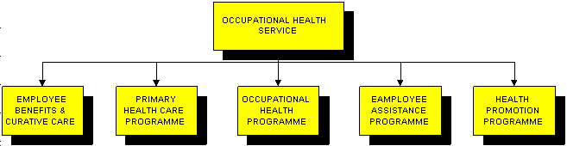

The SaftiCare Management System deals with the Occupational Health Programme component of the overall service.

The Occupational Health Programme is further comprised of:
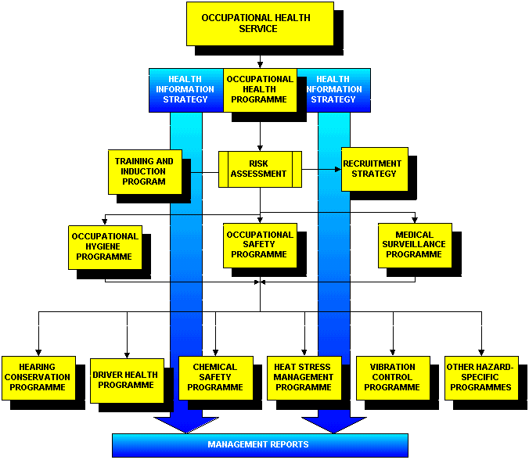
These sub-components of the Occupation Health Programme are described fully within each of their the Policy and Procedure Guideline documents. This document describes a suggested format for the implementation of the Synergee SaftiCare system, beginning with Risk Assessment, and ending with data analysis and recommendations.

SCOPE
The Implementation Plan is for all the employees involved in the Occupational Health Programme.

PURPOSE
The purpose of this document is to enable efficient implementation of the various components of the programme, with clear lines of function and accountability.

OBJECTIVES (Steps)
The implementation of the occupational health programme comprises two phases:
- Set-up Phase
- Operational Phase
The set-up phase comprises:
- Review of Company Policy and Procedure Documentation and Standards
- Health Risk Assessment (4 components)
- Design of Medical Surveillance and Occupational Hygiene Strategy
- Needs Analysis and Capex Provision
- Setting Time Lines and “Project Plan”
The operational phase comprises:
- Medical Surveillance programmes
- Occupational Hygiene surveys
- Data Analysis and Reporting
- Medical adjudication and remedial action

Let us look at this in more detail:

Risk Assessment (Objective 1)
- Construct a company organogram, down to individual job categories. This quantifies the task of covering every job category in the Risk Assessment.
- Conduct a Risk Assessment, as per the guideline document. In summary, cover the following aspects:
  - Occupational Risk Exposure Profiles (“OREPs”). Establish a process of data gathering that populates the required fields in the OREPs. One way is to use the OREP documents as input sheets to gather information by Job Category, as long as the Job Category comprises people with identical risk profiles. This process can be by interviews, completion of the sheets by the employees themselves (or by their supervisors). Input from Safety Reps is useful. For each hazard, the question should be asked – “what is the hazard score?”; and “what is the exposure score?”. The software will complete the equation that derives the risk score. Once the OREPs are completed, these should be reviewed and standardised (by the professionals in the Safety Team). This is an important phase, which sets an even standard for the scores, across the company.
  - Chemical Risk Assessment. This comprises establishing a chemical inventory for all the chemical substances to which employees are exposed. These are entered into the Synergee spreadsheet provided. The Occupational Health medical team should then review the MSDS records (or, if necessary, consult a credible toxicology database), and populate the relevant fields in the toxicology spreadsheet. The chemicals should then be linked to the job categories that are exposed to them, as described in the Toxicology SOP. Finally, the chemicals are risk-ranked for each job category, and the relevant chemicals are recorded on each job category’s OREP.
  - Workplace Risk Exposure Profiles (“WREPs”). This component comprises walk-throughs and a systematic examination of the working environment. Use the check-lists provided, and the instructions in the “WREPs” SOP.
  - Use the data collected for the OREPs and WREPs to populate the fields in the Risk Matrix.
Once the Risk Assessment Phase is complete, the various Occupational Health Programmes can proceed. These include Occupational Safety, Occupational Hygiene, Occupational Medicine, Education & Training, and Recruitment Policy design.

Programme Design: Occupational Hygiene (Objective 2)
Using the areas of highest risk as a guide, set a structured programme of measurement of the relevant hazards, such as noise, temperature, ventilation, dust and chemicals. Legal requirements will also dictate what requires measurement. For chemicals, use, as a guide, the list of hazardous chemical agents in tables 1 and 2 of the Hazardous Chemical Substances Regulations.
Ensure that an approved inspection authority conducts the measurements; otherwise the results carry no legal standing. The report should include practical solutions for mitigation of the risks of exposure.
The results of exposure are considered against the legal exposure limits (OELs). This information is fed back to the risk assessment, to verify or change the relevant exposure scores. It is important to bear in mind the limitations of hazard measurement – it is very difficult to establish with certainty, that a measured value is representative of the each exposed employee’s long-term exposure profile.

Programme Design: Occupational Safety (Objective 3)
Occupational Safety comprises a wide variety of disciplines. These have to be integrated into a working living process, with constant re-evaluation and feedback loops. Elements include:
- organisational structures and management accountability,
- safe work practices and lock-out procedures,
- equipment safeguarding
- preventative maintenance and housekeeping,
- fire prevention,
- incident investigation and reporting,
These form the key components of a wide variety of Safety Management Systems.

Programme Design: Occupational Medicine (Objective 4)
Whilst Occupational Medicine includes a wide variety of responsibilities, a primary function is the design and implementation of a Medical Surveillance Programme. This is a complex field, incorporating knowledge of the physiological effects of various hazards, an understanding of available clinical tools and their appropriate application, and skills in data analysis from which to make reliable inferences. Not only all this, but the programmes need to be appropriate to the context of the programme – the designer requires a good knowledge of the workplace for which the programme is intended.
The design of the Medical Surveillance Programme is simplified by the Synergee system. Using the information gleaned from the Risk Assessment, the elements which are required, include:
- Test Selection
- Standard Setting (standards of fitness)
- Test Frequency
This process, with supportive documentation, is detailed in the Guidelines for the design of Medical Surveillance Programmes. Once the tests are selected, the standards set (within reason), and the frequencies determined, this constitutes the final Medical Surveillance Strategy for the company.

Communication (Objective 5)
Communicate these conclusions to appropriate stakeholders by means of discussion forums, group meetings, presentations and standard letters. Some sort of agreement regarding the standards set in the OREPs should be resolved with employee representation, to obviate future industrial relation conflict.
Suspicions regarding confidentiality and job security should be overcome by open discussion, and, if necessary, formal policy. A sample of such a policy is available in the Policy Toolkit of the Starter Pack. A standard letter to the employees introducing the objectives and intent of the programme should be posted for public viewing and comment. A sample of such a letter is available in the Communications Toolkit of the Starter Pack.

Data Collection Preparation (Objective 6)
Spreadsheet templates exist for every conceivable Surveillance Programme. Using these, available in the Starter Pack, capture the core employee data (in the yellow sections) of the relevant worksheets. Ensure that all exposed employees are accounted for.
Examples include:
- Audiometric Screening Programme
- Driver-Operator Programme
- Chemical Worker Programme
- Dust Worker Programme

The spreadsheets are further divided into the following worksheets:  - Baseline (only in audiometry)  - Initial  - Periodic (labelled by year)  - Exit  - Casuals | For all of these worksheets (“datasets”), excepting the periodic tests, the list of names simply continues into perpetuity, thereby providing a growing dataset for each worksheet. Analysis of each of these datasets provides valuable information on each group.

The periodic tests are year-specific, and each year builds on the preceding one. Hence, at the end of each test cycle, the names of the current employees are to be copied into a new worksheet, retaining only the column of summary codes as well as the referral and compensation history. The outcome data (PFT, lab results, CXR, etc.) is removed, making blank spaces for the new cycle’s data. Important housekeeping on these periodic datasets at the end of each cycle is the removal of the names of those employees that have left (obtained from the “Exits” dataset), and the addition of the names of those that have arrived (obtained from the “Initials” dataset). This ensures that the new cycle’s list is current. The housekeeping that is more difficult, because it is dependant upon information from the company, is the transfer of employees from one job to another. Human Resource management policies are recommended to overcome this problem, whereby a clearance certificate is required by any employee to be transferred to any new occupation. This is particularly important when the OREPs have identified key inherent requirements associated with the particular occupation.

Programme Scheduling (Objective 7)
Using the templates available in the Starter Pack, plan the set-up phase and the subsequent programme action phases.
The year planner available in the pack is a useful tool for scheduling the wide variety of activities that comprise the various programmes for which the Occupational Health team is accountable.
This is a good time to prepare the employee health record documents. By this time, it is clear what the various elements of the programme will entail, so the appropriate templates can be drawn from the Starter Pack’s “Clinical Toolkit”. These are copied and kept in easily accessible places in the clinic, so that they can be used as employees arrive for their annual medicals. Every employee will require certain documents, such as the Medical Surveillance Summary (Holding) Sheets and the Initial Medical Evaluation sheets - casual (temporary) assistants can insert these into every folder in advance.

Programme Application (Objective 8)
The stage is set, and the programmes can proceed, in accordance with the time lines set in the year planner. It is understood that these will not always be followed exactly, given the demands and logistics of a busy work place. As the programme proceeds, the results of the medical tests and examinations are recorded in the appropriate spreadsheets. This comprises outcome data (“results”), as well as progress data (referral information, compensation submission information) and other information of relevance (in the “notes” section of the spreadsheets). The spreadsheets will provide an immediate and continuous statistical analysis of the progress (percentage complete) and the results.
The individual activities (audiograms, chest x-rays, examinations, etc.) are entered as they occur, and need not be all at once. The date of the medical should be recorded as the date when the last element of the WASP is completed for that individual, and the Summary Code is entered. (The “Summary Code” should only be entered when all the elements of the WASP are complete.)

Data analysis and Management Reporting (Objective 9)
The data that is subjected to scrutiny includes the Risk Assessment data as well as the outcomes of the various programmes. Medical Surveillance outcomes of interest are those that are work-related, especially those that are worsening. These can be analysed by departmental units, so that the responsibility for appropriate action is targeted directly at the managers for whom the information is relevant. Hierarchical management controls are thereby simplified, and accountability targeted with precision.
The Medical team should seek trends and signs of clustering. This is reliant on the accuracy of the demographic information in the spreadsheets.
The ultimate form of this level of data management, is the availability of this information on the company’s intranet (with access control on confidential elements of the information). In this form, all stakeholders will be able to track progress and analyse trends of interest at any time, with the reassurance that the information is current. Reliance on outdated and static management reports from the staff involved (such as the medical team), will reduce to interpretation and recommendations only.

RESPONSIBILITIES (IMPLEMENTATION PHASE)
Whilst it is understood that the circumstances at various companies will vary, with resultant shifts in responsibilities, the following provides a guideline. Taking into account the above, the roles of the various service providers would include:

Occupational Medical Team (these will vary according to circumstances):

Occupational Nurse Practitioner:
- Administration of the implementation phase – including:
  - Liaison with other stakeholders, ensuring the availability of the information required for WASP design
  - Document control, such as establishing the employee health record folders
  - Acquisition of employee lists from Human Resources
  - Programme scheduling
  - Maintenance of the integrity of the Starter Pack
- Risk Assessment, including:
  - Contributions to the OREPs
  - Walk-throughs, interviews, etc.
- Medical Screening
  - Performance of the screens (history, examination and special tests) as determined by skills, training and experience, and according to the WASP.
  - Data entry, in the absence of a data capture clerk, assuming the availability of a computer.
  - Data analysis

Occupational Medical Practitioner
- Risk Assessment, including:
  - Contributions to the OREPs
  - Review of toxicology.
- Medical Screening
  - Design of the Medical Surveillance Programmes (WASP design)
  - Performance of the relevant elements of the screens, according to the WASP.
  - Data analysis
  - Medical Adjudication

Risk Officer
- Risk Assessment, including:
  - Construction of the OREPs
  - Construction of the HAZOC matrix
  - Design and implementation of Risk Reduction strategies
  - Provision of the relevant information required by the medical team, from the Risk Assessment
  - Design and Implementation of the Occupational Safety Programme

Industrial Hygienist (Approved Inspection Authority)
- Hazard Measurement, including:
  - Reporting outcomes relative to relevant occupational exposure limits
  - Alerting to legal non-compliance
  - Recommendations regarding risk reduction

