GUIDELINE OF PHYSIOTHERAPY ASSESSMENT FOR CHILDREN WITH
CEREBRAL PALSY

ICF FRAMEWORK

Note in which area the child is experiencing the most problems. What are the connections between these elements?

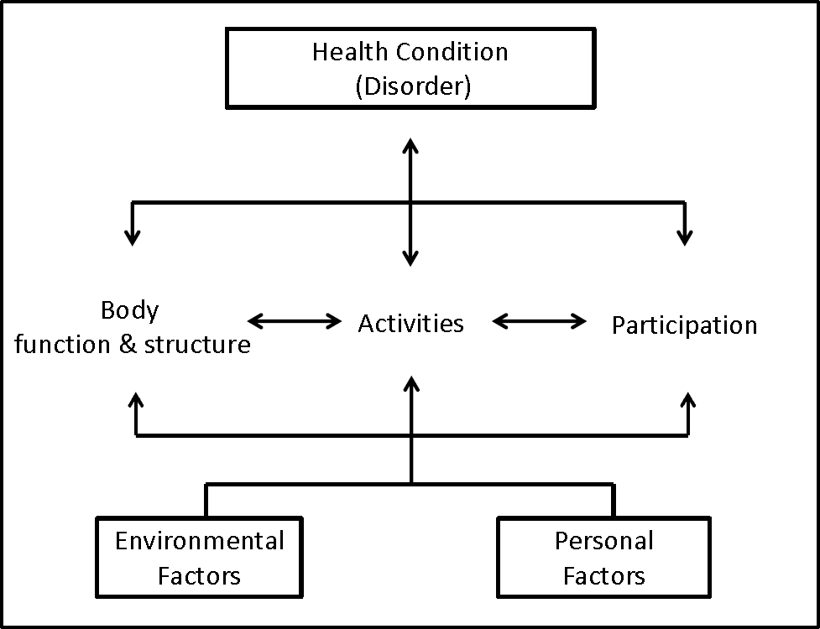
Figure based on Based on: World Health Organisation (WHO), 2001. International Classification of Functioning, Disability and Health, Geneva, pg 18.
Accessed online: http://www.disabilitaincifre.it/documenti/ICF_18.pdf

1. DEMOGRAPHIC DETAILS

NAME: ASSESSED BY:
DATE OF BIRTH: DATE OF ASSESSMENT:
AGE:
DIAGNOSIS:

From folder:
BIRTH HISTORY

SUBSEQUENT HISTORY

MEDICATION – type and what it is for

SURGERY – date and type

2. SUBJECTIVE ASSESSMENT

a. Impairments (only describe impairments relevant to the individual child)
- Mental function
- Sight, hearing
- Speech
- Feeding
- Pain
- Respiratory or cardiac function
- Continence
- Skin condition
- Activities
- Learning and applying knowledge
- Communication
- Self-care; dressing, bathing, brushing teeth
- Physical activity (highest level of activity, duration or distance?)
- Participation
- Domestic life (how he spends his day?)
- Interpersonal relationships
- Community and social life
- Environment
- Appliances
- Transport
- Accessibility in home (type of house, no. of rooms, no. of people sleeping per room, available amenities, space move around) and other areas
- Support of community and family involvement
- Services (disability and child support grant)

GENERAL OBSERVATION

How did child get to physiotherapy department?
Is child walking, in a buggy or wheelchair, using appliances?

Observe child undressing and comment

3. OBJECTIVE ASSESSMENT

a. Activity
START AT HIGHEST FUNTIONAL LEVEL!

If standing, assess POSTURE in standing, with appliances on.
If in a wheelchair, assess POSTURE in wheelchair (this is where he spends most of his time)

Describe and analyse FUNCTION IN HIGHEST LEVEL.
If ambulant, describe walking
Running
Jumping
Hopping left and right
Stair climbing
Throwing and catching a ball

Assess BALANCE in highest functional level, both static and dynamic.

Observe and describe how child moves to a lower functional level, eg. transitional movement from STANDING TO SITTING ON A CHAIR AND STANDING TO SITTING ON THE FLOOR AND BACK UP AGAIN.

Observe and describe how child gets into and out of HALF KNEELING, KNEELING and CRAWLING. Is child able to maintain these positions? Is he able to play in these positions? Describe type of play.

If the highest functional position is SITTING SUPPORTED IN A WHEELCHAIR, describe what child can do in this position. Can he reach and grasp an object? Can he hold a pen and write? Does he need help in getting out of wheelchair – how much assistance does he need?

Transfer child to the mat. Can he SIT UNSUPPORTED? If not, describe what is preventing him from doing so. Try LONG SIT, CROSS LEG SITTING, SIDE SITTING. What can he do in these positions, eg. maintain position with bilateral arm support, free one hand to reach or play, move out of these positions?

If child is unable to sit, position him in SUPINE. Describe function in this position. Can he reach symmetrically with both arms? Can he kick legs? Can he roll to SIDE LYING or PRONE?

In PRONE describe what he can do. Describe how he gets into PUPPY PRONE, can he maintain this? Can he lift his head? Can he free one arm and reach forward without collapsing on opposite side? Can he creep in this position, describe how. Can he move out of this position into SUPINE or CRAWLING POSITION? Describe this movement.

b. Impairments

CHEST CONDITION
Chronic productive cough

TONE
Describe tone in all affected muscle groups.

ROM
If full range of motion, document FROM.
If range is limited, you must measure limitation with goniometer and record accurately.

MUSCLE LENGTH
Note when muscle is shortened.

4. Review ICF Framework before analysing problems

5. PROBLEM LIST
Document FUNCTIONAL problems
Prioritise the most important problems and analyse completely, using the following table.

FUNCTIONAL MISSING UNDERLYING INTERVENTION INDICATOR
PROBLEMS COMPONENTS REASONS
Usually Usually Usually
activity or activity impairment
participation
restriction

6. SHORT TERM AIMS
Must be functional aims (likely to be achieved in the next few treatment sessions)

7. LONG TERM AIM
Think of ONE function you would like to improve in 6 months time.

8. SOAP NOTES
Including progress and any changes you need to make to your intervention plan.



Guideline of physiotherapy assessment for children with Cerebral palsy (ICF framework) by Prof. Jennifer Jelsma, Physiotherapy Division, Department of Health and Rehabilitation Sciences, University of Cape Town is licensed under a Creative Commons Attribution-NonCommercial-ShareAlike 2.5 South Africa License. Please see http://creativecommons.org/licenses/by-nc-sa/2.5/za/ for terms and conditions.
Source work available at vula.uct.ac.za
Permissions beyond the scope of this license may be available at www.healthedu.uct.ac.za or healthoer@uct.ac.za

