

**Student Portfolio Task**

**Looking through a human rights lens, use the Key as a tool for critical reflection**

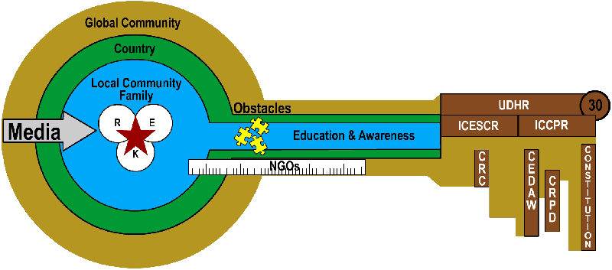

K: Knowledge 

E: Empathy

R: Reflection

NGOs: Non-Governmental Organizations

UDHR: Universal Declaration of Human Rights

ICCPR: International Covenant on Civil and Political Rights

ICESCR: International Covenant on Economic, Social and Cultural Rights

CRC: Convention on the Rights of the Child

CEDAW: Convention on the Elimination of All Forms of Discrimination against Women

## CRPD: Convention on the Rights of Persons with Disabilities

Briefly explore any 5 aspects of the Key relating to a clinical encounter

Below are some guidelines:

1. Community e.g. what facilitating and/or limiting factors impacted on the patient’s access to health care? How would you evaluate the quality of care?
2. Media influence e.g. have media messages shaped her/his health seeking behaviour?
3. Your developing professionalism e.g. consider how your knowing, empathic and reflective dimensions played out in the clinical encounter. How do you feel about the patient and yourself?
4. Education – what information was valuable to this client?
5. Relevant legal instruments – identify a legal document and a relevant Section e.g. from CEDAW
6. NGOs – name an NGO and contact details that could offer assistance and support
7. Obstacles – what constraining factors would you suggest impact on this person’s well-being / realization of her human rights?