**Developing the Key with students in their women’s health block in the Obstetric and Gynaecology Department, University of Cape Town.**

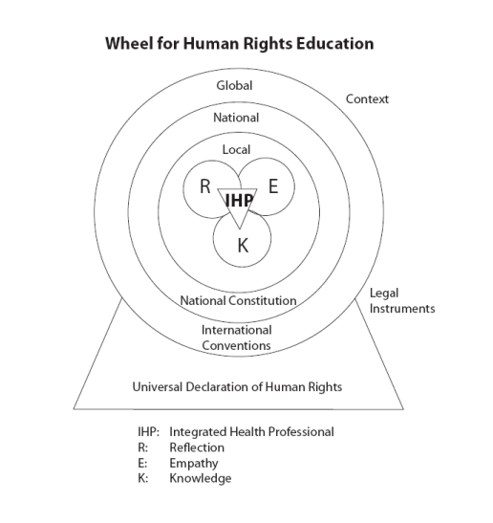

**2007**

**Describing** the Human Rights Wheel

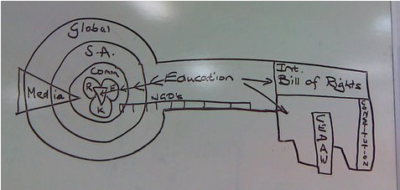

**2008**

Drawing a key on the white board

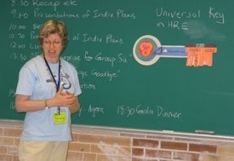

**2008**

Using paper templates

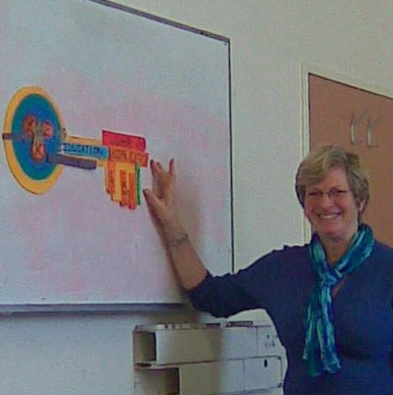

**2009**

Formalizing the templates

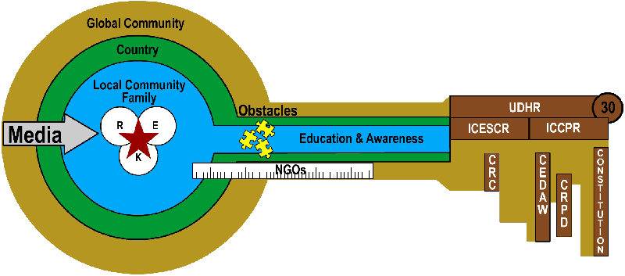

**2010**

Digitalizing the Key concept



**2011**

An extra dimension to promote student agency