

Case Study
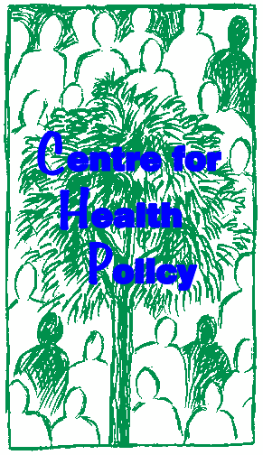

RESOURCE ALLOCATION TO REGIONS AND DISTRICTS
IN THE EASTERN CAPE PROVINCE OF SOUTH AFRICA

Di McIntyre

The Health Economic Unit, University of Cape Town, Cape Town, South Africa

Acknowledgement: This case study was prepared by the Health Economics Unit for the World Bank Institute as part of the Flagship Program on Health Sector Reform and Sustainable Financing.
This case study may be copied and used in any formal academic programme. However, it must be reproduced with appropriate acknowledgment of the author(s).

A. OBJECTIVES
• To demonstrate the process of resource allocation decision making;
• To develop a better understanding of equity in the geographic distribution of health care resources;
• To identify the indicators of relative need for health services that could be included in a resource allocation formula;
• To highlight the importance of identifying a realistic and appropriate time-frame for resource redistribution;
• To consider complementary actions needed to translate budgetary shifts into real redistribution of resources and health services on the ground.

B. BACKGROUND
Introduction to inequities in South Africa
South Africa has been described as one of the most unequal societies. Approximately 51% of annual income is attributable to the richest 10% of households (approximately 5.8% of the population) while less than 4% goes to the poorest 40% of households (approximately 53% of the population). There is also widespread poverty in South Africa. Poverty has a strong ‘racial’ dimension with 95% of the poor being African, and a geographic bias with 75% of the poor living in rural areas.

There are also marked inequities in access to social services within South
Africa. Disparities in access are particularly striking between the former
‘homelands’ areas and the rest of South Africa. In terms of the 1913 ‘Natives Land Act’, Africans (who account for about 76% of the South African population) were confined to living in ten ‘homelands’, which were highly fragmented geographic areas scattered throughout South Africa, and established along
‘tribal’ lines. These ‘homelands’ comprised less than 14% of the total surface area of South Africa. The ‘homelands’ were reincorporated within the nine new provinces established shortly before the 1994 democratic elections.

The extent of poverty and inequality in South Africa is thus largely attributable to apartheid policies, which fostered differential development of each ‘racial’ group. The government elected during the first democratic elections in 1994 has committed itself to implementing measures to reduce poverty and to redress the disparities in the distribution of income and social services.

While the political history of South Africa is unique, the disparities in access to social services are not. Differential access to health services, particularly between rural and urban areas, is a common phenomenon in many developing countries. This case study of one province in South Africa, the Eastern Cape, dramatically illustrates the challenges facing decision-makers when attempting to redress historical inequities in health service distribution.

Background to the Eastern Cape province
Approximately 65% of the Eastern Cape population live in rural areas and the overall population density is 39 per km2. Of South Africa’s nine provinces, the Eastern Cape is faced with the worst consequences of the apartheid era and has the most difficult task of reconstruction. This province has the task of unifying the wealthy, well-serviced areas of the former Cape province with two underdeveloped former ‘homelands’ (namely the Transkei and Ciskei). The

former Cape province areas contain some metropolitan areas, but mainly comprise small towns and large commercial farms. In contrast, the former Ciskei and Transkei are rural areas where the major activity is that of subsistence agriculture.

Health services in the Eastern Cape are provided by both the provincial Department of Health and by a range of local government structures. Historically, provincial departments have been responsible for curative primary care services (provided from mobile and fixed clinics and community health centres) and all hospital services. Local governments are responsible for preventive primary care services, communicable disease control and environmental health services. This situation has resulted in significant fragmentation of primary care services. In the former ‘homeland’ areas, local governments did not provide any health services. In these areas, primary care services are already integrated.

Each province in South Africa is given a global budget allocation from central government tax revenue. This is supplemented by revenue generated within the province (e.g. motor vehicle license fees, user fees at hospitals and school fees). The provincial legislature decides on the allocation of provincial resources to the various functions (e.g. health, education and housing). Local government health services are partially financed through subsidies allocated by the provincial Department of Health. This is supplemented by local government own revenue, in the form of rates, taxes and utility sales. The revenue generating potential varies greatly between different local governments, with those in metropolitan areas having the largest tax base.

There are significant disparities in health service access within the Eastern Cape, with a higher population to clinic ratio in the former ‘homelands’ relative to the former Cape province areas. The former Transkei has particularly poor health service infrastructure. Overall, there are 869 health facilities which render district-level health services. Over 36% of these health facilities are administered by local governments (318 facilities), while the Eastern Cape Provincial Department of Health administers the remainder. The state of these facilities varies. For example, while 46% of all primary care facilities in the Eastern Cape lack an adequate water supply, 82% of such facilities in the northern part of the former Transkei lack access to potable water.

The Eastern Cape Department of Health is in the process of developing a district health system. The province is divided into 5 regions and 21 districts. It is anticipated that district structures will facilitate greater co-ordination between, and ultimately the integration of, the primary care services provided by local governments and the provincial health department. It is proposed that there should be significant decentralisation of health service management to the district level. An important challenge for the provincial health department will be to ensure an equitable distribution of the provincial health budget between districts. This would promote equitable access to publicly financed health services for those dependent on the public sector for health care.

C. THE CURRENT DISTRIBUTION OF HEALTH CARE RESOURCES

Research team to consider resource allocation issues
A team from a South African university undertook a research project in collaboration with the Eastern Cape Department of Health. The aim of this research was to evaluate the existing distribution of public sector financial resources between health districts and regions, and to make recommendations on mechanisms for achieving an equitable allocation of these resources.

The Department of Health provided data on district-level health service expenditure (i.e. excluding specialist referral services) within each health district. The research team then calculated equitable resource allocation targets for each district, using a variety of needs-based formulae. These results were then presented to the provincial Department of Health, to assess which formula would be most appropriate for guiding resource redistribution within the province.

Results of resource allocation evaluation
The research team investigated the implications, in terms of the effect on equity target allocations, of using the following needs-based resource allocation formulae:
• A crude capitation formula, based on the total size of the population in each district;
• A formula which weighted the district populations to reflect their demographic composition (i.e. by taking account of the differential need to use health services between different age and sex groups);
• A formula which also weighted the population to reflect differential levels of ill-health (using mortality as a proxy measure) between districts; and
• A formula which accounted for differential access to private sector services (as the objective is to ensure equitable access to public sector health services for those who are dependent on the public sector, it could be argued that the population who utilises private sector health services should be excluded from the district population).

A further adjustment was to take local government own revenue into account. This is based on the proposition that the provincial health department should allocate relatively less of its budget to districts containing a local government which can generate significant revenue for primary care services.

Figure 1 summarises this analysis for the 5 regions in the Eastern Cape. It illustrates the effect of weighting the baseline population by various indicators of need. Each bar indicates how far the particular region’s current expenditure is from its ‘equity target’ allocation (which is based on the average weighted per capita expenditure for the province, and is represented in the graph by 0), when taking different needs-based factors into account.
Resource allocation to Regions and Districts in the Eastern Cape

Figure 1: Effect of weighting the population for different needs-based indicators and accounting for local government own revenue

Difference between actual expenditure and equity target as % of equity target allocation
80

65

Unweighted Population

W eighted for Age/Sex

60 W eighted for Age/Sex & Mortality
52

40
32

24 24

20

12 13 11 11
9

14 16 15

4 5

W eighted for Age/Sex, Mortality &
excluding private

Full weighting & adjusting for local government

0
-3 -2

-20
-11

-16

-20

-40

-60
-37 -39

-44

-48

-51

REGION A REGION B REGION C REGION D REGION E

Di McIntyre, Health Economics Unit, University of Cape Town 4

Figure 1 indicates that there are significant inequities in the current distribution of district level health care expenditure. In particular, Region A is substantially over-resourced, relative to the health needs of the population in that region, while Region E is significantly under-resourced. Unsurprisingly, Region A contains a metropolitan area while Region E includes the northern areas of the former Transkei (which is mainly rural). The addition of various indicators of health need in weighting the population tends to make these inequities starker.

Table 1 highlights the inequities in current resource allocation between health
districts.

Table 1: Difference between actual expenditure and equity target allocations for health districts (using population weighted for age/sex, mortality, excluding private and adjusting for local government own revenue)

Health districts and regions | Difference between actual expenditure and equity target as % of equity target allocation
Port Elizabeth | 69
Uitenhage | 76
Graaff Reinet | 71
Humansdorp | (4)
REGION A | 65
Queenstown | 5
Cradock | 66
Aliwal North | (14)
Elliot | 46
REGION B | 9
East London | 59
King Williams Town | 39
Butterworth | (50)
Fort Beaufort | 3
Grahamstown | 166
REGION C | 15
Umtata | 7
Libode | (37)
Mqanduli | (47)
Qumbu | (20)
REGION D | (20)
Flagstaff | (44)
Mount Frere/Kwabacha | (64)
Maluti | (77)
Umzimkulu | (2)
REGION E | (51)

The regional level analysis (Figure 1) provides an aggregated and deceptive picture of inequities. This is attributable to the fact that inequities within a region are obscured as relatively under- and over-resourced districts tend to compensate for one another. For example, while the difference between the current expenditure and the equity target allocation in Region C is only 15%

above the equity target, one district within the region is 166% above its equity target while another is 50% below its equity target allocation. Thus, inter- regional resource differences range from 65% above the equity target to 51% below the equity target (see Figure 1), in contrast to the inter-district resource differentials which range from 166% above to 77% below the equity target level (see Table 1).

D. PROBLEM STATEMENT AND QUESTIONS TO CONSIDER Stage 1
You are a senior provincial Department of Health official who has been
appointed to a task team to decide on the allocation of the global provincial health budget between districts. When briefing this Resource Allocation Task Team (RATT), the Minister of Health for the province indicated that she is concerned that historical inequities in the distribution of health resources should be redressed. She is particularly concerned that the enormous backlogs in health services in the former ‘homeland’ areas (particularly the former Transkei) should be addressed as soon as possible. However, she also emphasised that the Eastern Cape health budget is not increasing in real terms and would be reluctant to ‘rob Peter to pay Paul’.

The university research team is requested to make a presentation of their findings to the RATT. They argue that the most appropriate resource allocation formula to use is the one that weights the regional population for demographic composition and mortality, which excludes the population who use private sector services and which takes local government own revenue into account.

They urge the task team to take bold steps to redistribute financial resources between regions and districts. They suggest that the major focus should be on a relative redistribution of resources from Region A to Region E. Within the other 3 regions, the major challenge will be to achieve a relative redistribution of resources between districts within each region.

The research team has also modelled the implications for the pace of change of using different time-frames for achieving an equitable allocation of resources. This modelling indicates that the average annual decrease for over-resourced districts would need to be -6.9% while the average annual increase for under-resourced districts would need to be 12%, if redistribution is to occur within 5 years and if there is no real increase in the provincial health budget. If the time-frame for redistribution was set at 8 years, the average annual decrease for over-resourced districts would be -4.4% and the average annual increase for under-resource districts would be 7.3%.

The research team stresses that these are average rates of change, and that those districts which are far from their target allocations would require more rapid budgetary decreases or increases. For example, if all districts were to reach their equity target allocations within 5 years, the Maluti district would require an average annual real budgetary increase of nearly 35% and the Mount Frere/Kwabacha district would require annual increases of about 23%.

In contrast, the Grahamstown district would be faced with real annual budgetary cuts of nearly -18% per year.

At the end of the researchers’ presentation, a member of the RATT questions the research team’s alternative pace of change scenarios. He highlights the fact that during the resource allocation process in England, there was a
‘ceiling’, or maximum rate of annual real growth, of 5% for regions spending below their equity targets. The ‘floor’, or maximum rate of annual real budget cuts, was set at -2.5% for regions spending above their equity targets. He suggests that these ‘ceilings’ and ‘floors’ should be used in the Eastern Cape.

A member of the research team responds by highlighting the fact that the resource disparities in South Africa (and particularly in the Eastern Cape) are much greater than those that existed in England. Thus, less stringent floors and ceilings are required if equity is to be achieved within an acceptable time frame. She indicates that it would take about 50 years to achieve the equity targets in certain districts if the English ‘ceilings’ and ‘floors’ are used. She concludes by suggesting that the pace of change within a particular country should be based on the extent of existing resource differentials and on what key stakeholders regard as an acceptable time period for redistribution.

The RATT convenor suggests a recess in the meeting and requests the research team to do some additional modelling using longer time-frames. Within 30 minutes, the research team (who are never without their laptop computers) is able to report that the maximum annual budget increase would need to be 10% and the maximum annual budget decrease would need to be
-6% if equity targets are to be achieved within 15 years. If the time-frame was set at 20 years, the maximum rates of change would need to be 8% and -5% per annum for under- and over-target districts respectively.

The researchers are thanked for compiling the relevant information and for their helpful recommendations on resource allocation mechanisms. They are excused from the meeting, and the RATT members remain behind to consider what approach they should adopt. The RATT convenor suggests that they should consider the following issues:
• Which of the alternative formulae would be most appropriate for guiding the resource allocation process in the Eastern Cape (given that disparities appear greater when various needs-based factors are used to weight the regional and district populations and when private sector users are excluded from the baseline population)? You should try to reach consensus and be able to justify your preference.
• Should differences in local government own revenue contributions to district-level health services be taken into account when considering the allocation of the provincial health budget and why / why not?
• Are there other factors which should be taken into account when determining equity target allocations and if so, what are these factors?
• Given that there is unlikely to be a real increase in the global provincial health budget in the foreseeable future, and given the Minister’s dual concerns (i.e. to address backlogs rapidly but not to ‘rob Peter to pay

Paul’), what time-frame for achieving equity targets would be desirable and realistic? You should justify your decision.

Stage 2
On the basis of these discussions, the RATT had to propose an approach for resource allocation within the province. In particular, they had to reach consensus on the maximum annual rate of increase and decrease which districts can expect in their budgets. This information is conveyed to the regional and district offices. Regions are also informed of their budget for the next financial year, which has been determined on the basis of the ‘ceilings’ and ‘floors’ set by the RATT. The Director for Region A has many sleepless nights after he is informed that his budget will be cut drastically, while Region E’s Director also has sleepless nights trying to decide how to use the additional money which will be allocated to his region.

The regional Directors are invited to a meeting at the provincial Head Office to present their plans for accommodating their respective budget increases or decreases to the RATT. Region A’s Director arrives with all his district managers and a number of other eloquent regional stakeholders. The Director of Region E is only accompanied by his Deputy-Director (who was appointed a month before the meeting). No one else in his region was able to attend the meeting.

Region A’s Director hands out a 10-page document which provides extensive details of their recurrent expenditure requirements, given the existing service infrastructure. In addition, he makes a well-motivated presentation using overheads. He makes an impassioned plea for an additional budget allocation, and argues that many residents of other regions come to use health services in his region. He also points out that the majority of recurrent expenditure is attributable to staff and that he is not allowed to retrench staff. How can the province expect him to absorb such a large budget cut?

In contrast, the Director for Region E has not had much opportunity to prepare his presentation. He argues that his region needs even more resources than the RATT has allocated to it. The members of RATT are taken aback and ask for a motivation for this request. The regional Director indicates that his office believes that their current expenditure levels are actually higher than the provincial Head Office suggests. This is based on the fact that a considerable number of staff, particularly in management posts, have been seconded to his region from other areas. Their salaries are thus not reflected on his region’s accounts but are costs incurred in providing and managing services in his area. Once people are appointed on a full-time basis to posts currently filled by seconded staff, the additional budget allocation will be completely absorbed. This leaves little scope for actually expanding service provision. However, the regional Director is unable to provide data to substantiate these claims.

A member of the RATT then asks the regional Director what the additional budgetary resources, if granted, would be used for. The Director responds:

“The money would be used for buying motorcycles to provide mobile health services in small rural settlements.” Another RATT member follows up by asking how many motorcycles would be purchased and at what cost. There is a hasty consultation between the regional Director and his deputy. “We think about 10 would be sufficient, but we haven’t been able to determine the unit cost yet” responds the Director. “These motorcycles won’t account for the entire additional budget allocation you are requesting”, comments the RATT convenor. “What other plans do you have.” There is more consultation between the Director and his deputy. “We haven’t had time to develop a detailed plan yet; we received very short notice about this meeting” explains the Director.

The RATT convenor indicates that the team will consider all of the regional Directors’ submissions, and that the final decision on budget allocations will be conveyed to the Directors within a fortnight. He requests that those regions that have not submitted detailed written plans and budgets do so within 2 days. The meeting is concluded with words of thanks to all participants.

The RATT holds another meeting 3 days later to determine the final regional budget allocations. The provincial Minister must then approve these allocations. Region E has still been unable to submit a written plan and budget by this stage. The RATT convenor suggests that they should consider the following issues:
• What factors contributed to the inability of Region E to submit a detailed plan and budget, and are these factors likely to impact on the ability of this region to absorb budgetary increases? If so, in what way?
• Given the verbal (and in some cases written) submissions of the regional Directors, should the RATT reconsider their time-frame for, and hence the pace of, resource redistribution? If so, what time-frame should be selected and why? If not, why not?
• As the major reason that the budgetary cuts in relatively over-resourced districts and regions are so large is that the provincial budget is not expected to increase in real terms, are there additional sources of finance for provincial health services to ease the burden of redistribution? If so, what are these sources?
• What additional steps should the RATT take to facilitate the implementation of the resource redistribution process, to ensure that financial and other resources are actually reallocated on a geographic basis without significantly disrupting existing health services (i.e. to assist regions and districts in overcoming absorptive capacity constraints)?

This work is licensed under a
Creative Commons Attribution-NonCommercial-ShareAlike 2.5 South Africa License
December 2011
You are free:
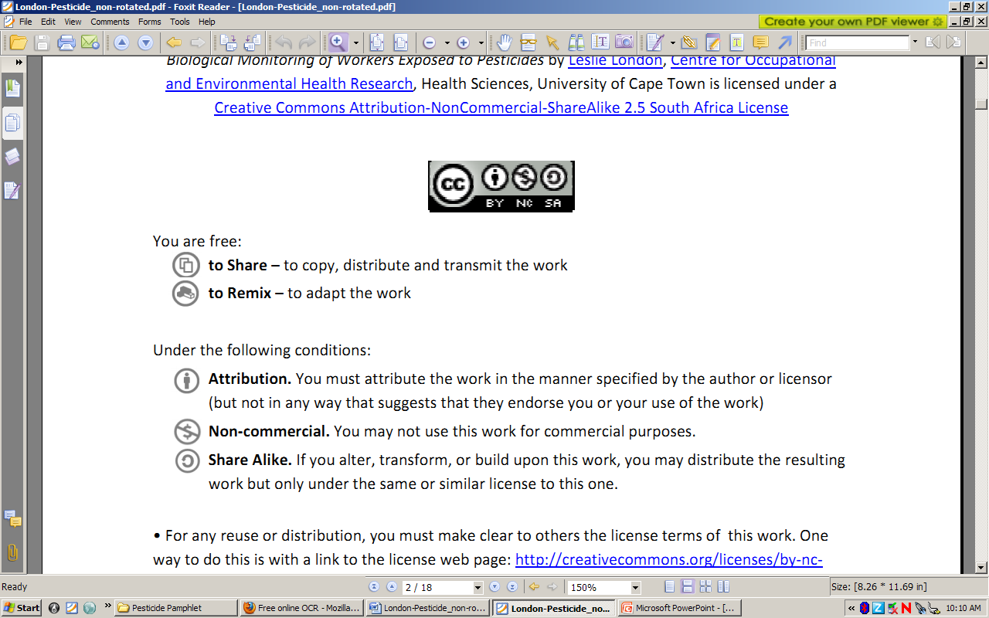to Share – to copy, distribute and transmit the work
to Remix – to adapt the work
Under the following conditions:
Attribution. You must at attribute the work in the manner specified by the author or licensor (but not in any way that at suggests that they endorse you or your use of the work)
Non-commercial. You m may not use this work for commercial purposes.
Share Alike. If you alter, transform, or build upon this work, you may distribute the resulting work but only under the same or similar license to this one.

• For any reuse or distribution, you must make clear to others the license terms of o this work. one way to do this is with a link to the license web page: http://creativecommons.org/licenses/by-nc-sa/2.5/za

• Any of the above conditions can be waived if you get permission from the copyright holder.
• Nothing in this license impairs or restricts the authors’ moral rights.
• Nothing in this license impairs or restricts the rights of authors whose work is r referenced in this document.
• Cited works used in this document must be cited following usual academic conventions
• Citation of this work must follow normal academic conventions

Source work available at Vula. Permissions beyond the scope of this license may be available at
www.healthedu.uct.ac.za or contact healthoer@uct.ac.za
We would appreciate your feedback for this Open Educational Resource (OER), by completing this form. Alternatively, you can email us at healthoer@uct.ac.za

