


COUNTRY GROUP EXERCISE

SOCIAL HEALTH INSURANCE DEVELOPMENT: STAKEHOLDER ANALYSIS

Lucy Gilson

Centre for Health Policy, University of Witwatersrand

This case study may be copied and used in any formal academic programme. However, it must be reproduced with appropriate acknowledgement of the author(s). Centre for Health Policy/Health Economics Unit

1. OBJECTIVES

• To undertake a stakeholder analysis focussing on SHI
development/implementation in the participant countries
• To identify strategies that can be applied in taking the next step in SHI
development within each country
• To identify critical information needed to finalise strategy development within each country
• To seek a common understanding amongst the different actors within the participant country groups of their own objectives and concerns in relation to SHI development, as a foundation for relevant action on returning home.

2. STRATEGY:

(Morning)
Step 1: Identify a chairperson, timekeeper, poster writer and rapporteur for your group. Review the steps outlined below to clarify the roles of these different people.

Step 2: Consider the outline country scenarios presented in section 2, and identify the one that is closest to your country’s current situation. If necessary, identify a few key adaptations of the scenario.

Step 3: Only for the specific scenario you have chosen, work through the sets of questions outlined in section 4, using the accompanying tables and information. You have a total of around 2.5 hours for discussion of all sets of questions and completion of your poster (step 4).

• Work quickly through question set 1 – give yourselves a maximum of around 20 minutes on table 1.
• Then move on to questions sets 2 and 3 (set 3 will probably take less time than set 2).
• Finally move on to question set 4: these are the most important set of issues to tackle (allow about 1 hour for these questions alone).

Please plan your time carefully so that you give time to each set of questions. If necessary, consider fewer actors in relation to the earlier questions to speed your discussions up. Please leave enough time (maximum 15 minutes) to finalise your poster (step 4).

Step 4: From your discussions prepare a brief poster using your completed tables, giving particular attention to your group’s discussions of question set 4.

(Mostly after lunch – maybe start before lunch if possible)
Step 5: Review of group posters:
• 10 mins presentation per poster to plenary, focussing primarily on question set 4 (1 hour).
• Detailed discussion of one set of posters in small groups for 30 mins.
• Detailed discussion of remaining set of posters for 30 mins. Step 6: Key issues and wrap up:

• Each person to identify one thing they will take away from the session.
• Facilitator to wrap up the session overall.

3. COUNTRY SCENARIOS

Choose one of the following scenarios as most relevant to your own country.

A. Little attention so far given to SHI as a financing policy option for the country, except, perhaps, some very early discussions – in the context of a health system in which there is little or no private sector provision of either primary and hospital care, and little or no private insurance

B. Little attention so far given to SHI as a financing policy option for the country, except, perhaps, some very early discussions – in the context of a health system in which there is both some private sector provision of both primary and hospital care and some private insurance coverage

C. A broad outline SHI proposal on the table and discussions are moving towards developing an implementation strategy -- in the context of a health in which there is limited private sector provision of both primary and hospital care, but little or no private insurance

D. A broad outline SHI proposal on the table and discussions are moving towards developing an implementation strategy -- in the context of a health system in which there is both some private sector provision of both primary and hospital care and some private insurance coverage

E. Plans for an SHI scheme are well-developed and moving towards implementation, but there is both some support and some continuing caution/opposition amongst key actors about the specific proposal on the table.

4. SPECIFIC TASKS AND QUESTIONS BY SCENARIO

Only complete the tasks for your selected country scenario!

For scenario A and B:
Imagine that you are members of a national task team in your country, and you have been asked to outline an initial proposal for SHI development.

1. Using Table 1:
• Who are the key actors that need to be considered in initiating discussions, as well as developing the goals and broad outline of the SHI scheme? Don’t forget yourselves!
• Other than yourselves, who are the 3-4 most important other actors for you to consider at this stage of SHI development?

2. Using Table 2 and only considering yourselves and the most important other actors:
• What are your own objectives in SHI development and what are the probable objectives of those of other most important actors?
• For each of you, what are your different levels and sources of influence?

• For which actors do you simply not have enough information at present to answer these questions fully and fairly?

3. Using Table 3:
• Locate yourselves and the other most important actors identified in Table 2 on the forcefield analysis table (i.e. simply write in actor names in relevant cells):
• Who is likely to be more or less supportive of initiating SHI discussions?
• Who is likely to be cautious and maybe even oppose such discussions?
• For which actors do you simply not have enough information at present to answer these questions fully and fairly?

4. Using Tables 2, 3 and 4:
• How can you get more information to better understand those actors about whom you currently don’t know enough?
• Identify and explain a maximum of 3 strategies both for developing alliances of support for initiating SHI discussions and moving ahead in developing an outline proposal, and for offsetting possible opposition to SHI discussions?

For scenario C and D:
Imagine that you are members of a national task team in your country that has been tasked with taking forward planning for implementing the current SHI proposals.

1. Using Table 1:
• Who are the key actors that need to be considered in taking forward discussions on how to implement the proposed SHI scheme? Don’t forget yourselves!
• Other than yourselves, who are the 3-4 most important other actors for you to consider at this stage of SHI development?

2. Using Table 2 and only considering yourselves and the most important other actors:
• Which, if any, among you have so far been involved in preparing these proposals?
• What are your objectives in relation to these proposals?
• Is everyone within your task team (country group) comfortable with the proposals and the objectives of those who have prepared them? If not, who is not comfortable and why not?
• What are the likely objectives of the other 3-4 most important actors in relation to SHI development, and do their objectives match the proposed SHI objectives/design?
• What are the different levels and sources of influence of yourselves and the other important actors?

3. Using Table 3:
• Locate yourselves and the other most important actors identified in Table 2 on the forcefield analysis table (i.e. simply write in actor names in relevant cells):
• Who is likely to be more or less supportive of taking forward the current SHI
proposals?
• Who is likely to be cautious and maybe even oppose these proposals?

4. Using Tables 2, 3 and 4:

• Can you work through any differences amongst your task team (country group) concerning the current set of proposals? How? If not, what 1-2 strategies will you apply to tackle these differences?
• Given the support and caution (or even opposition) of other actors, identify and explain a maximum of 3 strategies that you will use both to develop alliances of support for initiating the discussions and moving ahead in developing an outline proposal, and for offsetting potential opposition.

For scenario E:
Imagine that you are all members of a national task team in your country that has been tasked with implementing the current SHI proposal.

1. Using Table 1:
• Who are the key actors that need to be considered now in implementing the proposed SHI scheme? Don’t forget yourselves!
• Other than yourselves, who are the 3-4 most important other actors for you to consider as you move towards implementation?

2. Using Table 2 and only considering yourselves and the most important other actors:
• Which, if any, among you have so far been involved in preparing the SHI plan?
What are your objectives in relation to this plan? Is everyone within your task team (country group) comfortable with the plan and the objectives of those who
have prepared it? If not, who is not comfortable and why not?
• What are the likely objectives in relation to SHI development of the other 3-4 most important actors, and do their objectives match the SHI objectives/design?
• What are the different levels and sources of influence of yourselves and the other important actors?

3. Using Table 3:
• Locate yourselves and the other most important actors identified in Table 2 on the forcefield analysis table (i.e. simply write in actor names in relevant cells):
• Who is more or less supportive of implementing the SHI plan?
• Who is (likely to be) cautious or even to oppose these proposals?

4. Using Tables 2, 3 and 4:
• Can you work through any differences amongst your task team (country group) concerning the current set of proposals? How? If not, what 1-2 strategies will you apply to tackle these differences?
• Given the support and caution (or even opposition) of other actors, identify and explain a maximum of 3 strategies that you will use both to develop alliances of support for initiating the discussions and moving ahead in developing an outline proposal, and for offsetting potential opposition.

TABLE 1: IDENTIFYING ACTORS
ACTOR GROUP | KEY ACTORS IN YOUR COUNTRY WITH REAL POTENTIAL TO INFLUENCE SHI DEVELOPMENT
POLITICAL SECTOR

e.g President/Prime Minister, Minster of Health, other powerful politicians, parliamentary committees
GOVERNMENT SECTOR

e.g. different groups/people within national health ministry, middle-level health managers, frontline health workers, ministry of finance/planning, ministry of labour, ministry of public service
BUSINESS SECTOR

e.g. employers, insurance companies, private providers
SOCIAL SECTOR

e.g. trade unions, health sector professional organisations, civil servant organisations, lobbying/advocacy groups
NON-GOVERNMENT ANALYSTS

e.g. university groups, consultancy groups, technical assistants
DONORS

e.g. in-country agency representatives, agency headquarters

TABLE 2: STAKEHOLDER ANALYSIS
ACTOR (name each actor) | SHI INTERESTS | LEVEL/SOURCE OF INFLUENCE
Yourselves: Actor 1 =
Yourselves: Actor 2 =
Yourselves: Actor 3 =
Actor 4 =

Actor 5 =
Actor 6 =

TABLE 3: FORCEFIELD ANALYSIS
 | Proponents |  |  | Opponents
 | high support | << << | not mobilised | >> >> | high opposition
political sector
government sector
business sector
social sector
non-government analysts
donors

TABLE 4: STRATEGIES TO SUPPORT SHI DEVELOPMENT/IMPLEMENTATION

In developing strategies think about how to:
• redefine the goals of actors so that they are more likely to support the policy action
• redefine the way people understand the proposed policy action so they are more likely to support it
• mobilise an existing actor to support the policy action
• enhance the power of an existing actor in support of the policy action
• strengthen alliances among actors in support of the policy action
• directly block the power of actors opposed to the policy action

Nineteen possible strategies for working with actors

1. Create Common Ground1:
• seek common ground with other organisations, identify common interests, link different interests – invent new options, make decisions for opponents easier.
2. Create a Common Vision1:
• keeping in mind that the principal obstacles to reform are not only technical: create an atmosphere of shared values, unified leadership, articulate a common vision of equity and the respective roles of the public and private sectors
3. Define the Decision Making Process (around a particular reform)1:
• formalise who does what in making a decision and who approves what type of decision, legalise formal processes if relevant
4. Mobilize and Prepare Key Actors for their Roles in Reforms Debates1:
• identify who can take leadership positions and provide them with appropriate information, who can influence support/opposition by taking a strong and clear position and provide them with appropriate information, the most critical issues for discussion and focus debate on them.
5. Meet with Political Parties1:
• meet with politicians and their technical staff, attempt to integrate health reform policies and specific policy ideas into political debate and discourse, identify their specific concerns on reforms and seek to offset them through technical argument and debate
6. Initiate Strategic Communications1:
• initiate strategic contacts with the press, respond to attacks on reforms immediately, feed information and technical findings to the press, place key decision-makers in the media
7. Initiate Pilot Studies1:
• select pilot study sites according to technical and political exigencies, focus pilot study work on issues critical to technical understanding and/or political support, preserve neutrality of those involved in pilot study to maintain integrity of findings
8. Manage the Bureaucracy1:
• involve different groups in designing reforms, and in developing implementation strategies
9. Strengthen Alliances with International Organisations1:
• request technical-political assistance from international financial institutions and other donors in order to respond to criticisms of reforms, work together with supportive donors in some areas, ask for donor support for vision of reform and define their active participation in influencing key actors in the health sector
10. Involve ‘Friends’ in Planning1:
• hold informal consultations with ‘friends’ of the reform on the sequencing of actions and political strategy, bring together key ‘friends’ to formulate specific agendas in some reform areas

11. Create Strategic Alliances1:
• create alliances with key actors not usually involved in health sector policy debate
(e.g. unions, NGOs etc)

12. Use Backdoor Channels2:
• by-pass formal procedures and meet with those in power to try and influence the development of reforms and/or gain useful information about the future course of events for use in their own activities.
13. Establish Independent Commission of Inquiry To Create Support2:
• identify relevant ‘experts’ whose opinions and views will be valued publicly to sit on Commission, establish balance between declared supporters and opponents of reform in Commission membership to maintain neutrality and independence of Commission, provide technical support to Commission to gather additional ideas and/or generate additional analysis, create link between Commission and ‘policy champion’ within government
14. Establish Independent Commission of Inquiry To Block Opposition2:
• establish balance between declared opponents and supporters of reform in Commission, delay consideration of Commission report/findings after publication until no longer newsworthy
15. Establish Parallel Processes During Formal Commissions2:
• use informal parallel processes to gain guidance from constituencies on positions to take in debates, and/or to generate information to feed into debates
16. Use Technical Information to Offset Opposition2:
• identify key arguments of opponents to reform, undertake technical analysis to offset their arguments
• use technical analysis to support alternative line of policy development, feed technical analysis into relevant decision-making processes, make technical analysis widely available to policy-makers, media etc.
17. Divide and Rule2:
• put ‘high bid’ policy document forward for debate, through reactions to ‘high bid’ document, identify lukewarm opponents and hard core opponents, isolate hard core opponents by developing a detailed policy design that offsets the concerns of lukewarm opponents, proceed with policy implementation with support of previously lukewarm opponents
18. Mobilising a Third Party2:
• seek to bring a potentially powerful but as yet unmotivated actor into the debates to support own position
19. Create Tailored Information for the Public and Policy Leaders2
• tailor policy information to different target audiences to seek their support and to influence their understanding

Sources:
(1) Glassman A. et al. (1999) Political analysis of the health reform in the Dominican
Republic Health Policy and Planning 14(2): 115-126;
(2) Gilson L. et al. (1999) The Dynamics of Policy Change: Health Care Financing n South Africa, 1994-99. Monograph No. 66, Johannesburg: Centre for Health Policy, University of Witwatersrand/ Cape Town: Health Economics Unit, University of Cape Town.

This work is licensed under a
Creative Commons Attribution-NonCommercial-ShareAlike 2.5 South Africa License
December 2011
You are free:
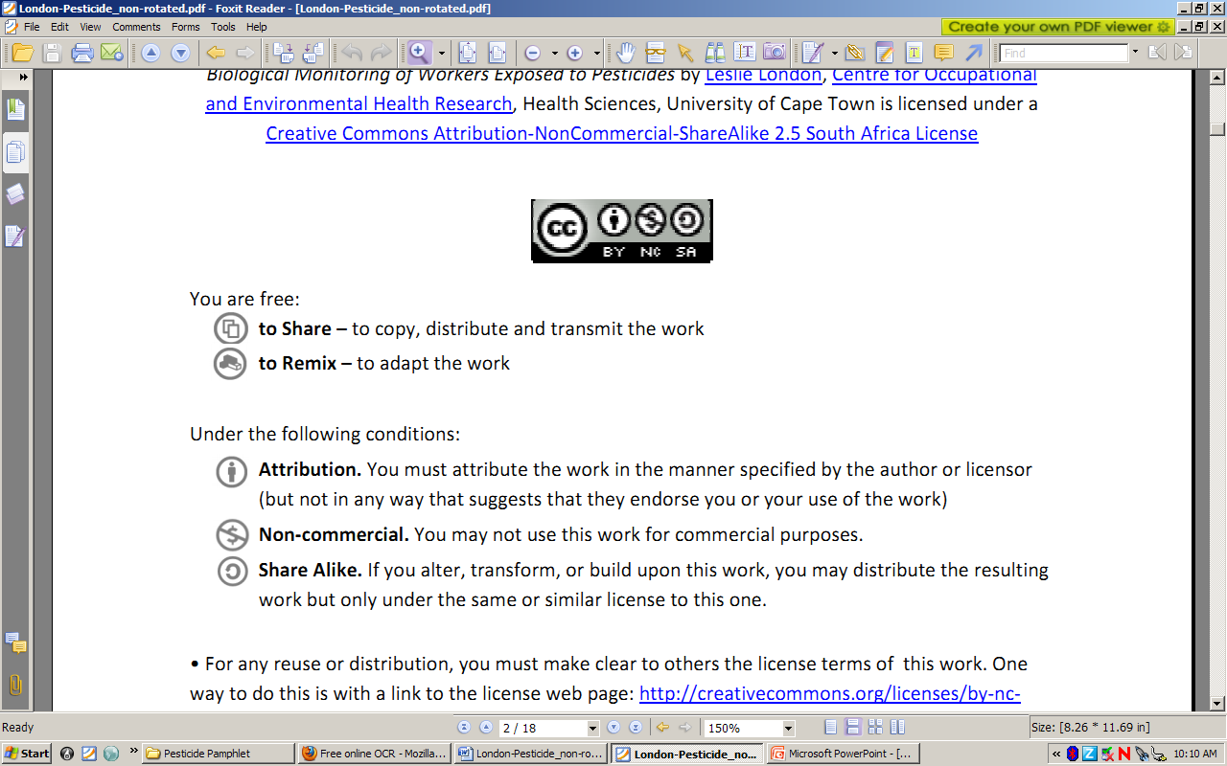to Share – to copy, distribute and transmit the work
to Remix – to adapt the work
Under the following conditions:
Attribution. You must at attribute the work in the manner specified by the author or licensor (but not in any way that at suggests that they endorse you or your use of the work)
Non-commercial. You m may not use this work for commercial purposes.
Share Alike. If you alter, transform, or build upon this work, you may distribute the resulting work but only under the same or similar license to this one.

• For any reuse or distribution, you must make clear to others the license terms of o this work. one way to do this is with a link to the license web page: http://creativecommons.org/licenses/by-nc-sa/2.5/za

• Any of the above conditions can be waived if you get permission from the copyright holder.
• Nothing in this license impairs or restricts the authors’ moral rights.
• Nothing in this license impairs or restricts the rights of authors whose work is r referenced in this document.
• Cited works used in this document must be cited following usual academic conventions
• Citation of this work must follow normal academic conventions

Source work available at Vula. Permissions beyond the scope of this license may be available at
www.healthedu.uct.ac.za or contact healthoer@uct.ac.za
We would appreciate your feedback for this Open Educational Resource (OER), by completing this form. Alternatively, you can email us at healthoer@uct.ac.za

