

Exercise
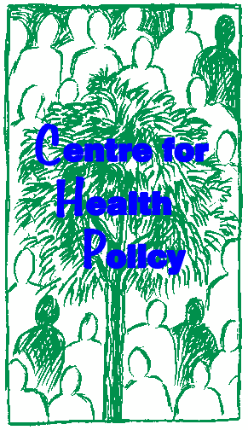

STAKEHOLDER ANALYSIS EXERCISE

Lucy Gilson

Centre for Health Policy, University of the Witwatersrand

This case study may be copied and used in any formal academic programme. However, it must be reproduced with appropriate acknowledgement of the author(s). This case study has been derived from Gilson et al. 19991. Centre for Health Policy/Health Economics Unit

1 Gilson L., Doherty J., McIntyre D., Thomas S., Brijlal V., Bowa C. and Mbatsha S. (1999) The Dynamics of Policy Change: Health Care Financing n South Africa, 1994-99. Monograph No. 66, Johannesburg: Centre for Health Policy, University of Witwatersrand/ Cape Town: Health Economics Unit, University of Cape Town.

1. OJECTIVES:

To use the South African experience of SHI development in the 1990s to:
• Undertake a stakeholder analysis
• Consider the influence of actors over policy change
• Consider how stakeholder analysis can be used in developing strategic action to support policy change

2. BACKGROUND INFORMATION:

Demographic and socio-economic context2
Population
• total population of 40.6 million (1996)
• 54% lived in urban areas (1996)
• 13.7 million economically active people (1996)
• 34% of economically active unemployed (1996)
• 36% of economically were employed in the formal business sector (1998)

Income inequality:
• middle income country: per capita income of US$3160 (1995)
• Gini coeffficient of nearly 0.6 (mid 1990s)
• the poorest 40% of households account for only 11% of total income but the richest
10% of households capture 40% of total income (mid-1990s)

The South African health system: the apartheid legacy3,4
• The health system is costly, fragmented, inefficient and inequitable

• SA spends a relatively large amount on health care (about 8% of GDP) but has relatively poor average health status indicators e.g. infant mortality rate estimated as
54/1000 live births in 1990/91 (revised to 45 per 1000 by the 1998 Demographic and
Health Status Survey) [Zimbabwe, in contrast, had an infant mortality rate of 48/1000 in 1990/91 but had an income level around a quarter of that of South Africa (US$650) and spent only around 3% of GDP on health care]
• SA has large inequalities in health: for example a five to six fold difference in infant mortality rates between the African and white populations and a three-fold difference between the highest and lowest income households

The South African health system is divided between
• the public sector, serving the majority of the population, the lower income groups, and

2 Statistics South Africa (2000). Statistics in brief 2000. Pretoria: Statistics South Africa; May J (ed) (1998) Poverty and Inequality in South Africa. Report prepared for Office of the Executive Deputy President and Inter-Ministerial Committee for Poverty and Inequality. Durban: Praxis Publishing
3 McIntyre D, Bloom G, Doherty J, Brijlal P (1995). Health expenditure and finance in South Africa. Durban: Health Systems Trust and World Bank.
4 van den Heever A (1997) Regulating the funding of private health care: the south African experience. Chapter 10 in Bennett S., McPake B and Mills A (eds) Private health providers in developing countries:
Serving the public interest? London: Zed Press

• the private sector primarily serving the middle and high-income groups that represent the minority of the population

In 1992/93 the private sector:
• routinely served only 23% of all South Africans
• accounted for 58% of total health care expenditure
• captured the majority of all types of health personnel (except nurses)

The public sector = services provided directly by government and funded from conventional tax revenue
The private sector = several different sub-sectors funded through various combinations of insurance premia, employer contribution and out of pocket payments.

The four main sub-sectors within the private sector are:

(1) Medical aid schemes (the main form of private medical cover):
• employer-based, voluntary schemes offering comprehensive benefits to members and their dependents
• schemes are not themselves allowed to make profits but are managed by administrators who are profit-making
• members and their employers make monthly contributions to the schemes; a tax deduction is available on the employer contribution
• the schemes reimburse providers, primarily on a fee-for service basis (with some co- payment). The use of this payment mechanism is one of the important reasons for the high levels of cost escalation experienced within the South African private health sector.
• as employees of all backgrounds are members of the same medical scheme the schemes usually involve a cross-subsidy from health to unhealthy and relatively high to relatively low income (but not to the lowest income groups served by the public sector).
• in 1994 there were 169 such schemes.

(2) Health insurance (a form of private insurance that grew substantially over the 1990s):
• offered by insurance companies as one of a variety of insurance products, on a for- profit basis
• benefits are explicitly defined, comprehensive cover is not supported
• benefits are funded through a mix of a premium and co-payments
• there is no cross-subsidy between healthy/unhealthy and high/low income groups through these products
• the products have specifically sought to attract the higher income/more healthy people away from medical schemes by offering them a lower cost product (because there is no cross-subsidy to other groups)

(3) Employer-provided care:
• services directly provided and financed by employers (such as the large mining companies), primarily for lower income workers.

(4) Out-of-pocket payments:

• the purchase by all income groups of private primary care, particularly the services of general practitioners, through direct payments.

Although the institutionalised racism of the apartheid era reserved the private sector for the white population, the powerful trade union movement began to demand access to it for its lower income, African and Indian members over the 1980s. This led to the provision of some employer-based medical benefits for people who had previously relied exclusively on the public sector. But as these were still largely funded separately from the traditional medical aid schemes, virtually no income-related cross-subsidy occurred within the newer schemes. Nonetheless, this development did increase demand for privately-funded medical benefits from lower income groups – particularly in the face of a perceived decline in the quality of public services.

The evolution of social health insurance proposals
Anticipating a new government, towards the end of the 1980s the health policy community inside South Africa began debating policy matters. A key element in these debates was the form that the health system should take after the election of a democratic government, and the role of the private sector within that system. Some favoured a tax-funded national health system along the UK lines. Others suggested that some form of insurance-based system would be more technically and politically feasible as an immediate goal. The second group’s views won the day. They began to develop initial ideas around the design of an insurance-based system and the African National Congress’s Health Plan, published in 1994, recommended that a commission be established to investigate the appropriateness and feasibility of an insurance-based option, through consultation with interested parties.

This proposal was then fed into a series of ad hoc committees established after 1994 to advise government on these issues. The three main committees that considered SHI between 1994 and 1999 were:

The Health Care Finance Committee (HCFC) of 1994:
• established by the new national Minister of Health as a body to advise her on a range of financing issues
• comprised 17 members drawn from the South African academic community, government structures and private sector (1 member from the medical aid scheme environment), with three international advisors
• worked over a 6 month period, behind closed doors
• proposed three insurance options in a confidential report to the Minister: one of these came to be known as ‘the Deeble option’, after the international adviser who proposed it, and following a leak to the press became the subject of much media debate;
• proposals largely ignored by Minister and policy-makers.

The Committee of Inquiry into a National Health Insurance System of 1995:
• established by the national Minister of Health to provide advice on how to fund the provision of primary care access to all South Africans (either through an insurance- based system or through a tax-funded alternative)
• a key starting point of its deliberations was the government’s intention to remove all public primary care fees (finally announced in 1996)

• in practice its deliberations included a broader investigation of insurance options and of how to regulate the private insurance industry
• comprised 13 members, drawn from the South African academic and government community, with 2 private sector analysts, 2 Department of Finance representatives and 3 international advisers
• worked over only a four month period, and involved both detailed face to face discussions with key stakeholders such as the medical aid schemes as well as public consultations around the country
• published a draft report for public comment in mid-1995 and a final report in 1996
• proposals on SHI largely ignored by Minister but those on regulation of private insurance industry fed forward into development of 1998 Medical Schemes Act.

The SHI Working Group of 1997:
• established by the Department of Health’s Deputy Director General (equivalent to deputy principal/permanent secretary)
• comprised only 6 members drawn from the academic community and national
Department of Health
• specifically tasked with developing detailed proposals for an SHI scheme for low income groups that would support public hospital use
• met periodically throughout 1997
• proposals were submitted to and approved by the structure ten national and provincial ministers of health
• proposals apparently overlooked after 1997 decision of the African National Congress to look at health insurance in context of a broader review of social security undertaken in 2000-01.

Therefore, despite the work of these three committees, SHI had not moved into an implementation phase by 1999, the end of the first government’s term of office.

Yet, in contrast, the South African parliament passed the Medical Schemes Act in 1998 - legislation that is supporting the re-regulation of the private insurance sector. Although initially intended to be developed with SHI, the regulation proposals were eventually developed through a separate process.

The design of different SHI proposals, and the key actors involved in SHI debates
Table 1 outlines the key design details of the 1997 SHI proposals, and Table 2 then identifies the range of relevant actors in these debates, their interests and the levels and sources of power they brought to the debates.

TABLE 1: THE 1997 SHI PROPOSALS
ELEMENTS | MAIN FEATURES OF 1997  PROPOSALS | KEY CHANGES FROM EARLIER PROPOSALS
Main objectives of proposals | 1. Generate revenue for the public sector  2. Expand coverage and some increased cross-subsidisation  between people served by the public sector  3. Improve efficiency of service provision | Focus on those served by public sector only  Emphasis on generating revenue for public sector
Beneficiary group | Formal sector employees, particularly targeting the lower  income (although above the tax  threshold) and currently uninsured | Focus on lower income employed and uninsured  workers only (as opposed to  wider population)
Contributors | Only those formally employed (above the tax threshold) and currently uninsured | Focus on lower income employed and uninsured workers only (as opposed to all formally employed)
Basis of membership | Compulsory for target group and voluntary for informally employed
Benefit package | Defined public hospital package (possibly including better amenities than usually provided in public  hospitals) | Public hospital provision only (as opposed to including primary care and allowing private sector provision)
Benefit provider | Primarily public hospitals (top-up cover from private sector allowed)
Benefit funding mechanism(s) | Shared employer/employee contributions
Provider payment mechanism | Some form of re-imbursement
Regulation | To define core benefit package and ensure target group take out public hospital insurance
Administrative body | Statutory SHI authority located outside civil service to manage  scheme (plus small administrative  role for medical aid schemes) | Creation of new administrative body

3. SPECIFIC TASK

1. Pick 5 actors from Table 2 that you judge were most important in relation to the 1997
SHI proposals (make your own assessment of what ‘importance’ means, but be prepared to explain it!).

2. For those actors, complete Form 1 as far as you can (make educated guesses when necessary!)

3. Locate these actors on the forcefield analysis (Form 2) i.e. simply write in actor names in relevant cells:
• Who was likely to be more or less supportive of initiating SHI discussions?
• Who was likely to be cautious and maybe even oppose such discussions?

4. Using Box 1 and your own ideas:
• Identify and explain a maximum of 3 strategies both for developing alliances of support for initiating SHI discussions and moving ahead in developing an outline proposal, and for offsetting possible opposition to SHI discussions?

TABLE 2: ACTORS AND SHI DEBATES WITHIN SOUTH AFRICA 1994-99
ACTOR | PRIMARY INTERESTS | POTENTIAL SOURCE AND LEVEL OF POWER/INFLUENCE
The public | The uninsured:  • To improve security of access and sense of social protection  The insured:  • To maintain and improve existing benefits (of access to private care) at reduced or lower cost | The uninsured:  • Some broad political power through the democratic process and through membership in trade unions but no direct influence over SHI debates which largely occurred ‘behind the closed doors’ of government and committees.  The insured:  • Some broad political power through the democratic process but no direct influence over SHI debates.
Private providers | • To secure or improve incomes and working conditions by obtaining access to a large pool of private patients  • To increase access to new technologies in order to improve quality of care | • Potential economic power partially contained by fragmentation and competition within sector  • Limited political power in the post 1994-era  • Organised medical profession weak because main organisation discredited by history and considerable fragmentation among alternative organisations  • Roles within SHI discussions limited to making submissions to some committees  • Technical knowledge of own operations.
Employers | • To limit costs by keeping premiums low  • To secure benefits for workers  • To improve labour relations | • Economic power, harnessed through various organisational structures  • Limited political power  • No formal role in SHI discussions but regular meetings with government and trade unions on broader macroeconomic and labour issues  • Technical knowledge of its own operations
Trade  Unions | • To expand and improve health care coverage for poorer groups within society  • To consolidate or expand the current benefits available to their own members (which, for many, means free public primary care and cheap public hospital care; but some TU members are seeking access to private primary care) | • Strong political power through formal alliance with the African National  Congress and role in anti-apartheid struggle  • Potential economic influence constrained by political alliance and allegiances (limiting strike action, for example)  • No formal role in SHI discussions  • Limited technical capacity to support direct engagement in these discussions.

TABLE 2: ACTORS AND SHI DEBATES WITHIN SOUTH AFRICA 1994-99
ACTOR | PRIMARY INTERESTS | POTENTIAL SOURCE AND LEVEL OF POWER/INFLUENCE
Medical schemes | • To maintain market share and revenue levels, and if possible expand it  • To counter proposals hostile to its interests  • To support the new government in expanding access | • Considerable economic power initially harnessed through a single structure (the Representative Association of Medical Schemes: RAMS) but later undermined by fragmentation within industry  • Limited political power after 1994 but considerable tactical awareness, and some strategic action  • Given formal place in SHI committees of 1994 and 1995  • Technical knowledge of its own operations

TABLE 2: ACTORS AND SHI DEBATES WITHIN SOUTH AFRICA 1994-99
ACTOR | PRIMARY INTERESTS | POTENTIAL SOURCE AND LEVEL OF POWER/INFLUENCE
Government  : Department of Finance | Overall objectives rooted in the relatively conservative post-1996 macro-economic framework which aimed to promote economic growth by encouraging private international and national investment. They  include:  • To improve efficiency in government expenditure  • To contain public expenditure levels and reduce the government deficit  • To contain the tax: GDP ratio  • To protect the ‘already highly taxed’  middle income from further taxation  • To ensure accountability for government expenditure  Given these objectives, the Department of Finance’s interests in SHI included ensuring that overall public expenditure limits would be maintained; the overall tax: GDP ratio would not be increased by an ‘earmarked tax’; that all decisions about health spending levels would be made through Cabinet; that the middle income were protected from increased health taxation; and that improved efficiency of spending remained a key priority of the health sector. | • Strong political and economic power as the central economic ministry within the newly-elected government, charged with ensuring implementation of the politically high profile and well-accepted macro- economic policy (particularly after 1996)  • Strong role in all policy processes concerning government policy on financing and expenditure issues, although varying formal role within SHI discussions  • Strong technical capacity only enhanced other forms of power

TABLE 2: ACTORS AND SHI DEBATES WITHIN SOUTH AFRICA 1994-99
ACTOR | PRIMARY INTERESTS | POTENTIAL SOURCE AND LEVEL OF POWER/INFLUENCE
Government  : Department of Health | Objectives not clear but broadly a combination of:  • Improving equity through strengthening cross-subsidisation mechanisms (between sectors of the system and between population groups)  • Revenue generation for public sector  Apparently changing over time from stronger emphasis on cross-subsidisation towards stronger emphasis on revenue generation | • Some political power from leading role given to the health sector in formal ANC policy documents, and from personal standing of Minister in government; but contained by position as spending ministry subject to overall government economic policy  • Technical and managerial capacity undermined by broader evolution of governmental structures, appointment of new government personnel, limited technical knowledge and understanding of new personnel of health financing issues
Minister of  Health | • To improve access to health care particularly for the poor and rural populations, preferably through government controlled funding arrangements  • To maintain a public health system with the same access and quality levels for all  (and cautious about profit-motivated private health sector) | • Strong political power from being in health sector base , itself seen by the ANC as a sector where speedy change to redress the apartheid legacy could be implemented, and from personal standing within ANC (personal backing of President and Deputy President)  • Strong formal role in health and wider policy processes, as national  Minister of Health and cabinet member  • Additional influence from clear values and stated goals, and from decisive management style
Health economists advising government | • To develop a technically and politically feasible insurance-based funding mechanism with which to support overall health system development | • No economic or political power  • Strong formal role in SHI committee processes constrained by the way in which the committees functioned (e.g. limited time, too many issues, little interaction with senior policy-makers)  • Technical capacity constrained by limited understanding of their role among DOH officials and by their own weak strategy

FORM 1: STAKEHOLDER CHARACTERSTICS
ACTOR (name each  actor) | LEVEL OF INTEREST IN 1997  PROPOSALS  (high, medium, low) | LEVEL OF INFLUENCE IN 1997 (high, medium, low) | IMPACT ON ACTOR OF 1997  PROPOSALS  (high, medium, low)

FORM 2 (FORCEFIELD ANALYSIS)
 | Proponents |  |  | Opponents
 | high support | << << | not mobilised | >> >> | high opposition
political sector
government sector
business sector
social sector
non-government analysts
donors

BOX 1: STRATEGIES TO SUPPORT SHI DEVELOPMENT/IMPLEMENTATION

In developing strategies think about how to:
• redefine the goals of actors so that they are more likely to support the policy action
• redefine the way people understand the proposed policy action so they are more likely to support it
• mobilise an existing actor to support the policy action
• enhance the power of an existing actor in support of the policy action
• strengthen alliances among actors in support of the policy action
• directly block the power of actors opposed to the policy action

Nineteen possible strategies for working with actors

1. Create Common Ground1:
• seek common ground with other organisations, identify common interests, link different interests – invent new options, make decisions for opponents easier.
2. Create a Common Vision1:
• keeping in mind that the principal obstacles to reform are not only technical: create an atmosphere of shared values, unified leadership, articulate a common vision of equity and the respective roles of the public and private sectors
3. Define the Decision Making Process (around a particular reform)1:
• formalise who does what in making a decision and who approves what type of decision, legalise formal processes if relevant
4. Mobilize and Prepare Key Actors for their Roles in Reforms Debates1:
• identify who can take leadership positions and provide them with appropriate information, who can influence support/opposition by taking a strong and clear position and provide them with appropriate information, the most critical issues for discussion and focus debate on them.
5. Meet with Political Parties1:
• meet with politicians and their technical staff, attempt to integrate health reform policies and specific policy ideas into political debate and discourse, identify their specific concerns on reforms and seek to offset them through technical argument and debate
6. Initiate Strategic Communications1:
• initiate strategic contacts with the press, respond to attacks on reforms immediately, feed information and technical findings to the press, place key decision-makers in the media
7. Initiate Pilot Studies1:
• select pilot study sites according to technical and political exigencies, focus pilot study work on issues critical to technical understanding and/or political support, preserve neutrality of those involved in pilot study to maintain integrity of findings
8. Manage the Bureaucracy1:
• involve different groups in designing reforms, and in developing implementation strategies
9. Strengthen Alliances with International Organisations1:
• request technical-political assistance from international financial institutions and other donors in order to respond to criticisms of reforms, work together with supportive donors in some areas, ask for donor support for vision of reform and define their active participation in influencing key actors in the health sector
10. Involve ‘Friends’ in Planning1:
• hold informal consultations with ‘friends’ of the reform on the sequencing of actions and political strategy, bring together key ‘friends’ to formulate specific agendas in some reform areas

11. Create Strategic Alliances1:
• create alliances with key actors not usually involved in health sector policy debate
(e.g. unions, NGOs etc)

12. Use Backdoor Channels2:
• by-pass formal procedures and meet with those in power to try and influence the development of reforms and/or gain useful information about the future course of events for use in their own activities.
13. Establish Independent Commission of Inquiry To Create Support2:
• identify relevant ‘experts’ whose opinions and views will be valued publicly to sit on Commission, establish balance between declared supporters and opponents of reform in Commission membership to maintain neutrality and independence of Commission, provide technical support to Commission to gather additional ideas and/or generate additional analysis, create link between Commission and ‘policy champion’ within government
14. Establish Independent Commission of Inquiry To Block Opposition2:
• establish balance between declared opponents and supporters of reform in Commission, delay consideration of Commission report/findings after publication until no longer newsworthy
15. Establish Parallel Processes During Formal Commissions2:
• use informal parallel processes to gain guidance from constituencies on positions to take in debates, and/or to generate information to feed into debates
16. Use Technical Information to Offset Opposition2:
• identify key arguments of opponents to reform, undertake technical analysis to offset their arguments
• use technical analysis to support alternative line of policy development, feed technical analysis into relevant decision-making processes, make technical analysis widely available to policy-makers, media etc.
17. Divide and Rule2:
• put ‘high bid’ policy document forward for debate, through reactions to ‘high bid’ document, identify lukewarm opponents and hard core opponents, isolate hard core opponents by developing a detailed policy design that offsets the concerns of lukewarm opponents, proceed with policy implementation with support of previously lukewarm opponents
18. Mobilising a Third Party2:
• seek to bring a potentially powerful but as yet unmotivated actor into the debates to support own position
19. Create Tailored Information for the Public and Policy Leaders2
• tailor policy information to different target audiences to seek their support and to influence their understanding

Sources:
(1) Glassman A. et al. (1999) Political analysis of the health reform in the Dominican
Republic Health Policy and Planning 14(2): 115-126;
(2) Gilson L. et al. (1999) The Dynamics of Policy Change: Health Care Financing n South Africa, 1994-99. Monograph No. 66, Johannesburg: Centre for Health Policy, University of Witwatersrand/ Cape Town: Health Economics Unit, University of Cape Town.

This work is licensed under a
Creative Commons Attribution-NonCommercial-ShareAlike 2.5 South Africa License
December 2011
You are free:
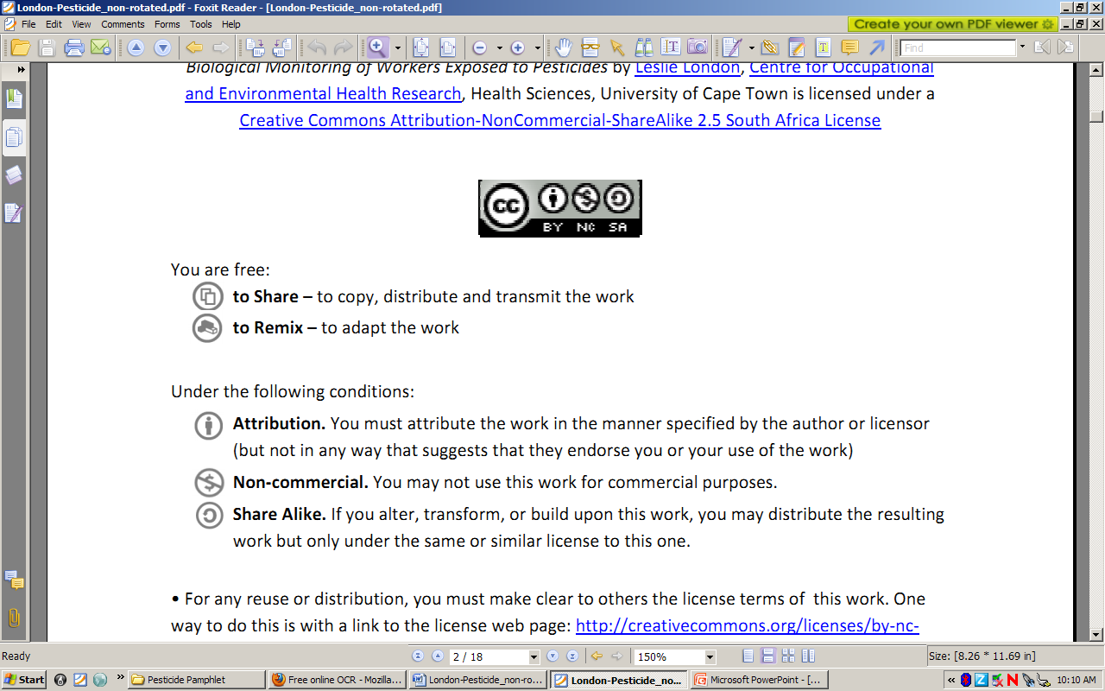to Share – to copy, distribute and transmit the work
to Remix – to adapt the work
Under the following conditions:
Attribution. You must at attribute the work in the manner specified by the author or licensor (but not in any way that at suggests that they endorse you or your use of the work)
Non-commercial. You m may not use this work for commercial purposes.
Share Alike. If you alter, transform, or build upon this work, you may distribute the resulting work but only under the same or similar license to this one.

• For any reuse or distribution, you must make clear to others the license terms of o this work. one way to do this is with a link to the license web page: http://creativecommons.org/licenses/by-nc-sa/2.5/za

• Any of the above conditions can be waived if you get permission from the copyright holder.
• Nothing in this license impairs or restricts the authors’ moral rights.
• Nothing in this license impairs or restricts the rights of authors whose work is r referenced in this document.
• Cited works used in this document must be cited following usual academic conventions
• Citation of this work must follow normal academic conventions

Source work available at Vula. Permissions beyond the scope of this license may be available at
www.healthedu.uct.ac.za or contact healthoer@uct.ac.za
We would appreciate your feedback for this Open Educational Resource (OER), by completing this form. Alternatively, you can email us at healthoer@uct.ac.za

