FACILITATOR’S NOTES ON:
“South African Health Insurance Development in the 1990S: How Design
Influenced Actors’ Positions”

1. Objectives of case study:

The primary objectives of this exercise are to consider both how actors influence the process of Social Health Insurance (SHI) policy development, and how SHI design details impacts on actors in ways that may generate support or opposition to SHI proposals.

The exercise can provide a foundation for thinking in more detail about specific actors (such as the Ministry of Finance) or for developing action plans for SHI development.

2. Description

Participants work in small groups of 4-5 people. These could be country groups – if you want to encourage reflection about how the experience of South Africa might inform SHI development in another country.

The first step is for the facilitator to take everyone through the exercise and the details provided about South Africa. At this stage the facilitator must also allocate one or two actors from Table 2 to each group; the groups will then consider these actors only in task B. It is useful to get different groups examining the same actor to see if different analyses are generated.

The first step in the group work is for each person to read the outline. Then the groups can complete tasks B and C themselves. Finally, there should be a feed-back and wrap up session using the ideas outlined in section 4 below.

3. Preparation and linkages

This exercise is best used as part of a series of sessions on Social Health Insurance. It is best preceded by introduction and discussions of the nature of SHI and the key design issues that need to be considered in developing SHI proposals. The session requires participants to consider how these technical design details influence the process of implementation through their impact on actors. There might also be value, therefore, in including discussion of the common difficulties of SHI implementation experienced in practice – and of the need for support and buy in from influential actors.

4. Timing and logistics

Overall the exercise should take between 2 to 2.5 hours.

The initial presentation by the facilitator should take around 10-15 minutes.

The first step in the small groups is for each person to read the outline. Although the exercise suggests this should only take 10 minutes, in practice it generally takes

longer! It is, nonetheless, good to encourage groups to watch the time they spend on tasks. Overall the group work (tasks A-C) should take about one to 1.5 hours.

The final feed-back session can take two forms.

Option one is to give each group say 10 minutes to feed-back their responses to tasks B and C. As different groups may have looked at the same actors, groups should be encouraged to highlight the similarities and differences between their responses and those groups that have presented before. Finally, at the end of the session the facilitator can present the findings of the study on which the exercise is based – and both point to some of the differences between these findings and the groups’ responses, and suggest why these differences occurred. The length of the feed-back session in this option depends on the number of groups presenting. The facilitator’s wrap up should take around 15 minutes.

Option two is for the facilitator to begin the feed-back session by presenting the findings of the study on which the exercise is based. These can then be the basis for a discussion with groups about whether they had drawn similar or different conclusions, and why there might be differences between the study’s analysis and the groups’ conclusions. Overall, this feed-back option will take around 30-45 minutes to conduct.

5. Points for discussion

First, in the facilitator’s initial presentation about the exercise and South Africa, it is useful to highlight some key issues of particular relevance to SHI. For example, the number of people economically active and the proportion of this group who are unemployed; the nature of the public/private mix in South Africa; the way SHI proposals evolved over time. It is also particularly useful to describe the information contained in Tables 1 and 2 as these are the focus of subsequent discussions. Facilitators should note that in Table 1 the 1994 ‘Deeble option’ is only presented as background information – small group discussions of task B should focus only on experience in 1995 and 1997.

Second, the following tables provide a summary of the analysis of stakeholder positions and concerns. Facilitators should be sure that they are comfortable with these analyses as they are a critical element of the final wrap-up session. It is particularly useful to make copies/overheads of the forcefield analysis tables and to use these as the basis of discussion in the wrap-up session. The other table provides the information that explains the positions of actors in the forcefield analyses – facilitators can therefore simply draw on it in the wrap up (rather than preparing hand- outs or overheads of it).

ACTORS’ POSITIONS ON SHI PROPOSALS, 1990s
ACTOR | PRIMARY INTERESTS | PROPOSAL POSITION
The public | The uninsured:  • To improve security of access and sense of social protection  The insured:  • To maintain and improve existing benefits at reduced or lower cost. | Views not known
Private providers | • To secure or improve incomes and working conditions by obtaining access to a large pool of private patients  • To increase access to new technologies in order to improve quality of care | Both GPs and private hospitals largely neutral in relation to all proposals as did not see them as likely to undermine their existing position within the health system except:  • GPs strongly opposed to the 1994 Deeble option  • Hospitals potentially supportive of 1995 proposals as allowed to offer services to newly insured
Employers | • To limit costs by keeping premiums low  • To secure benefits for workers  • To improve labour relations | • Position not very clear as made limited inputs into formal processes of SHI development but likely to have been anxious about the impact of the proposals on their overall wage bill, as well as any form of increased taxation
Trade  Unions | • To expand and improve health care coverage for poorer groups within society  • To consolidate or expand the current benefits available to their own members | • Largely supportive of pre-1994 and 1995 proposals because improving health benefits for trade union members (for example, by enabling wider access to private providers) and, in terms of the pre-  1994 proposals, for other groups in society.  • Probably supportive of the 1994 Deeble proposals for the same reasons, but also concerned about the lack of hospital benefits within them.  • Opposed to the 1997 proposals because did not fund improved health care provision for the poorest nor improved coverage for Trade Union members, instead required members falling within the target group to pay for public hospital care already receiving at low or no cost

ACTORS’ POSITIONS ON SHI PROPOSALS, 1990s
ACTOR | PRIMARY INTERESTS | PROPOSAL POSITION
Medical schemes | • To maintain market share and revenue levels, and if possible expand it  • To counter proposals hostile to its interests  • To support the new government in expanding access | • Supportive of pre-1994 and 1995 proposals because given role as intermediaries for SHI so consolidating and expanding position and profits  • Opposed to 1994 Deeble option as no role envisaged for them and membership for PHC lost  • Unclear on 1997 proposals because whilst no role envisaged for them, had secured place in private insurance sector through parallel regulatory legislation (and had been focusing on fighting competition from newer insurance products)
Government  : Department of Finance | All objectives rooted in the relatively conservative post-  1996 macro-economic framework which aimed to promote economic growth by  encouraging private  international and national investment:  • To improve efficiency in government expenditure  • To contain public expenditure levels and reduce the government deficit  • To contain the tax: GDP  ratio  • To protect the ‘already highly taxed’ middle income from further taxation  • To ensure accountability for government expenditure | From 1994 consistently opposed all SHI  proposals because:  • Deemed all proposals to be unaffordable for country as a whole;  • Specifically increased government costs as employer, with consequences for overall public expenditure levels;  • Deemed SHI as an additional tax which would increase overall tax levels to unacceptable levels  • Effectively increased taxation levels on the middle income, who they judged as already highly taxed  • Felt that proposals not clear and perhaps not feasible in important respects

ACTORS’ POSITIONS ON SHI PROPOSALS, 1990s
ACTOR | PRIMARY INTERESTS | PROPOSAL POSITION
Government  : Department of Health | Objectives not clear but broadly a combination of:  • Improving equity through strengthening cross- subsidisation  mechanisms (between sectors of the system and between population groups)  • Revenue generation for public sector  Apparently changing over time from stronger emphasis on cross-subsidisation towards stronger emphasis on revenue generation | • Difficult to determine an official position on the various policy proposals until 1997, as the earlier proposals were largely developed by technical/advisory bodies;  • Probably opposed the 1994 Deeble proposals because technical advice suggested both financially and politically not feasible  • Promote the 1997 proposals, which did become official policy
Minister of  Health | To improve access to health care particularly for the poor and rural populations, preferably through  government controlled  funding arrangements  (and cautious about profit- motivated private health sector) | • Only supportive of the 1994 Deeble proposals which brought one group of private providers under state control and ensured universal access for all to a strengthened primary care network  • Opposed to all other proposals because introduced differentials in care provided to insured and uninsured, as well as giving direct role to private insurers and providers within SHI schemes, and did not clearly benefit the poorest groups in the populations  • Although the 1997 proposals did not envisage a role for the private sector they did not offer significant either for the poorest or for the targeted group
Health economists  advising government | To develop a technically and politically feasible insurance-  based funding mechanism with which to support overall health system development  (over time, possibly accepting less emphasis on cross-subsidy and more on revenue generation for the public sector) | Were the key proponents of all SHI proposals except the 1994 Deeble proposals which they  strongly opposed.

Figure 1: Forcefield Analysis, 1995 SHI proposals

Actor
Proponents Opponents

categories high support
<<< <<< non mobilised
>>> >>> high opposition

political sector
political parties
Minister of
Health

governmen t sector
DOH DG, DHFE
DOF

business sector

Medical aid scheme s
private providers Employers

analysts some analysts
some analysts
Dr. Deeble

social sector
all groups, including COSATU

Figure 2: Forcefield Analysis, 1997 SHI proposals

Actor categories
Proponents Opponents

high support
<<< <<< non mobilised
>>> >>> high opposition Minister of

political sector
MINMEC political parties other
than ANC
Health
ANC

governmen t sector

DOH DDG DHFE

DOH DG

DOF

business sector
Medical aid schemes
employers; private providers

analysts some analysts
some analysts
Dr. Deeble

social sector
other groups COSATU

Notes:
• actors highlighted played most critical role
• not mobilised = did not play identified role in debates, but this allows for an actor to have played a ‘behind the scenes’ role
• ANC = African National Congress; COSATU = Congress of South African Trade Unions; DG = Director General; DDG = Deputy Director General; DHFE = Directorate of Health Financing and Economics; MINMEC = meeting of national Minister of health and nine provincial Ministers of Health

This work is licensed under a
Creative Commons Attribution-NonCommercial-ShareAlike 2.5 South Africa License
December 2011
You are free:
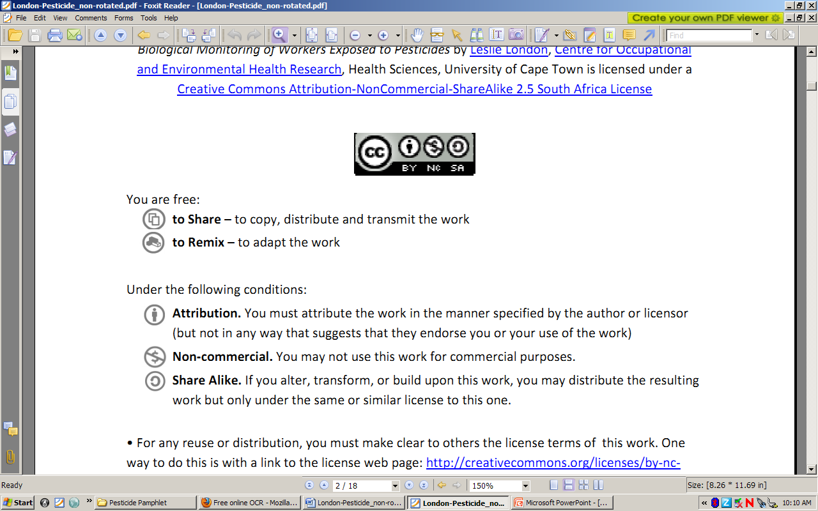to Share – to copy, distribute and transmit the work
to Remix – to adapt the work
Under the following conditions:
Attribution. You must at attribute the work in the manner specified by the author or licensor (but not in any way that at suggests that they endorse you or your use of the work)
Non-commercial. You m may not use this work for commercial purposes.
Share Alike. If you alter, transform, or build upon this work, you may distribute the resulting work but only under the same or similar license to this one.

• For any reuse or distribution, you must make clear to others the license terms of o this work. one way to do this is with a link to the license web page: http://creativecommons.org/licenses/by-nc-sa/2.5/za

• Any of the above conditions can be waived if you get permission from the copyright holder.
• Nothing in this license impairs or restricts the authors’ moral rights.
• Nothing in this license impairs or restricts the rights of authors whose work is r referenced in this document.
• Cited works used in this document must be cited following usual academic conventions
• Citation of this work must follow normal academic conventions

Source work available at Vula. Permissions beyond the scope of this license may be available at
www.healthedu.uct.ac.za or contact healthoer@uct.ac.za
We would appreciate your feedback for this Open Educational Resource (OER), by completing this form. Alternatively, you can email us at healthoer@uct.ac.za

