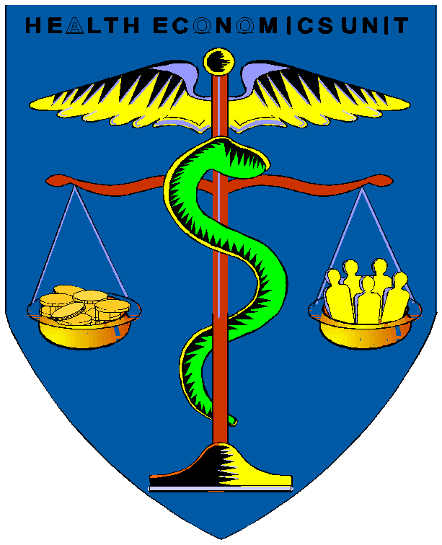

Case Study
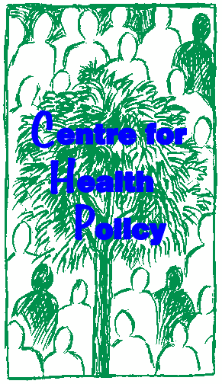

HEALTH INSURANCE: RURAL HEALTH CARE IN CHINA

Jane Doherty
Khethisa Taole

Centre for Health Policy, University of Witwatersrand Johannesburg, South Africa

This case study may be copied and used in any formal academic programme. However, it must be reproduced with appropriate acknowledgement of the author(s).The financial contribution of the World Bank Institute for materials development is acknowledged.

1. OBJECTIVES

This case study aims to provoke discussion about the factors influencing the likely success of community pre-payment schemes. It prompts participants to consider how to address some of the problems raised.

2. BACKGROUND TO THE CASE STUDY

Below you will read a dramatised account of the visit by an American PhD student to a rural village in China, Janling. The student is doing his dissertation on community financing. The main characters in the play are:

Frank Lee: a doctoral student in international health from Harvard, is conducting research on China’s community financing scheme for his dissertation.

Dr Wu: a deputy director of Planning and Finance of the Ministry of Health, is accompanying Frank to JanLing village: He has studied 2 years of health policy and management in the United States.

Mr Chu: town mayor on JanLing.

Task:
After reading the play, try to characterise the main problems faced by the villagers in financing their health care. Can you suggest any solutions?

Scene I: JanLing Village

A Toyota jeep with a UNICEF insignia on it cruises along a narrow dirt road toward the small rural village JanLing in the Yunnan Province of China. After wiping the perspiration from his brow, Frank Lee, momentarily distracted by the endless view of dry mountainsides, turns his attention to a document on a UNICEF-sponsored research study on health in rural China which includes JanLing as part of its sample. Frank has been in Beijing for a week, talking to government officials about China’s new policy to revitalise the Cooperative Medical System (CMS) in rural areas. He is eager to finally get to a rural setting to see how health care is financed and delivered in such poor areas. Though he is having trouble concentrating given the scorching heat, the dusty road, and the jostling of the jeep, he wants to have a solid background understanding of the village he is approaching.

Just as Frank finishes reading, Dr. Wu notifies him that they are entering the periphery of the village. Full of anticipation, Frank drinks in the sight of the village. He notes the dry fields, the thatched houses built of mud, and the men squatting in the rice fields in the sweltering heat. Frank glances down at his watch. They will arrive just in time for the annual town meeting. Although such a post-harvest meeting would normally deal mainly with how the village welfare fund should be spent, Dr. Wu thinks there will be an

opportunity to find out what the villagers think about establishing CMS in their community.

Dr Wu: Frank, what are your thoughts on the background information?

Frank Lee: Well......it seems like there are so many complicated issues with which we must wrestle. On the one hand, these poor villages seem more susceptible to disease and need some type of financing scheme. But, on the other hand, how can they possible afford to contribute enough to finance CMS?

Dr. Wu: Yes, Frank, there are no easy solutions here. The issue of rural financing in these poverty-stricken regions is very complicated. These poor people are not only sicker, but utilize health care services less often, relative to the national average rural rate. I believe that all over the world we struggle with how to finance the massive costs of catastrophic illnesses. However, in these areas, the villagers cannot even afford basic primary care, let alone get access to higher levels of care! The average infant mortality rate is higher and the maternal death rate is twice that of the national rural average. The net per capita income in these areas is less than the rural poverty line, which is the equivalent of ...$50 to you. Some villagers incur health expenditures exceeding their total household income
– and then they have to become indebted in order to pay. These farmers have always lived off the land and are barely literate.

Frank Lee: But, Dr Wu, health financing is based on a pooling of risk and resources.
How can the rural indigent support something like CMS if they are sicker and poorer than the average? How can people afford to pre-pay if they barely have enough to eat?

Dr. Wu: Well, it is difficult. But community financing is possible even in these poor, remote areas. The average income in villages that now support a functional CMS is lower than those without. Those villages charge about
6.4 yuan per capita for the welfare fund. 6.4 yuan in and of itself cannot cover a whole lot, but pooled over many people, a basic benefit package of pre-natal care, delivery, post-natal care and immunizations is completely within reason. However, medical care would be 2-3 times more depending on what was covered. Overall, a total of 20 yuan per person would be needed to provide a basic primary care package, with some acute medical coverage and drugs covered as well. The fact that few villagers can afford such a steep prepayment cost is the crux of the problem. The challenge is to tap into all potential sources of financing, not only the individuals of this village. As to your question yesterday as to why all villages have not bought into such a plan,....well, why don’t you see how this meeting goes and then give me your feedback?

Just then, the jeep pulls up to a small meeting area where 60 or so men have gathered in the humid afternoon, under the scanty shade of an old tree. The wheels of the jeep crackle over the gravel as they ease to a stop in front of the curious men who, staring at their visitors, pause in mid-conversation. Frank and Dr. Wu are greeted by the town mayor, Mr. Chu.

Mr Chu: Welcome, welcome to our meeting. We have been expecting you! You have arrived just in time for our discussion on how the resources of the welfare fund will be distributed next year. Please, take a seat.

Dr. Wu and Frank squat near the periphery while Mr. Chu quiets the crowd and resumes the meeting.

Mr Chu: Okay, okay, everyone. We have two visitors with us today, Dr Wu from the Ministry of Health and Frank Lee from the United States. They are very interested in seeing how villages such as JanLing feel about restoring CMS...ahem...anyhow, as we were saying, how shall we spend the funds from this year?.

1st villager: Well, Mr. Chu, I think we should continue to spend a fair amount on the education of our children. I think it has been a great opportunity to have the next generation literate in Mandarin.

2nd villager: Ummmm...yes, but I also think we should reconsider devoting part of the funds to some type of crop insurance. I mean, those locusts almost wiped me out. Education is wonderful, I admit, but you cannot eat your books!!!.

3rd villager: Mr. Chu, Mr. Chu! I believe we should spend a portion of that money on the very poor. I mean, its a welfare fund...there are some here in JanLing who are so sick and poor that they are bankrupt. Don’t you think it’s important to help them out as well?

Mr Chu: I am glad that you brought that up...JanLing used to have a Cooperative Medical System that pooled money from several resources to provide basic care to our villages. Now, I am told the party and the government want me to re-establish this system wherever possible. If we return to that system, we would have to charge each person a certain amount as a prepayment. Let me ask you all how much would you be willing to prepay?

The people begin whispering back and forth. A few suggestions are made. 10 yuan! 6 yuan! 4 yuan! 3 yuan!

4th villager: I am not willing to pay more than 1 yuan a year!

Mr Chu: Well, if each family only pays 1 yuan a year, there’s no way this is worthwhile! I mean, that’s only about 200 yuan a year in the fund and that won’t cover more than a few sicknesses per year.

Old villager: I’ll tell you why I am not even sure I want to be part of this scheme. I’m 65 years old and I paid 7 yuan a year for about 15 years and I never ever got any use of it. Let me tell you, I would have never paid those 7 yuan if the Government had not threatened to take one of my chickens. No, I don’t even think its a good system. I mean, all it does is serve those rich farmers’ kids. They just tough it out. None of this “depend on some other

guy” business. Not worthwhile. Besides, who has 6-7 yuan just lying around? I mean, we only get a few hundred yuan a year. Why should I spend 7 of it on something that I won’t ever use? This is a waste of my time. I’ve got to get back to the field.

The old villager takes his straw hat and starts to leave, walking unsteadily with the aid of his makeshift cane.

3rd villager: Ai-ya, wait a moment, Old Wong, you are getting grumpier in your old age. Well, I do not totally agree with you. I don’t think it’s a waste of time. I mean, my grandmother was terribly ill last year and I had to pay 60 yuan for her to see those doctors at the county hospital. If we had been under the CMS, I wouldn’t have had to pay 1/2 as much! Luckily, it was a good crop year and we could pay that bill. But if that had happened this year, there is no way that I could have helped poor grandmother out! To me, I like the system of paying once a year and not worrying about having to pay for some medical bill if it comes up. I’d put in 20 yuan a year. It sometimes pays off. At least, it would be nice to know that if something happened to me, I would be covered. I mean, its a lot like having one of those shots that we got before. It hurts a little now to make sure my children are healthy in the future. Don’t you want your great grandchildren to have basic care and immunizations, Old Wong?

Old villager: Well...I guess so...I do know that since they started those massive campaigns, there were a lot fewer people who became crippled because of those shots, they say. And well...I suppose that I lost 3 children when they were infants and now all the babies seem to survive to much older ages and are much healthier. Well...I still am not totally convinced that I would want to put money into the fund again...I will have to think about it.

The old man sits down again.

5th villager: Excuse me, Mr Chu, who is going to be in charge of this fund? I mean, that is a lot of money in one person’s hands! Are you going to be in charge of this?

Mr Chu: Well, I was assuming that we could all decide who would be the best person to be in charge of the funds. I mean, we definitely want someone who is accountable to the village. What do you all have to say?

6th villager: I think it should be Mrs. Yeh. She’s good with her family money. I mean, how else could she have afforded those cows last year. Plus, she manages the town funds doesn’t she?

5th villager: No, I think it should be Mr. Lee. He has at least finished grade school. He is well educated. Or better yet, how about Dr. Chen? He is the barefoot doctor here. Why doesn’t he just take charge of that whole programme. The rest of us have no idea about how to run some health care fund. Dr. Chen’s been our doctor for 45 years! He’s perfect. He’s had so much experience!

Mr Chu: Well, that’s a good idea. But, Dr. Chen is getting a little older. He was one of the first barefoot doctors trained. He doesn’t exactly know how to run something like this.

7th villager: Well, does anyone? I mean, really, we’re just a bunch of farmers anyway.
Where are we supposed to learn how to deal with all this money? Besides, who’s going to want to go to that clinic. It’s filthy and hasn’t been used for years. No medicine. Nothing.

Mr Chu: Oh my, that’s a good point. I have no idea. Maybe this is not such a good idea after all.

Just then, Frank, who has been taking notes on the meeting, notices two men struggling to carry someone on a stretcher toward the meeting area. He nudges Dr. Wu and points toward the men. Both he and Dr. Wu step out of the meeting for a moment to talk with the men. Out of breath and covered with sweat from their exertion, the two men gently lay down their stretcher, made out of a torn blanket and old bamboo poles, onto a cracked patch of dry earth.

Dr Wu: Is there a problem here?

1st cousin: My cousin here says he is in great pain, especially in his stomach. Dr Wu: Did you talk with the Village doctor?
2nd cousin: We tried to visit him, but he is difficult to reach. He spends most of his time in the fields, working on his land. Besides, by the time that our cousin Lao Chang decided to seek medical help, he felt so bad that we doubted any of those things a simple village doctor could do would help. We have come here to find transport to take him to the clinic in the town.

Dr. Wu bends over the groaning patient and examines him.

Dr Wu: It looks like he has severe appendicitis. We can take him to the town for you. Come with us. Come, Frank.

Scene II:
The Chenghui Township Health Centre

Two hours later the jeep pulls up at the small township health centre. The sick man’s cousins rush inside. The building is shabby. After what seems a long time they return with a doctor who briefly examines the patient..

Doctor: If the appendix is not removed, it may burst and he could become even more ill and perhaps not survive. I would like to help you, but this type of operation cannot be performed at the township level. You must go to the county hospital.

1st cousin: How much will such an operation cost at the county hospital? Doctor: I would say it would be approximately 500 yuan.
2nd cousin: 500 yuan!! That is much more than I make in a year!!! It’s impossible to ask for that type of money. I spent most of that money already on seeds for the new crop. We’ve already come so far! Why can’t you help us? I remember our grandfather came here to take that thing out of his stomach and he did not have to pay 500 yuan. Why are you treating us differently?.

Doctor: We do not have the money to buy the necessary equipment for surgery anymore. When your grandfather came here, it was most likely 20 years ago when there was a community health fund. We don’t have that anymore and this hospital cannot survive if it continues to serve patients who do not pay. I am very sorry, but I cannot help you. I would like to help, but there are just too many people who come who cannot pay.

The sun blazes down on the disheartened group. Frank, unused to the heat, feels weak. His knees buckle under him. Dr. Wu grasps him by the elbow, feels his forehead and peers into his eyes.

Dr Wu: Ai-ya. You Americans. Now I have a dehydrated doctoral student on my hands! What shall we do? Well, let’s find you some water, get back into the jeep and go to the County Hospital! I just hope my old friends are on call today.

Scene III:
The Wushan County Hospital

The jeep arrives at the Wushan county hospital, which is extremely busy with crowds waiting in the halls and emergency rooms. Doctors and nurses were rushing about with no time to attend to their newest arrivals. Dr. Wu disappears for a while and then magically reappears with the head of surgery who ushers everyone into the surgical ward. The patient is quickly placed on a stretcher and taken off to the operating room, accompanied by the surgeon. Frank is given some rehydration solution to drink and the lies down, with his feet raised. Dr Wu and the cousins sit by him.

1st cousin: Dr. Wu, we cannot thank you enough for the help you have given us.
Even if it takes the rest of our lives, we will promise to pay you back for this. Were it not for you and Frank, our cousin would surely have died.

Frank raises himself eagerly onto his elbows.

Frank: I’m curious about the health care system in your village. I know that a while ago, you all had village financing schemes. Would you prefer to have such a scheme or not have any system?

1st cousin: Well, to be honest, there is some talk of revitalizing the CMS. But we are so poor. We barely survive on the money we save from selling our crops.

It is hard to give that money to others, especially since we rarely get sick. Even if we do get sick, we avoid those village doctors and only get help when it’s really, really bad. We usually just wait till whatever illness we have goes away. It usually works, but I guess our cousin is just unlucky.

2nd cousin: Besides, those community schemes are so confusing. Everyone wants this or that and it’s such a hassle to go to those town meetings that drag on and on. We are so tired by the end of the day from working that we don’t want my money to be going for those things like baby care and stuff. My wife and mother both took care of themselves just fine and it would be silly to spend everyone’s hard-earned money on such simple services. It should definitely be spent on those really bad illnesses. But, of course, not everyone agrees. I doubt the village will ever be able to agree on anything. Until then, we just hope that we’re not unlucky again.

1st cousin: But, thinking about it, we should remember the good things. Don’t you remember how care used to be like under the CMS: I mean, we used to give a bit of money each year, the clinic was always available, we could get simple drugs and some basic care. Now, we have to pay each time we go to the doctor, each time we want a drug and each time we want any type of advice. It is such a hassle that I rarely go anymore. Remember a few months ago I ended up getting pneumonia because of that? Looking back cousin, I think had we had some type of system where getting access to care and drugs was much easier. I would not have had to miss so many days in the field because of that chest problem.

At that point, doctors emerge from the surgical ward to inform them that the patient has had a successful appendectomy and is recovering. Everyone sighs with relief.

This work is licensed under a
Creative Commons Attribution-NonCommercial-ShareAlike 2.5 South Africa License
December 2011
You are free:
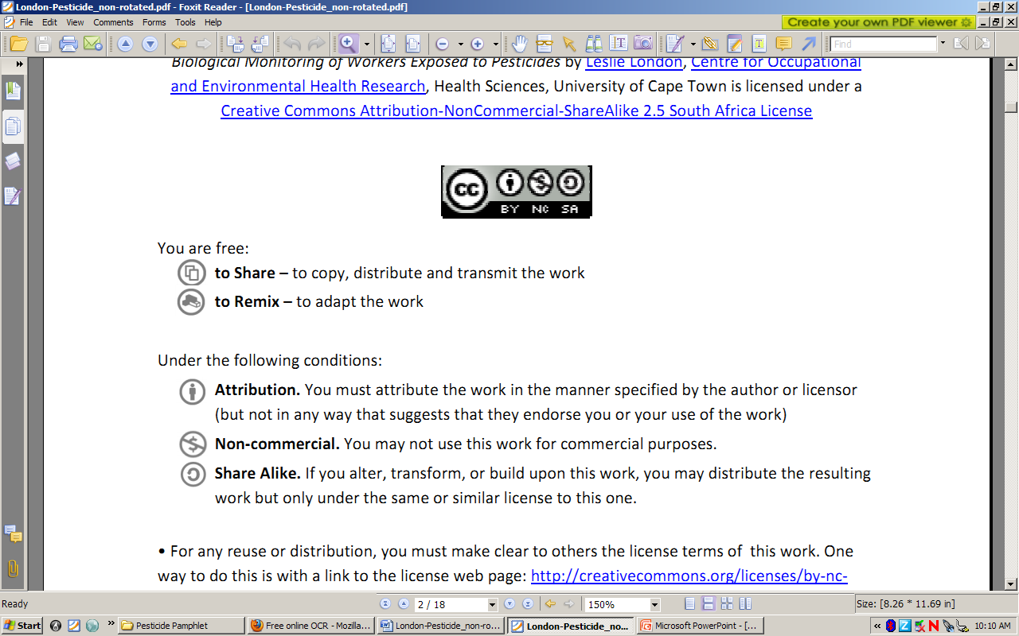to Share – to copy, distribute and transmit the work
to Remix – to adapt the work
Under the following conditions:
Attribution. You must at attribute the work in the manner specified by the author or licensor (but not in any way that at suggests that they endorse you or your use of the work)
Non-commercial. You m may not use this work for commercial purposes.
Share Alike. If you alter, transform, or build upon this work, you may distribute the resulting work but only under the same or similar license to this one.

• For any reuse or distribution, you must make clear to others the license terms of o this work. one way to do this is with a link to the license web page: http://creativecommons.org/licenses/by-nc-sa/2.5/za

• Any of the above conditions can be waived if you get permission from the copyright holder.
• Nothing in this license impairs or restricts the authors’ moral rights.
• Nothing in this license impairs or restricts the rights of authors whose work is r referenced in this document.
• Cited works used in this document must be cited following usual academic conventions
• Citation of this work must follow normal academic conventions

Source work available at Vula. Permissions beyond the scope of this license may be available at
www.healthedu.uct.ac.za or contact healthoer@uct.ac.za
We would appreciate your feedback for this Open Educational Resource (OER), by completing this form. Alternatively, you can email us at healthoer@uct.ac.za

