FACILITATOR’S NOTES ON:
“Integrated Health Care Financing Approaches – Household Perspective
Case Study from Burkino Faso”

1. Objectives

• Strengthen/consolidate an orientation towards household concerns amongst policy makers and planners;
• Understand the types of economic burdens households have to cope with as a result of illness, and potential livelihood effects.
• Understand various coping strategies that poor household use

2. Description

Participants are required to read extracts from the Sauerborn et al. paper, consider the questions, and discuss amongst their group.
Initially the facilitator should briefly describe the article, and take the students through the questions. The class should then be divided into groups of 3 or 4 people. Time should then be given for students to read the paper individually, and then time to consider the questions as a group. Then, during a feedback session, the facilitator should ask each group at a time to give an answer to one question, and then allow the broader group to make additional comments. The four questions requires that different financing mechanisms have been discussed in another session.

3. Timing and Logistics

Half an hour should be allowed for reading of the article, though it may take longer with, and another half an hour to consider the questions. The feedback session should also take about half an hour. (Total time 1.5 hours). It is good to walk round the class and listen in to discussion within the groups, and be ready to answer questions as they arise within the groups. Try to be aware of which groups are struggling with the questions and to determine if there are any misunderstanding of concepts.

4. Points for discussion

Table 1 takes requires some careful thought and explanation, particularly the difference between economic and financial costs, and the seasonal variation.
With coping strategies section, it is good to get students to think about their own culture/country, and whether these strategies have any relevance for the poor from their own country. Giving students time to describe their own country experience will enable them to engage with the material much more. It is also important to point out how households differ – that the poor are not a homogenous group, and to identify the variations.

5. Other readings

Hotchkiss DR, Rouss JJ, Karmacharya K, Sangraula P (1998). Household health expenditures in Nepal: implications for health care financing reform. Health Policy and Planning; 13(4):371-383.

Messer E. (1997). Intra-household allocation of food and health care: Current findings and understandings – Introduction. Social Science and Medicine; 44(11):
1675-1684.

Pannarunothai S, Mills A (1997). The poor pay more: health-related inequality in
Thailand. Social Science and Medicine; 44(12): 1781-1790.

Russell S (1996). Ability to pay for health care: concepts and evidence. Health policy and Planning; 11(3): 219-237

This work is licensed under a
Creative Commons Attribution-NonCommercial-ShareAlike 2.5 South Africa License
December 2011
You are free:
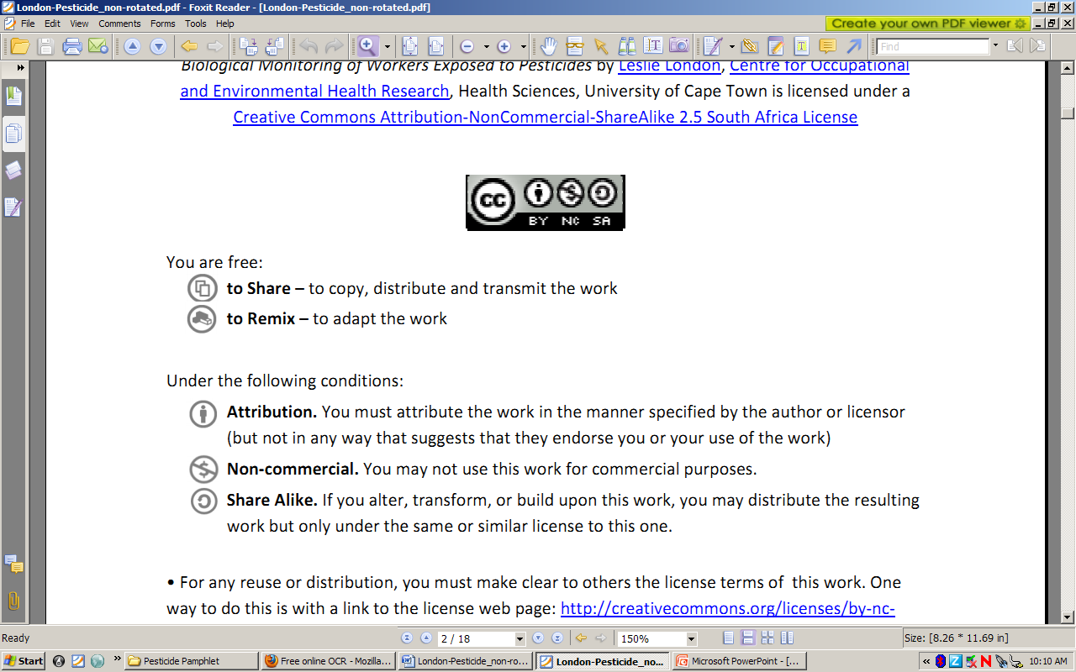to Share – to copy, distribute and transmit the work
to Remix – to adapt the work
Under the following conditions:
Attribution. You must at attribute the work in the manner specified by the author or licensor (but not in any way that at suggests that they endorse you or your use of the work)
Non-commercial. You m may not use this work for commercial purposes.
Share Alike. If you alter, transform, or build upon this work, you may distribute the resulting work but only under the same or similar license to this one.

• For any reuse or distribution, you must make clear to others the license terms of o this work. one way to do this is with a link to the license web page: http://creativecommons.org/licenses/by-nc-sa/2.5/za

• Any of the above conditions can be waived if you get permission from the copyright holder.
• Nothing in this license impairs or restricts the authors’ moral rights.
• Nothing in this license impairs or restricts the rights of authors whose work is r referenced in this document.
• Cited works used in this document must be cited following usual academic conventions
• Citation of this work must follow normal academic conventions

Source work available at Vula. Permissions beyond the scope of this license may be available at
www.healthedu.uct.ac.za or contact healthoer@uct.ac.za
We would appreciate your feedback for this Open Educational Resource (OER), by completing this form. Alternatively, you can email us at healthoer@uct.ac.za

