

Case Study
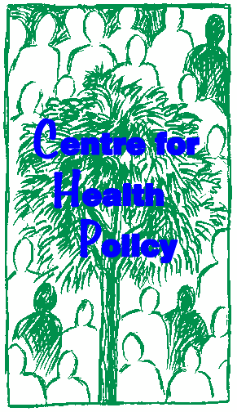

INTEGRATED HEALTH CARE FINANCING APPROACHES
HOUSEHOLD PERSPECTIVE: CASE STUDY FROM BURKINO FASO

Jane Goudge
Veloshnee Govender

Centre for Health Policy, University of Witwatersrand, Johannesburg, South Africa.

Health Economics Unit, University of Cape Town, Cape Town, South Africa.

This case study may be copied and used in any formal academic programme. However, it must be reproduced with appropriate acknowledgement of the author(s)
The financial contribution of the World Bank Institute for materials development is acknowledged.

1. INTRODUCTION

Extracts from: Household strategies to cope with the economic costs of illness
Sauerborn, R., Adams, A. and Hien, M.
Social Science and Medicine 1996 Volume 43, No.3 pp291-301

This article examines the strategies rural households in Burkina Faso used to cope with the costs of illness in order to avert negative effects for household production and assets. 51 qualitative interviews, a household time allocation study and a household survey were used to gather the data in 1992.

2. OBJECTIVES

• Strengthen/consolidate an orientation towards household concerns amongst policy makers and planners;
• Understand the types of economic burdens households have to cope with as a result of illness, and potential livelihood effects.
• Understand various coping strategies that poor household use

3. RESULTS

Table 1 summaries the main components of household costs of illness. In the context of the present analysis, the key findings are threefold: i) time costs represent more than two thirds of the total household costs of illness; ii) time costs of the caretaker are about as large as those incurred by the sick person; iii) the average annual financial costs amount to 6.2% of total annual household expenditures. This chapter describes how households coped with these costs.

Table 1: Household economic costs of illness per year by type of cost
 | DRY SEASON |  | RAINY SEASON |  | ALL SEASONS
 | CFA Franc | Percenta ge | CFA Franc | Percenta ge | CFA Franc | Percenta ge
Time costs of illness | 1395 | 34.9 | 604 | 56.7 | 11,988 | 39.5
Time costs of caretaker | 1356 | 33.9 | 263 | 24.7 | 9,717 | 32.0
Financial costs of care | 1250 | 31.2 | 197 | 18.5 | 8,686 | 28.6
Total economic costs | 4002 | 100.0 | 1065 | 100.0 | 30,401 | 100.0

4. TYPES OF COPING STRATEGIES

Coping is defined as a short-term strategy adopted within the prevailing value system to avert a negative effect on the actor. In the context of this paper, the actor is the household defined as a group of individuals – most commonly but not necessarily linked by kinship ties – who live together and share functions of production and consumption as well as reproduction. In the context of this paper, the negative effect coping strategies seek to avert is the breakdown of the household as an economic

and social entity. As in famine research, the criteria for calamity are household destitution and disintegration.

As a first step, most households used any available cash or savings to pay for health care expenditures. The amount, however, was generally insufficient: in only four out of 25 cases were illness expenditures completely covered. Cash sources included agricultural and craft production and migrant remittances. In addition, two households derived cash from millet beer sales, and three from the pension income of members who were veterans of the French Army (anciens combattants).

The sale of assets was the second most common way to meet health care expenditures. For households who did not possess sufficient cash, the sale of assets in the form of livestock was a widespread response to crises of many kinds. Indeed, in this part of Africa, animals were perceived as ‘ambulatory savings-banks’. The sale of cereals, on the other hand, was considered a last resort.

‘You know you raise animals with the aim in mind to face this kind of expenditure, but as to the millet, that’s very different because even if you sell the millet to pay for health care, after the cure, what are you going to eat?’

Villagers emphasized the dangers of selling cereal to overall food security, and stressed the need to avoid adverse seasonal fluctuations in food prices. During the dry season in which the majority of health expenditures occur, cereal prices are substantially lower than in the rainy season. As one farmer stated, selling millet in this season to cover health care costs was foolhardy as it might necessitate having to buy millet in the rainy season at a much higher price.

Only one household head, who had neither cash nor animals, was forced to sell millet as a last resort in order to feed his newborn with formula milk after the mother died in childbirth.

In both villages of the qualitative sample it was customary to take loans. In Seriba no interest was claimed, while in Bourasso the going rate was 10% (except for loans to kin, which were interest free). The option to take loans, however, was only available to wealthy households with collateral (generally in the form of animals).

‘Not everybody can get a loan. You have to have a guarantee or you must have someone who can guarantee for you...By all means, the poor can’t get a credit.’

In general, loans were perceived as a buffer between the time of need for cash and the time when the household was in a position to pay back. Given the widespread belief that selling livestock under pressure would lead to a bad price, it was considered more advantageous, even for the wealthy, to take a loan and delay repayment until livestock prices were more favorable. Another less common way to receive small loans was for the loanee to offer his labor to work on the fields of the creditor.

Men and women from poor households used slack time in the dry season to generate additional income. Men typically enjoyed more leisure time during the dry season (3.4 hours per day compared to 2.0 hours per day for women). This leisure time could be used to generate additional revenue to cover extraordinary expenditures, such as for health care. Household members engaged in a wide variety of income

generating activities ranging from fetching firewood for millet beer breweries, building fences, weaving straw mats and honeycombs, and tailoring.

In this subsistence farming environment, working as a wage-laborer was considered a last resort for those lacking assets, access to credits and kin/community support. In the rainy season, the trade-off between working one’s own field to ensure household livelihood and selling one’s labor to generate money for health care expenditures was especially stark.

‘...one is obliged to leave one’s own field in order to go to cultivate for someone else in order to be able to meet the needs of one’s own family, this is the difference.’

Both the formal health services and traditional healers sometimes provided services at no cost (in 3 out of 25 cases). However, free care was not received by the needy, but rather by wealthy and influential households.

In 14 out of 25 illness events, households received gifts from extended kin. The large majority of households who received gifts were wealthy. Only one poor household received a 5000 F CFA gift by an expatriate health worker. The reallocation of tasks among household members was the most frequently chosen strategy to cope with anticipated production losses. In 24 out of 27 illness episodes, households sought to reallocate the home production task of the ill member among the healthy members. In the two cases where craftsmen suffered from illness that prevented them from working, the household was not able to substitute their specialized skills.

In the case of lost field production, household members who had not participated in agriculture before the illness event were mobilized. Children less than 10 years old, those who had retired from field work or who participated in other activities were called to the fields.

Another strategy was to switch the sick person’s tasks from physically demanding field work to craft production. In household SET-01, the sick person took to weaving, whereas in BOU-06, the chronically ill household head started to sew clothes when he could no longer work in the fields.

It is intuitively obvious that the ability to reallocate the tasks of ill or deceased members depends on household size and composition. The monogamous nuclear family household BOU-05 in Bourasso, for example, had no capacity to ‘recruit’ a new member into the field labor force. The polygamous 23-member household SER-
03, on the other hand, was able to compensate for the production of a deceased household member by mobilizing the labor of three individuals.

Two households responded to imminent long-term production loss due to illness by investing in capital, thus changing the capital/labor mix. One such household introduced oxen-plowing on its millet and sorghum fields to enhance productivity.

Another way to change the capital-labor mix of agricultural production was to change the crop mix from a less capital-intensive one, namely millet, to one that requires more capital input (pesticide, fertilizer) and less labor for each unit of output. After the death of one of its main field workers, household BOU-12 shifted half of its own area from millet to cotton. The household head was able to do the necessary investments (seeds, fertilizer, pesticides, etc.), since he drew a pension from the French army as a veteran of the Indochina war.

‘We are now growing cotton, which we have not done before, in order to fill the gap. Instead of selling the millet as cash crop, cotton is ideal for this.’

In only 3 out of 27 illness episodes with production loss did households chose this strategy. This comes as no surprise since additional financial resources, on top of those used for health care expenditures, were needed to invest in additional capital. Both of the above households belonged to the upper wealth quartile in the village.

Some households hired laborers when they anticipated a short-term illness-related production loss during the peak agricultural season, when farmers had little flexibility to substitute or postpone work. However, the expenditures the household had to incur to pay laborers in addition to paying for health care, were considerable which limited this strategy to households with the ability to generate cash quickly. Only two households in the sample hired labor. In this case, the household head was a veteran who received a monthly pension of 15,000 cfa, the equivalent of about 60 days of hired labor. He hired 27 young men to work for one day as a substitute for one month of his wife’s foregone labor. She had to be operated on for an incarcerated umbilical hernia during harvest time.

In 2 out of 27 illness episodes with production loss, free labor was supplied to the household, in one instance by a community organization (the Young Farmers’ Association in Bourasso), in the other instance by a neighboring household in the village.

According to accounts of his wives and brother and to hospital records, Philippe Tiawa, a household head from Bourasso, had a bicycle accident with an open head trauma with a cerebrospinal fistula and subsequent meningitis. He was treated from March to June 1991, when he died. During the course of his illness, the household lost his work input as well as the field work of one of his three wives who stayed with him at the hospital. However, the resulting harvest equaled the previous one to which Philippe had contributed. This was due to the fact that the young men from the quarter went several times to cultivate his fields.

In summary, intra-household labor substitution was by far the most frequently chosen strategy (in 24 out of 27 events with production loss). Two additional strategies, namely changing the capital-labor mix, and hiring labor required cash resources, which most households did not have. Free labor was only given to two wealthy households. Therefore, only four households in the upper wealth quartile were able to employ strategies other than intra-household substitution. In addition to poverty as a factor limiting the ability to cope with production loss, household size and composition compromised the availability and effectiveness of intra-household labor substitution. Poor small households are therefore at greatest risk of experiencing illness-related production loss.

So far we have looked at household behavior to cope with illness related costs after they had been incurred by the household. The evidence in table 1 suggests household members change their perception of illness during the rainy season. In spite of evidence for higher disease transmission and increased case fatality of key diseases, such as malaria during this season, people perceived fewer illnesses, and perceived them as less severe. We developed the hypothesis that the change of the household’s economic parameters in the rainy season (i.e. increased opportunity costs of time, lower availability of cash, diminished assets) influenced illness perception. We consider this a strategy (albeit unconscious) of households to avoid

costs. For the same reasons, households are less inclined to seek any treatment at all, and even those who perceive themselves to be ill tend to keep working. Finally, during the rainy season healthy household members dedicate much less time to their sick kin than during the dry season. These behavioral changes significantly reduced the economic costs of illness for the household. Table 1 indicates that the economic costs of illness in the rainy season are approximately ¼ of the costs in the dry season.

5. CRITERIA FOR SUCCESS

As to the first criterion laid out above, namely calamity aversion, coping strategies were highly successful: none of the households disintegrated or migrated as a consequence of illness costs.

The second criterion concerns the degree to which coping was successful in minimizing adverse effects on household production. Only a small proportion of wealthy households (4 out of 27) were able to maintain household production by substituting labor lost due to illness. Large households were at a clear advantage in replacing labor lost to illness. The majority of households, however, lost production in spite of attempts to reallocate labor internally.

As to the third success criterion, whether coping behavior jeopardized the household’s asset base, the majority (16 out of 25) of households which purchased health care or labor did so by selling livestock, thus reducing their asset base. They emerged from the illness episode poorer and more vulnerable, i.e. with a reduced ability to cope with further stress. Since the same asset buffer was needed for coping with a variety of stresses including seasonal food insecurity and other social and economic crises, the seeds for future calamity were sown. Gifts from other households were rarely given to cover treatment costs (5 out of 25), and in only two illness episodes did gifts cover costs sufficiently, such that the household concerned did not have to sell livestock.

6. THE ROLE OF THE HOUSEHOLD IN COPING

While illness occurred in individuals, its costs do not fall on ill individuals alone. Indeed, substantial amounts of costs would not have been captured in the analysis, nor could coping behavior have been assessed, without treating the household as the unit of analysis. It was the household as the “therapy managing group” that made decisions regarding health care choice and the allocation of time an financial resources to treatment. Sickness in one member affects the time use of healthy members and influences household decisions regarding the allocation of financial resources. Both the costs of care and strategies to cope with them, therefore, can only be understood in a household framework.

Study findings indicate that coping with the costs of illness largely occurred at the level of the household itself, and that inter-household transfers of financial or time resources played a smaller role. Chen’s (1991) study of rural Indian farmers coping with drought and seasonality, and Adam’s (1993) work on household coping with food insecurity in Mali also emphasized the central role of the household in coping. However, evidence suggests that in inter-household transfers are more acceptable in the context of food shortage than in the context of health care.

In the present study, both kin and community support (loans, gifts) were generally not available to poor households. The exclusion of poor households from inter- household networks of support has been observed in other African settings. In rural Mali, Adams noted that poor households had neither the time, status nor resources to invest in the maintenance of exchange relations, or their cultivation through marriage and reciprocal gift giving. This is in contrast to Das Gupta’s (1987) observation of strong community support for the poor households in rural India.

Not surprisingly, other household characteristics such as size, dependency ratio and wealth had a strong influence on coping behavior. Larger households were able to substitute labor much more easily than small ones. In addition to household size, household age (i.e. the years elapsed since the founding of the household) and life cycle stage may influence its capacity to substitute labor. As the household matures, and children move from being net consumers to net producers, dependency ratios become more favorable, labor more easily substituted and coping strategies more diverse. The relationship would work through changes in dependency ratios during the lifetime of the household.

In spite of the importance of the household in coping with illness, policy has customarily targeted individuals at risk by characteristics such as age or gender. One lesson from the current study is that there are households at risk of being pushed into poverty and calamity as a result of catastrophic illness. The most vulnerable and least able to cope are small and/or asset deprived households. It is conceivable that health centres establish household lists for their catchment areas which target small and poor households for special care. Home visits, for example, might reduce the time access costs of care, waiving user fees for these households might reduce their financial access costs.

This work is licensed under a
Creative Commons Attribution-NonCommercial-ShareAlike 2.5 South Africa License
December 2011
You are free:
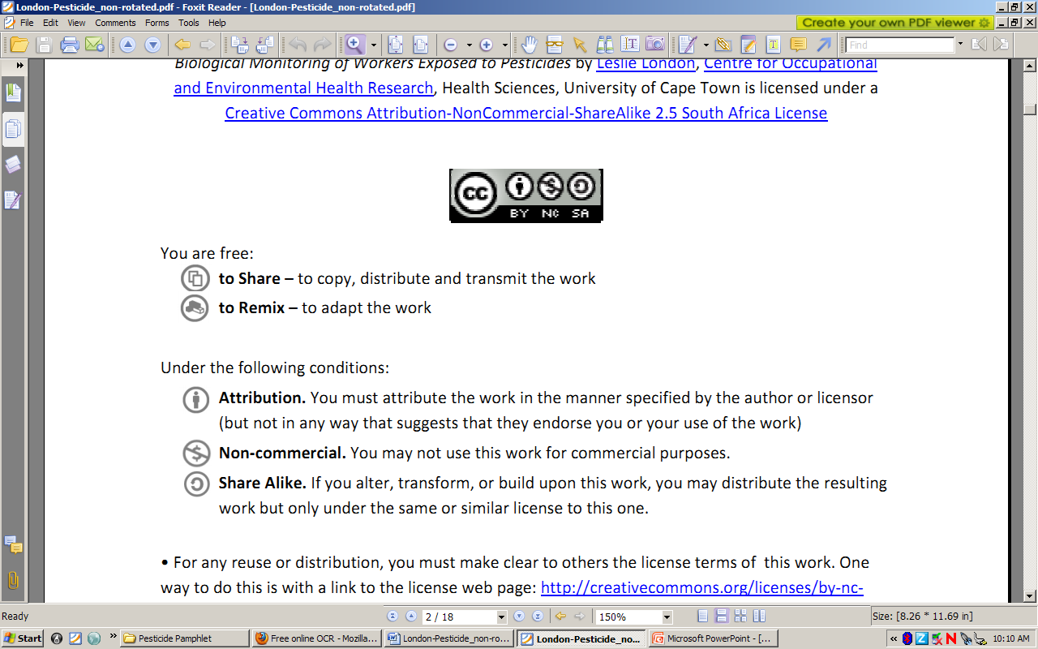to Share – to copy, distribute and transmit the work
to Remix – to adapt the work
Under the following conditions:
Attribution. You must at attribute the work in the manner specified by the author or licensor (but not in any way that at suggests that they endorse you or your use of the work)
Non-commercial. You m may not use this work for commercial purposes.
Share Alike. If you alter, transform, or build upon this work, you may distribute the resulting work but only under the same or similar license to this one.

• For any reuse or distribution, you must make clear to others the license terms of o this work. one way to do this is with a link to the license web page: http://creativecommons.org/licenses/by-nc-sa/2.5/za

• Any of the above conditions can be waived if you get permission from the copyright holder.
• Nothing in this license impairs or restricts the authors’ moral rights.
• Nothing in this license impairs or restricts the rights of authors whose work is r referenced in this document.
• Cited works used in this document must be cited following usual academic conventions
• Citation of this work must follow normal academic conventions

Source work available at Vula. Permissions beyond the scope of this license may be available at
www.healthedu.uct.ac.za or contact healthoer@uct.ac.za
We would appreciate your feedback for this Open Educational Resource (OER), by completing this form. Alternatively, you can email us at healthoer@uct.ac.za

