FACILITATOR’S NOTES ON:
“Assessing the rationale for, and forms of, decentralisation”

1. Objectives:

• To review the differing experiences of selected countries with respect to their rationale for initiating decentralised health management and the forms of decentralisation initiated;
• To compare and contrast experiences of the countries profiled with participants’ own experiences;
• To provide analytical frameworks for understanding different forms of, and approaches to, decentralisation.

2. Key issues to cover before using case study:

It is important to provide a brief introduction to the different categorisation methods used in decentralisation studies. These include:
• The World Health Organisation’s (WHO) ‘streams of decentralisation’ (Strengthening lower levels of the health system/districts; local government; autonomous institutions; executive agencies; non-governmental providers)
• Public administration ‘types of decentralisation’ (Deconcentration, devolution, delegation, privatisation).
It is also useful to explain the difference between political decentralisation and the decentralisation of only technical functions. It may also be helpful to get participants to briefly brainstorm some the most frequently cited reasons for introducing
decentralisation.

It is essential that facilitator(s) read all the country profiles (and complete the attached table) themselves before using this case study.

3. Overview of case study:

The country profiles are deliberately chosen to reflect a diverse range of decentralisation experiences within and across countries. The primary objective of the country profiles is to get participants to reflect on the differing types and forms of decentralisation, and the implication of form for areas and extent of responsibility transfer. In addition, the profiles provide real life examples of the diverse objectives proposed for decentralisation.

Groups of about 4 people should be set up. Each person should be asked to read one country study (preferably before the session). Each group should review and compare the experience of two countries (so 2 people in the group will read one country profile and the other 2 will read the other country profile). Previously, the following combinations of country profiles have been allocated to individual groups: Uganda and Mali; Kenya and Nicaragua; Zambia and PNG. The plenary discussion serves to provide a comparative analysis of all 6 countries’ experiences.

This case study takes about 3-4 hours to complete.

There should be a brief introduction to the questions that groups should consider. Facilitators may wish to provide a copy of the blank table attached to these notes to assist groups to work through the questions (and to take notes on the other countries during the plenary presentation). Participants should be guided to use the differing categorisations

presented in advance of the small group discussion (the WHO ‘streams’ and the public administration ‘types’) in analysing the decentralisation experiences, and to see what information they can glean about the areas and degree of responsibility transferred to decentralised units. However, the level of detail concerning country experiences varies quite a lot from profile to profile and they should not waste time trying to do too much with too little information. They should also be guided to see the difference between political and technical decentralisation.

About 2-2.5 hours should be left for group work. Group members should provide a brief overview of their country profile to the other team members. Group members can then jointly answer the questions posed in the case study.

About 1-1.5 hours should be allowed for plenary report backs. These could be very comprehensive and could take various forms – e.g. each group could present all the answers for their countries in turn, or the facilitator may request inputs from each group on a question-by-question basis. The latter approach is helpful in drawing comparisons across all the countries. Alternatively, if time is limited, facilitator(s) could request that groups only to present what forms of decentralisation occurred, provide 3 of the main motivations for decentralisation and 1 or 2 striking features about the country profile (e.g. key success factors). It is important to conclude the plenary discussion session by drawing the linkages between the countries considered by different groups (highlight common themes, key differences, etc.).

4. Key issues for discussion:

Type of decentralisation:
• What different ‘types’ or ‘streams’ of decentralisation have been introduced within each country?
This question allows participants to identify the different types or streams of decentralisation in each country, and so develop a better understanding of
deconcentration vs. devolution vs. delegation etc. Most of the countries have examples of more than one type of decentralisation (e.g. deconcentration to health districts and delegation to autonomous institutions). Papua New Guinea (PNG) is the only country with a single type of decentralisation (devolution to provincial governments). Participants should not only be focusing on decentralisation within the
health sector, but should also be looking at broader decentralisation initiatives within
each of the countries. Mali (as well as PNG and Uganda) provide clear examples of political decentralisation outside the health sector; these countries are included to emphasise that decentralisation is not just a health sector reform.

• For each country, did decentralisation focus on creating new political structures to which representatives are elected, or on establishing new technical/managerial bodies, or both?
This question prompts participants to consider the differences between political and functional decentralisation. It also shows the linkages between the different decentralisation categorisation systems (e.g. devolution is associated with political decentralisation while deconcentration is associated with functional decentralisation). Mali and PNG are again the clear examples of creating new political structures and so
could be used to illuminate the issue for the whole group; Uganda’s local government
type of decentralisation is also more political.

• What, if any, structures or bodies were affected by decentralisation, or established in the process of decentralisation?
The possibilities include local government, multi-sectoral development committees, district boards, district health management teams (DHMTs), hospital boards, executive
agencies (such as the Central Board of Health – CBoH - in Zambia) etc. The intention of this question is to review the different kinds of organisations, committees etc. that might be created through decentralisation. It is important to highlight the differences in authority of these bodies e.g. what’s the difference between what District Boards do and what DHMTs do?

• In what ways are the experiences of the countries reviewed different or similar to other countries represented in the group? Have any other types of functions or bodies been the focus of decentralisation in these other countries?
This question may not be relevant if all the participants are from one of the countries included in the profiles. If not, it allows participants an opportunity to present other experiences and so get more diversity in the discussion of decentralisation. It also
allows participants to apply the concepts and decentralisation categories to their own
country context.

Rationale:
• What are the explicit, stated reasons or motivations for decentralisation and what, if any, implicit reasons are suggested to underlie decentralisation?
A wide range of reasons or motivations can be found in the various country profiles,
although the emphasis in terms of stated objectives is on improving technical performance. Some of the other reasons are: promoting community self-reliance or
‘self-help’ (Kenya and PNG), increasing accountability (Zambia, Nicaragua and Uganda), increasing community participation, involvement and ownership (Kenya, Uganda), generating local revenue (Kenya, Zambia and Uganda). Mali, has more explicit political goals such as increased democracy (PNG also has quite explicit political objectives). Some countries have more implicit goals, such as Zambia’s focus on districts rather than local government, because local governments were tainted by their association with the former regime.

• Do the reasons differ by type or ‘stream’ of decentralisation? How and why? Is there any conflict between the different reasons given
There is quite limited information on this issue, but it is most evident in those countries
with both political and health sector specific decentralisation (particularly Mali/Uganda). In these countries, the different objectives of the ‘types’ of decentralisation are easier to discern. On the one hand, the devolution of political powers to local or provincial government may be specifically aimed at increasing democracy, while simultaneous deconcentration of some technical functions to health districts may entrench central control and be in conflict with efforts to promote local democratic decision-making. Mali provides a good example of where there are a number of parallel decentralisation initiatives being implemented at the same time, which can cause considerable confusion (local health services may not know who they are accountable to) and it may lead to not being able to achieve some of the objectives for the different types of decentralisation. It would also be good to try and explore the differences between the objectives of the ‘classic’ DHMTs (which are primarily intended to improve implementation of services, and some argue, hang on to central control) and those of the more recent and more radical district initiatives (where there are efforts to develop real planning capacity as a means to improving efficiency).

• If you know any country under assessment, do you agree with the analysis of its experience? If not, what do you think the rationale(s) for decentralisation in the country was?
This question allows for insider knowledge and for participants to provide more detail than contained in the country profile reports.

• Are these country experiences’ different or similar to other countries represented in the group?
Once again, this question may not be relevant if all the participants are from one of the
countries included in the profiles. If not, it allows participants an opportunity to present other experiences and so get more diversity in the discussion of decentralisation objectives. It also allows participants to consider the rationale for decentralisation in their own country context.

Drawing conclusions:
• Does the type of decentralisation have any influence over whether the objectives established for decentralisation are achieved? If so, which appears more appropriate as a mechanism to achieve which goal?
The intention of this question is to prompt participants to think about what goals might be feasible to establish for which type of decentralisation. It is important to emphasise how difficult it is to design structures that will achieve stated goals. It is useful to use this question as a way of exploring the complexity of decentralisation issues. For
example, broadening political representation is only possible by creating new political
structures (such as local governments), but greater accountability to the community might be achieved best through establishing boards with local representation. However, boards may not be entirely representative. It is important to consider how people get to be on the board: if they are elected, this may be considered representative; but if they are appointed by the Minister (as in Zambia), then who do they represent?

• What other key factors appear to influence the achievement of objectives? Participants may be able to identify other factors that contribute to the successful implementation (or not) of decentralisation in the various countries. The kinds of issues that may come up include: conflict between different types of decentralisation within a country (seen to some extent in Mali); confusing lines of accountability (seen to some extent in Uganda); donor support (in Zambia, donors were seen as providing support rather than trying to drive the decentralisation process and this was seen as a positive influence, but in Mali, donors were seen as promoting their own agendas which created resistance to the decentralisation process); fear of losing control and therefore resistance to giving up power and responsibilities (as in PNG), resource availability and competition for control over resource allocation decision-making (as in PNG); ability to identify obstacles and find ways to overcome them (such as in Mali – when the Ministry of Territorial Administration failed to effectively implement decentralisation [as they would have lost significant power], a separate mission for decentralisation was created and attached to the Prime Minister’s office).

• Do you see the transfer of authority of any function to bodies outside the public sector as a form of decentralisation? why/why not?
This question prompts participants to consider whether ‘new public management’ type
reforms (which attempt to introduce market principles into the health system) may be undermining the role and goals of the public sector, and for participants to discuss what they see the public sector’s goals and values to be.
Facilitator’s Notes for decentralisation country profiles

ISSUE | Uganda | Mali | Kenya | Nicaragua | PNG | Zambia
Forms, streams or types of
decentralisation
Decentralisation of political or technical/
managerial authority or both
Structures or bodies affected or
established
Explicit/stated or
implicit reasons for decentralisation
Differences in reasons
or motivations between types; conflict between reasons
Link between type and
achievement of objectives
Other key factors
influencing achievement of objectives (success and failure factors)

This work is licensed under a
Creative Commons Attribution-NonCommercial-ShareAlike 2.5 South Africa License
December 2011
You are free:
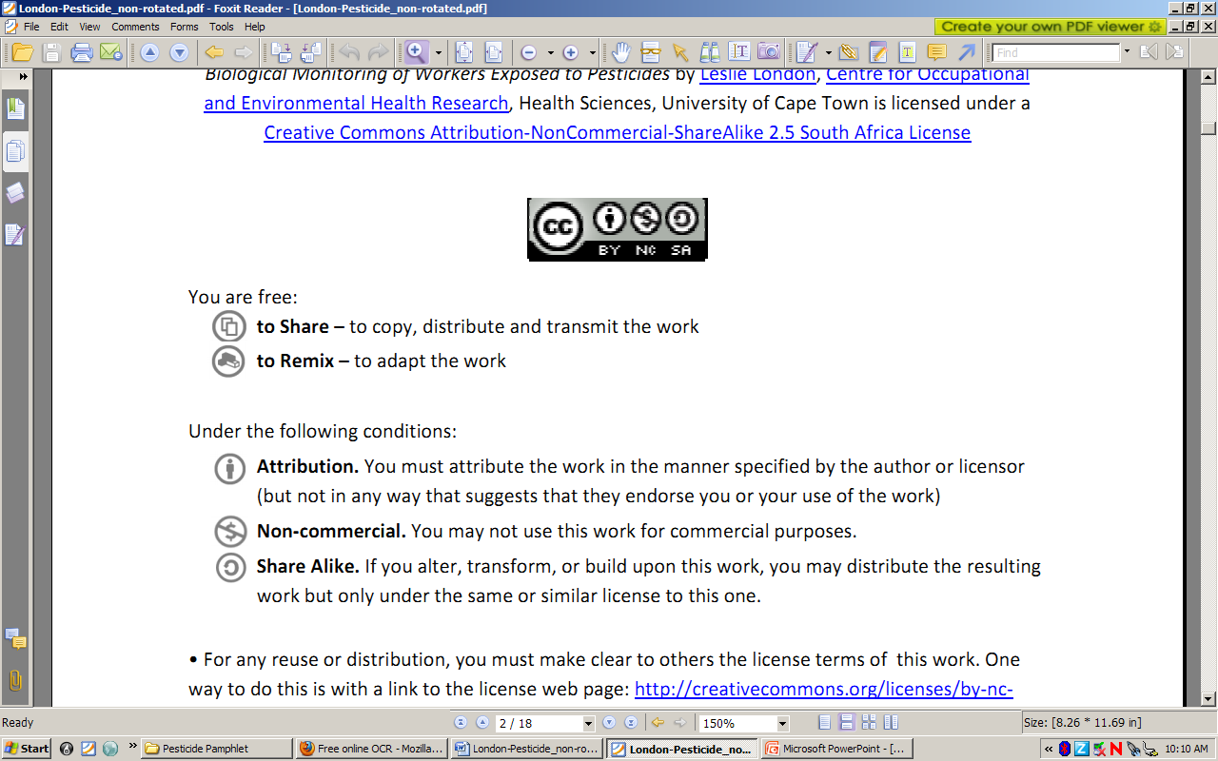to Share – to copy, distribute and transmit the work
to Remix – to adapt the work
Under the following conditions:
Attribution. You must at attribute the work in the manner specified by the author or licensor (but not in any way that at suggests that they endorse you or your use of the work)
Non-commercial. You m may not use this work for commercial purposes.
Share Alike. If you alter, transform, or build upon this work, you may distribute the resulting work but only under the same or similar license to this one.

• For any reuse or distribution, you must make clear to others the license terms of o this work. one way to do this is with a link to the license web page: http://creativecommons.org/licenses/by-nc-sa/2.5/za

• Any of the above conditions can be waived if you get permission from the copyright holder.
• Nothing in this license impairs or restricts the authors’ moral rights.
• Nothing in this license impairs or restricts the rights of authors whose work is r referenced in this document.
• Cited works used in this document must be cited following usual academic conventions
• Citation of this work must follow normal academic conventions

Source work available at Vula. Permissions beyond the scope of this license may be available at
www.healthedu.uct.ac.za or contact healthoer@uct.ac.za
We would appreciate your feedback for this Open Educational Resource (OER), by completing this form. Alternatively, you can email us at healthoer@uct.ac.za

