Where does insight come from?

This session will look at research skills both as a formal step-by-step process and as an intuitive, creative process.

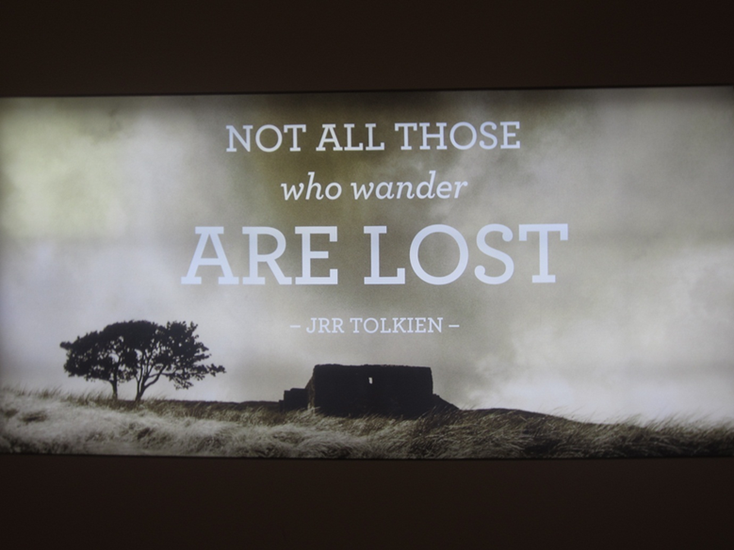

CONTENTS

Serendipity 2
Research is often presented as a rather mechanical process. 2
The human element in research 4
Transformative Research (TR) 6
Examples from across disciplines. 6
The “context of discovery” and the “context of justification” 9
What actually is serendipity? 12
And what actually is insight? 14
How do we foster serendipity and insight? 17
And what HINDERS serendipity and insight? 19
Nihil in intellectu nisi prius in sensu. 20
The unconscious mind. 24
The “Aha” moment. 27
A librarians’-eye view of the serendipitous research process 29

Serendipity
The term serendipity was coined by the English writer Horace Walpole and refers to the “knack of making fortunate discoveries unexpectedly, by accident or coincidence.” (Nutefall, 2010 : 228)
Well – yes – but it is a bit more complicated than that.
And even before we work out how it happens, and how to encourage it to happen, we have to acknowledge that it happens, quite respectably, and quite often, in formal academic research.
This, in itself, can be quite a step.

Research is often presented as a rather mechanical process.
While ideas can indeed come from reading in a formal, purposive, rationally directed literature review, there is a widespread tendency to present the research process as a rather plodding, step-by-step procedure - a rather mechanical one. This is convenient in one sense since research can be clearly and simply taught, justified and evaluated by fixed-step parameters.
In consequence, all kinds of diagrams exist to map out research procedures and support this simple image of research.
Here are some Google screenshots of examples of the “research process”:

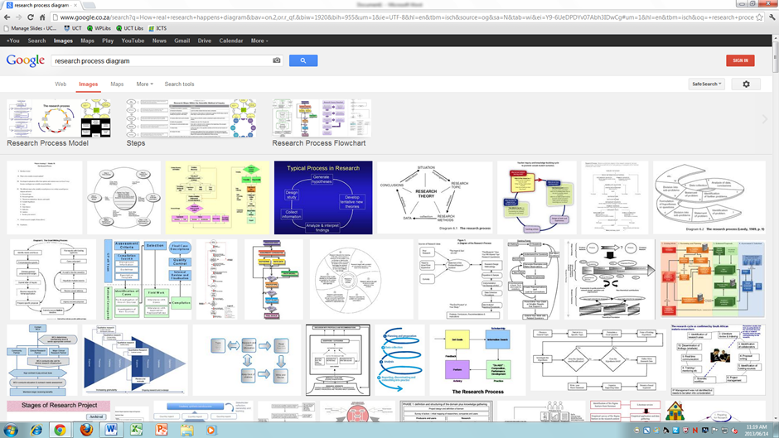

And, for the most part, they are quite mind-numbingly mechanical in approach. Viz.
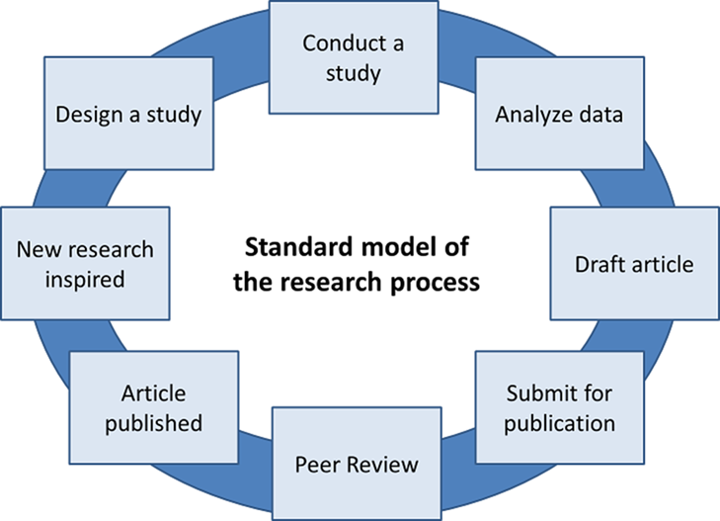
From http://projectimplicit.net/nosek/rp.png

But even so, there are a few which are more honest and complex and woolly…. Notice the arrows in the diagram below lead both ways, to and from the “idea”…. The idea is alive and fluid and developing constantly in response to new discoveries and insights.

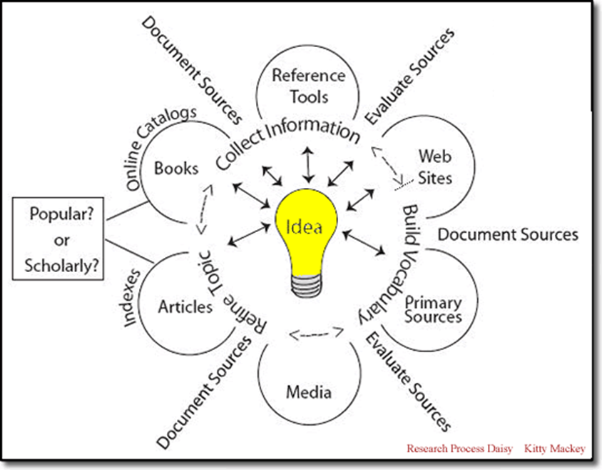
From http://www.clark.edu/Library/iris/types/research_process/images/research_daisy.gif

And then there are some diagrams which are very rationally woolly, in that they do specifically take into account the role of serendipity and chance discovery amidst all the careful planning (below) ….

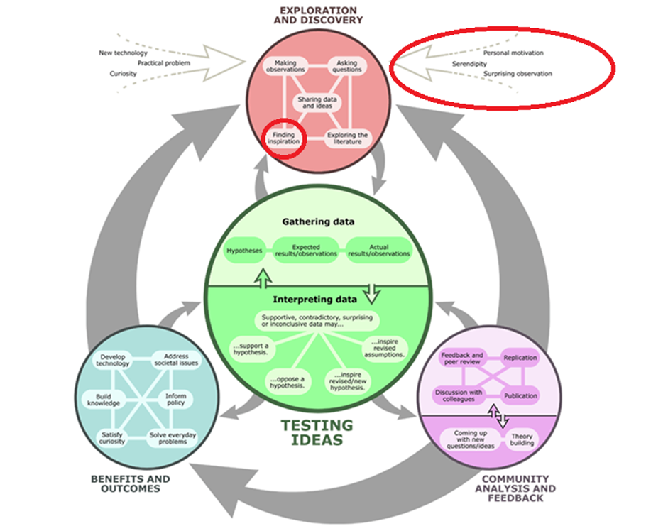
From http://mistypedurl.com/wp-content/uploads/2009/03/science_process_diagram_big.gif (Red highlight is mine)

The human element in research

In fact, while we are at it, it might be worth considering the human complexity behind research as well…. Note the reference in the “Exploration and Discovery” diagram above to “personal motivation” – linked as it is to Serendipity.
This is how the mind of the researcher, and anyone else, works in reality:
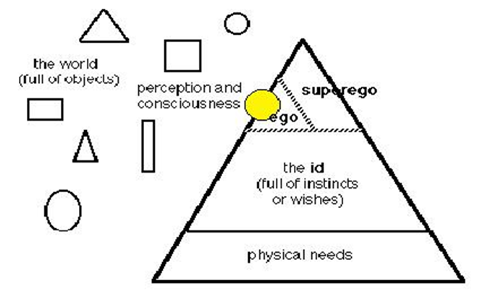
From http://jmccrackenworld.com/oldsite/Freud_partspersonality.JPG

Is this Freudian view of human motivation relevant to research?
In terms of illustrating the value both of serendipity and of deep inner motivation as it relates to the research process, we have the example of Pasteur, who provided one of the most famous quotes in this area:
In the field of observation chance favours only the prepared mind.
(Louis Pasteur, Lecture, University of Lille, 1854).

The official story of Pasteur’s discoveries is as follows:

“…. The breakthrough came in 1880 as a result of an oversight by his assistant, who had inadvertently left a batch of chicken cholera bacilli standing in the laboratory over a long hot summer. On injection into some healthy chickens the culture produced only mild and transient signs of disease. Pasteur then instructed his assistant to prepare a fresh batch of the bacillus and once more inject it into the chickens. They survived unscathed, whereas chickens fresh from the market succumbed rapidly to a similar injection. Pasteur had accidentally discovered an attenuated vaccine.….”
"Pasteur, Louis." In A Dictionary of Scientists. : Oxford University Press, 1999. http://www.oxfordreference.com/view/10.1093/acref/9780192800862.001.0001/acref-9780192800862-e-1099

But A.H. Barnett points out that while Pasteur, who was, incidentally, a chemist not medical doctor, “… described the secret to his achievements as ‘solely in my tenacity’ and ‘enthusiasm’ in scientific practice. …. What is less well known is that three of his children died of typhoid and it was this that stimulated him to discover why, and what could be done about the terrible infectious diseases so rife in his lifetime.”
(Barnett, 2011 : 1290)
So, it appears that we must factor into the research process not only the role of chance, and the impulse to capitalise on it, but also the deep inner motivations of the researcher.
This is quite a far cry from the common assumption of the detached scholar, methodically and dispassionately advancing, step by careful step.
Such research does exist, of course – and students are trained to do it, mainly because method can be reliably trained into people, whereas inspiration and insight cannot – but it is important to bear in mind that in some cases, often in the cases of truly ground-breaking, transformative work, the research process is often a lot woollier in reality.

Transformative Research (TR)

In fact it can be especially, and necessarily, woolly in the case of “Transformative Research” (TR) which by definition breaks free of the normal understandings of the discipline.
TR has been described as
… that which ‘‘transforms’’ or causes a major change in thought patterns concerning an area of scientific endeavor. This type of research is often elusive, requires different approaches and sometimes depends on a bit of luck. TR concerns intangibles such as human intuition, serendipity, unpredictable events, implausible hypotheses, a well-prepared mind and often interpersonal communications.
TR is usually not planned, although it depends on a receptive mind. It takes advantage of unpredictable events leading to novel hypotheses, some that seem implausible.… Anyone who discovers something genuinely new, or comes to appreciate information that was not previously recognized by the same person, experiences a personal revelation, often accompanied by feelings of elation.… New knowledge leaves the person permanently changed. Such individuals will never again be the same. They have intellectually evolved.
(Trevors et al., 2012 :118)
“They have intellectually evolved” is a lovely phrase – and true not just of the individual’s development, but, in Transformative Research, is also of the new impact on the discipline.

Examples from across disciplines.

The best known popular stories of serendipitous discovery tend to come from the Science or Medicine, since these breakthroughs often have the greatest impact on our lives and so pass into popular knowledge. Even when not widely known to the public, such examples are widely acknowledged in those disciplines:

Serendipity--the propensity for making surprising discoveries--is common throughout biology. Prominent examples include the discoveries of penicillin (Fleming 1929), meiosis (Beneden 1883), and cellular immunity (Metchnikoff 1901). It has been argued that major scientific discoveries cannot be premeditated, that they are instead the consequence of scientific preparedness of mind and, to a lesser degree, luck …..
(Michener, William K.Bildstein, Keith L.McKee, ArthurParmenter, Robert R.Hargrove, William W.McClearn,DeedraStromberg, Mark, 2009:49)

And openly acknowledged in the lives of individual researchers:

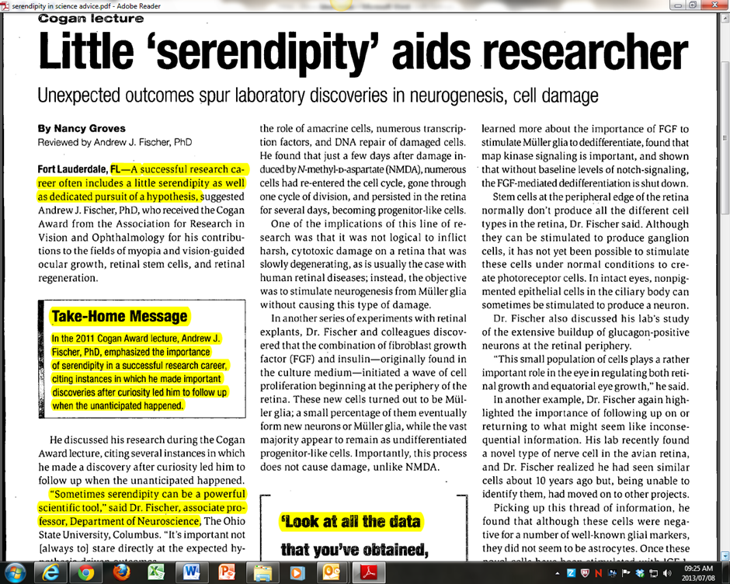

(Groves, 2011: 11)

However, such stories can be coaxed out of other disciplines too:

McClellan, for example, is one historian prepared to write of his belief that

“… every piece of historical writing shares an analogous set of accidental factors shaping its genesis. Most historian colleagues with whom I have broached these matters at once agreed that accidental factors are indeed at play. More than once, raising this point has elicited an "Oh, yeah,... when I was working on X-project, this and that intervened in this and that way to change the course of my research." The best example I have encountered is a colleague who specializes in American foreign relations and who, in the bowels of the library at the University of Alabama, came across an uncatalogued six-hundred-page manuscript about a massacre of missionaries in China in 1895. Not only did he publish a study of the manuscript, but it set the course for his own work, and has in turn influenced his field in general. (McClellan III, 2005 : 6)

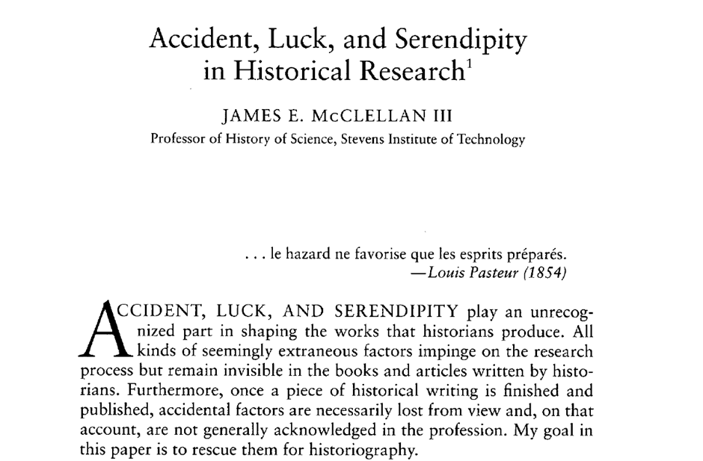

As a librarian, I have more than once heard senior historians dismiss the concept of “method” in research, saying that they “follow their nose,” or have developed “antenna,” and so forth during their research in libraries, or archives, or simply in looking about them at the surrounding world. From this perspective everything has a history – and everything can trigger an historical antennae.

And the Social Sciences, though commonly associated with very formal statistical surveys, have some established techniques for actively fostering serendipity….

ABSTRACT The paper deals with the issue of “serendipity” (which constitutes the context of discovery) in field research and the analysis of data by using the grounded theory methodology. The thesis of the paper is: the methodology of grounded theory is naturally associated with serendipity…..

In the methodology of grounded theory one assumes that at the beginning of research one ought to avoid detailed conceptualization. The research concept (its main categories and/or hypotheses and the whole theoretical construct consisting of combined hypotheses and their descriptions) should emerge in the process of empirical research and permanent analyses accompanying it. The social reality described and explained gradually comes into the view of an analyst and a researcher.

(Konecki, 2008: 171)

And even the hard-headed practitioners of the business disciplines have been known to acknowledge it …. sometimes….
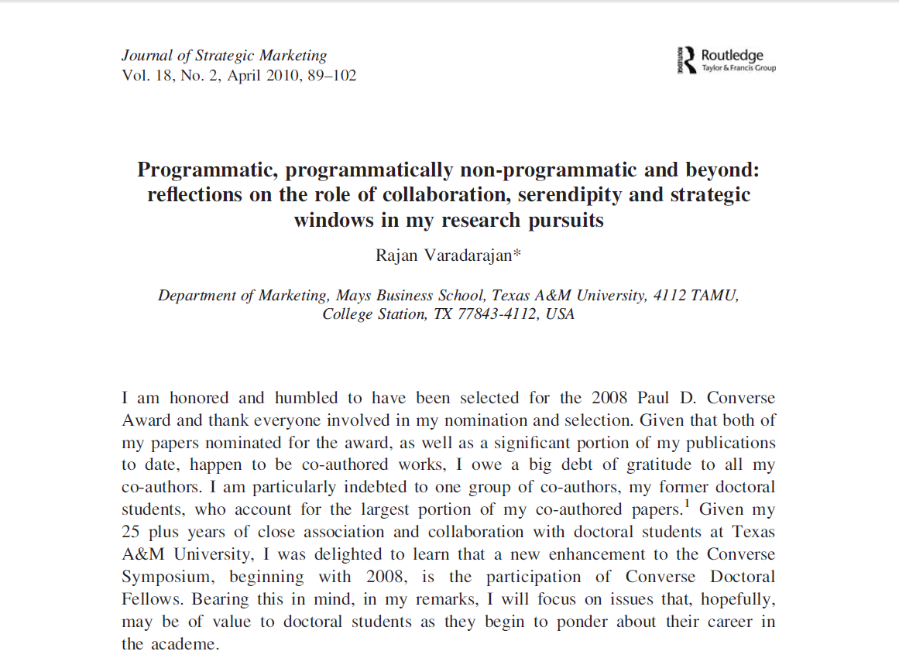
(Varadarajan, 2010 : 89)
But however open a researcher might be about the role of serendipity, or “luck” in their research, intentionally or otherwise the finished product often disguises the original discovery process.
Actually, there is a perfectly respectable, non-perfidious reason for this.

The “context of discovery” and the “context of justification”

In searching through subject encyclopaedias on historiography, I have come across no references to serendipity, a finding borne out by McClellan’s much more thorough investigation:

McClellan writes that he found “…nothing substantial in the historiographical literature that deals directly with the messy realities of historians in medias res. The closest I have come to a historiographical piece that touches on the issues of concern in this paper is the set of erudite essays published by Carlo Ginzburg in 1999, History, Rhetoric, and Proof' ….(the purpose of which was to explore) "the working methods of historians . .. the concrete work of historians . . . and actual historiographical practice."

McClellan goes on to quote Ginzburg: I find the current approach to historical narratives highly simplistic, since it usually focuses on the final literary product, disregarding the research (archival, philological, statistical, and so forth) that made it possible…. (McClellan III, 2005 :9)

McClellan accounts for this submersion of the serendipitous process of discovery (across disciplines) by Hans Reichenbach’s distinction between the "context of discovery" and the "context of justification" in the sciences:

The scientist who discovers a theory is usually guided to his discovery by guesses; he cannot name a method by means of which he found the theory and can only say that it appeared plausible to him, that he had the right hunch, or that he saw intuitively which assumption would fit the facts. Some philosophers have misunderstood this psychological description of discovery as proving that there exists no logical relation leading from the facts to the theory.... These philosophers do not see that the same scientist who discovered his theory through guessing presents it to others only after he sees that his guess is justified by the facts…. The act of discovery escapes logical analysis….but it is not the logician's task to account for scientific discoveries.... logic is concerned only with the context of justification. The route a scientist takes in making a discovery is thus different, often quite different, from the presentation he or she makes to persuade others of the correctness of a claim….
(McClellan III, 2005:11)

For Karl Popper:

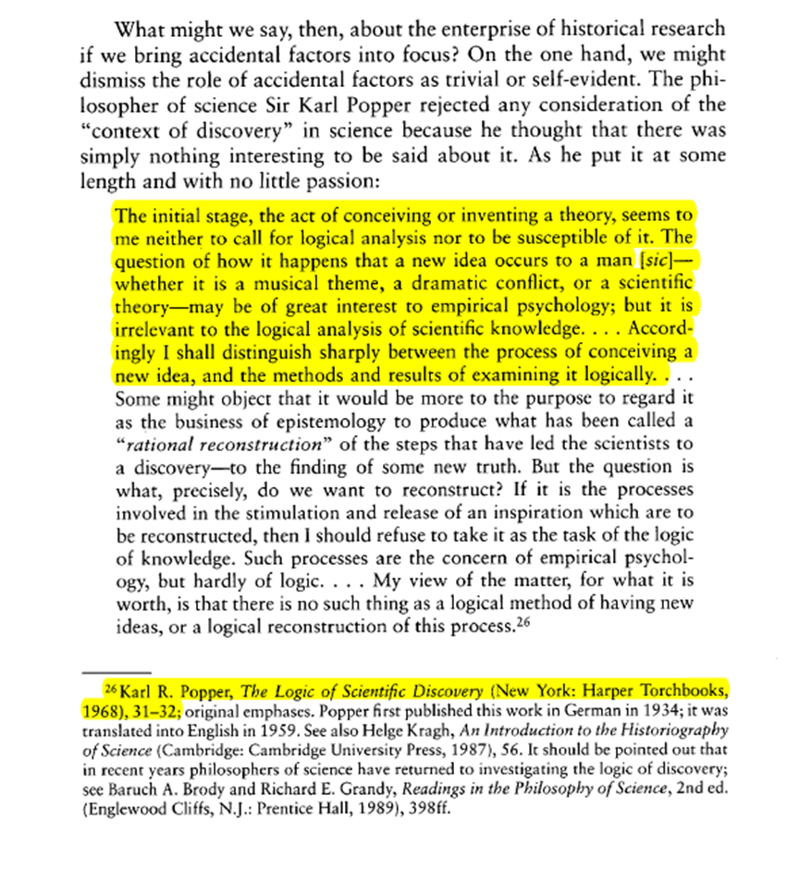

Karl R. Popper, The Logic of Scientific Discovery (New York: Harper Torchbooks,
1968), 31-32 in (McClellan III, 2005: 13)

Or, as the scientists themselves have described it:
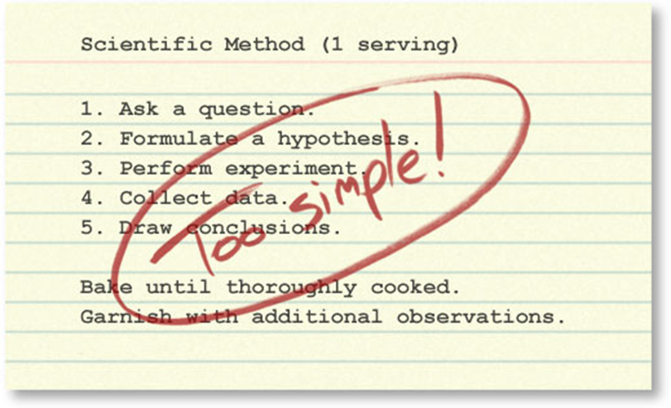
The linear, stepwise representation of the process of science is simplified, but it does get at least one thing right. It captures the core logic of science: testing ideas with evidence. However, this version of the scientific method is so simplified and rigid that it fails to accurately portray how real science works. It more accurately describes how science is summarized after the fact— in textbooks and journal articles — than how science is actually done.
From: http://undsci.berkeley.edu/article/howscienceworks_01
So – there we have it - serendipity happens, and that’s ok, but it must thereafter be justified by logic or experimentation that tests its insights.
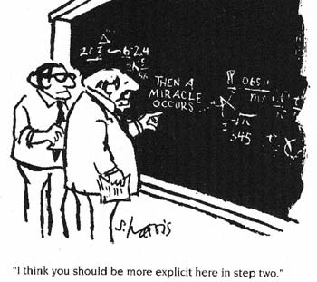
From : http://revelation4-11.blogspot.com/2009/06/why-does-science-work-so-well.html
But what actually is serendipity? (And, for that matter, what is insight?)

What actually is serendipity?

Makri and Blandford explored various definitions and models of serendipity, noting that:

The examples provided were varied, but shared common elements (they involved a mix of unexpectedness and insight and led to a valuable, unanticipated outcome).

(Makri & Blandford, 2012a :684)

One clear definition of serendipity referred to in this article is that of Cropsey, who “argues that knowledge is created by someone noticing the significance of an observation or piece of information and making a mental connection as a result (rather than from the observation or information itself), and another definition which emphasises the personal uniqueness of the insight is that of Fine and Deegan (1996), who define Serendipity as “the unique and contingent mix of insight coupled with chance. ”

(Makri & Blandford, 2012a :685)

The article also explores various models of the process of serendipity:

The first of these models was proposed by McCay-Peet and Toms (2010), who
adapted work by Cunha (2005) to describe the process of serendipity. They suggest
that:

(1) While searching for a solution to an information task (Task A) . . .
(2) And with certain precipitating conditions and a serendipity “trigger” . . .
(3) A bisociation (a surprising association between disparate, previously
unconnected pieces of information) is made . . .
(4) And an unexpected solution is found – either to Task B (a different information
task to Task A) or to Task A (which they refer to as “arriving at the right
destination by the wrong boat”).

(Makri & Blandford, 2012a: 684-685)

Liestman’s model, examined in a follow up article by Makri and Blandford, is valuable in taking into account various forms of serendipity, one of which,“Prevenient Grace”, quietly acknowledges the role of librarians, as well as “Altamirage”, the unique and idiosyncratic ragbag of personal knowledge each individual possesses, and “Sagacity”, the quiet connection of disparate bits of information in the mind.
(Makri & Blandford, 2012b: 710-711)

Liestman (1992) proposes six combinable approaches to serendipity:

(1) Coincidence – the most narrow of the six approaches, which regards
serendipitous information discoveries to be a result of “random luck – plain and
simple” .

(2) Prevenient grace – that serendipitous discoveries can occur due to expert prior
organisation of information (i.e. “efforts performed on [a library user’s] behalf
by those who are unseen and unknown”).

(3) Synchronicity – that serendipitous discoveries can be a result of the
“simultaneous occurrence of two meaningfully but not causally connected
events” .

(4) Perseverance – that serendipitous discoveries can be encouraged by looking
hard for information, tipping the odds in favour of unanticipated discoveries

(5) Altamirage – that serendipitous discoveries can be a result of idiosyncratic
expertise – i.e. “distinctively personal habits, character, knowledge, or other
individualized traits” .

(6) Sagacity – that serendipitous discoveries come either sub-consciously from ““a
random juxtaposition of ideas,” in which loose pieces of information frequently
undergo a period of incubation in the mind and are brought together by the
demands of some external event, such as a reference query which serves as a
catalyst” .

(Makri & Blandford, 2012b: 710-711)

Makrio and Blandford’s own model of serendipity, however, emphasises the recognition of serendipity only in hindsight: “The circumstances that led to the connection are subsequently (and subjectively) considered to have involved an amount of unexpectedness. The making
of the connection itself is subjectively considered to have involved an amount of
insight.”



(Makri & Blandford, 2012a: 691 Figure 2.)

While this hindsight effect may be valid in many cases, I am not sure it should be seen as a constant rule. There are many instances when the realisation of serendipity, and the moment of insight, happens instantly – on sight, as it were – and much “serendipitous” information comes about through vaguely-purposive browsing rather than pure chance.

As opposed to Makri and Blandford’s whole-process approach, De Bruijn and Spence focus on this moment of serendipity.

We refer to the serendipitous acquisition of information which typically occurs when a user’s gaze happens to fall on a representation – perhaps an image and two or three words - of some information of interest. Up until the point at which the relevance of the representation to some long-standing interest is recognized, current theories suggest that no conscious cognitive effort is involved in the discovery of such information….
The fact that a mere glance – perhaps only 100ms in duration – can trigger the awareness of a possible solution to a problem, coupled with the typical abundance of latent interests stored in a user’s long-term memory, suggests that the serendipitous acquisition of information is a phenomenon that deserves to be studied with a view to its exploitation.
(de Bruijn & Spence, 2008: 5:3)

So – all this is starting to look as if there are two components to “serendipity” – The chance encounter with information, cultivated or otherwise, and the connection between bits of information in the head.
Altamirage, Sagacity, Bisociation …. As the old joke goes, Newton’s dog also saw the apple fall, but it was Newton who made the connections in his head and had an insight.

And what actually is insight?

Serendipitous encounters are not serendipitous unless they light this little fire in the head. Without the insight, they are just things that happen and objects passing through view.
The first scholar to really work in “insight” was Wolfgang Köhler:

Köhler, Wolfgang (1887–1967).
Co-founder and leading member of the Gestalt school of psychology… His celebrated book describing his observations and experiments appeared in German as Intelligensprüfungen am Menschenaffen (English translation The Mentality of Apes, 1925). In this book, Köhler developed the important thesis that problem solving involving detours or simple tool using comes about through sudden insight, and does not depend on fortuitous trial and error as E. L. Thorndike had contended….
Zangwill, O. L. "Köhler, Wolfgang." In The Oxford Companion to the Mind. : Oxford University Press, 2004. http://www.oxfordreference.com/view/10.1093/acref/9780198662242.001.0001/acref-9780198662242-e-501
One of the best known experiments involved a chimp, Sultan, trying to get hold of a banana outside his cage. He had a number of bamboo poles, of different diameters, but none of them were long enough to reach the banana….
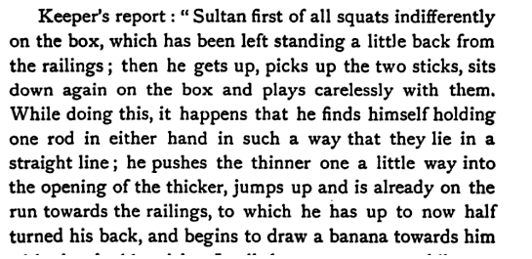
(Köhler, 1927:132)
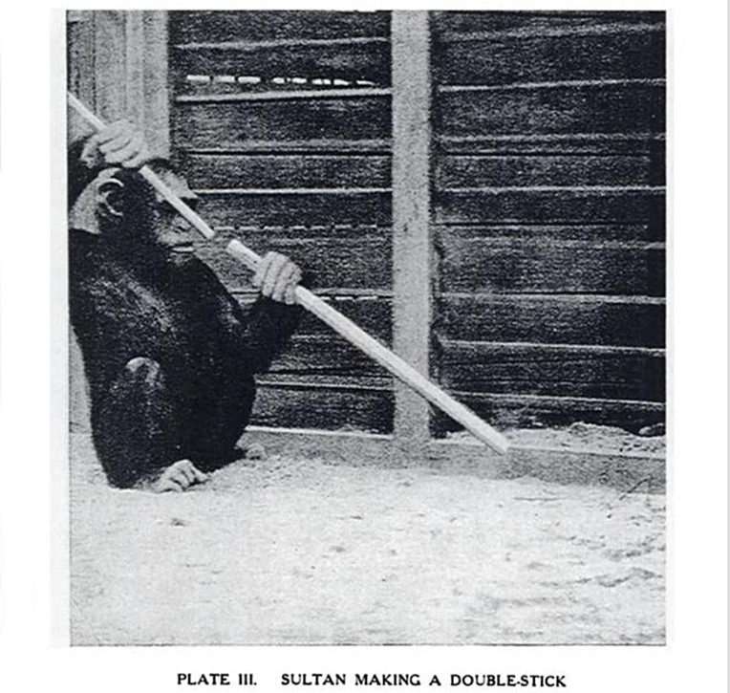
Some observations from this:
Sultan had a library (of sticks) in which he browsed until suddenly he made a chance connection between two items (two sticks). It was also not an especially foregone conclusion - Sultan spent some time mucking around (“plays carelessly with them”) before the penny suddenly dropped that one stick could connect to another.
But once it did drop, he then connected the concept of “artificially long stick” with “I can get the banana!!!!” very swiftly indeed.
This last connection was not chance juxtaposition – this was insight in which the different domains, the old problem of bananas and the new discovery that sticks can fit together were connected in the head. The word for that act of insight is “Bisociation.”
According to Koestler, a bisociation is a result of literal processes of the mind when making completely new associations between concepts from contexts (domains/categories/classes) that are usually considered separate.
(Petric et al., 2012) :47-48
Bisociation is a key element in insight. One definition of insight learning relies upon it implicitly.
insight learning
A form of learning in which an animal responds to new situations by adapting experiences gained in other contexts…. Chimpanzees are capable of insight learning.
Martin, Elizabeth, and Robert Hine. "insight learning." In A Dictionary of Biology. : Oxford University Press, 2008. http://www.oxfordreference.com/view/10.1093/acref/9780199204625.001.0001/acref-9780199204625-e-2291

And it is worthy considering the role of the (incredibly slippery term) “intelligence” in this context….

intelligence
The coordination of memory, learning, and reasoning in animals. Intelligence has also been defined as the ability of an animal to form associative links between events or objects of which it has had no previous experience (see insight learning)….
Martin, Elizabeth, and Robert Hine. "intelligence." In A Dictionary of Biology. : Oxford University Press, 2008. http://www.oxfordreference.com/view/10.1093/acref/9780199204625.001.0001/acref-9780199204625-e-2300.
These two definitions, together, seem to form a bit of a recursive loop between intelligence and insight learning....
Related to such bisociations is also the factor of memory:
In this respect, interesting light is shed on long-term unresolved goals by Zeigarnik [1938] who showed that uncompleted tasks are remembered better than completed ones. The fact that a mere glance – perhaps only 100ms in duration – can trigger the awareness of a possible solution to a problem, coupled with the typical abundance of latent interests stored in a user’s long-term memory.
(de Bruijn & Spence, 2008 :5.2)
Or, more plainly “An insight is often a long-forgotten memory or combination of memories.”
(Rock, 2011: 47)
Serendipity, it seems, only works if you have a head full of background stuff to connect the new stuff to, and are bright enough to make that connection, either immediately or after a little while of “playing carelessly” with ideas.

How do we foster serendipity and insight?

In a library context, a magic word is “browsing” – but there are different types of browsing:
…. we define two classes of browsing where browsing is taken to mean the perceptual registration of visual content [Spence 1999].

Opportunistic browsing (OB) is intentional, but the user is unaware of any goal being pursued. The attitude underlying OB is “let’s see what’s there”.

In contrast, involuntary browsing (IB) is unintentional, though again the user is unaware of any latent goal that might be pursued. An example is provided by a scenario in which a user’s eye gaze, naturally moving rapidly between a series of fixations, serendipitously fixates on an information item that may lead to the answer to a longstanding query.

There is a third type of browsing which is not serendipitous in intent but will be discussed later, and it is useful to define it here for comparison. Search browsing (SB) is intentional, and the user is aware of the goal being pursued, however precisely or otherwise it is defined…. SB is typified by a Web search for specific information

(de Bruijn & Spence, 2008:5.3-5.4)

And while browsing, Makri and Blandford’s interviewees mentioned the importance of “being relaxed, alert, in a good mood and willing to deviate from the current task.”
(Makri & Blandford, 2012a : 685)
But there are two intellectual approaches that can be taken routinely, and deliberately, to foster serendipity.
The first is to deliberately explore beyond the known boundaries. Many times I have warned students against searching too “tightly” – in terms of index term selection and imposed database limiters -since this will often result in finding little beyond what one already knows to begin with.
I am not alone in thinking this, as witness the abstract of an article on “Outlier Detection in Cross-Context Link Discovery for Creative Literature Mining”
…. detecting interesting outliers which appear in the literature on a given phenomenon can help the expert to find implicit relationships among concepts of different domains.
The underlying assumption is that while the majority of articles in the given scientific domain describe matters related to a common understanding of the domain, the exploration of outliers may lead to the detection of scientifically interesting bridging concepts among disjoint sets of scientific articles.
(Petric et al., 2012: 47)

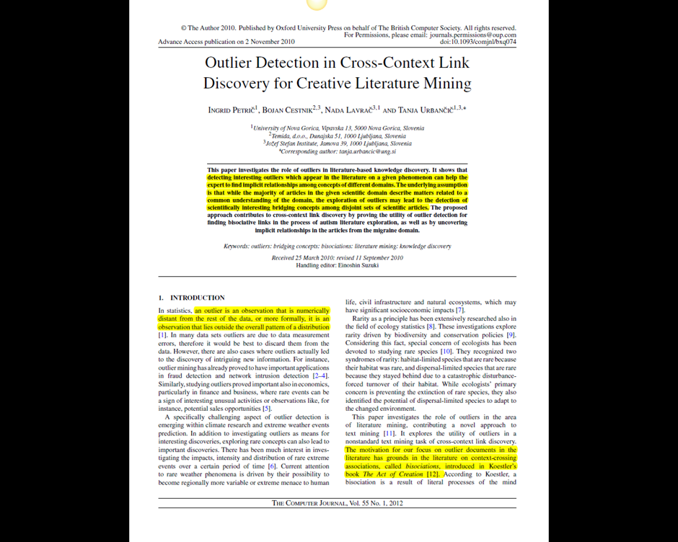

The other requirement to capitalise on your new insights is intellectual honesty and courage.
With regard to the difficulties in conveying Transformative Research (TR):
Transformative discoveries leading to paradigm shifts can transform at many levels including scientific, personal and sociological. They may change cultural values and transform a society. When this occurs, there are sociological ‘‘stages’’ of resistance preceding transformation: first denial, then anger, and finally acceptance. Arthur Schopenhauer summarized this progression as follows: ‘‘All truth passes through three stages. First, it is ridiculed. Second, it is violently opposed. Third, it is accepted as being self-evident.’’ On the other hand, Winston Churchill noted: ‘‘Men occasionally stumble over the truth, but most of them pick themselves up and hurry off as if nothing ever happened.’’
(Trevors et al., 2012: 119)
Not incidentally, the title of this article - Transformative research: definitions, approaches and consequences.

This brings us to the second point about intellectual honesty – the courage to articulate it.
The final word on this belongs to Orwell:
Political writing in our time consists almost entirely of prefabricated phrases bolted together like the pieces of a child's Meccano set. It is the unavoidable result of self-censorship. To write in plain vigorous language one has to think fearlessly, and if one thinks fearlessly one cannot be politically orthodox.
From Essay of 1946 “The Prevention of Literature” http://orwell.ru/library/essays/prevention/english/e_plit (accessed 11 July 2013)

And what HINDERS serendipity and insight?

What is required to perform transformative science?
One needs to diligently work at not rushing off or ignoring ideas when one stumbles over a potential truth. One must not be dissuaded if it does not conform to accepted dogma.…
(Trevors et al., 2012: 119)
In some cases serendipity and insight can be hindered by a learned (or externally imposed) intellectual rigidity:
How to conduct TR is difficult to teach to students, research teams, the public and bureaucrats. Research is ultimately about thinking, focusing, dreaming, and writing.
(Trevors et al., 2012: 121)

But in other cases we can be quite unconsciously embedded in what Harold Rosenberg famously called “the herd of independent minds,” (Rosenberg, 2013) and even the international community of the internet may be less helpful in overcoming this than we think:
Day-to-day homophily—the tendency of like to congregate with like—exerts a stronger influence over us than the desire for novelty or difference. In all aspects of our lives, off-line and on-, we compulsively and mostly unconsciously sort ourselves into groups and niches, reassuring cocoons from which we rarely venture.
To put it another way, parochialism is a symptom of audience empowerment. We search for information we already want or find new things through people we know, and since these people tend to resemble ourselves, a lot happens in the world that we never hear about.
(Taylor, 2013)
And even when we are not – and are actively seeking exposure to alternative points of view, our search tools may be overly helpful in circumscribing our findings:

A scholar who only reads exactly what a computer-based indexing system thinks is what is relevant to her work is at serious risk of not being exposed to new ideas, and will never get an overall grasp of her broad subject field.
When I started off as librarian of the Institute of Psychiatry, somewhat over quarter of a
century ago, it was our custom to put all the printed journals received each day out on a
display table. There were a considerable number of academics who would make a point of
coming up to the library once a day, for half an hour or so, in order to browse through the
whole lot…. Browsing through it may trawl up nothing useful at all except the emotionally important fact that other people are working in the same general field as you, but, on the other hand, an apparently irrelevant paper in it just might serendipitously trigger off some new idea: a way of thinking that distinguishes a human from an ants nest.

(Guha, 2009: 278-279)

Nihil in intellectu nisi prius in sensu.
Blackburn, Simon. "nihil in intellectu nisi prius in sensu." In The Oxford Dictionary of Philosophy. : Oxford University Press, 2008. http://www.oxfordreference.com/view/10.1093/acref/9780199541430.001.0001/acref-9780199541430-e-2173.

Asking the right questions is often the single most difficult thing about research, since it involves identifying what you don’t know – that can be quite a vicious circle, of course, since you don’t know what you don’t know – and even when you find out, phrasing the question in the right terminology….. sometimes you simply have to see it before you can think it.
That brings us back to browsing, physically and electronically, since, after all, you can’t search for what you don’t know.
I recall an academic telling me of routine serendipity in the shelves – finding a “book you’d never thought of looking for, absolutely essential to your work, right next to the one you were looking for.” I ground my teeth slightly at that, since, while serendipitous, all right, that is actually all down to the miracle of Dewey numbers and good subject cataloguing – the behind-the-scenes activity of library cataloguers that is referred to as “prevenient grace” (Makri & Blandford, 2012b:711)
But real serendipity happens when you are idly scanning the shelves, miles from your usual subject area, and a book title leaps into vision that suggests …. Or that reminds you… or that makes you wonder….
You see, the great secret of serendipity in browsing at random on library shelves is that the division of knowledge in academe and in library systems are highly artificial – they are simply an administrative convenience – and in reality everything is connected, if you can only follow the web of associations far enough.
In this sense the library shelves, and the titles on them, even just glimpsing a book title, can serve as an old fashioned “memory palace” – physical props that jog memories of books once read, or meant-to-be-read, or topics once thought of… or never thought of until that moment….
Unintentional Knowledge : What we find when we're not looking

By Julio Alves
…. Now students hardly ever use books in their research, and their papers have become as predictable as those they write from assigned readings.
When I started teaching, books were easier to find than articles…. Students took different paths in their research and came up with wildly different sets of texts….
As periodical-search engines blossomed, students, ever adaptable, started using more articles….
Today we applaud students not for exploring the stacks but for being efficient, making research quick and easy.
But should research be quick and easy? Yes and no.
If we think of education as the gaining of intentional knowledge, then yes: The students had a question, and they found an answer. Search engines lend themselves well to the learning of that kind of knowledge.
But as the late philosopher Michael Polanyi and others have argued, most of the knowledge we possess is not conscious and intentional; it is incidental, or tacit, acquired as a by-product of performing some other activity.… The library stacks are a mine of incidental knowledge.
Imagine a first-year student in a course on global poverty who is trying to determine if a policy of economic "degrowth" can alleviate the plight of the extreme poor. She can find excellent full-text articles on the topic …. She could be done with her research.
But what if she decides she wants to look at a book, perhaps Serge Latouche's Farewell to Growth, an accessible, impassioned introduction to the degrowth movement?
After tracking down the call number, she sets off.
On her way, she walks past a wealth of scholarship, some of which may catch her eye. Given her interest in social justice, she might stop and look at the section of books on Brazilian history and culture, which contains prominent titles on social justice. These opportunities for incidental learning happen multiple times on the way to her book….
Before she spots the thin single volume of Farewell to Growth, she will probably notice Paul Wachtel's hefty The Poverty of Affluence: A Psychological Portrait of the American Way of Life, a title that will resonate with the conversations we have been having in class. If she scans the table of contents, she will see chapters like "The Illusions of Growth," "The Cultural Context of Growth Ideology," and "New Alternatives."
She may not know of the popularity of Wachtel's book when it first appeared, but she would probably understand its intriguing argument: More is not necessarily better, and growth does not necessarily bring happiness. If she notices the publication date—1983, apparent in its call number—she might realize that the degrowth movement may be new and edgy, but that its roots predate her birth. She would learn all this before reading Wachtel's book, but she might decide to read it and use it in her paper, which would make for a rather original discussion.
These library journeys feel like a waste of time to students, but they are of immense value. Incidental knowledge may not be of immediate use, but it will become the fuel that powers acts of creativity and discovery to come. Students can see the holdings and make decisions for themselves instead of allowing an algorithm to decide for them….
Julio Alves is director of the Jacobson Center for Writing, Teaching and Learning and of the Writing Program at Smith College.
(Alves, 2013)
Above – the human browser in full exercise of inexpressible, near magical, insight.
And in terms of electronic articles rather than physical books or journals - there are sites which do a similar job by garnering articles of truly eclectic interest from hundreds of sources. Arts and Letters Daily, for example, is a prime site of serendipity for Humanists in action….

(www.artsandlettersdaily.com)
And then there is the old academic standby of searching for a journal article – in print or electronically – and then taking a few minutes to scan the whole journal while you are at it. Journal alerts can be set up to alert you to new issues of a journal, for quick scanning of entire issues as published:


But above all, when searching journal databases, it is useful to develop the habit of searching in layers – loosely at first, with broad subject terms, then seeing what there is and gradually tightening up the search with more terms or more precise terms gleaned from the results and their subject headings.
It is this kind of broad searching that brings up “outliers” in the literature, and also encourages interdisciplinary results. The drawing of connections between apparently unconnected topics, or topics in different registers (sticks and bananas, in Sultan’s case, for example) is the key factor in insight. Koestler, below has termed it “bisociation,” and because such insights fall outside the routines of conscious mentation, they are often the province of other parts of the mind, ticking away quietly behind the scenes….
(Blurb from the cover of The Act of Creation)
Modern psychology states that up to a point every person is an automaton. "The Act of Creation" begins where this view ceases to be true.
Koestler affirms that all creatures have the capacity for creative activity, frequently suppressed by the automatic routines of thought and behaviour that dominate their lives. The study of psychology has offered little in the way of an explanation of the creative process, and Koestler suggests that we are at our most creative when rational thought is suspended—for example in dreams and trance-like states.
Then the mind is capable of receiving inspiration and insight. Taking humour as his starting point, Koestler examines what he terms 'bisociative' thinking—the creative leap made by the mind that gives rise to new and startling perceptions and glimpses of reality.…
(Koestler, 1989)

The unconscious mind.

The topic of accident, luck, and serendipity is not exactly the elephant in the room whose presence we need to recognize; perhaps it is more like the staff in the kitchen whose labor we do not ordinarily think about, but who make real contributions to the meals we digest at the high table of intellectual inquiry and discourse.

(McClellan III, 2005 : 2)

The creative /insightful workings of the mind are a technical activity of the unconscious mind. The physical (neural) workings of the mind have been examined in a number of studies. A layman-speak summation of some of these is available in a rather more accessible blog posting:

Why we have our best ideas in the shower: The science of creativity
So, what is actually active in our brain when we are doing something creatively? That’s always been extremely hard to track as creativity has always been considered a very vague activity. Until recently researchers Allen Braun and Siyuan Liu had a genius idea: Track the brain activity of rappers doing freestyle and turn it into a research study.
….
To make it a bit more understandable:
“We think what we see is a relaxation of ‘executive functions’ to allow more natural de-focused attention and uncensored processes to occur that might be the hallmark of creativity,” says Braun.
So, the areas in our brain, that we use to make decisions is largely inactive. The “medial prefrontal cortex” area, which is responsible to learn association, context, events and emotional responses however was extremely active on the other hand. This graphic of brain activity probably describes it best:
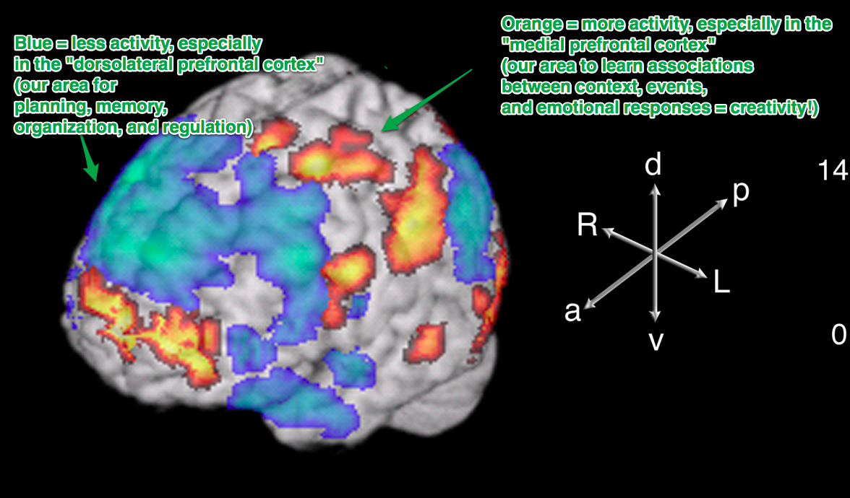
….
The fact that free-style rapping shows us a high level of creativity, still doesn’t explain why great ideas happen in the shower.
Alice Flaherty, one of the most renowned neuroscientists researching creativity has an answer for us. Another ingredient, that’s very important for us to be creative is dopamine: The more dopamine that is released, the more creative we are, she says:
“People vary in terms of their level of creative drive according to the activity of the dopamine pathways of the limbic system.”
….
Typical triggers for events, that make us feel great and relaxed and therefore give us an increased dopamine flow are taking a warm shower, exercising, driving home, etc. The chances of having great ideas then are a lot higher.
Still, that’s not all there is to it. Dopamine alone, which gets triggered in hundreds of events, where we aren’t very creative, can’t be the only reason. Another crucial factor is a distraction, says Harvard researcher Carson:
“In other words, a distraction may provide the break you need to disengage from a fixation on the ineffective solution.’’
Especially if you have thought long and hard all day about a problem, jumping into the shower can turn into what scientist call the “incubation period” for your ideas. The subconscious mind has been working extremely hard to solve the problems you face and now that you let your mind wander, it can surface and plant those ideas into your conscious mind.
Lastly, after you have received an influx in dopamine, can be easily distracted by an extremely habitual task like showering or cooking, a relaxed state of mind is absolutely important to be creative, says Jonah Lehrer:
“Why is a relaxed state of mind so important for creative insights? When our minds are at ease–when those alpha waves are rippling through the brain–we’re more likely to direct the spotlight of attention inward, toward that stream of remote associations emanating from the right hemisphere. In contrast, when we are diligently focused, our attention tends to be directed outward, toward the details of the problems we’re trying to solve. While this pattern of attention is necessary when solving problems analytically, it actually prevents us from detecting the connections that lead to insights. ‘That’s why so many insights happen during warm showers,’ Bhattacharya says. ‘For many people, it’s the most relaxing part of the day.’ It’s not until we’re being massaged by warm water, unable to check our e-mail, that we’re finally able to hear the quiet voices in the backs of our heads telling us about the insight. The answers have been there all along–we just weren’t listening.”
So this seems to be the magic combination: If you are in a relaxed state of mind, easy to distract and full of dopamine, your brain is most likely to give you your best, most creative ideas.
….
(Widrich, February 28th, 2013)

A similarly accessible report stresses the importance of a quiet mind for picking up the quiet voice of insight:
…. insights tend to involve connections between small numbers of neurons.
An insight is often a long-forgotten memory or combination of memories. These memories don’t have a lot of neurons involved in holding them together. The trouble is we only notice signals above whatever our baseline of noise is. Whereas everyday thoughts, such as wondering what to have for lunch, might involve millions of neurons speaking to each other, an insight might involve only a few tens of thousands of neurons speaking to each other.
…. Hence, we tend to notice insights when our overall activity level in the brain is low. This happens when we’re not putting in a lot of mental effort, when we’re focusing on something repetitive, or when we are just generally more relaxed such as we are when we wake up.
Insights require a quiet mind because they themselves are quiet.
(Rock, 2011: 47)

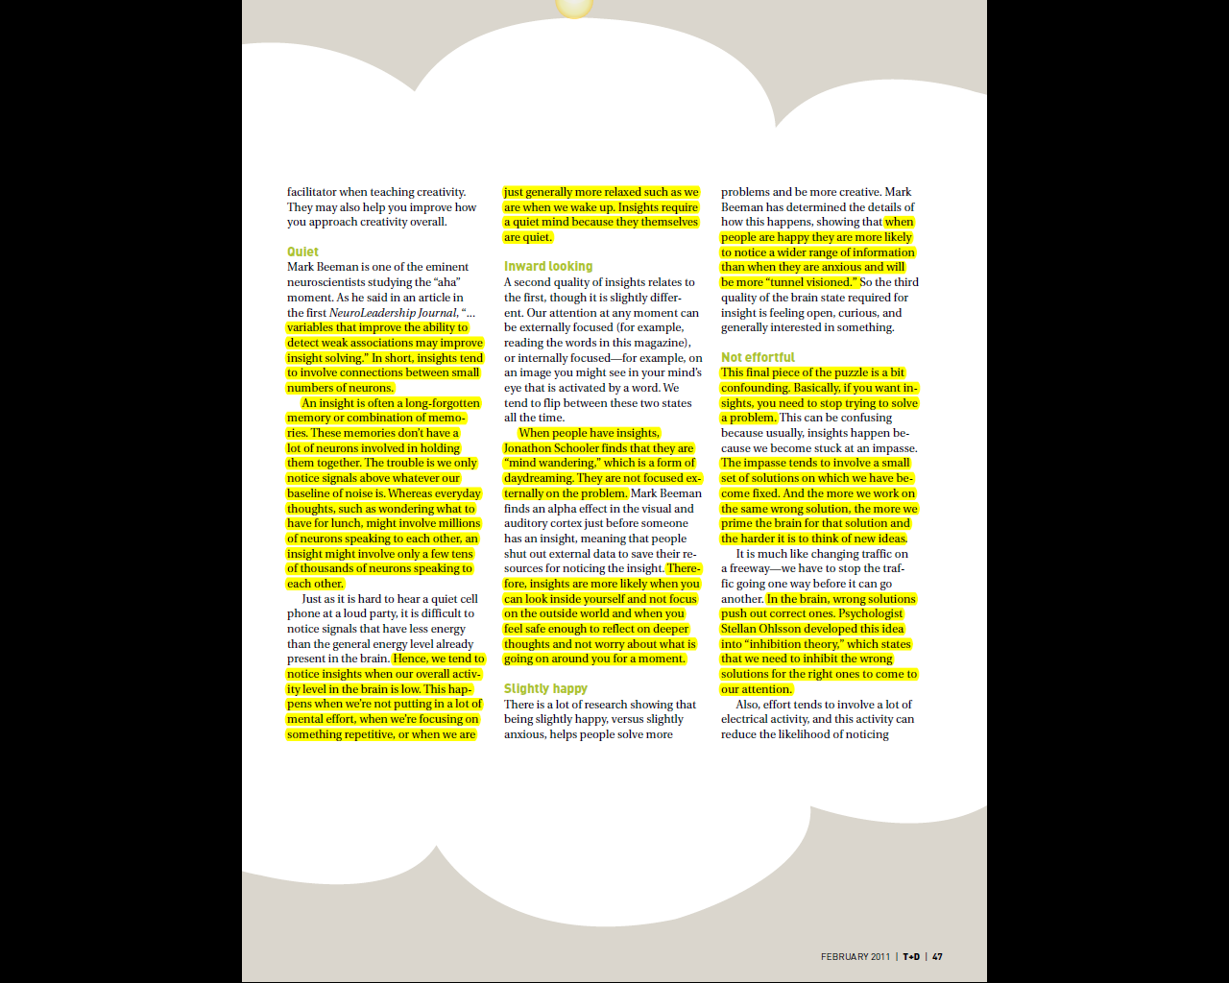
(Rock, 2011: 47)

The “Aha” moment.

The title of the Rock article, above, references the “Aha” moment. It is a characteristic of insight to be accompanied by a sense of realisation – a sense of certainty.
This sense of certainty is a sign of unconscious processes making their report to consciousness.
Simply put:

‘‘At a certain point, you just have to admit that your brain knows more than you do.’’

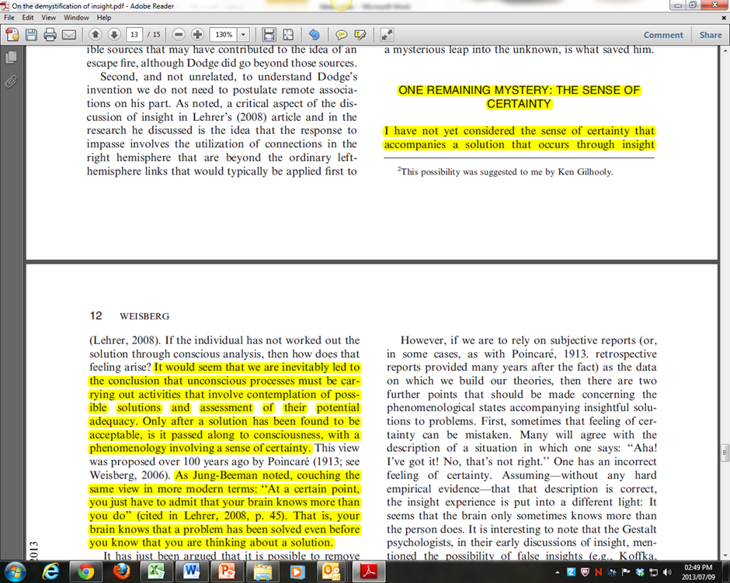
(Weisberg, 2013 : 4)

And it is not mere animal instinct – there is a lot of rational thought going on, in the unconscious:

…. For his own discoveries Poincaré describes ‘appearances of sudden illumination, obvious indications of a long course of previous unconscious work’, and he gives interesting first-hand examples. He holds that most creative work consists of unconscious selection of possibilities, the selection being guided by subtle rules for rejection which may be worked out during conscious activity. The result is direction and purpose, with a minimum of thinking time wasted on dead ends.
Gregory, Richard L. "Poincaré, Jules Henri." In The Oxford Companion to the Mind. : Oxford University Press, 2004. http://www.oxfordreference.com/view/10.1093/acref/9780198662242.001.0001/acref-9780198662242-e-685

A librarians’-eye view of the serendipitous research process

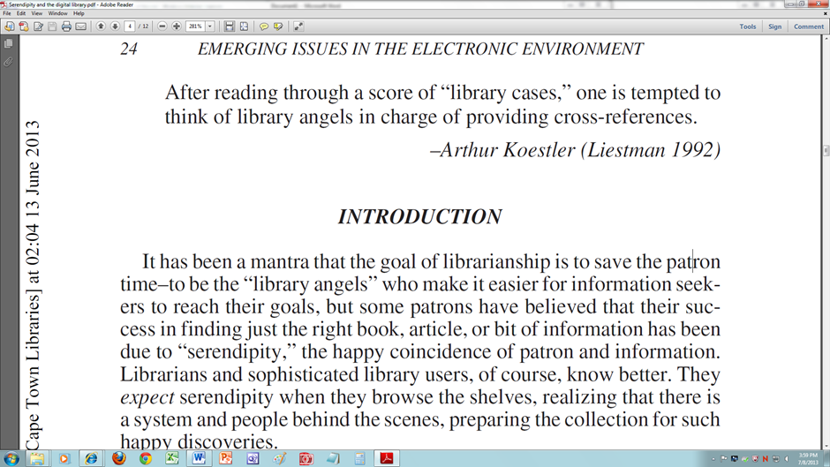
(Cooksey, 2004 : 24)

One aspect of serendipity, referred to by Liestman, above, is “prevenient grace.”

“Prevenient grace assumes that researchers are led to serendipitous materials through “the cataloging, classification and organization of information”; in other words, through the work of others.“ (Nutefall & Mentzell, 2010: 229)

Such background work is often invisible to the user, but it is there, and one of the tasks of librarians might be to help users become more conscious of the existence of these connections – how they work and how to follow them, linking from one to another, related, but unanticipated subject heading.

…. some patrons have believed that their success in finding just the right book, article, or bit of information has been due to “serendipity,” the happy coincidence of patron and information. Librarians and sophisticated library users, of course, know better. They expect serendipity when they browse the shelves, realizing that there is a system and people behind the scenes, preparing the collection for such happy discoveries.
(Cooksey, 2004: 24)

Linked to this, is the way that a research question can, and perhaps should, develop in response to information uncovered and new ideas developed. Nutefall and Mentzell focus on the work of Marcia Bates in this regard, and her term “berrypicking.”

In her work on “berrypicking” Bates argues that real life queries change and evolve during the course of searching. Berrypicking is defined as a “bit-at-a-time retrieval” and differs from a traditional model in that the question is evolving and the search process changes instead of there being a best retrieved set. She writes that each new piece of information they encounter give them new ideas and directions to follow and consequently, a new conception of the query.
At each stage they are not just modifying the search terms used in order to get a better match for a single query. Rather the query itself (as well as the search terms used) is continually shifting, in part or whole.

(Nutefall & Mentzell, 2010 : 229)

Librarians, as well as users, also need to be aware of the various ways people actually do search for information (as opposed to the way people are taught that they “ought” to search for information.) Library users can differ very greatly in their understanding of, and approaches to, serendipitous searching.

Nutefall and Mentzell reference a study by Sandra Erdelez on researchers who make use of serendipitous processes.

Her findings identify four groups. The super-encounterers were “respondents who very often experienced information encountering, who relied on it, and considered it as an integral element of their information behavior.” Encounterers were those who experience information encountering yet did not perceive a connection to their own searching behavior. Occasional encounterers are those that perceived encountering as a happy accident and the nonencounterers who rarely or seldom encountered information.
(Nutefall & Mentzell, 2010 : 230)
Nutefall and Mentzell add that while:

Serendipity is a method of research that many academics have incorporated into their own information seeking behavior. Yet there is still a stigma attached to serendipity and its role in the research process. Erdelez mentions this reluctance when discussing super-encounterers. She writes that their habit of encountering is not “something they are willing to talk about casually, mainly because information encountering does not adhere to the traditionally prescribed methods for finding information.” She continues by stating that people who use encountering (and we would say serendipity) as a method for information retrieval are concerned that they will be ridiculed if they tell others about their method.
(Nutefall & Mentzell, 2010 : 232-233)

At the end of their own study, which revealed some variation in the valuation of serendipity among those interviewed, Nutefall and Mentzell ask:

What would it take to make serendipity more widely accepted?
First, serendipity should be considered just one aspect of the research process in that it is used in conjunction with other methods to achieve a more in-depth research project.
Second, faculty and librarians should work together to create opportunities for students to experience serendipity in their research projects. Through these opportunities faculty and librarians can share their own experiences with serendipity and how it can lead to more interesting and informative projects.
The more serendipity is talked about the more accepted it will become as part of the research process.
(Nutefall & Mentzell, 2010: 233)

Serendipity has been a fact of library research right from the beginning, but the many hundreds of keyword-searchable tools now found in libraries, and the ease of searching across hundreds or thousands of sources from diverse disciplines, has massively increased the opportunity for serendipitous encounters. If they are used….

Librarians have seen all too frequently the library users who miss valuable resources in the mistaken belief that what has always worked for them surely cannot be improved upon. When they are content with their two or three comfortable databases, and believe they are too busy
to meet with their librarians for advice, too often they are limiting their possibilities for serendipity.

(Cooksey, 2004: 30)

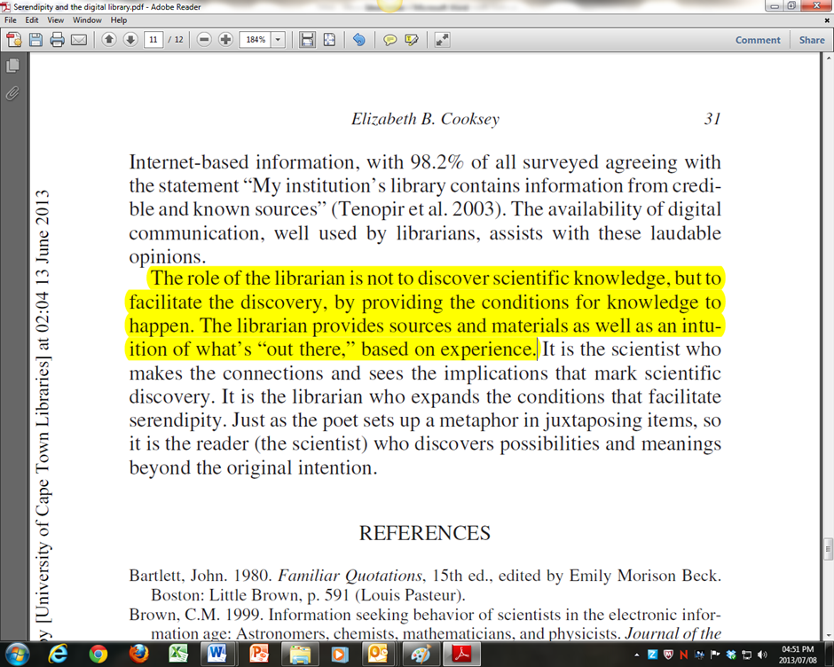
(Cooksey, 2004: 31)

It is our experience, our antenna, and our nose for “what might exist” always has been, and increasingly will be, what turns librarians themselves into manifestations of the “Library Angel.”

In the many libraries whose resources have expanded several hundredfold by the addition of e-journals and the indices to search them online, librarians find that they are needed more, not less. As practitioners, they develop the skills needed to be successful with the variety of approaches required as one moves from database to database. Infrequent use of more than two or three of these databases by patrons often results in frustration if they attempt to move out of their comfortable “ruts,” and so the explosion of information needed by many, especially competitive research scientists, requires the librarian’s guidance more than ever.

(Cooksey, 2004: 29)



Alex D’Angelo
UCT Libraries, August 2013

Bibliography

Alves, J. 2013. Unintentional Knowledge : What we find when we're not looking. Chronicle of higher education. June 23, 2013:31 July 2013.
Barnett, A.H. 2011. Diabetes-science, serendipity and common sense. Diabetic medicine. 28(11):1289-1299. Available: http://search.ebscohost.com/login.aspx?direct=true&db=aph&AN=66607291&site=ehost-live.
Cooksey, E.B. 2004. Too Important to Be Left to Chance--Serendipity and the Digital Library. Science & technology libraries. 25(1):23. Available: http://search.ebscohost.com/login.aspx?direct=true&db=f5h&AN=16014686&site=ehost-live.
de Bruijn, O. & Spence, R. 2008. A New Framework for Theory-Based Interaction Design Applied to Serendipitous Information Retrieval. ACM transactions on computer-human interaction (TOCHI). 15(1):126-163. Available: http://search.ebscohost.com/login.aspx?direct=true&db=ufh&AN=32201642&site=ehost-live.
Groves, N. 2011. Little 'serendipity' aids researcher. Ophthalmology times. 36(15):11. Available: http://search.ebscohost.com/login.aspx?direct=true&db=f5h&AN=64432897&site=ehost-live.
Guha, M., 2009. Serendipity versus the superorganism. Journal of mental health. 18(4):277-279. Available: http://search.ebscohost.com/login.aspx?direct=true&db=aph&AN=43429467&site=ehost-live.
Koestler, A. 1989. The act of creation (London, Arkana, 1979).
Köhler, W., 1887-1967. 1927. The mentality of apes. (London : Kegan Paul, 1927 , repr. 1931)
Konecki, K.T. 2008. Grounded Theory and Serendipity. Natural History of a Research. Qualitative sociology review. 4(1):171-188. Available: http://search.ebscohost.com/login.aspx?direct=true&db=sih&AN=32169049&site=ehost-live.
Makri, S. & Blandford, A. 2012a. Coming across information serendipitously – Part 1A process model. Journal of documentation. 68(5):684-705. Available: http://search.ebscohost.com/login.aspx?direct=true&db=aph&AN=79385855&site=ehost-live.
Makri, S. & Blandford, A. 2012b. Coming across information serendipitously – Part 2A classification framework. Journal of documentation. 68(5):706-724. Available: http://search.ebscohost.com/login.aspx?direct=true&db=aph&AN=79385856&site=ehost-live.
McClellan III, J.E. 2005. Accident, Luck, and Serendipity in Historical Research. Proceedings of the american philosophical society. 149(1):1-21. Available: http://search.ebscohost.com/login.aspx?direct=true&db=hlh&AN=17346681&site=ehost-live.
Michener, William K.Bildstein, Keith L.McKee, ArthurParmenter, Robert R.Hargrove, William W.McClearn,DeedraStromberg, Mark 2009. Biological Field Stations: Research Legacies and Sites for Serendipity. Bioscience. 59(4):300. Available: http://search.ebscohost.com/login.aspx?direct=true&db=f5h&AN=37383558&site=ehost-live.
Nutefall, J. & Mentzell, P. 2010. The Serendipitous Research Process. Journal of academic librarianship. 36(3):228. Available: http://search.ebscohost.com/login.aspx?direct=true&db=f5h&AN=50403278&site=ehost-live.
Petric, I., Cestnik, B., Lavrac, N. & Urbancic, T. 2012. Outlier Detection in Cross-Context Link Discovery for Creative Literature Mining. Computer journal. 55(1):47-61. Available: http://search.ebscohost.com/login.aspx?direct=true&db=aph&AN=70005160&site=ehost-live.
Rock, D. 2011. Neuroscience provides fresh insights into the "aha" moment. T+D : American society for training & development. FEBRUARY 2011(4511):23 June 2013.
Rosenberg, H. 2013. The Herd of Independent Minds: Has the Avant-Garde Its Own Mass Culture? (1948). Commentary. July/August 2013.
Taylor, A. 2013. A Small World After All. Bookforum. June/July/August 2013:20 June 2013.
Trevors, J., Pollack, G., Saier, M. & Masson, L. 2012. Transformative research: definitions, approaches and consequences. Theory in biosciences. 131(2):117-123. Available: http://search.ebscohost.com/login.aspx?direct=true&db=aph&AN=77330844&site=ehost-live.
Varadarajan, R. 2010. Programmatic, programmatically non-programmatic and beyond: Reflections on the role of collaboration, serendipity and strategic windows in my research pursuits. Journal of strategic marketing. 18(2):89-102. Available: http://search.ebscohost.com/login.aspx?direct=true&db=psyh&AN=2010-08441-002&site=ehost-live.
Weisberg, R.W. 2013. On the “Demystification” of Insight: A Critique of Neuroimaging Studies of Insight. Creativity research journal. 25(1):1-14. Available: http://dx.doi.org/10.1080/10400419.2013.752178.
Widrich, L. February 28th, 2013. Why we have our best ideas in the shower: The science of creativity. Available: http://blog.bufferapp.com/why-we-have-our-best-ideas-in-the-shower-the-science-of-creativity [July 30, 2013].

