The South African RESEARCHER’s GUIDE TO LIBRARY TOOLS

I’m going to cover a research basic that is often neglected, and then focus on some of the more advanced practical tools and how-to techniques in searching.
I would also like to share a few tips and problems that I have learned the hard way. For this reason at least I will focus at least in part on things that can go wrong, and how to wriggle round them.
Contents
How to find us 2
Subject Encyclopedias for a map of the territory 4
Finding Books 10
Boolean searching 21
Searching the National Catalogue 25
Searching WorldCat 31
Searching for Theses 34
Finding South African Theses 36
International Theses 52
Following up a reference to an electronic journal article 55
Searching a Database 61
Using the formal Thesaurus to find the right subject term 75
Slimming down results with a Visual Search option 80
Cross-Searching Databases 87
Finding Books and Journal Articles with one search on WorldCat Local 88
What to do with your WorldCat Local results 103
Cross-Searching by Platform 113
Citation Searching 127
Referencing & RefWorks 139
DRAWING IT ALL TOGETHER 153

How to find us

The library’s electronic front door can be found at:
www.lib.uct.ac.za

(Important: if you are off-campus you will need to use the off-campus login on that page.)

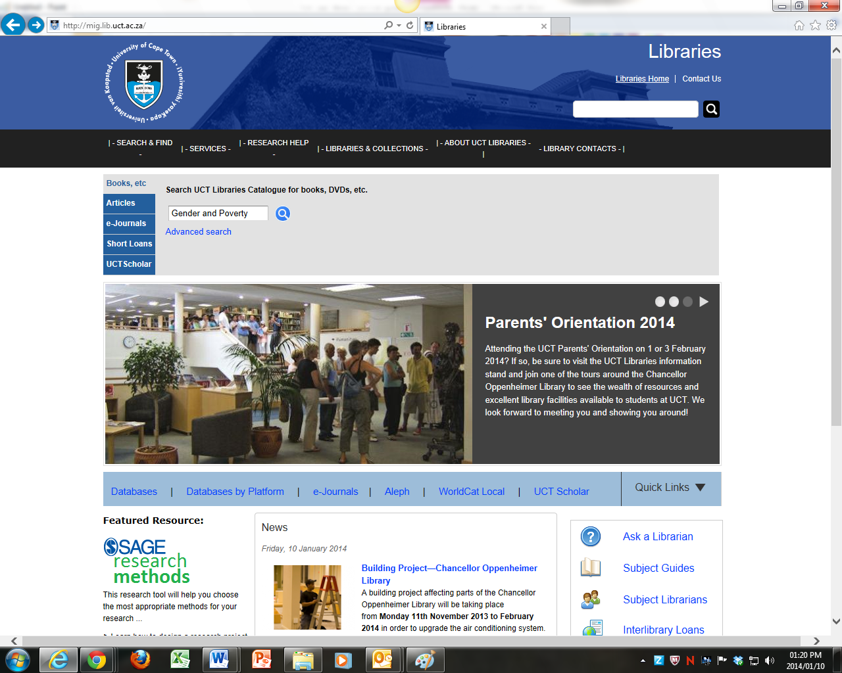

From our homepage you can access our catalogue and databases and, under the Research Help tab, find help on referencing and find subject-guides with library resources for each area of study.

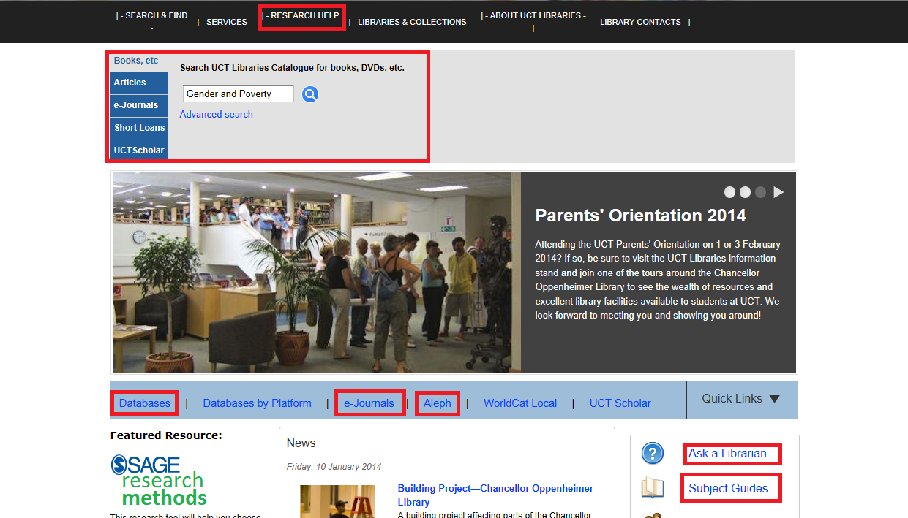

Subject Encyclopedias for a map of the territory
Getting a clear and simple outline map of the territory is an often-neglected research basic - I’m not talking about the Britannica here, or Wikipedia, though both can be very useful in fact, even at University, when it comes to getting a bird’s eye map of the territory of your research.
I’m talking about thousands of genuinely specialized reference works – all narrowly focused and with each section written by an expert in that field.
An entry in a good subject encyclopedia can give a background history of research trends (i.e. the history of academic thought on that subject), as well as outlining likely issues for current and future research (as in the example below).
Example:
If you want to get a quick understanding of “African legal systems”, , you will find a short discussion alphabetically on pages 229-232 of International encyclopedia of the social & behavioral sciences / editors-in-chief, Neil J. Smelser, Paul B. Baltes. (Amsterdam : Elsevier, 2001.) Vol. 1
The 4-page article is broken up into helpful headings:
- Opening Definition
- Customary and Religious (Non-state) Legal Systems
- State Legal Systems
- Past and Present Trends in Legal Development
- Current and Future Issues in Legal Development, Theory and Research
- Cross-references to other articles in the encyclopedia
- A Bibliography of 13 major sources
The article is signed and you can check the author’s affiliation –University of Birmingham. And the articles are overseen by section editors and editors in chief, also with affiliations listed.
Above all, a good subject encyclopedia entry will have a short bibliography which usually lists the seminal works, or at least most commonly sought works, on that subject.
This can form the core of a research bibliography – the past sources which you can’t not read if you want to be taken seriously - and can also be a very useful starting point in a citation search.
We’ll come to a citation search later, but in essence it involves finding a really key article or book and seeing who has cited it more recently – either because their research supports it, or disagrees with it, or takes it forward by adding a new dimension to it.
It might also be a good idea to do a search for any other/more recent books or articles by one of these key authors, or by the writer of that section in the encyclopedia – experts tend to write a number of other books or articles on their topic of expertise, and, if contemporary writers, may still be at it.
The other important thing about subject encyclopedias is that they can often suggest a set of search terms appropriate to that topic – or define a term as it is used in that area of specialization. A lot of our searching success or failure will revolve around our choice of search terms – so we need all the help we can get in picking them
Words like paternal or maternal as used in Anthropology have a lot more to do with a very specific focus on kin-structures and bloodlines, than on the political role of the family, for example, as they might in Political Studies. It is important to be aware of this if you are thinking of using those terms in Political Studies search on a multidisciplinary database which includes Anthropology journals …. They may not mean what you think they mean, and so your searches will bring up useless hits, which ever database you try them on.
How to find subject encyclopedias? Ask us. We can usually find good ones for particular topics.
We also have some handy online encyclopaedias, though these are far less detailed in coverage for the most part.
Go to the library homepage at www.lib.uct.ac.za, mouse over “Search & Find” and select “E-Reference” from the drop-down menu to find a list of the electronic reference works.

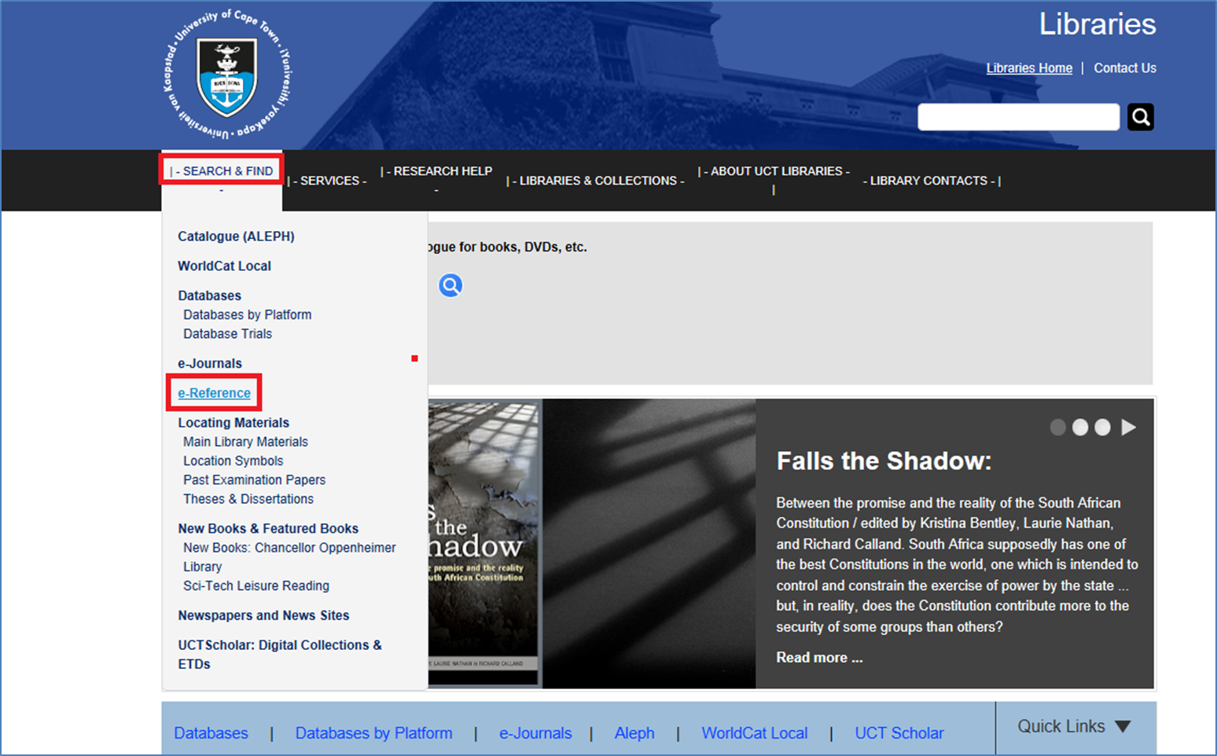
This opens up a screen of our most commonly-used electronic reference works:
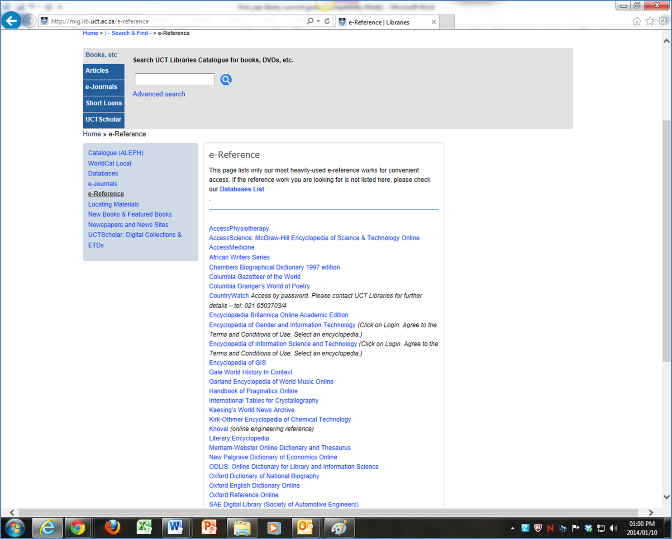
These reference tools are all quite respectable sources – they are electronic books, not just random websites.
Otherwise you can use the library catalogue to find print reference books, of which we have far more than the electronic variety, at least at present.
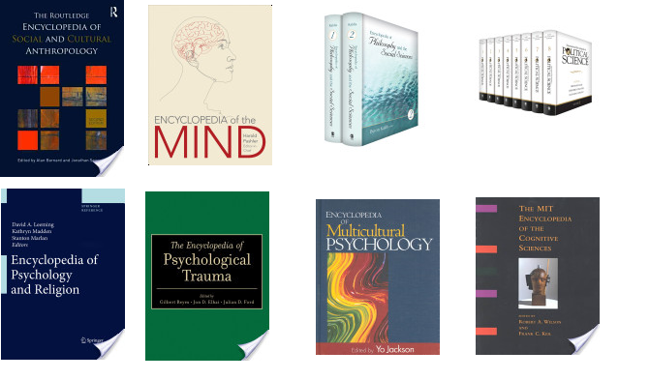

On the catalogue you can combine the word Encyclop* with subjects like Politic*. (I’m using a wildcard *, btw, to bring up anything that follows the stem “Encyclop” and anything that follows the stem “Politic”. This will bring up variant spellings of Encyclopaedia and Encyclopedia, as well as Politics, Political….)
I’ll tell you more about these wildcards and Boolean operators in a minute.

Finding Books
This could be considered a neglected research-basic too. It is amazing how many people jump straight into a journal database search without following this step.
When doing a search for books you will find that the authors and book titles and subject terms you have picked up from the Encyclopaedias come in handy. The catalogue, all on its own, can also suggest subject headings to refine the search.
The book catalogue (aleph) can be found from the library website at www.lib.uct.ac.za
Mouse over the "Search and Find" tab and select "Catalogue" from the drop-down menu.

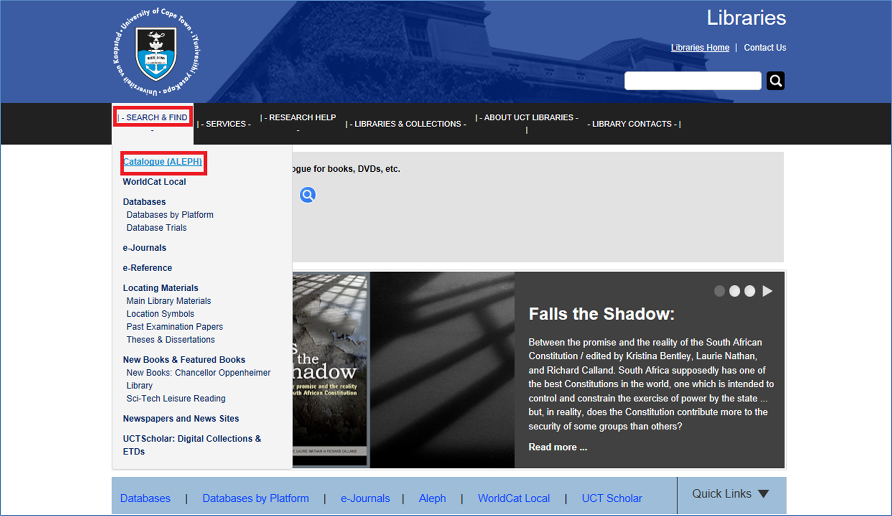

If you are looking for a book by a specific author, it is helpful to search the book catalogue by putting in the author’s surname and a word of two from the title:
Marx and capital, for example
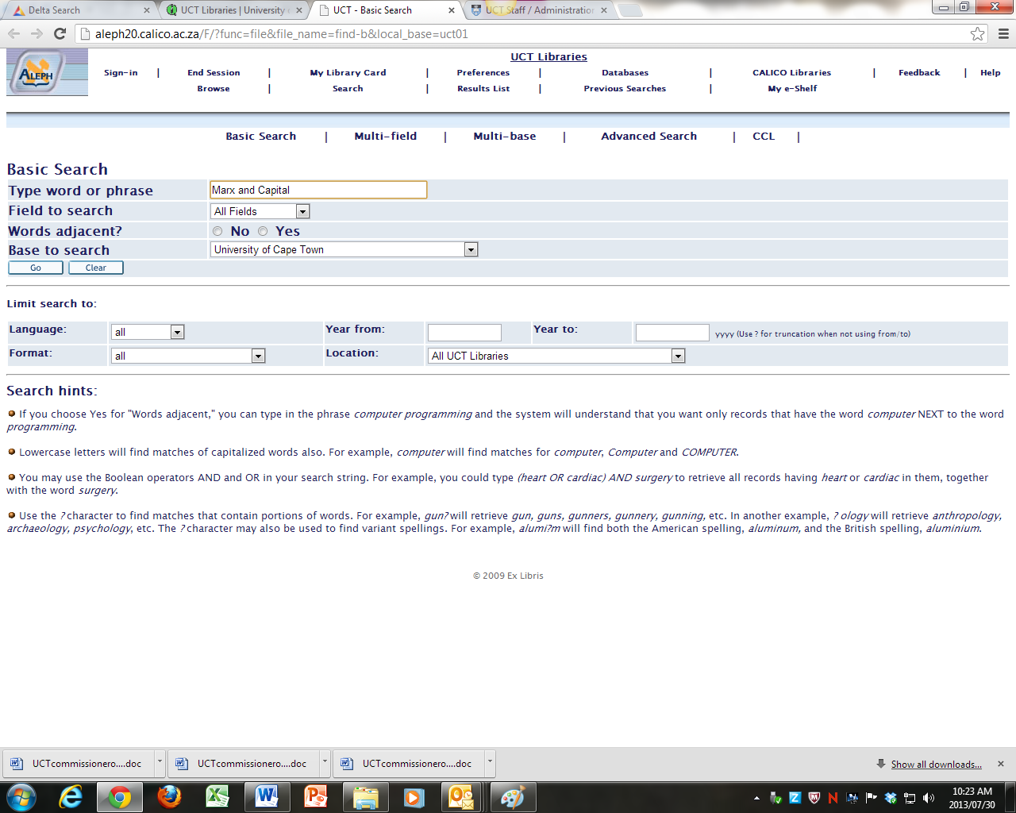

This brings up not only Marx’s Capital, but books about Marx’s Capital. That is why I love quick and dirty searching; it fosters serendipity (more on this crucial aspect of successful research later on.)

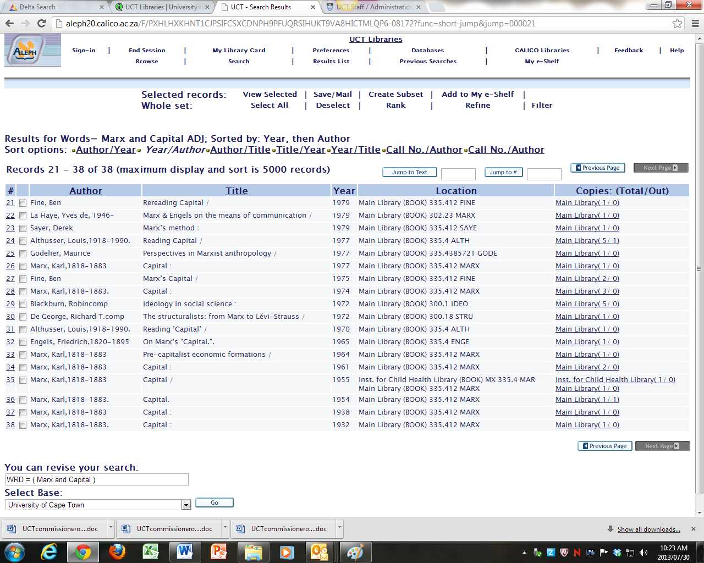
The shelf number, 335.412 MARX, is the book’s street address on the shelf.
The record tells you which library the book is in: Main Library in this case, and whether it is on loan or not.
1/0 means there is 1 copy and nobody has borrowed it (yay!) If somebody has borrowed it you can curse a bit, but most of the time browsing the shelves at that shelf number will bring up something equally good – the magic of shelf-numbers, see?
It also allows the Library Angel, a.k.a the Angel of Serendipity, to work in your favour. She (all reports insist that the Angel is definitely female) is summoned by walking in the shelves, handling volumes, and allowing your mind to operate a bit laterally, while muttering:
“I’m sure I saw a bl**dy book on this a while back…It was a green one, I think, or blueish ….by someone called Osborne… or was it Humphreys… Hello – what’s this one here? Hmm…. that’s interesting… covers something I was thinking about just the other day….Blimey! This is a gold mine!”

Searching for books by subject:
Same procedure, only a bit looser and requiring a bit more thought.
Type in the main, simple keywords that describe your subject, separated by ANDs – Gender AND Poverty AND Africa, for example, or Violence AND Television.
Avoid typing in a phrase like Television violence – that will call up only those books which use exactly that phrase (possibly very few, or none whatsoever).
The results list might be quite wide-ranging. If you get too many results, or they don’t seem very relevant, try adding another word – Violence AND Television AND Children, for example.

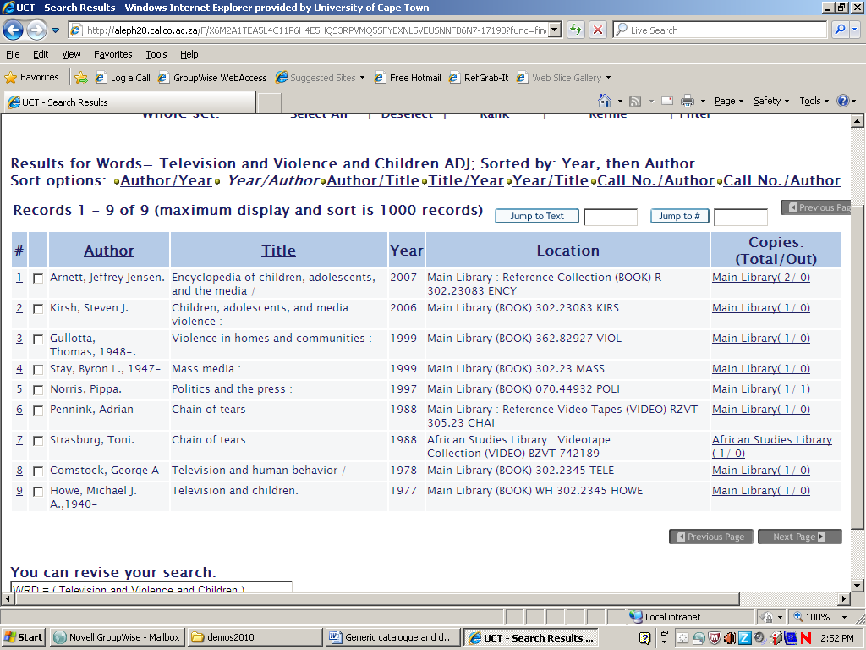
Note, btw, that a useful-looking subject encyclopaedia has come up in this search.
If you find a book that looks promising (Kirsh, Children, adolescents, and media violence, for example) you can either look on the shelves at that shelf number (302.23083 KIRS) and find a lot more just like it, or you can open the full record and see what formal subject terms the librarians have assigned to that record, and search again using those formal terms, to get a more focused list of books just like the Kirsh one.

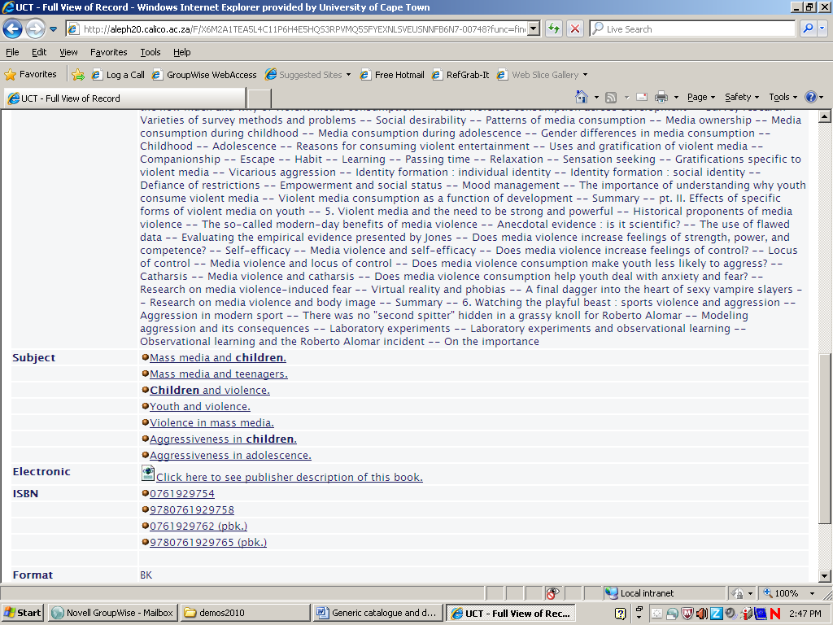
Using simple keyword searching (in the “all fields” box) rather than restricting the catalogue search to just author, title or subject fields allows you to search the entire record – title, author, subject, and table of contents, if one is attached.
This allows you to find things you would definitely have missed if searching only in the title or subject headings, and is especially useful for more recent records which often have the tables of contents attached to them, as in the example above. This gives the book catalogue some of the advantages of a journal database, where the keyword search searches the abstracts of the articles as well as the title and assigned subject headings.
If you find a good subject heading on the catalogue, and clicking on it brings up too limited a selection of hits, try using some of the subject heading words in a keyword search – this gives you the best of both worlds; everything with that subject heading will come up, as well as everything which mentions that subject term in the title or table of contents.
Searching our book catalogue will also bring up theses on that topic written at UCT, though there are better ways of finding theses, which I’ll get to in a minute.
If you are looking for a list of UCT theses in political studies, for example, the best search is Thesis and Politic*, btw.

Boolean searching
Right – we are getting onto the promised more-advanced search techniques here.
It is possible to create very precise searches just using keywords.
The trick is to combine them with Boolean Operators, wildcards and brackets. Most of our databases, including our library catalogue, take Boolean operators.
The guide below is from an Ebsco database help file:

Boolean Operators (And, Or, Not)
And - combines search terms so that each search result contains all of the terms. For example, education and technology finds articles that contain both terms.
Or - combines search terms so that each search result contains at least one of the terms. For example, education or technology finds results that contain either term.
Not - excludes terms so that each search result does not contain any of the terms that follow it. For example, education not technology finds results that contain the term education but not the term technology.

Wildcard (?) and Truncation (*) Symbols
Use the wildcard and truncation symbols to create searches where there are unknown characters, multiple spellings or various endings. Neither the wildcard nor the truncation symbol can be used as the first character in a search term.

Wildcards
The wildcard is represented by a question mark ? or a pound sign #.
To use the ? wildcard, enter your search terms and replace each unknown character with a ?. EBSCOhost finds all citations of that word with the ? replaced by a letter.
For example, type ne?t to find all citations containing neat, nest or next. EBSCOhost does not find net because the wildcard replaces a single character.
Note: When searching for a title that ends in a question mark, the symbol should be removed from the search in order to ensure results will be returned.
To use the # wildcard, enter your search terms, adding the # in places where an alternate spelling may contain an extra character. EBSCOhost finds all citations of the word that appear with or without the extra character.
For example, type colo#r to find all citations containing color or colour.

Truncation
Truncation is represented by an asterisk (*). To use truncation, enter the root of a search term and replace the ending with an *. EBSCOhost finds all forms of that word.
For example, type comput* to find the words computer or computing.
Note: The Truncation symbol (*) may also be used between words to match any word.
For example, a midsummer * dream will return results that contain the exact phrase, a midsummer night's dream.

Grouping Terms Together Using Brackets
Brackets also may be used to control a search query. Without brackets, a search is executed from left to right. Words that you enclose in brackets are searched first. Why is this important? Brackets allow you to control and define the way the search will be executed. The left phrase in brackets is searched first; then, based upon those results, the second phrase in brackets is searched.
Generalized Search: dog or cat and show or parade
Focused Search: (dog or cat) and (show or parade)
In the first example, the search will retrieve everything on dog or cat shows as well as everything on parades, whether or not the articles refer to dogs or cats.
In the second example, we have used the brackets to control our query to only find articles about shows or parades that reference dogs or cats.

Right. I couldn’t have put it better myself.
Sometimes you don’t need to use Booleans much, apart from the odd AND, and sometimes the separate fields of a multi-field search screen (commonly found under the Advanced Search option on most databases) do the job of the brackets.
It is also wise not to be too specific – at least to start out with. You might find yourself searching only for what you already know, and miss out on new insights.
Also be very careful about using the not operator – you will literally not know what you are missing.
The other thing to watch out for is USA and British standard spelling. Words like behaviour/behavior or colour/color, can radically effect your search results. Use wildcards for these * or ?
Some other caveats about language searching international databases and catalogues:
Be especially careful about differences in terminology between American and Standard British English. Not just spelling – but actual terminology - American business databases tend to use “corn” where European ones, and South African ones, would use “maize”, for example. “Mielies”, “Dagga” and “Tik” are words unique to South Africa, of course. They can be used when looking for only SA material, particularly popular material, but should be combined with the more generally used terms if you want a comprehensive search for SA material, overseas material, and SA material that uses overseas terminology.
There are also social taboos which vary from country to country - terms for race, poverty, or social class, in particular, can vary wildly, not only from database to database but also between journals of different national origins or different disciplines within a database.
There is also a major caveat about the advantages of using keyword searching over sticking to the subject headings - it must be said that those few databases which do not have good abstracts for their articles, including the library catalogue, which does not always have a table of contents for its books, respond a bit less helpfully to Boolean keyword searching than ones which are lavish with their abstracts.
In these cases, typically older databases which have migrated from an original printed index, it probably is wise to pay close attention to their formal subject terminology.
So, back to our searches….

Searching the National Catalogue
Having done a search on UCT catalogue, it is a good idea to repeat it on the National Catalogue, SACAT, found under S on our databases list:
You can get to our A-Z database list by mousing over Search & Find on the library web page, or clicking on Databases on the Quick Links bar:
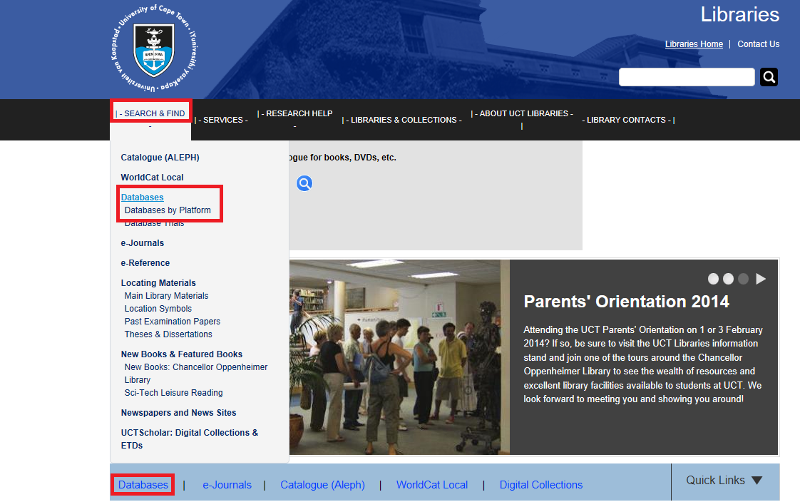

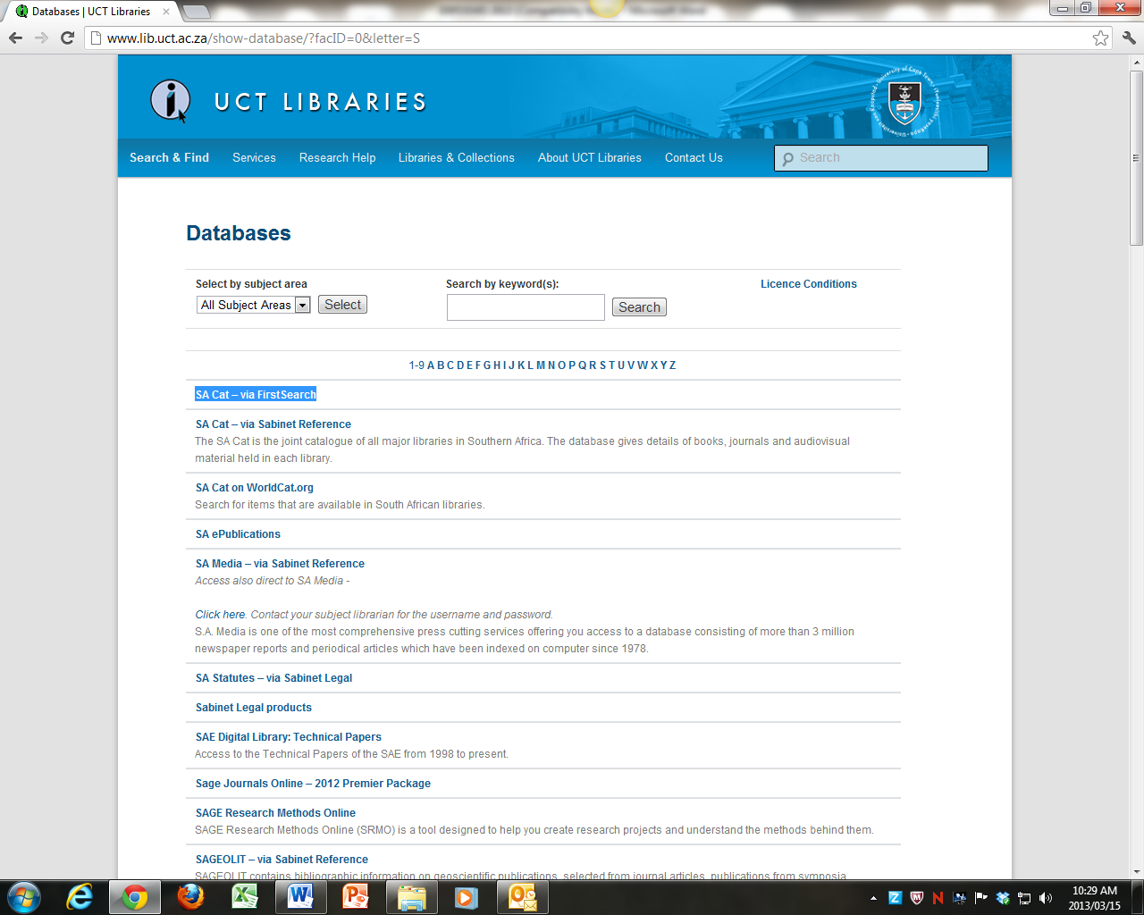

This covers the holdings of all the major libraries, including university and major research institution libraries in South Africa.
You will pick up titles of books, reports, papers, theses, etc. which UCT does not have, but which can usually be obtained by inter-library loans, at no cost.
Again, I find keyword searches are usually most effective – though because the national catalogue does not give abstracts for its book records, your keyword searches will be a bit less comprehensive than they would be on the UCT catalogue.
For this reason, although the National catalogue will show material that is in UCT library amongst its findings, it is best to search our own catalogue separately – the search on our interface can be simultaneously more comprehensive and more precise.
Also, our catalogue gives our specific shelf numbers.
Also, it works slightly differently with regard to finding phrases:
If you search the UCT catalogue for Poverty and South Africa and Gender, our catalogue will treat South Africa as a phrase. The SA Catalogue, on the other hand, will treat South and Africa as separate words, unless they are put in inverted commas.
At any rate, searching for Poverty and “South Africa” and Gender on the National Catalogue brought up 152 hits (below.) The same search on UCT catalogue (minus the inverted commas) brought up 34.

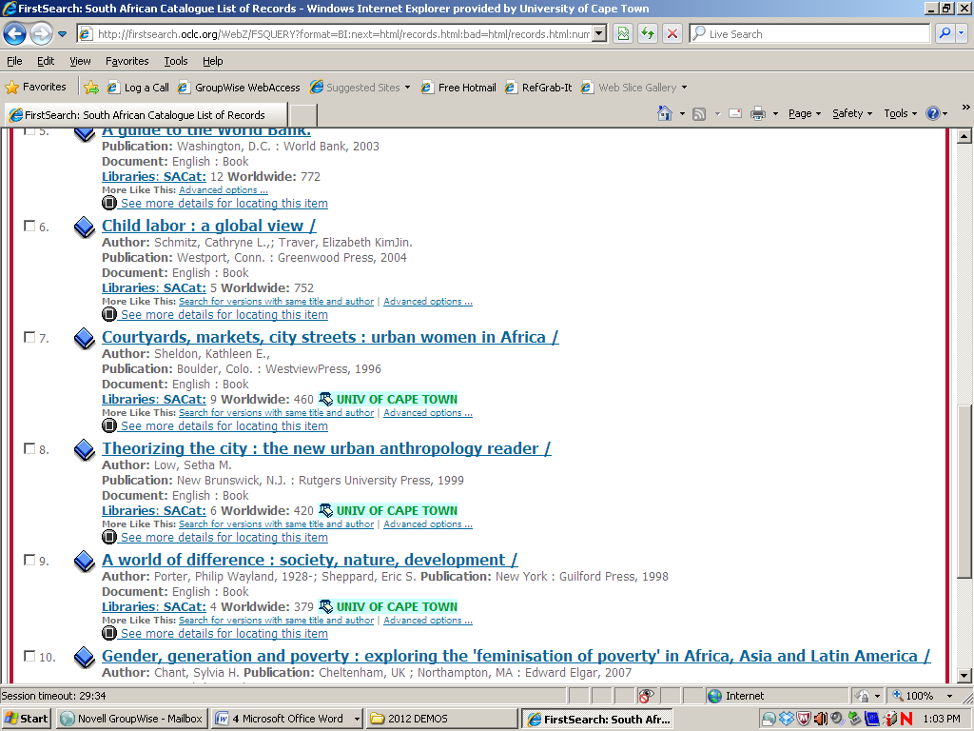
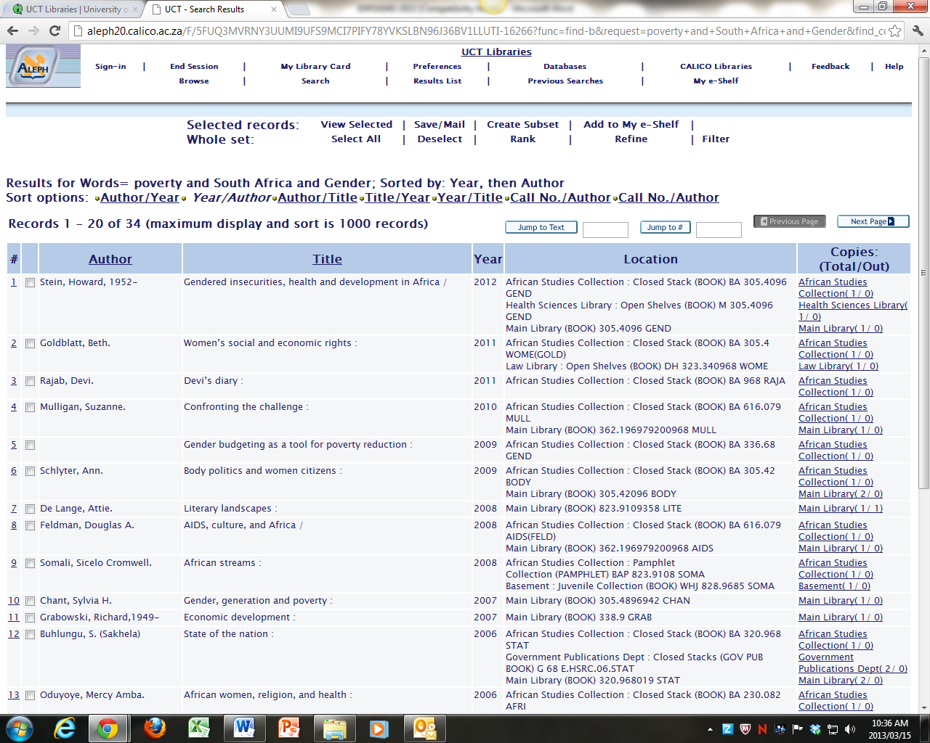

Searching WorldCat
Found under W on our Database list and does what it says on the can – searches internationally across library catalogues. Here is the blurb:
WorldCat - via OCLC FirstSearch
The world's most comprehensive bibliography, with more than 44 million bibliographic records covering books, manuscripts, computer data files, maps, computer programs, musical scores, films and slides, newspapers, journals, sound recordings, magazines, and videotapes. Provides holdings information for South African libraries.
So, it does what the SA Cat does for South Africa, only it is MUCH BIGGER since includes a lot of other countries (not all, but still very many.)
A search of this for Poverty and “South Africa” and Gender - you’ll note that it also requires inverted commas around phrases - brought up 531 results. I’m glad to see that we have some at UCT, but if we don’t have a book that your need, and it is not available in SA, then let me know and I would think about trying to buy it rather than doing an interlibrary loan from overseas.
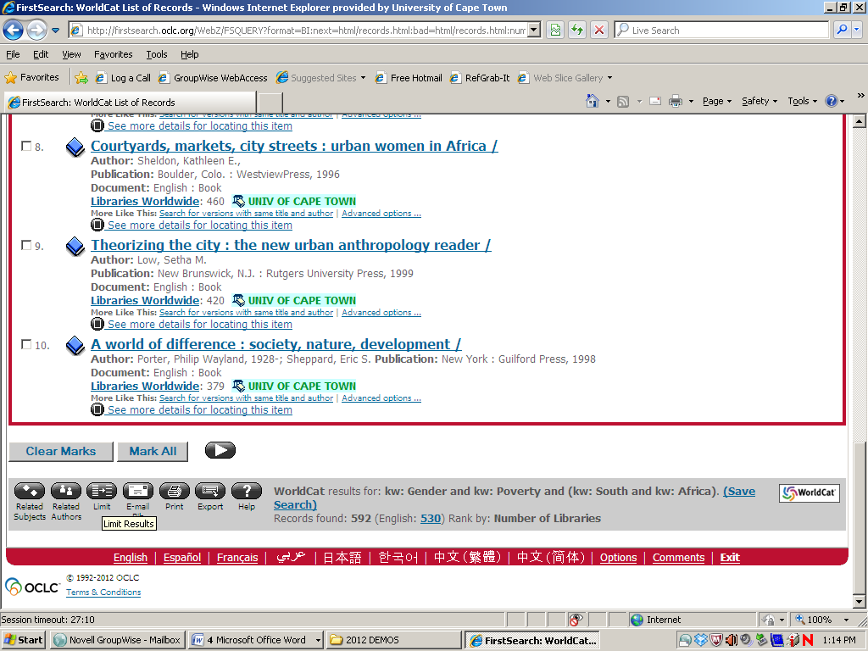
With so many hits it might be an idea to try to use the limiting functions on this database:

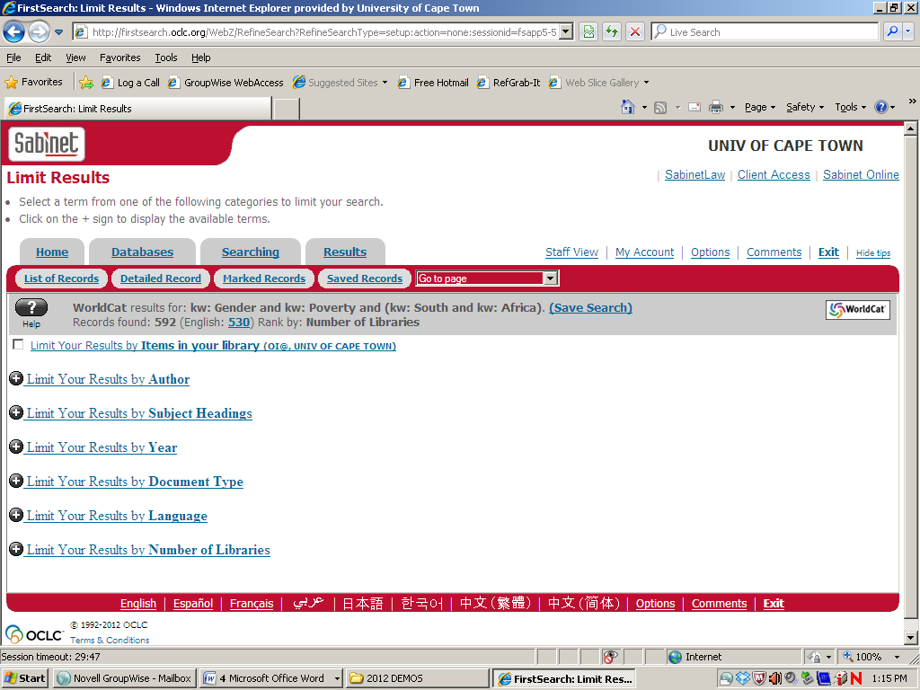
Limiting by year, or range of years (e.g. 2000-2012) is often helpful, as is limiting by Number of Libraries – on the (occasionally justified) assumption that a really good book will be held by a fair number of libraries.
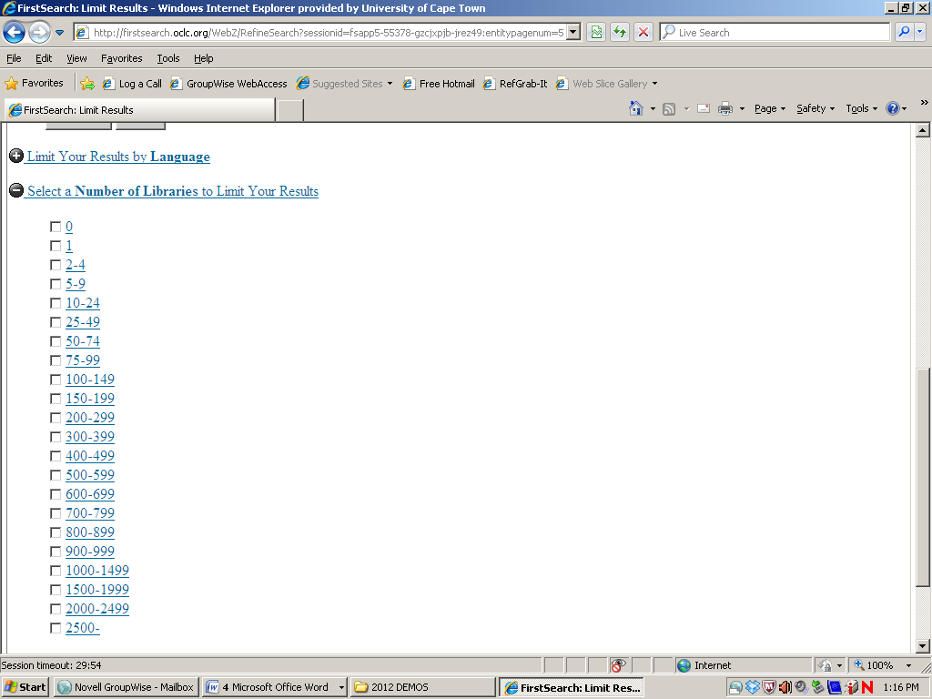

Searching for Theses

Having got a sense of what books have been published, or what is available in print in South Africa, it is now time to see if there is a gap in the research industry for your own interests, and to see what is being written at the cutting edge of unpublished research.
It is useful to see what similar work has been done on your topic – you can use a thesis’s references and bibliography as a starting point and take the research further, or explore a different angle. Often the thesis itself will constitute a body of material that is available nowhere else – results from an individual’s primary research in a local town or suburb, for example.
Most importantly, searching them allows you to check that your exact thesis has not been, or is not at this moment being, written at a university down the road.
Of course, there may often be some overlap of interests – plenty of people might be working in or close to your area, and the fact that others like you are writing on this is evidence that you are taking part in a hot debate or being part of the cutting edge on this topic – adding your own unique perspective and study and methodology. So finding similar-ish work is not automatically a train smash.
But you do not want to discover, just before, or just after, handing in, that exactly your own uniquely South African, cutting edge, thesis has been written a couple years earlier. This happens, and it would be soul-destroying to find that you have spent a year or two repeating somebody else’s work; even worse if it were to lead to suspicion of plagiarism.
If a Master's or Doctoral thesis was done at UCT, you will find it on the catalogue the same way you would a book – look for the author’s last name or words from the title or both.
You can also do a very quick and dirty search for theses by subject on the UCT catalogue, just type Psychology and thesis, for example.
If it was done at another South African university we can get a copy through Inter-library loan or, increasingly, simply download it for free from that university’s web site.
This is sometimes possible for overseas theses too, but most likely we would have to buy a copy. This can often be done, but the thesis might take some time to arrive.

Finding South African Theses

South African Theses, in full text, can be found on: National ETD Portal South Africa: South African theses and Dissertations
“This site is run by the South African National Research Foundation (NRF) in collaboration with the Committee of Higher Education Librarians of South Africa (CHELSA).It provides access to the full text of many thousands of doctoral PHD and some other dissertations produced in South African universities. These cover the full range of science, social science and humanities topics. There is some coverage from as early as the 1970s although there are larger numbers of post 2009 records. Search by keyword or browse.”
However – this site lists only those theses which have been digitized in full text: On the plus side – there are a lot of them, they are recent, and they can go back quite a long way due to retrospective scanning.
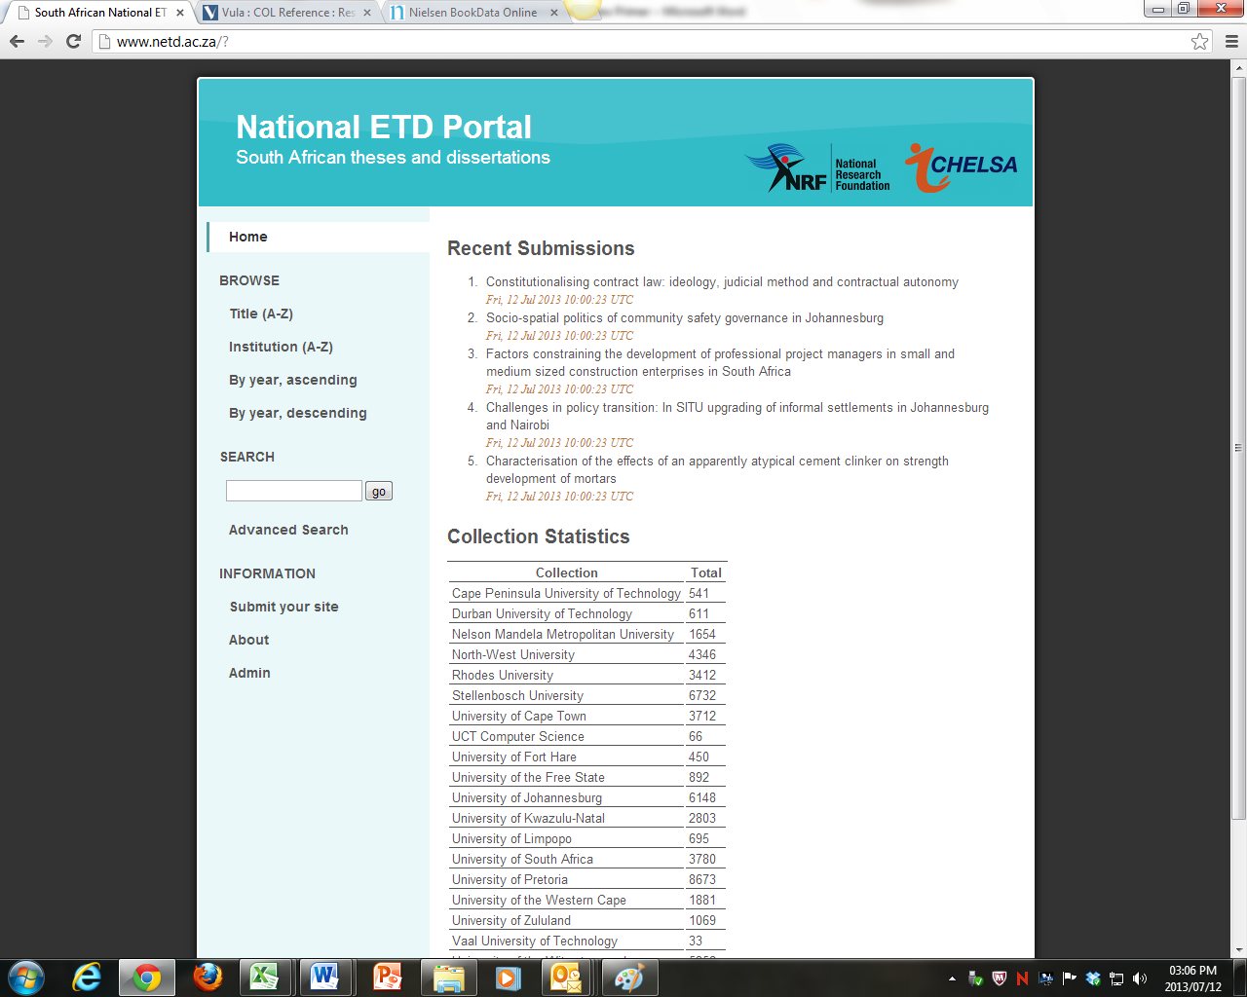

A Search for Child Psychology AND Poverty brought up 85 hits, though some of them were a bit broad – it does not seem to take the phrase “Child Psychology”... I suspect, in fact, that it is regarding the two words as separated by an OR – and so bringing up results for child and poverty as well as psychology and poverty ….

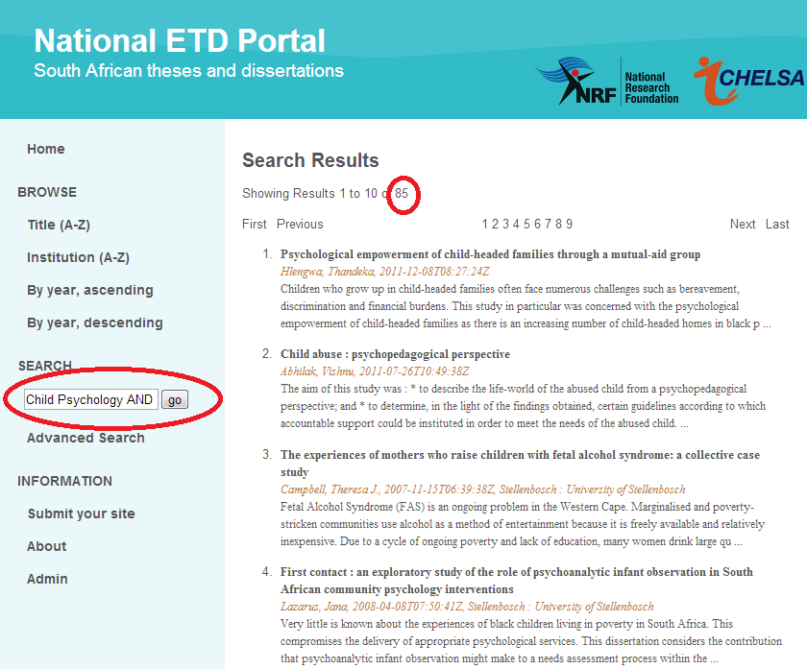

Whereas a search for Child AND Psychology AND Poverty, which should, in theory, broaden the search from “Child Psychology”, in fact shrunk it, bringing up 24 hits – thus I suspect that it only now includes all three words:

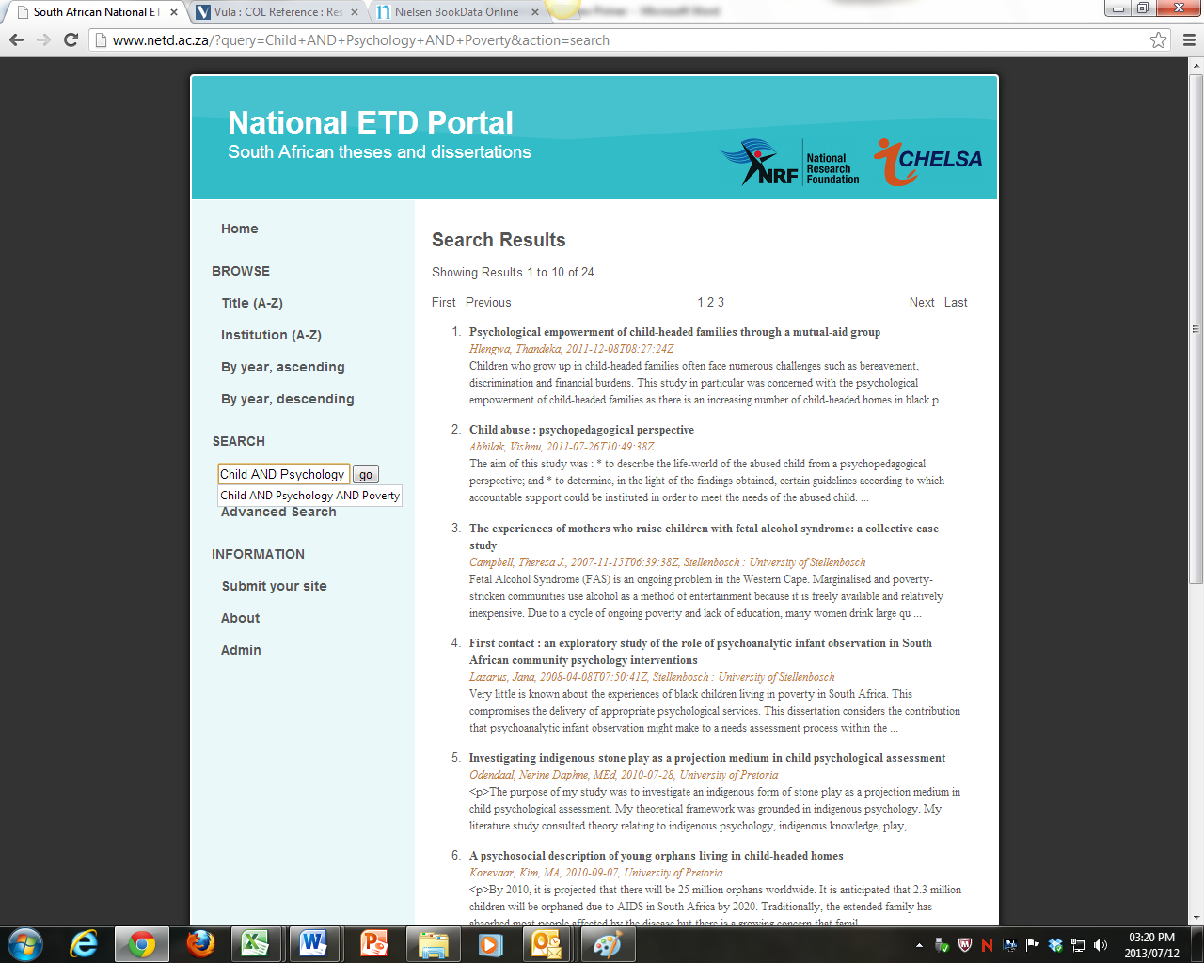

Nevertheless – it is a very useful database, if one is prepared to play around with alternative terms.
An alternative index, going back right to the earliest theses, though not with full text, can be found on the Nexus database from the National Research Foundation, on our A-Z database list.
Nexus Database System
Provided by the National Research Foundation, Nexus includes databases of: Current and Completed Research Projects in the Humanities and Social Sciences; Professional Associations; Forthcoming Conferences; Periodicals’ Submission Requirements; Research Organisations; Research Networking; Research Methodology Courses; and Women in Research. The database of Current and Completed Research Projects requires a password – please contact the Chancellor Oppenheimer Library on 021 650 3703/4 or the Law Library on 021 650 2708/9.
Actually, theses are also indexed on the Union Catalogue of Theses and Dissertations (UCTD) and on the Africa Wide Database, but Nexus is more up to date, covers current as well as completed research, and gives better abstracts. On the downside, it is a bit clumsier to search – it does not take Boolean operators very well other than AND.
I usually search both Nexus and UCTD for this reason.

Nexus:
Click on the Current and Completed Research Projects Database:
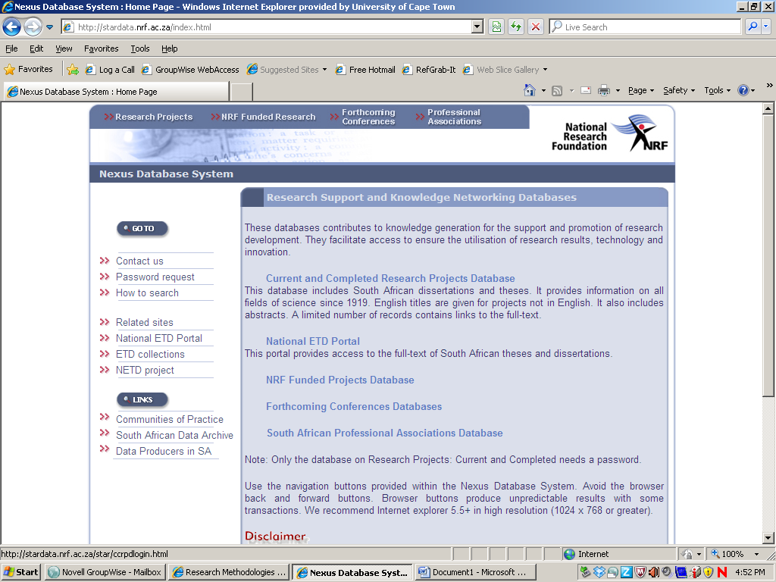

I find it is best to do a simple keyword search in the Titles, subjects, abstracts field:
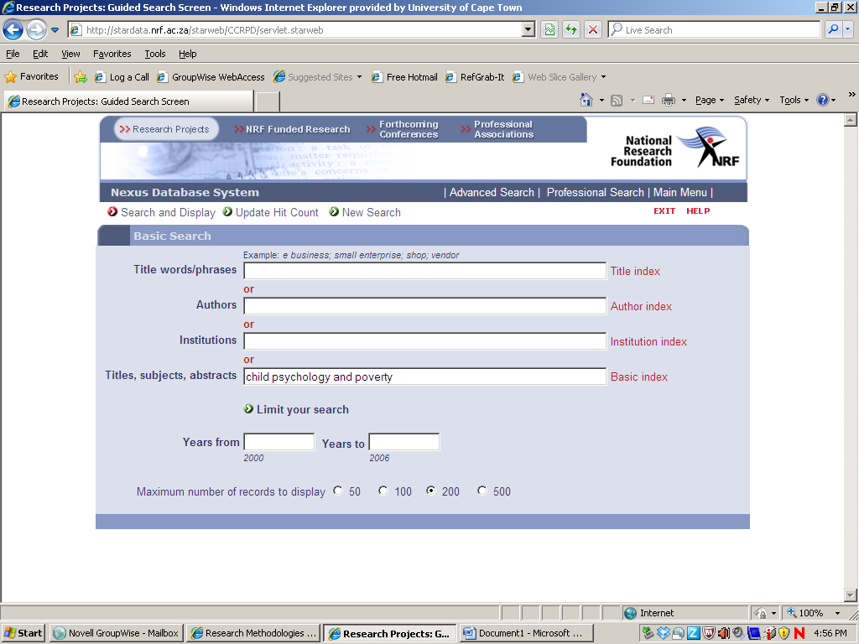
A search for child psychology and poverty brought up 29 theses (A search for child and psychology and poverty brought up the same, btw):
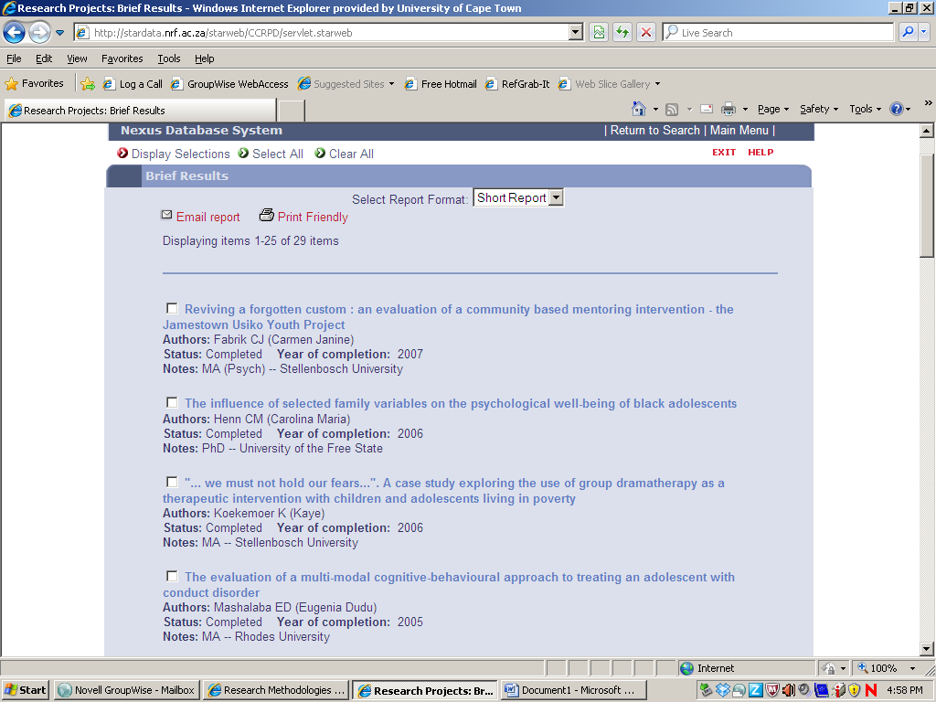
Selected items can be displayed on a separate list:
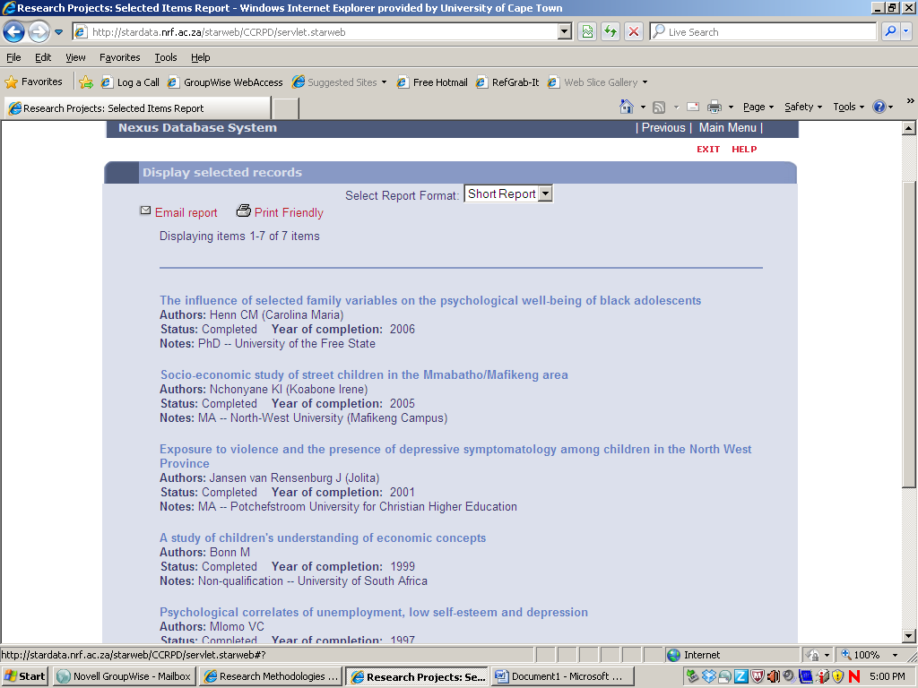
And viewed with their abstracts by changing the “short report” option to “full report”
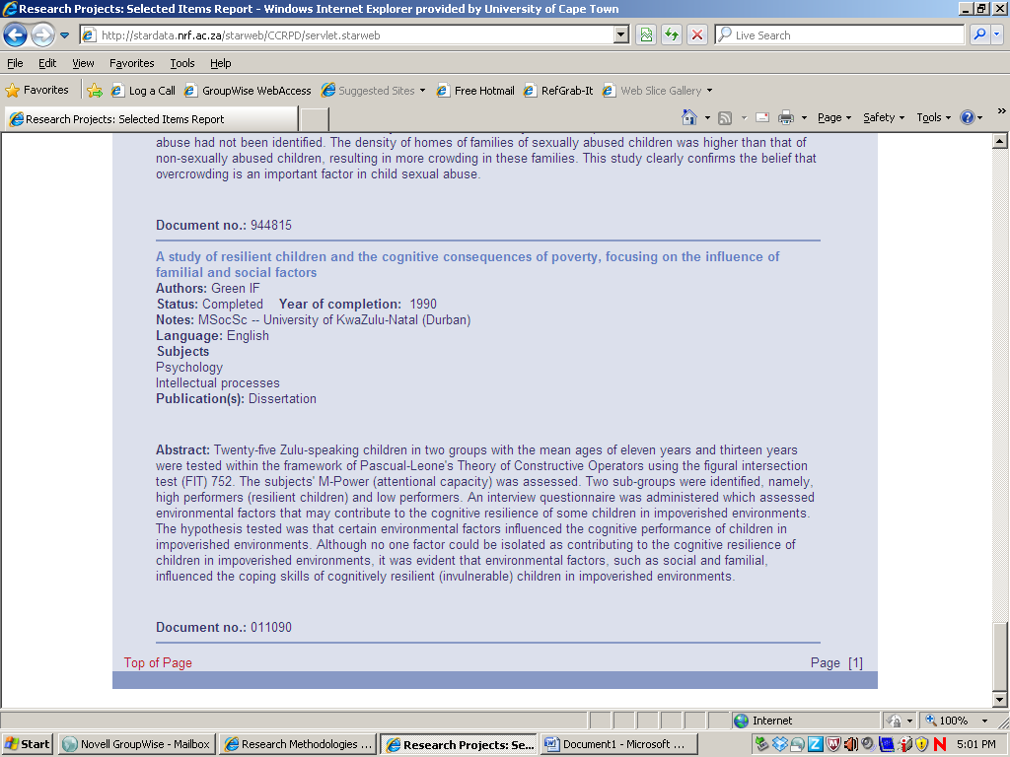
Any South African thesis not at UCT can be ordered by inter-library loan. Quite a lot of the most recent ones are available on the web nowadays too, so putting the title into a Google search can often be rewarding.
Any thesis at UCT can be found on the book catalogue and borrowed from level five (rows of blue volumes near the lift in the Research Wing.) Increasingly they are digitized – the UCT catalogue record will have a hotlink to the full text if this is the case.

Union Catalogue of Theses and dissertations
Again, available under U on the Databases A-Z list.
Union Catalogue of Theses and Dissertations (UCTD) - via Sabinet Online
Bibliographic records of theses and dissertations at Master and Doctorate level submitted to universities in SA since 1918. Updated annually.
Interestingly, a search for Child psychology and poverty (With or without inverted commas around “Child psychology” brought up only 1 result, unlike the 29 on Nexus. This is because the Nexus search also picks up keywords in the abstracts, and the UCTD search does not, simply because it doesn’t have those abstracts.
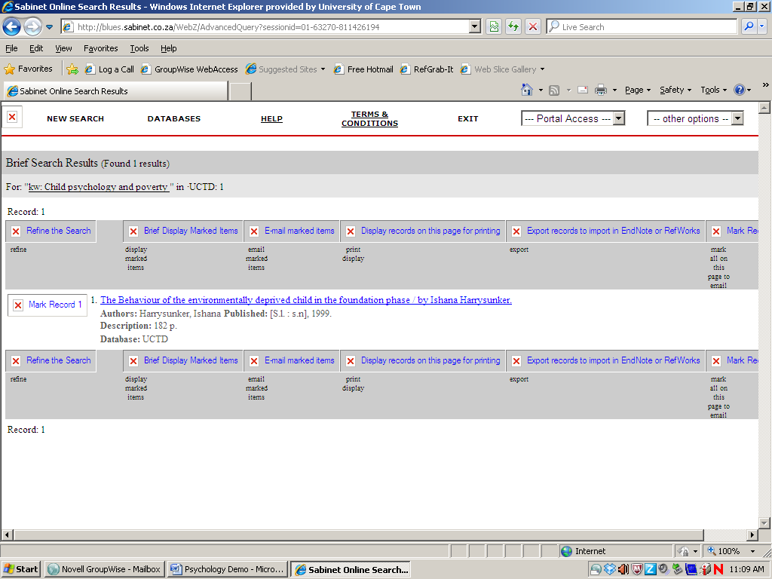
However, clicking on the record opens up a list of the subject headings associated with each record, which can be helpful:
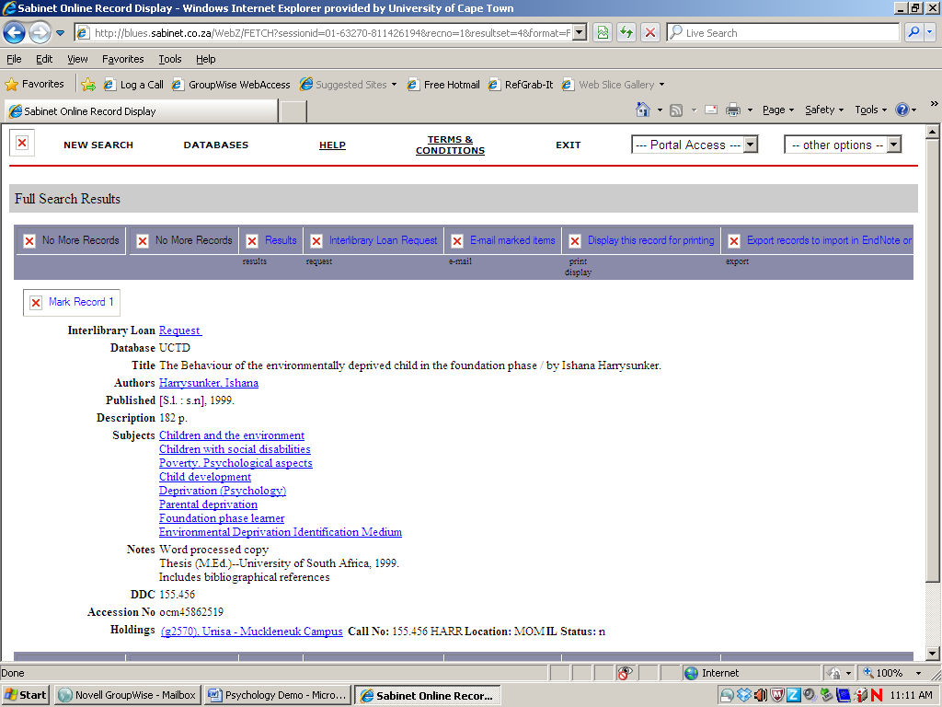
Using these terms brings up three more hits, but still, nothing like the Nexus results.
However – I have on occasion found that UCTD brings up a hit which an identical search on Nexus doesn’t….
So you really do have to search them both to be sure.
It is also a good idea to search a third source… a wider-ranging database, Africa-Wide Information- via EBSCOhost, which holds records of theses as well as book chapters and journal articles, and is very helpful in bringing up SA theses.

International Theses
For international theses, a good tool is ProQuest Dissertations and Theses - A&I Blurb goes:
With more than 2 million entries, PQD&T is the single, central, authoritative resource for information about doctoral dissertations and master's theses. Dissertations published from 1980 forward include 350- word abstracts written by the author. Master's theses published from 1988 forward include 150-word abstracts. Titles available as native or image PDF formats include free twenty-four page previews. UMI offers over 1.8 million titles for purchase in microform, paper or electronic formats.
With big abstracts, this database offers the same keyword searching flexibility as Nexus.
Another source for international theses is WorldCat Dissertations and Theses
This database provides access to the dissertations and theses available in OCLC member libraries. With no, or few, abstracts, this database suffers the same problems as UCTD. As with its sibling databases, you will get different results for “Child psychology” and poverty, with or without inverted commas.
However, it does link to theses which are available free on the web – often the only practical way to get hold of foreign theses without paying for a pricey inter-library loan or having them bought for the library.
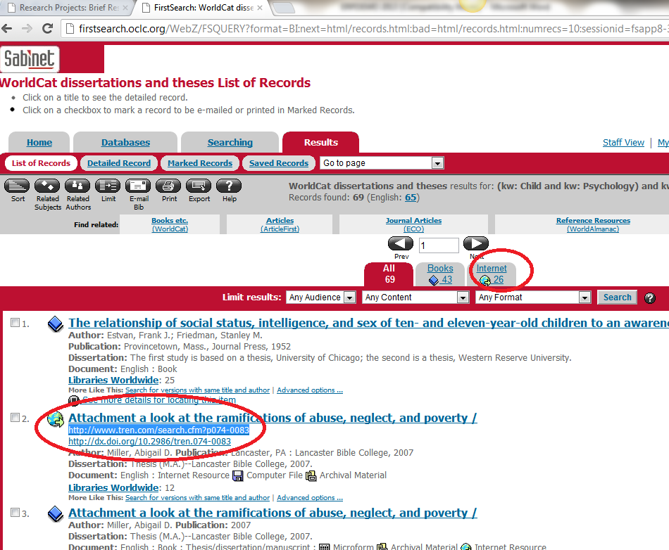

Some of our other databases, particularly MLA (for Literature), Humanities International, SocIndex (for Sociology and more general social sciences), EconLit (for economics), and PsycInfo (for psychology), provide abstracts of theses along with abstracts of books and journal articles. You will often encounter a reference to a relevant thesis when searching for journal articles or book chapters on these databases.
Interestingly – people who have written a thesis, particularly a Doctorate, on a particular topic often go on to publish articles on the same topic, so if you find a good thesis, it might be worth searching the journal databases for the writer’s name to see if they have continued to write on that theme.

Following up a reference to an electronic journal article

You will find an E-Journals tab on the Library homepage.

This is used for finding specific articles, from a specific journal, whose title is already known to you– in other words for following up references from a reading list.

It is also useful, if a particular journal proves to be a major one for an essay, to browse through the issues of that journal.

Search for the title of the journal, not for a subject or an article title

A search for “Journal of African Cultural Studies”, for example, shows which of our databases hold it, and for which years.

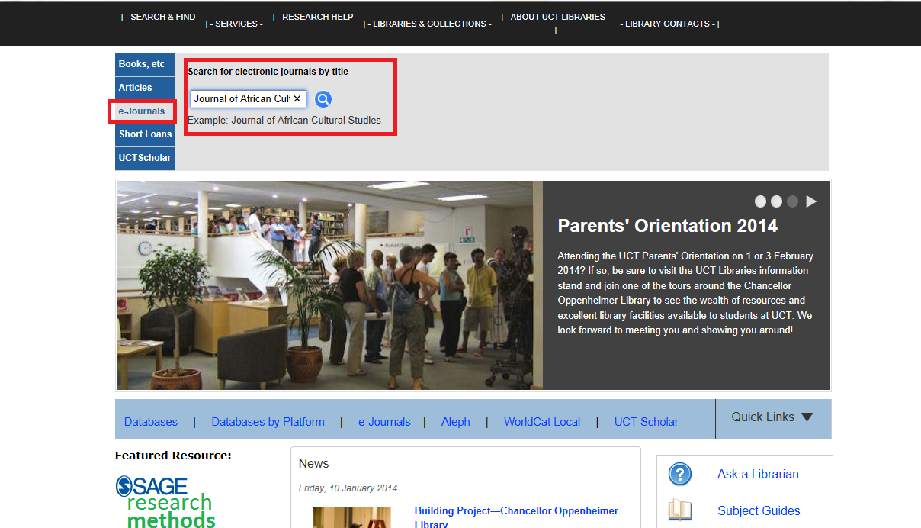

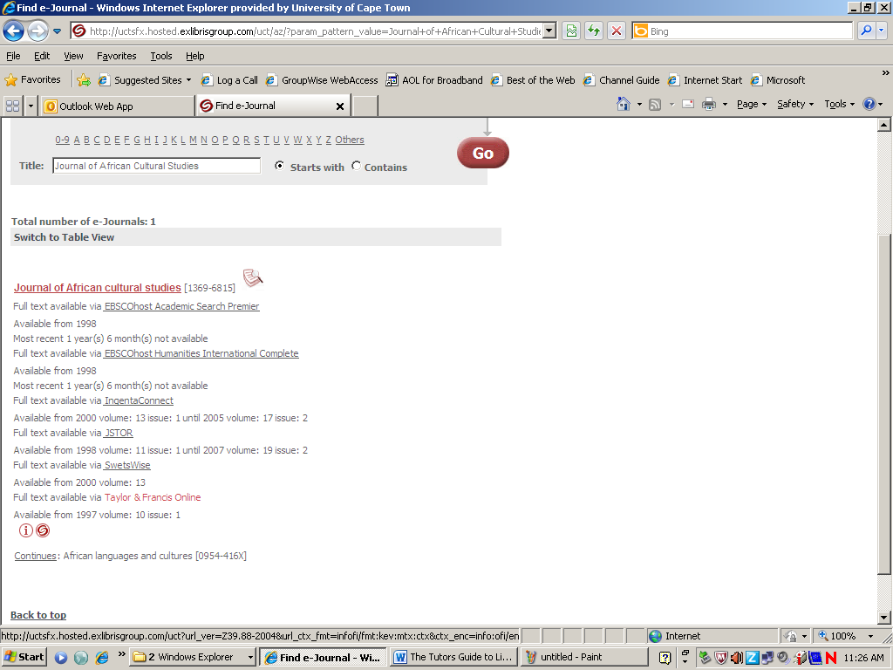

Clicking on the database allows access to the issues of the journal, which can be browsed year by year, issue by issue or, in many cases, simply searched by keywords.
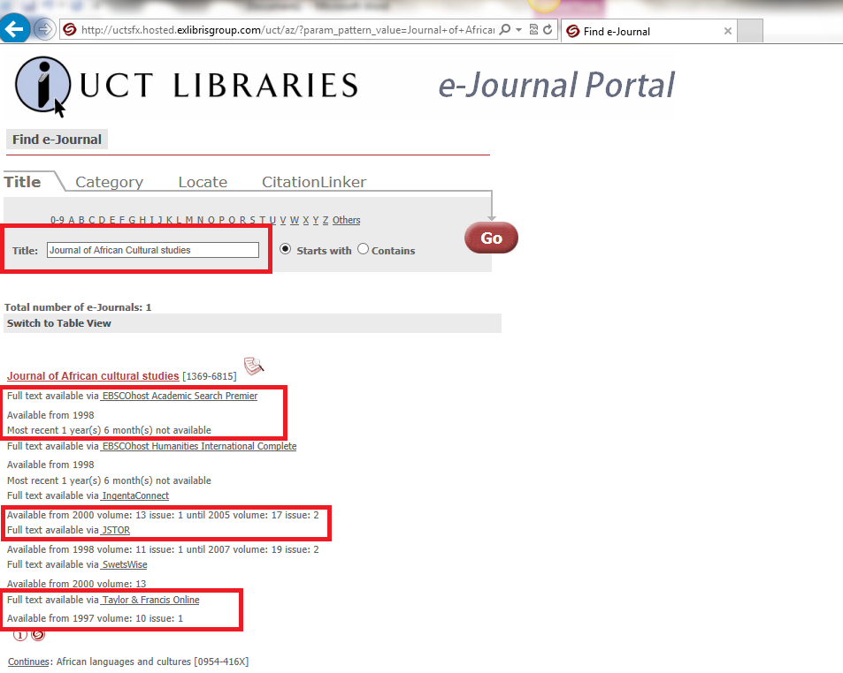

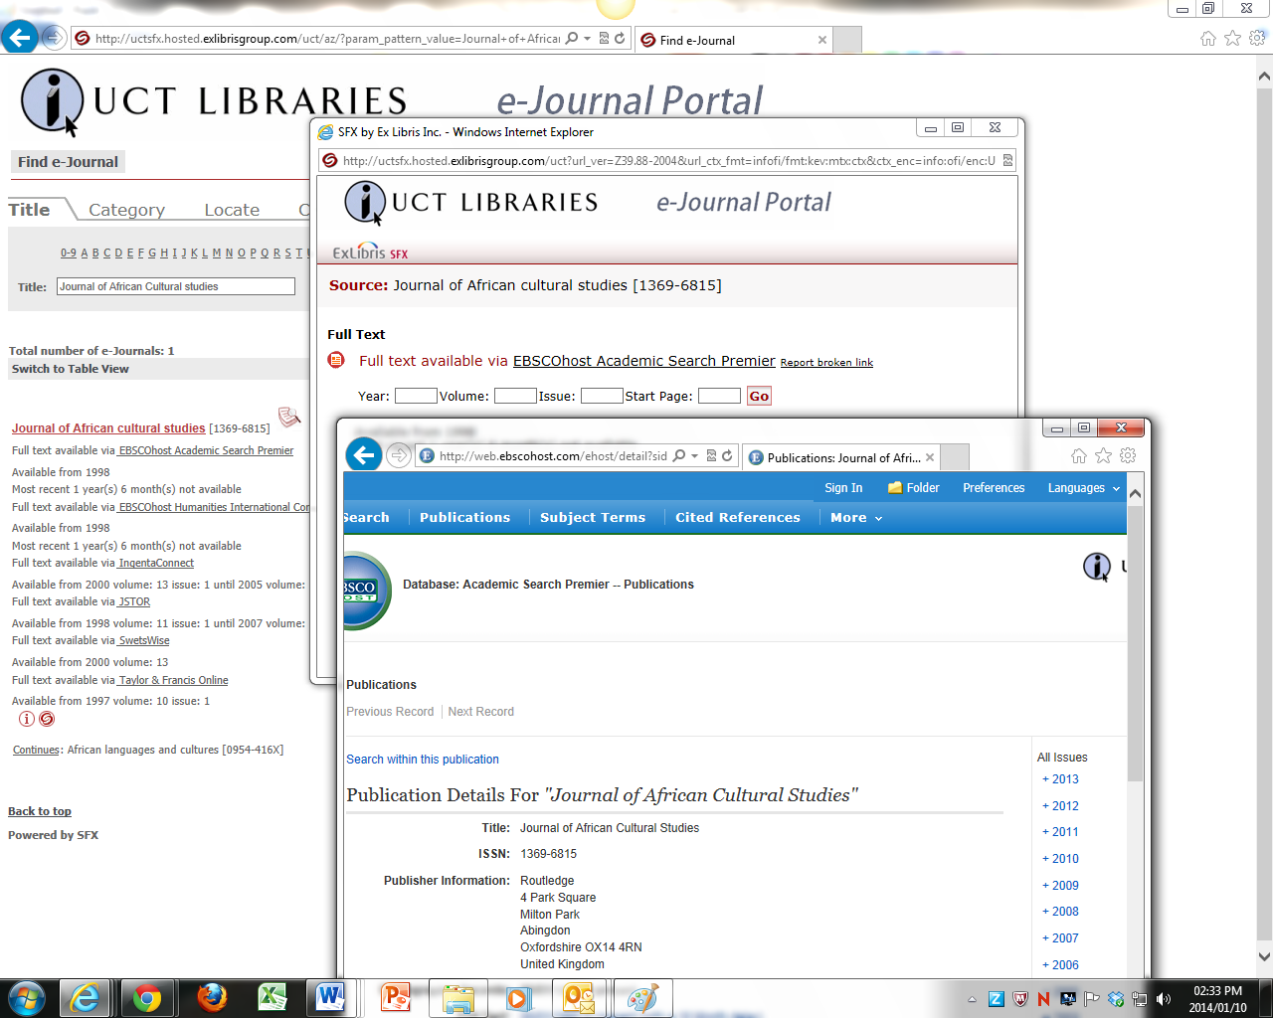

Searching a Database
Our electronic databases index journal articles – the mainstay of academic publishing and debate. Many of them also index book chapters, conference papers, Government or institutional or NGO reports, and theses.
You can use the databases to find journal articles and chapters in books by subject, authors or keywords. We have about 180 databases, some of general interest, others subject specific (and your librarians are really good at matching specific databases to particular questions.)
UCT subscribes a number of specific subject databases as well as some very good general databases which will help with most queries, BUT there is no single magic-bullet database.
Many of our databases will hold material of interest to just about any subject.
For example:
ScienceDirect (Full Text) - often has very good articles in the SOCIAL SCIENCES as well as the physical sciences – I would definitely try it for Politics, Psychology, Sociology, Education, Gender Studies, Religious Studies … the social sciences in general. It has good holdings in language sciences (Linguistics) too. It is also often a unique source of full text from the Elsevier journals.
SAGE Research Methods Online is a tool which allows you to find research papers by their methodology, and also provides many methodological guides.
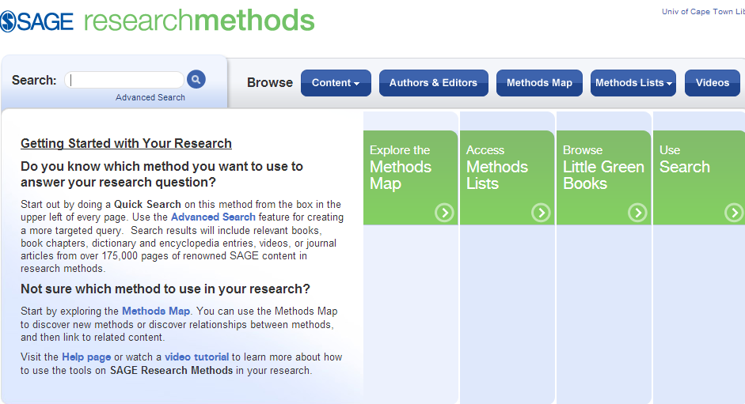

JSTOR – is an historic archive of major journals, across disciplines, usually from their first issue until five years ago (so IT IS NOT UP TO DATE.)
Project Muse Premium Collection - if you like JSTOR, you will love MUSE, a collection of high quality, peer reviewed, interdisciplinary journals from leading university presses, not-for-profit publishers and prestigious scholarly societies.
SA ePublications– a small, full text database of specifically South African journals – good for local research.
Africa-Wide: NiPAD - via EBSCOhost - a much bigger combination of African interest databases (African Studies, South African Studies, and African Healthline). Important, but not always full text.
EconLit - via EBSCOhost would have material on poverty and work and economics – including their Humanities/Social Sciences aspects.
PsycARTICLES - via EBSCOhost - on any aspect of psychology, including the Political and Sociological.
And in fact I would almost automatically search a selection of the these three general EBSCO databases (Academic Search Premier - via EBSCOhost (Full Text), Humanities International Complete - via EBSCOhost, SocINDEX with Full Text - via EBSCOhost) as well.
From our Library Homepage, you can mouse over the Search & Find tab and Click on Databases, or Click on Databases on the quick link bar, and get to an A-Z list of our 180 databases:
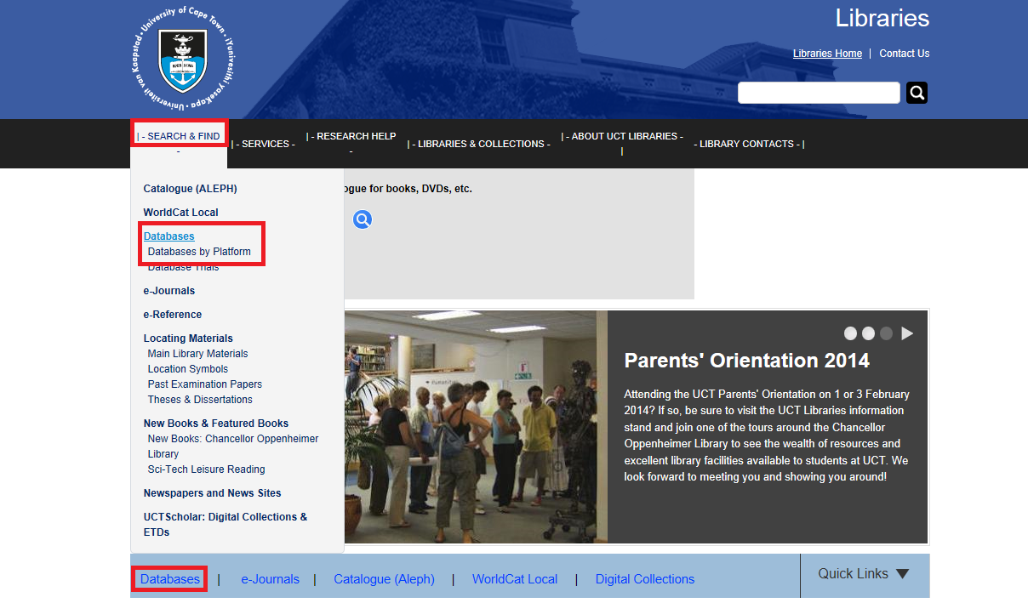
Academic Search Premier is second on the list
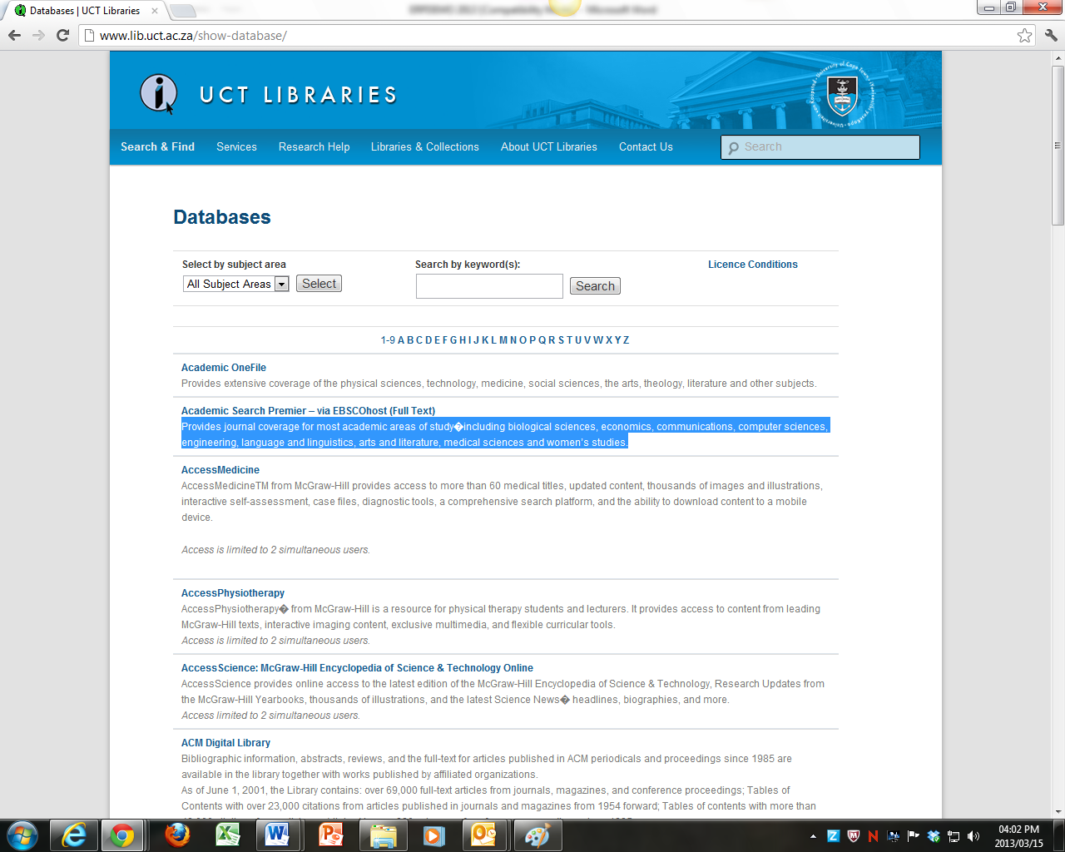

Academic Search Premier is a good general Full Text database. Full Text means that many of the articles will be available in full text on that database, you can simply click on the HTML or PDF link to open them. If they are not, they may be available in full text on one of our other databases …. I’ll show you how to get them in a minute.
The easiest way to search it is with simple keyword searching, like a chunk of Google. Any string of words not separated by “and” will be searched for as a phrase.
A quick search for Social Class:
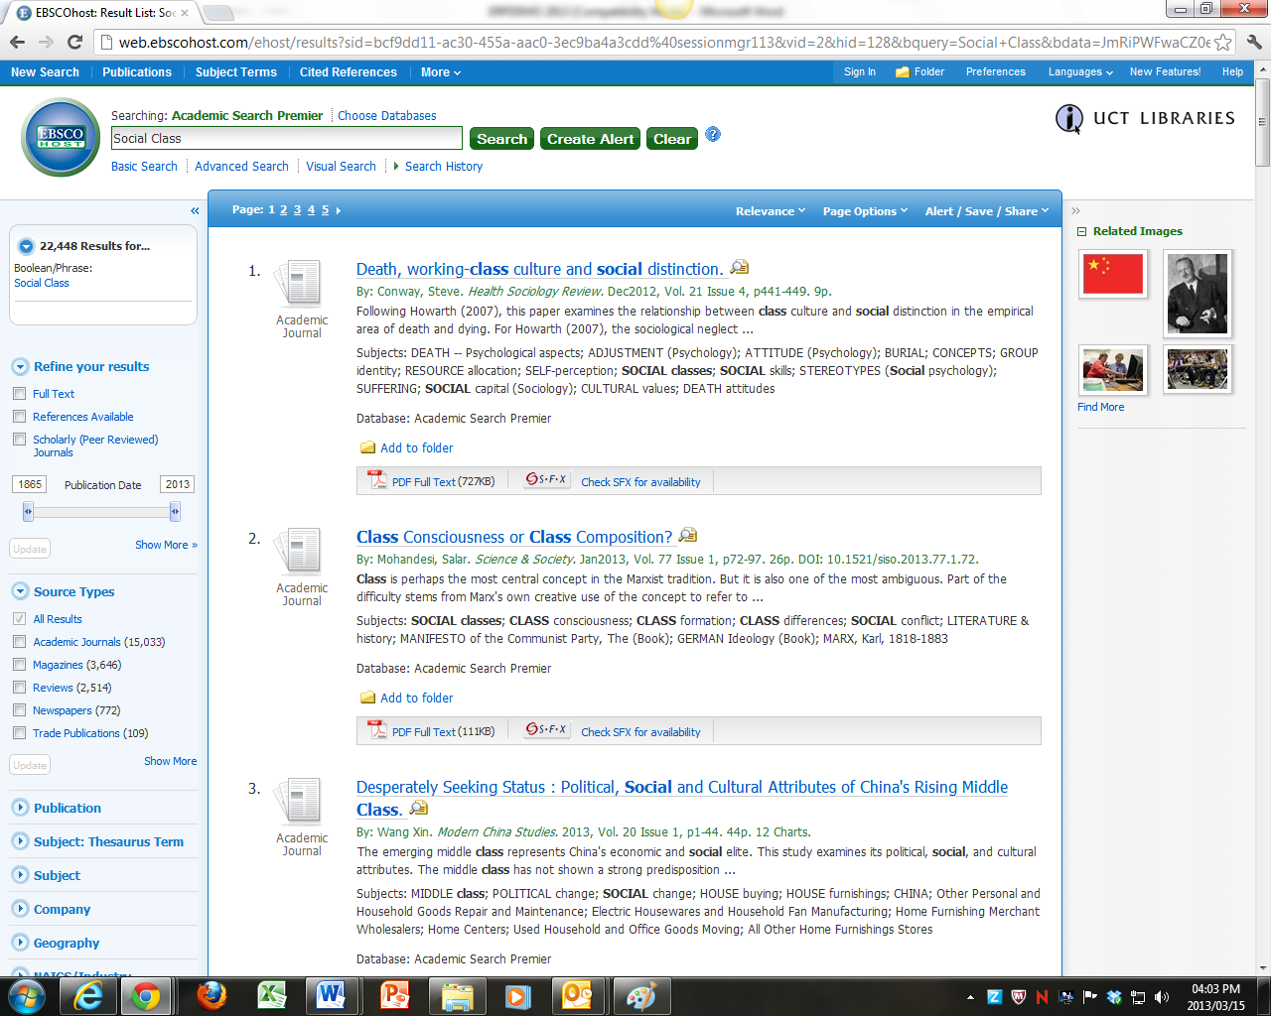
Called up over 22448 results which had the phrase “Social class” somewhere in their title, abstract, or subject classification, which is rather too many.
Not everything on Academic Search Premier is available in full text – in other words, you would not always get direct access to the whole text of an article. On the left hand side of the screen you will find an option to restrict the search only to those articles which have linked full text.
Be careful – it can drastically reduce your result list, especially on narrow searches and you could be missing a lot of important stuff – apart from still not cutting your quantity of hits down to a digestible level, in this case.
Even worse – it lies, if only by omission.
It restricts your results only to those articles which are full text on Academic Search Premier– it weeds out results which may well be full text on other databases and which can be easily accessed by clicking on the SFX link that follows articles.
SFX stands for Special effects, and links records from one database to the full text on other databases to which we subscribe.
In this search, the fourth record does not have a full text link on Academic Search Premier, but clicking on its SFX link …..
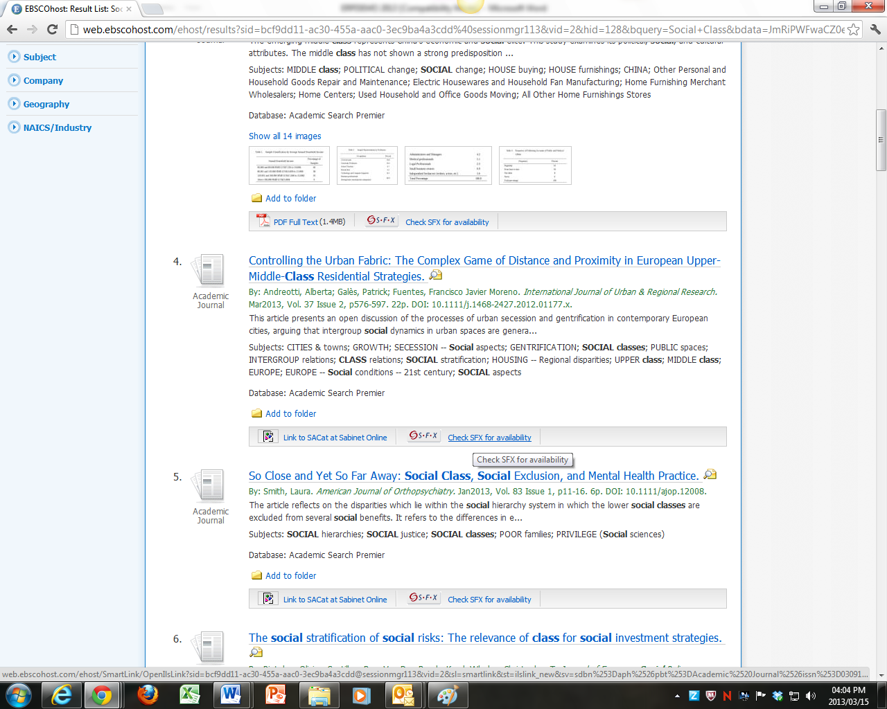
Takes us to another database that does have the full text:
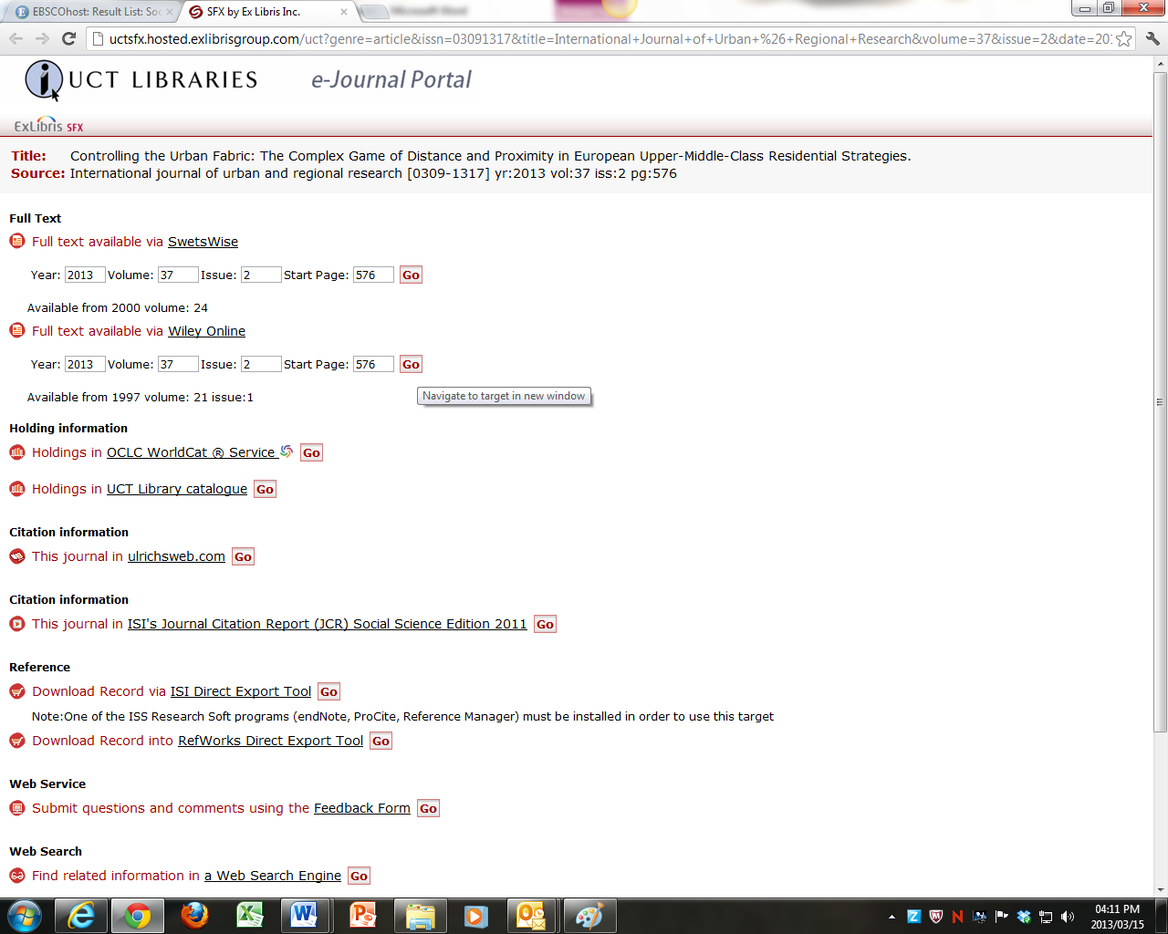

You could shorten your huge result list by weeding out book reviews and book chapters, by restricting the search only to Scholarly (Peer Reviewed) Journals, on the left hand panel.
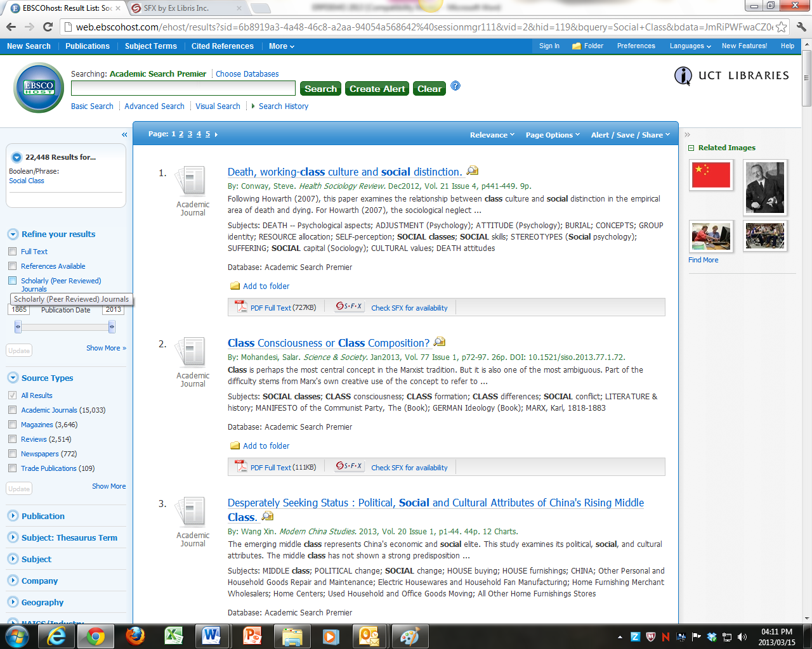
But this could (in fact will) lead us to miss some useful book chapters, which we may well be able to find in print in the library or easily get through inter-library loan. On the other hand, it does kill all the magazine-type hits, although these too can be useful for a voice-of-the–people view.
Moral thus far though - don’t weed things out with automatic limiters unless you are really, really sure that you don’t want them.
One thing that can be useful, at times, though, is the date slider bar. It is sometimes convenient to restrict results only to material published in the last year or so, especially when you have done a broad search that gives hundreds or thousands of results.
On the other hand – you can use a drop down menu to sort them by date order anyway (the default is often Relevance, btw, based on the number of hits of the term “social class”), with the most recent articles on top, so you can simply stop reading when you feel you’ve gone back far enough…. Or maybe decide to go a bit further back after all because you’ve scented something interesting….most often because, this date order, when read from the bottom up, and with more precisely targeted searches, can be handy in sketching out the progression of academic argument on a particular subject.
BUT BY FAR the safest way to reduce your number of results to a manageable level, as well as to ensure the relevance of the articles you do find, is to add more keywords.
Social Class AND South Africa brought up 203 results
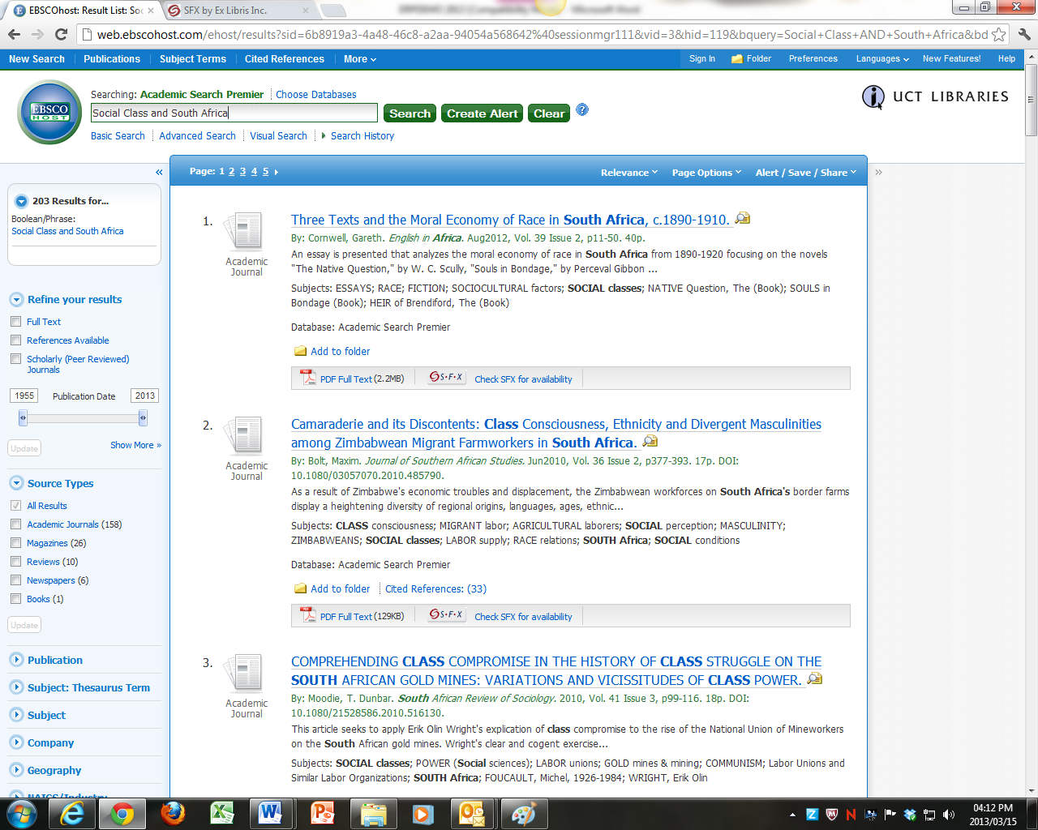

Adding new keywords targets the search more precisely – but can be too specific, especially where specific colloquial phrases are used – like “South African social class”. The database would find only articles, if any, which used exactly that phrase.
Moral of this – be careful about using phrases – you will miss writers who do not use exactly that phrase.

Using the formal Thesaurus to find the right subject term
At the top left of the search pane in Academic Search Premier (and many other databases) you will find an option for Subject Terms or Thesaurus.
From this link you can select a Thesaurus which shows the formal subject headings supported in this database:
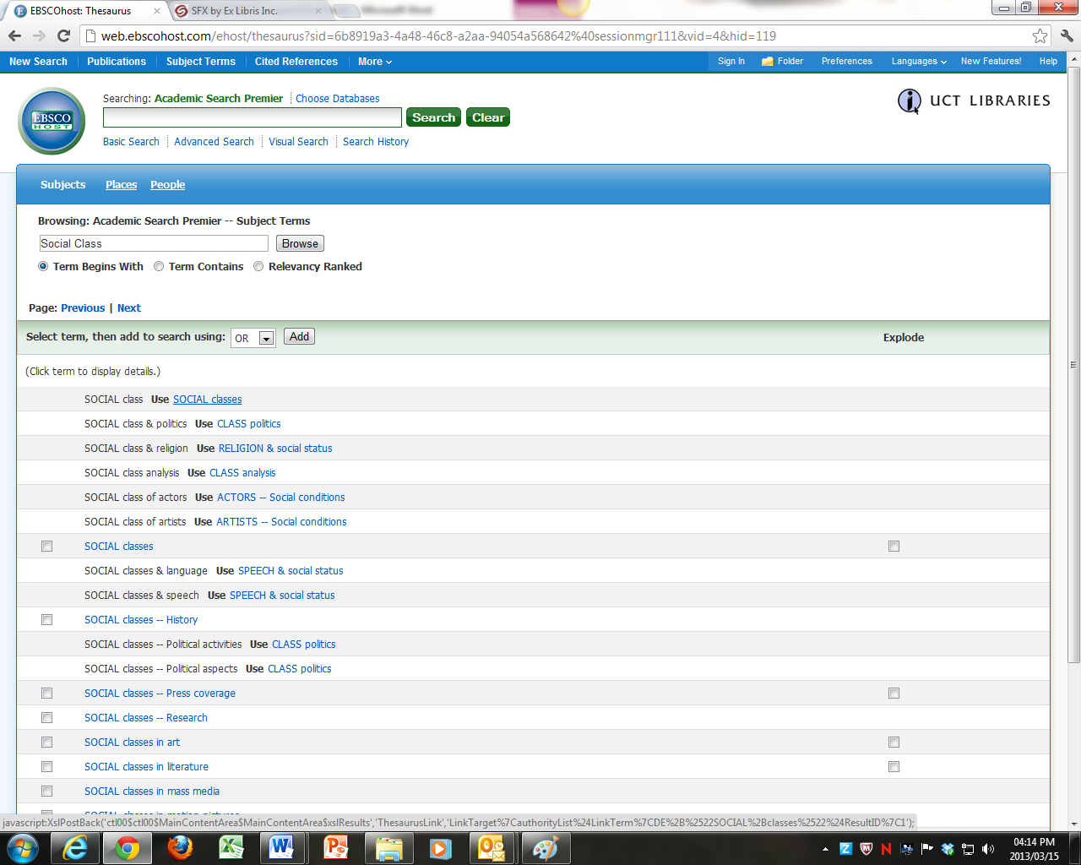
Very useful for finding terms you haven’t thought of, or the correct form of term - in this case Social Classes not Social Class.
In the words of many, I wish I had known this somewhat earlier….
I’ll click the term and add it to my search, to replace Social Class. It does so by adding the term as a formal descriptor (DE “SOCIAL classes”), and will search for it only in the assigned subject headings.
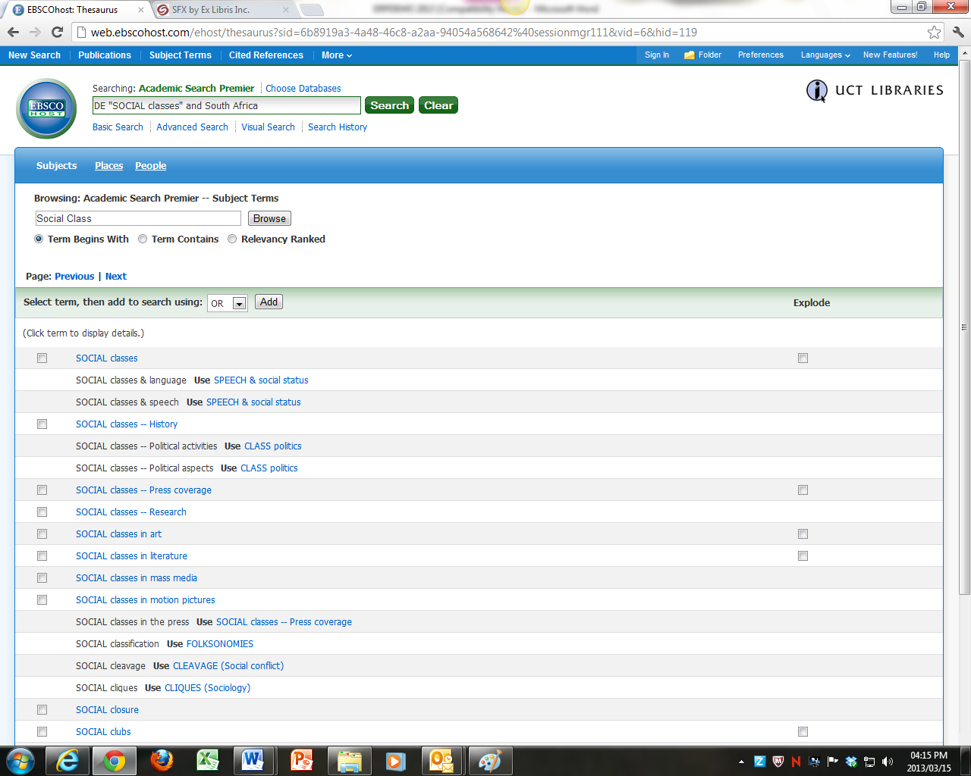
But - there is a big snag with this…..
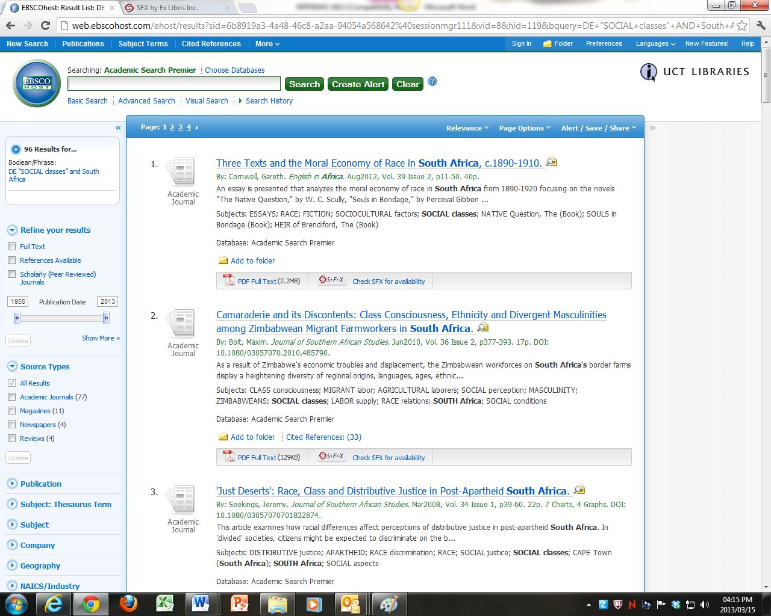

The snag is that when I ran the search, I found that only 96 records had been formally indexed with this term, rather than the 203 I had previously found simply by keyword searching.
Yes, the articles will, or should be, be predominantly and specifically about Social Classes, while some of the 203 I found earlier might have referred to Social Class/Social Classes only as a minor theme, but, on the whole, I’m not sure I trust another human indexer to do all my deciding for me to quite that extent.
Unless I get tons of hits from a keyword search and really want to narrow it all down to formal subject headings, I’d rather do a keyword search and judge for myself.
Still, indexes are sometimes useful for suggesting alternative forms of a word or by telling you to use certain terms instead. But, be careful – verify that not too much has been cut out by hard, human-error-prone, subject indexing.
Anyway, I could get results for both Social Class and Social Classes by using a wildcard in a keyword search for Social clas* now that I know about Social Classes.
That calls up 228 results – giving me the best of both worlds.

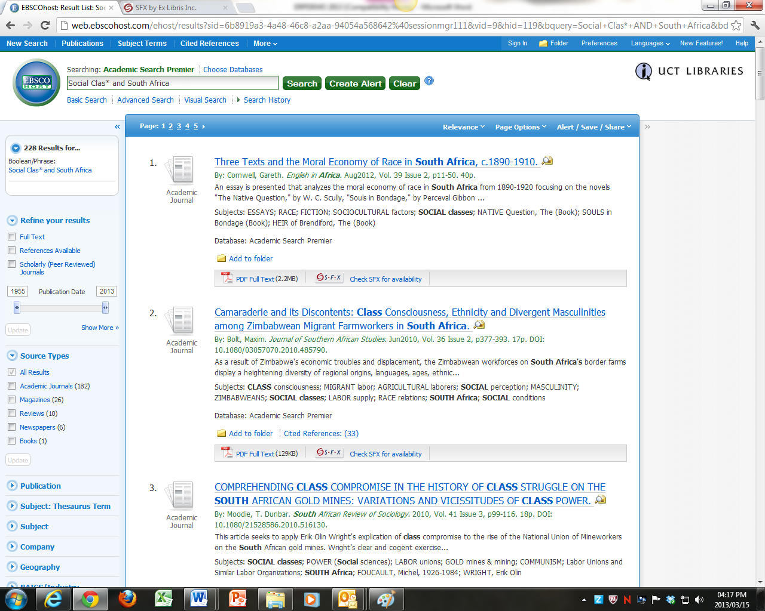

Slimming down results with a Visual Search option

One rather neat way of sorting your results into handy categories is to use the visual search option – common to many of the databases provided by EBSCO – we’ll use History and South Africa and later Anti-Apartheid Movements as simple search terms in this example, just to kick off with.
Click on the visual search option:
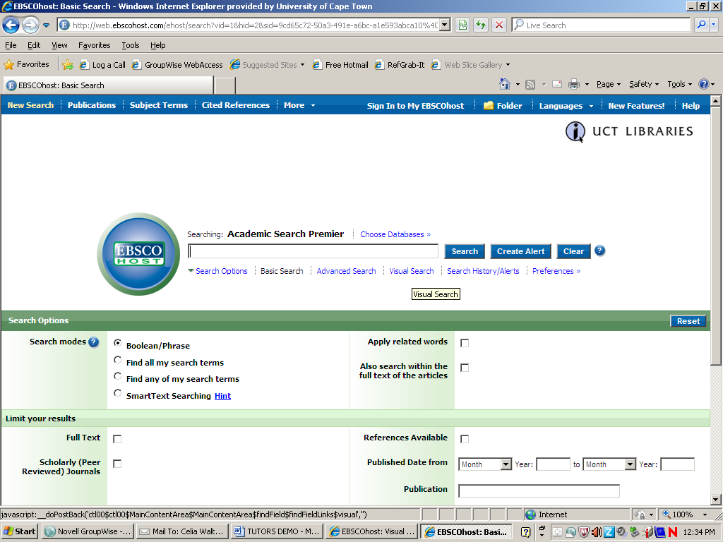
Type in your phrase or keywords:
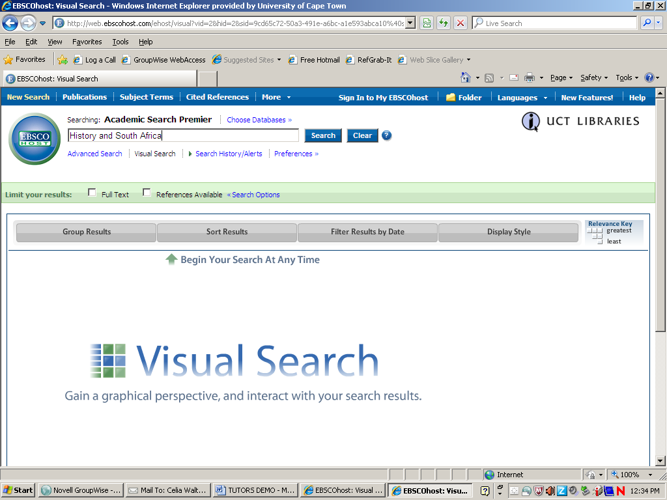

250 results come up. Select a category to narrow them, in this case Apartheid.

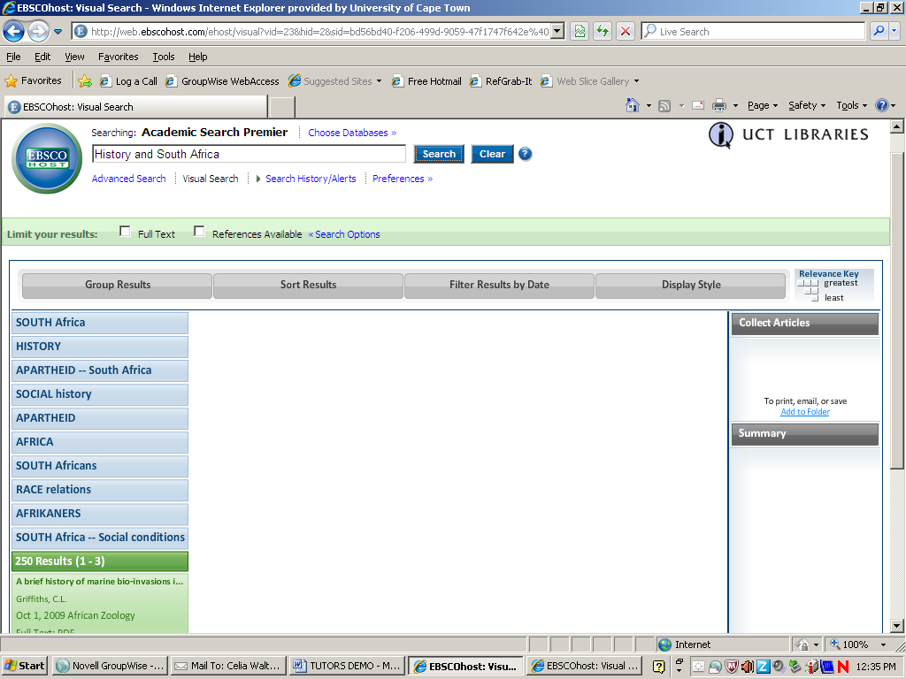

51 results fall into the subcategory Apartheid. Narrow it further by ANTI-apartheid movements.
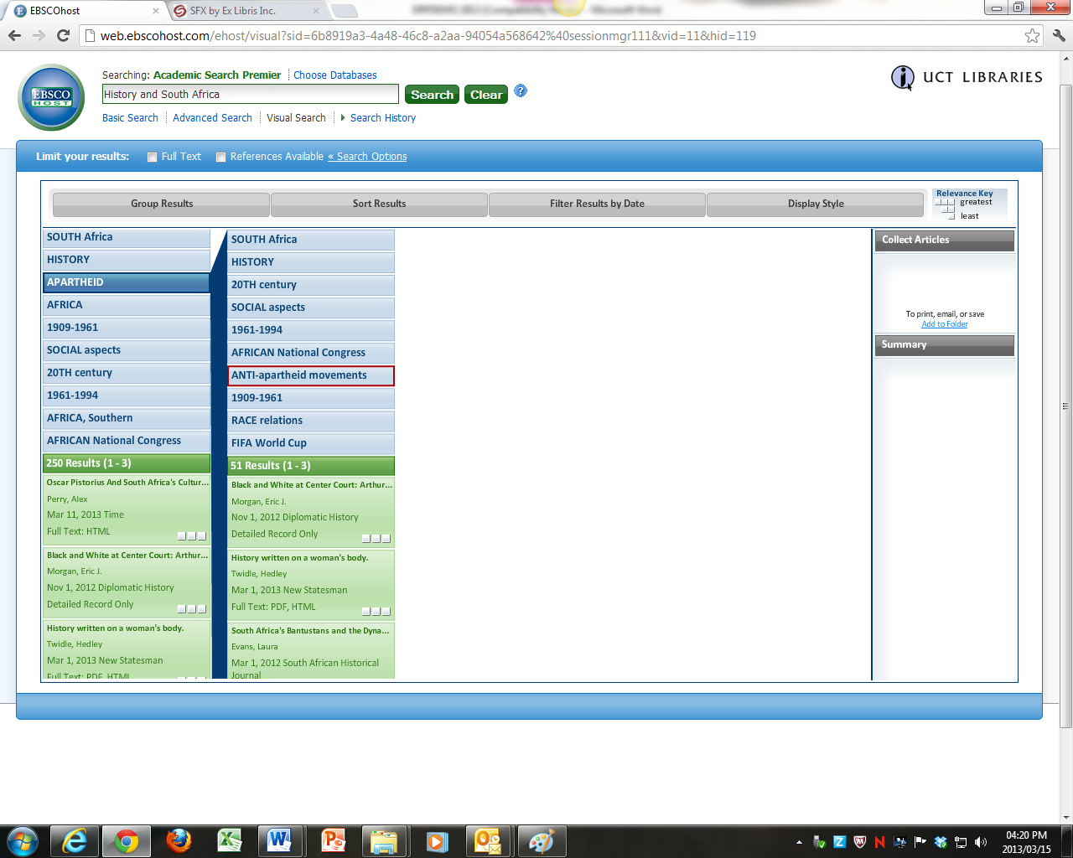

4 results fall into this sub-sub category.
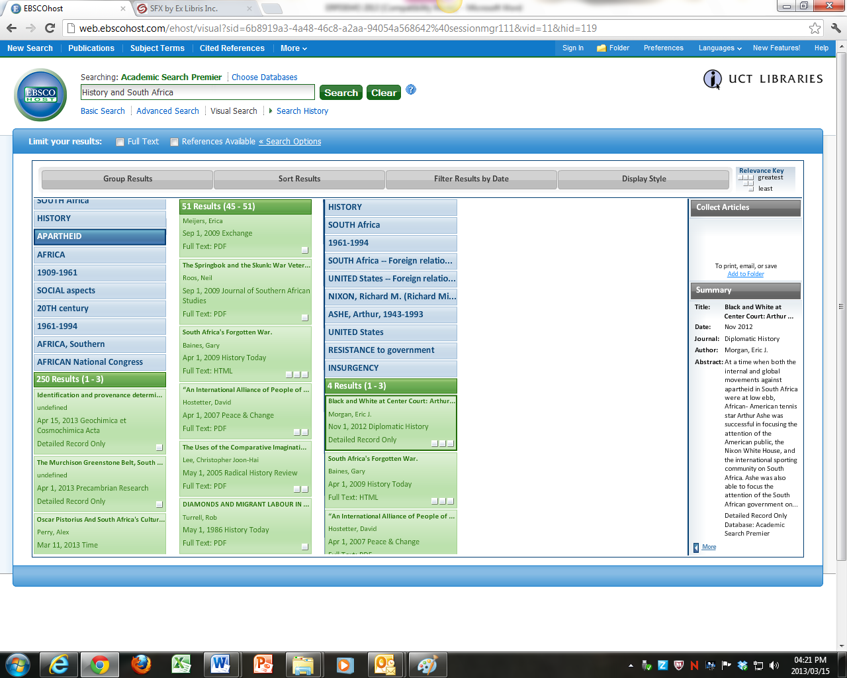

By clicking on any of these, I can get further details and an abstract, – which open in the right hand pane and, by clicking on MORE, I can get the full record, including a link to full text.
But, I do have to say that cutting 250 results down to 4 in this way might cause me to, …er… miss some stuff, don’t you think?
There is a lot to be said for hand-sifting, if the quantity of hits at all allows it.

Cross-Searching Databases
It is possible to cross-search some of our databases rather than go through them one by one.
There are two ways of doing this:
- Use the Databases by Platform search, which allows you to search a series of databases from a particular publisher (the producer of the electronic platform on which those particular databases work.)

- Use our cross-database interface, WorldCat Local
Cross-database (aka “Federated Search”) interfaces like WorldCat Local are intended as a one-stop shop for searching for books and journal articles and cross-searches many databases, provided by different publishers.
They are designed for ease of use by undergraduates – and in searching across a great many different databases they sacrifice the precision searching that is possible when searching only one database, or a set of databases all from the same publisher/provider. Very often, too, they do not properly support Boolean searching.
It important to avoid relying on subject headings when you are cross-searching several databases simultaneously – because not all databases use the same index terms – in fact some index terms are unique to a particular database – think of specialist psychological terms used on PsycINFO, for example.
By selecting the subject headings used on only one of the databases you are effectively cutting out all the others.
Still, WorldCat Local is useful for quickly obtaining a very large hit list of results and getting an idea of what has been written on a topic from across disciplines.

Finding Books and Journal Articles with one search on WorldCat Local

WorldCat Local is a tool for searching across the UCT library catalogue (Aleph) as well as a selection of our databases of full text journal articles, all with one query.

It is a quick and dirty search aimed predominantly at undergraduate students, but is also rather useful in bringing up a large mass of material for an overview of what is being written across disciplines, before starting to search on the narrower, more discipline specific, individual databases.

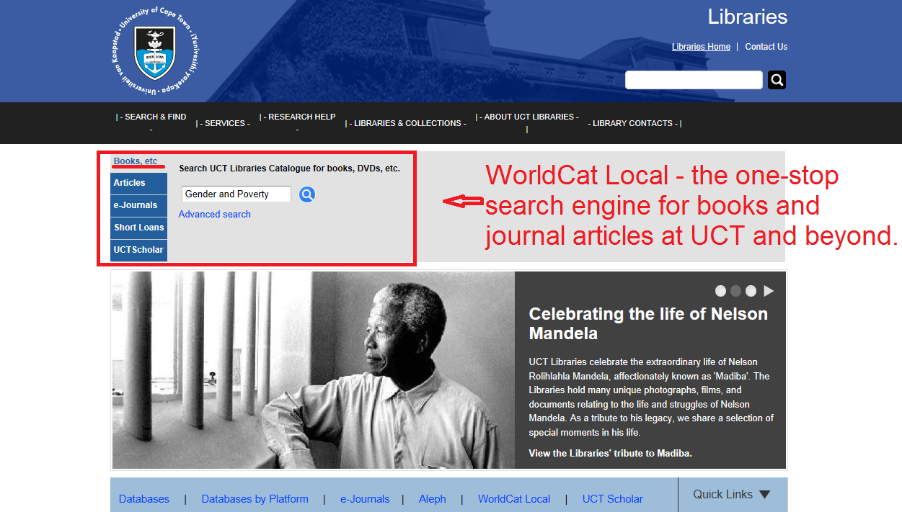

The search screen has a drop-down menu to search for material at UCT or Worldwide. Material from other libraries in South Africa can often be obtained by Inter-Library Loans, but start with our library first.

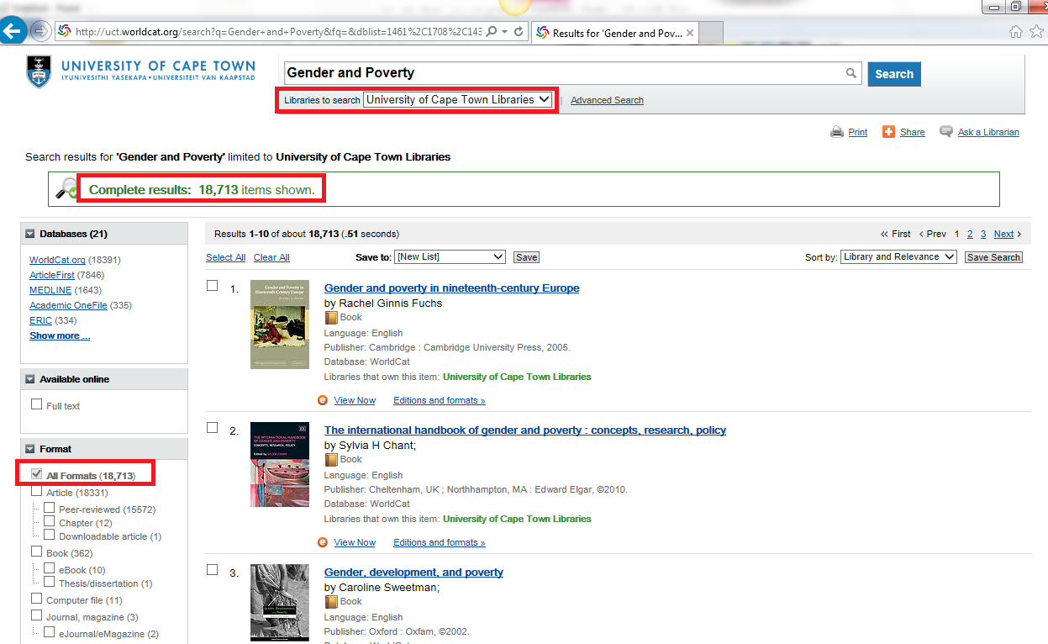

For this search, “gender and poverty”, there are 18,713 results for items at UCT.

The default search (books etc.) brings up both the books we have at UCT and many of the full-text journal articles to which we have access.

The best articles, of course, are “peer reviewed”, which means that they have been checked and approved by other academics before they are published.

The books are listed first. On the left hand side, you can filter the results to show only books, or only journal articles:

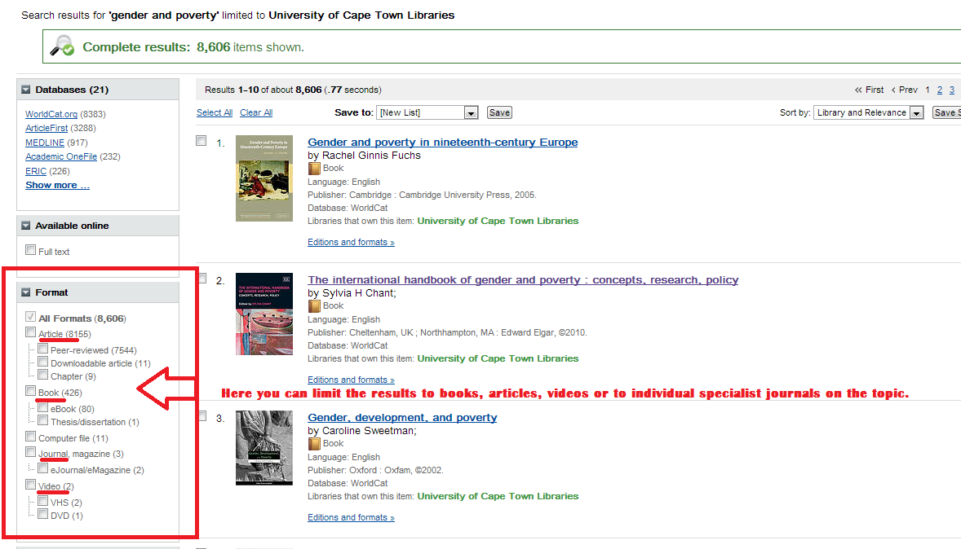

You can organise the results in different ways by using the drop down box at the top right of the screen. Date order is often useful in bringing up only the most recent materials. However, there is also another reason why date order is useful - remember that there are tides and seasons in academic publishing; a topic may be hot at one time, then fall out of favour, only to become popular from a different angle later. Date order can help you spot the tides and patterns of discourse on a particular topic over time. This can be incredibly useful in building a literature review, many of which trace the development of research on a topic over time.

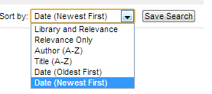

Below the Format options, on the left of the screen, you will find other options for refining your search results. The Refine options cut out the other results; they don’t just order them differently.

Topic is often the most useful of these options – the topic is a formal subject heading, which means that the results must be wholly, or largely about that topic – the Sociology of gender and poverty, for example, not fiction about gender and poverty.
Be careful though. Databases often have their own subject indexing vocabularies, so in cross-database searches such as WorldCat, the selection of a subject heading will effectively weed out any other databases which do not use that subject heading…..

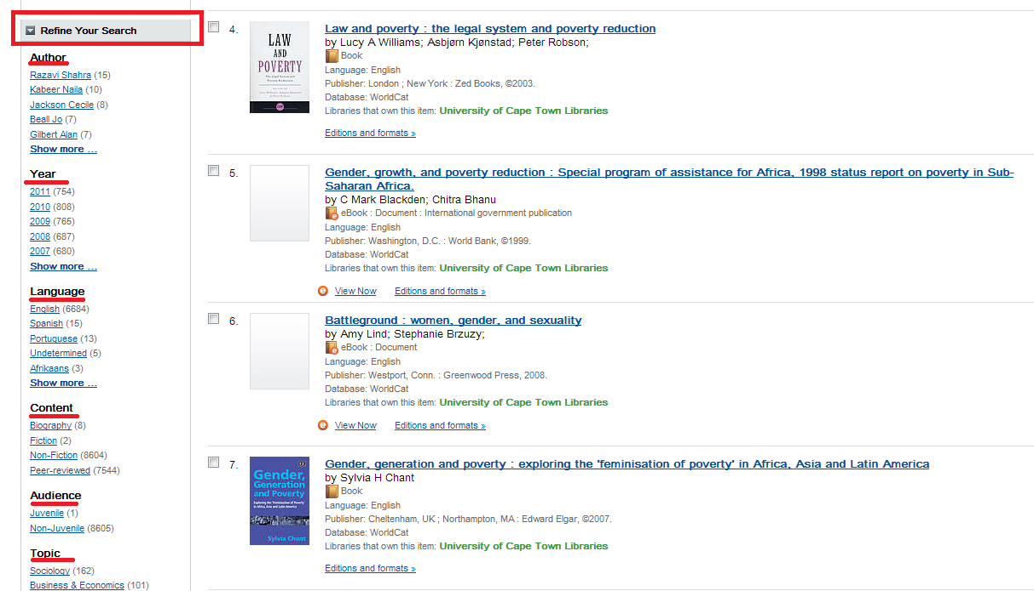

If you find a book on WorldCat that you like, click on the title:

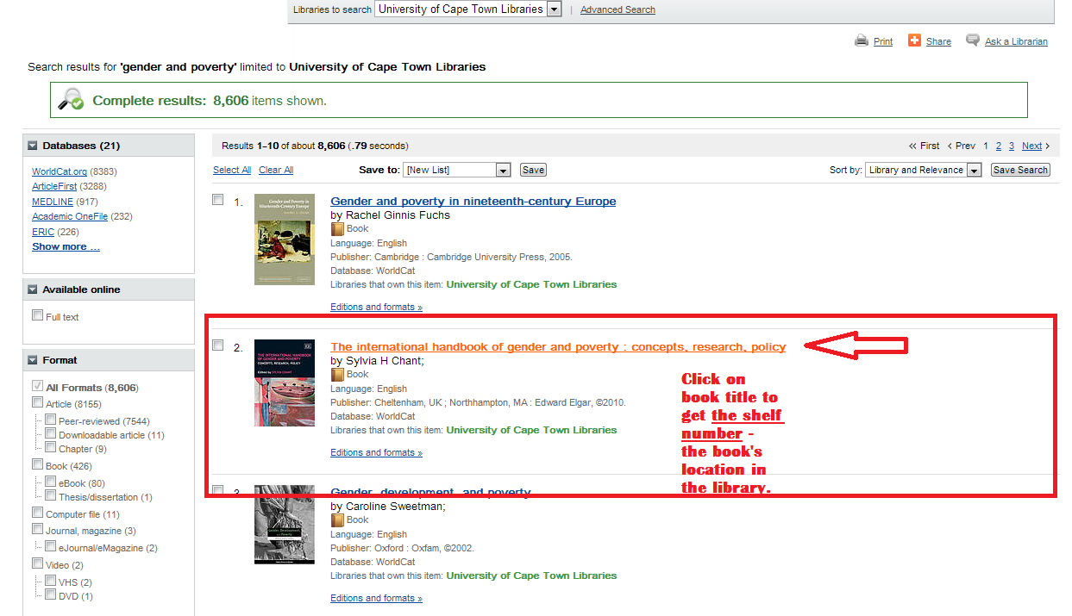

This will tell you which of the UCT Library sections to visit to get the book and whether it is on the shelf or on loan. Most importantly, it will give you the shelf number for finding that book on the shelf. The shelf number works like a street address – just follow the numbers until you get to the right location.
(Tip - shelf numbers keep related works together, so it is often worthwhile browsing the shelves at that number for related books as well.)

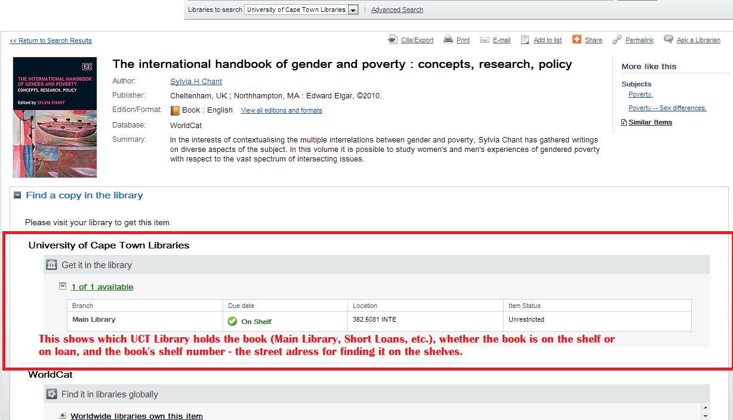

And if you scroll further down the record, you will often find a table of contents for the book under Details.

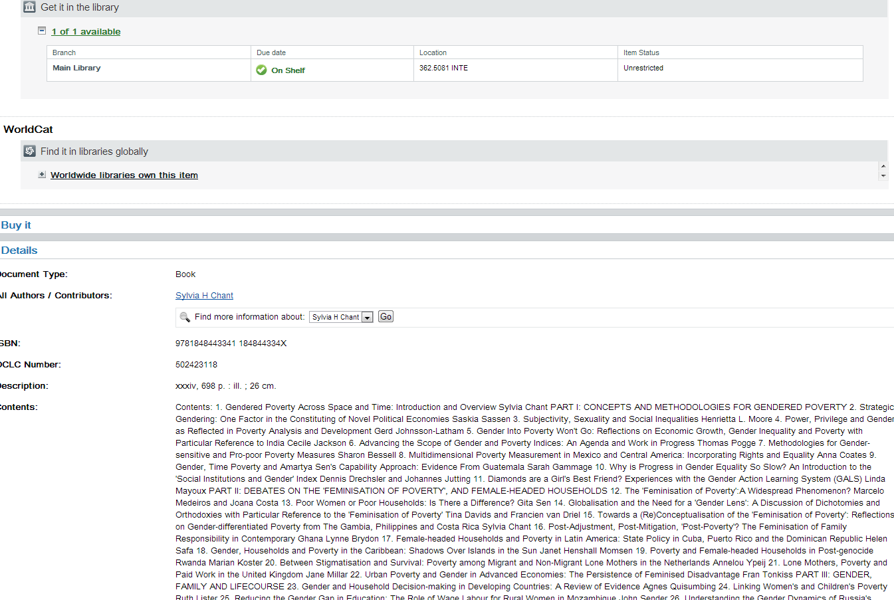

If you limit the search to articles only, or have found an article you like on the results list, click on the View Now link below the reference to the article:

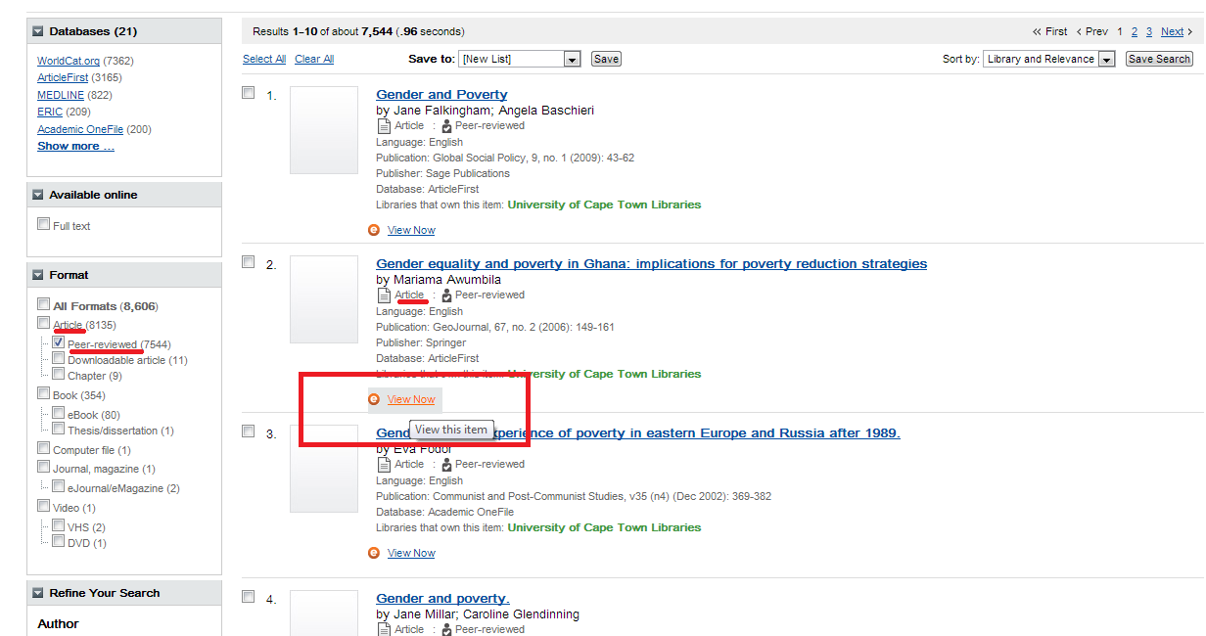

This will tell you which of our many databases holds that article. You can click on the link to that database:

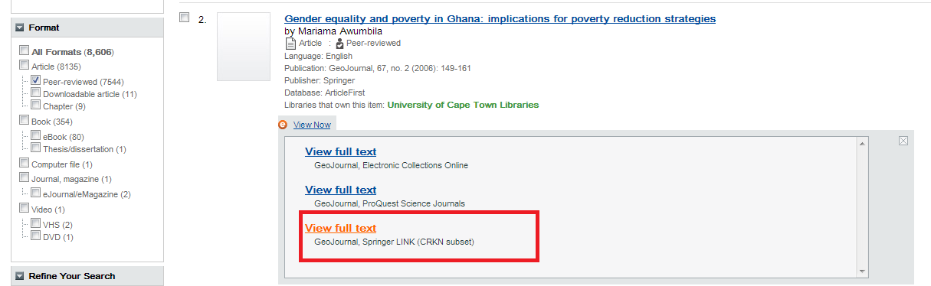

The first time you do this you might be asked to sign on to the UCT network, since these databases are only available to registered students.

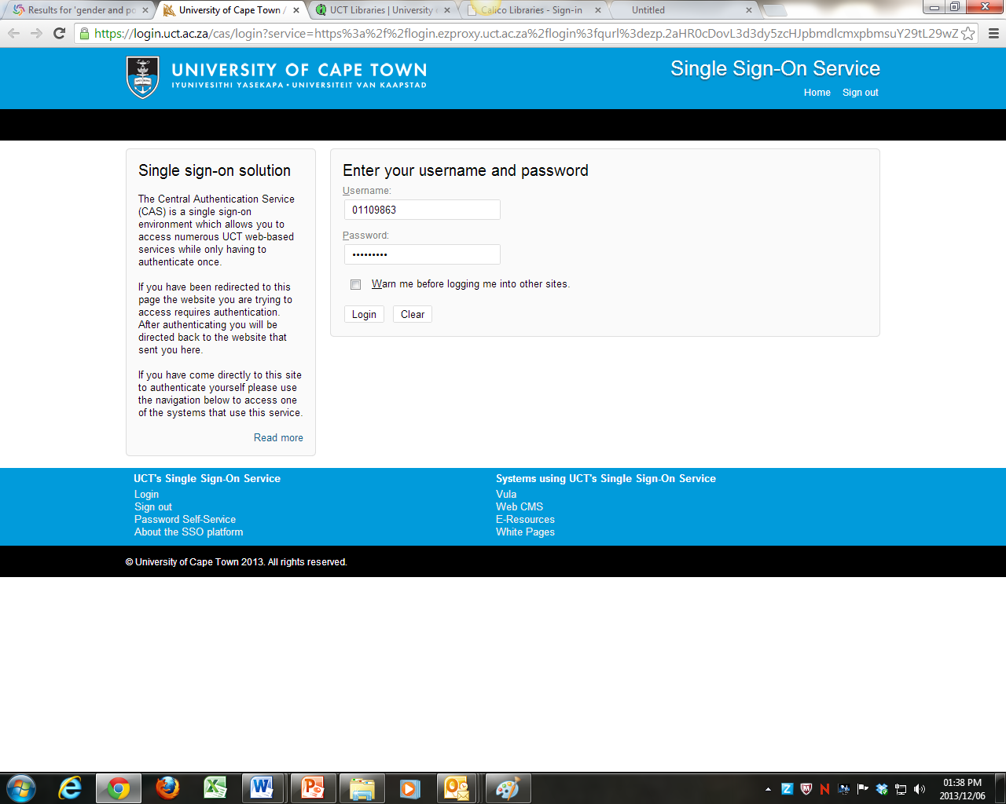

Once you have signed in with your student number and password, you will be taken to that article on the database. There you will find an abstract of the article – a short piece that tells you what the article is about – and a link to download the full text of the article.

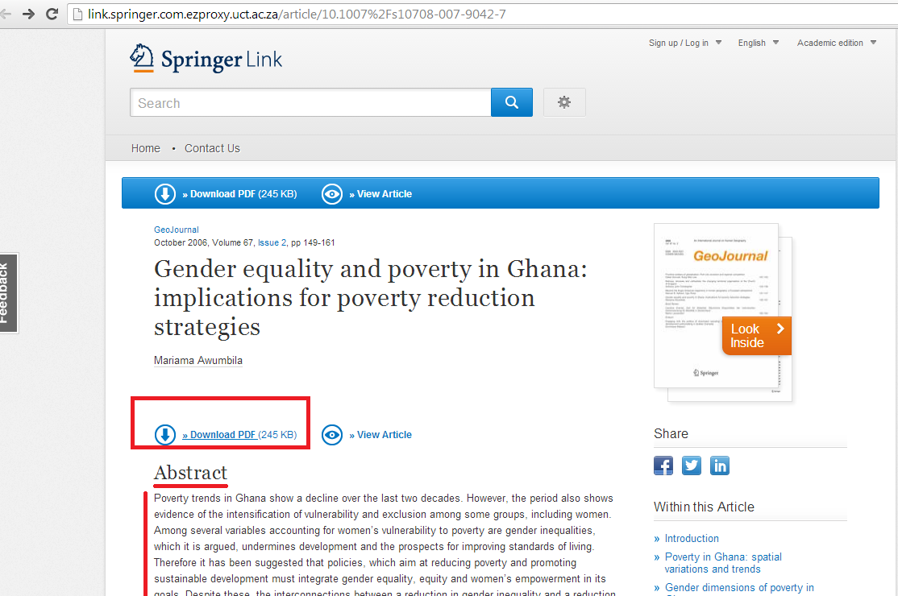

You can then print it or save it to a flash drive:

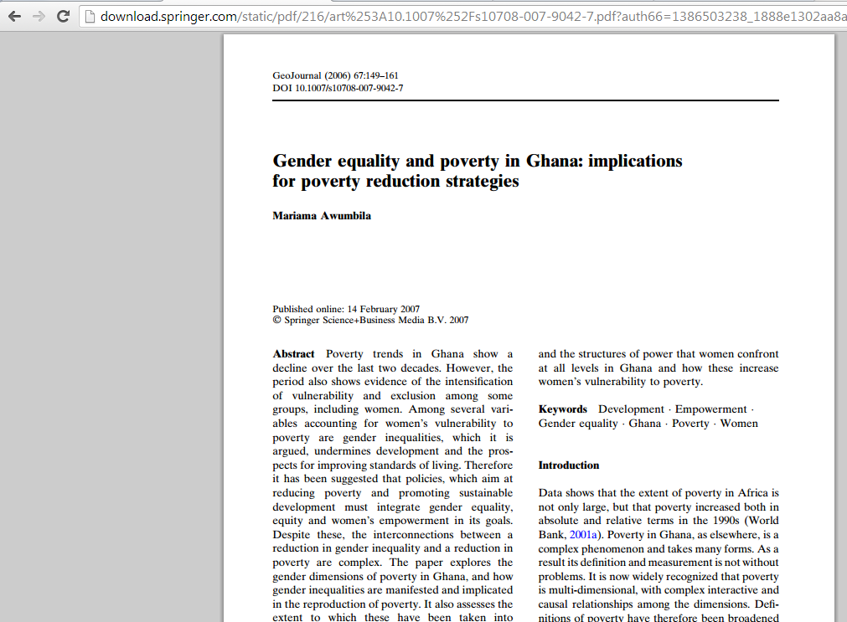

Search. Find. Download…. Simple as that.

What to do with your WorldCat Local results

If you click on the title of the book or article, you will find options of emailing the record (not the full text) to yourself, printing out the record, copying the formal citation of the record or exporting the citation of the record to a database that allows you to cite it as you write, adding it to a private list of references… and, at the end, asking a librarian about it.

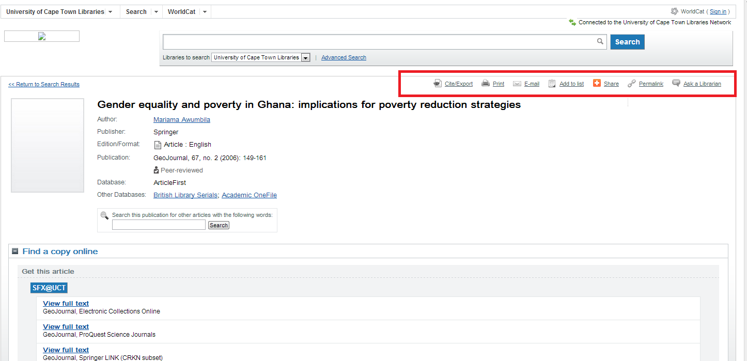

The Cite/Export option can be particularly useful:

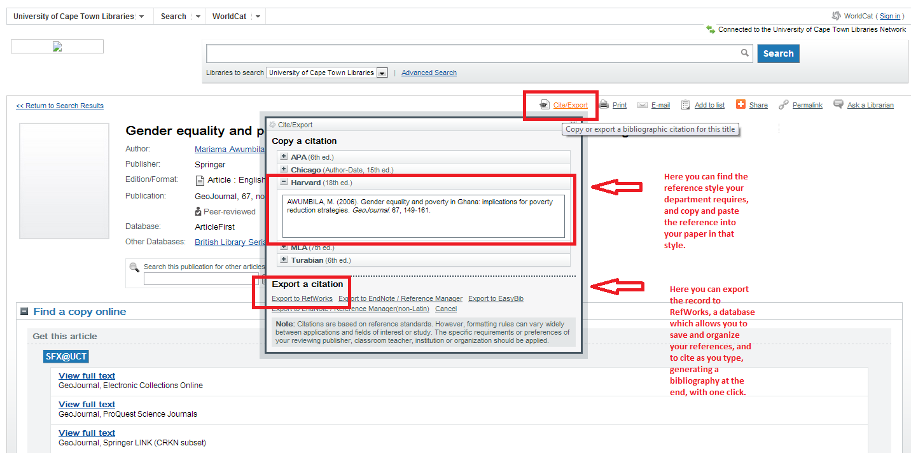

If you have signed in to WorldCat Local, you can save the reference to a private bit of cyberspace, where you can create and save lists of your search results, and share them with others if you like.

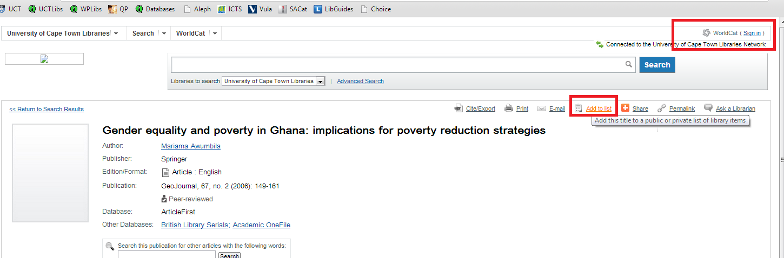

You don’t have to go into the individual records to save your results to a list. You can do it from the result list too, for multiple records all at once, by using the checkbox next to each record and adding them to a list:

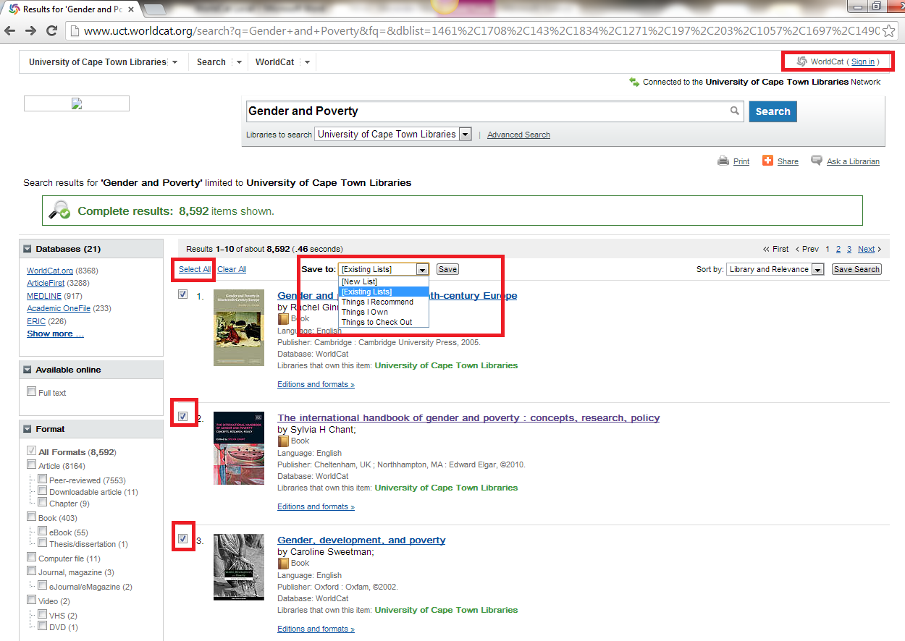

But you will need to sign in first, to create, or access, your private account on WorldCat.

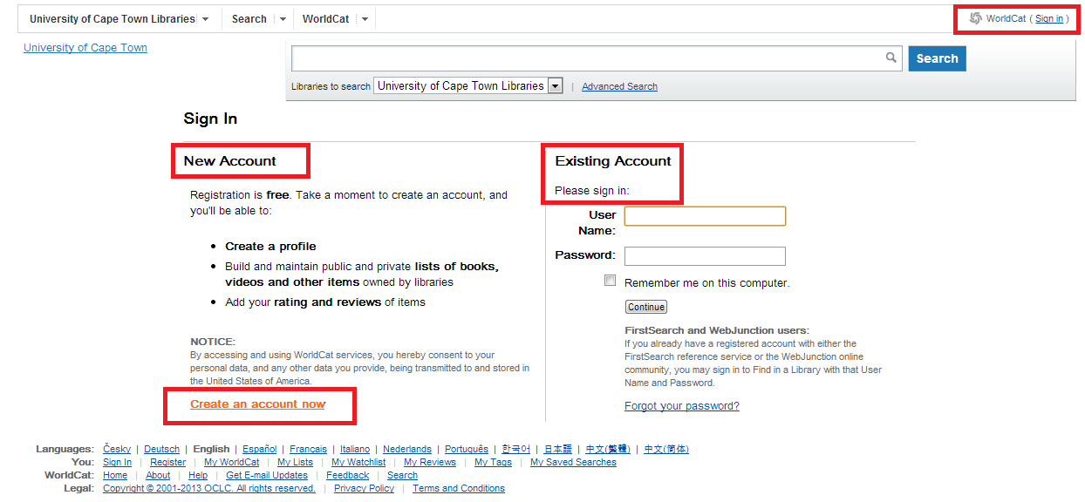

Once you have signed in you can create and add material to lists.

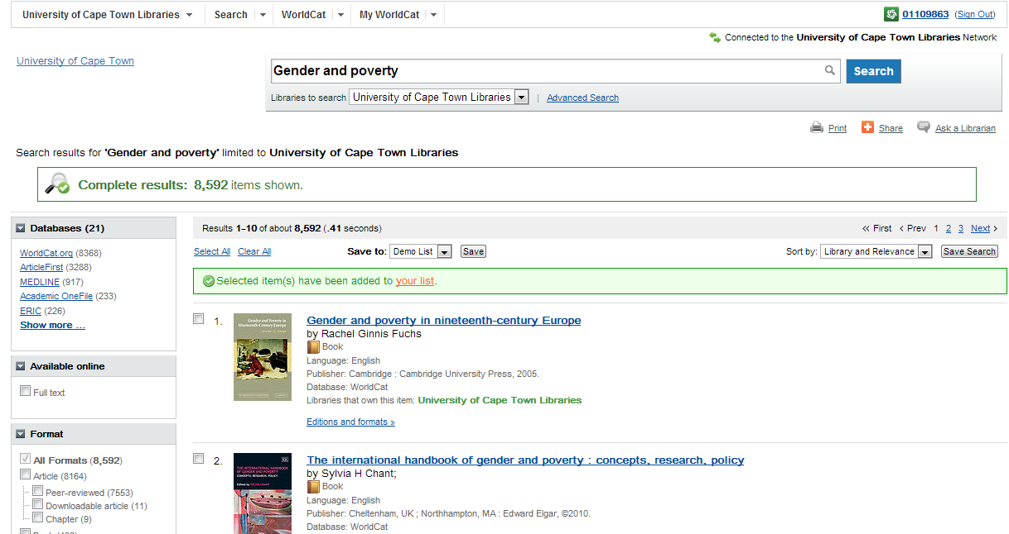

From the Citations View on your list page you can select a citation style (Harvard, APA, etc.) for the records, for copying and pasting. Or simply export the list to RefWorks, a tool which allows you to cite your references by clicking on them as you write, and then format a bibliography with a mouse-click. (More on RefWorks below.)

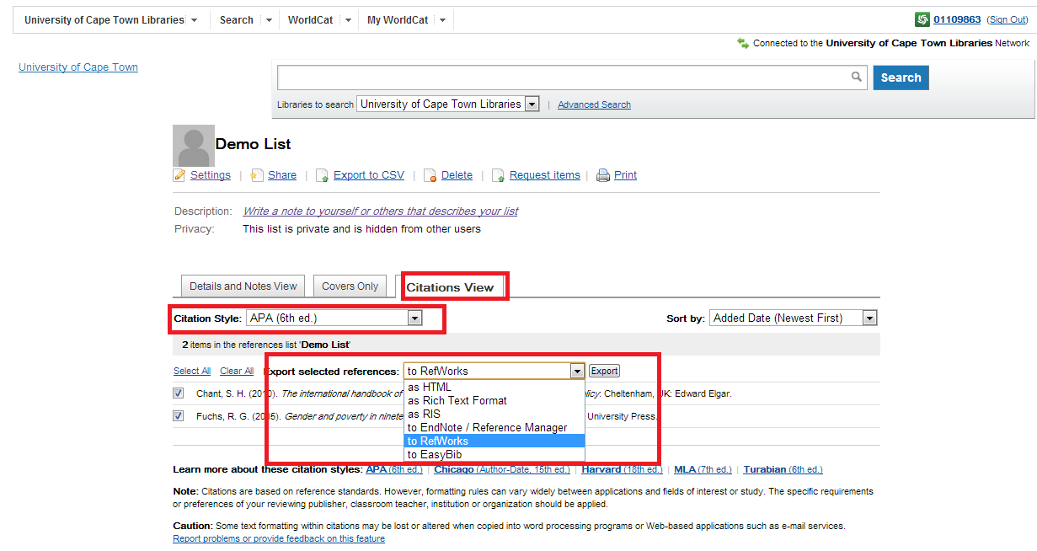

The Advanced Search option on WorldCat Local
Next to the default search screen is an Advanced Search option.

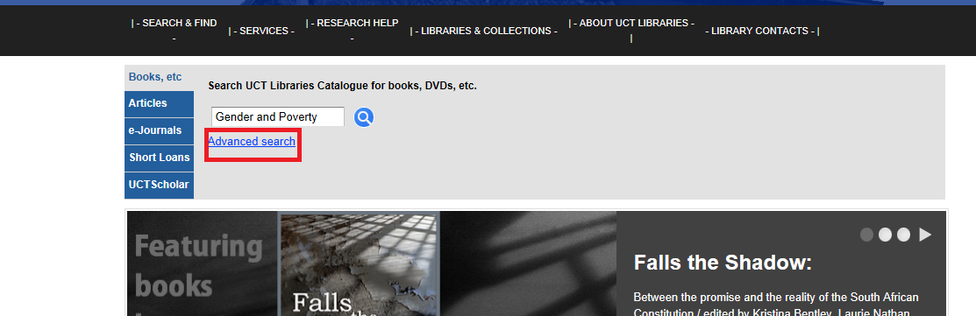

The Advanced Search option allows you to restrict your search to particular databases, particular areas of the record and specific years or types of results.

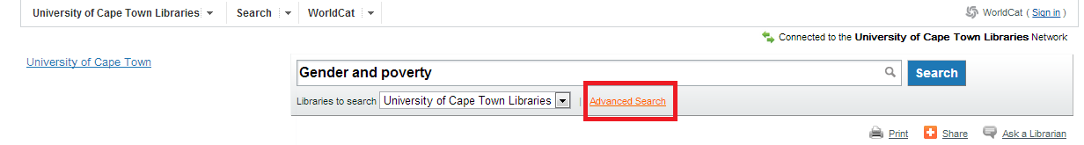
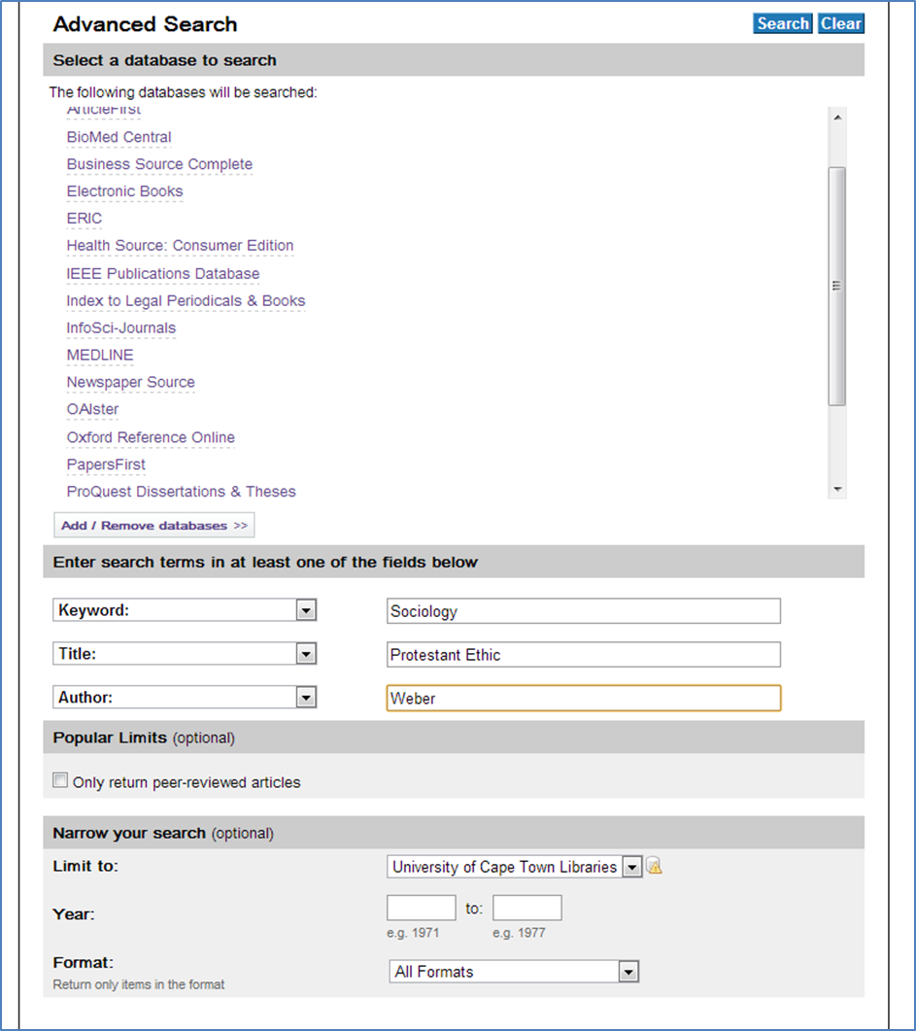

Do not forget the Ask a Librarian option if you get stuck:

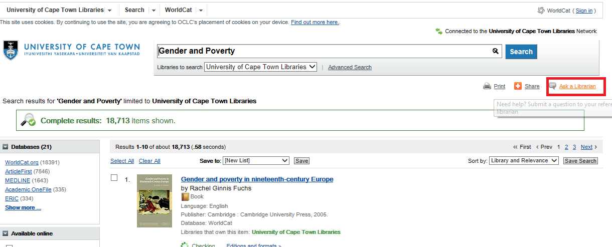

Cross-Searching by Platform
The “Platform” is the standard interface used by a publisher of a set of particular databases.
Go to the library homepage, mouse over Search & Find and select Databases by Platform
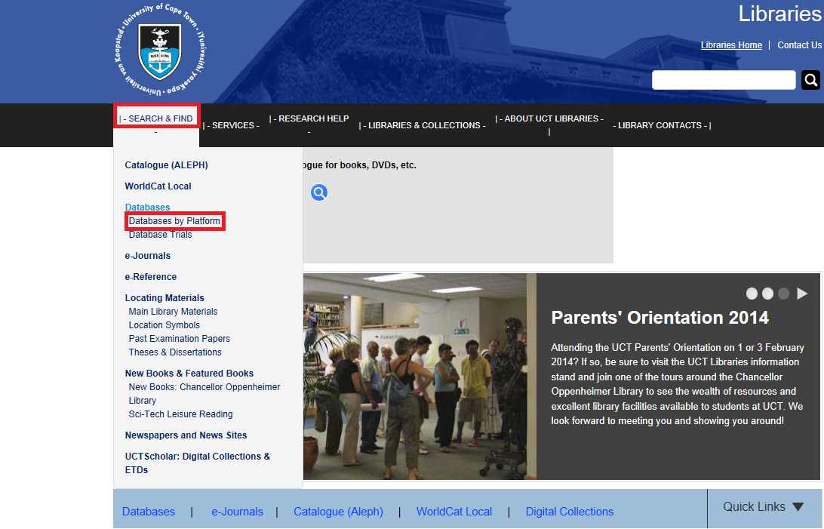

Then select the Ebsco set of databases :


Ebsco is the platform for a large number of very good inter-disciplinary databases, as well as a number of specialised ones for particular subjects –MLA for Literature and Language, PsycINFO or PsycARTICLES for Psychology, EconLIT for Economics, SocIndex for Sociology.
It is also the platform for the Africa-Wide database – this is an absolutely essential database to search if your work has any link to Africa at all.
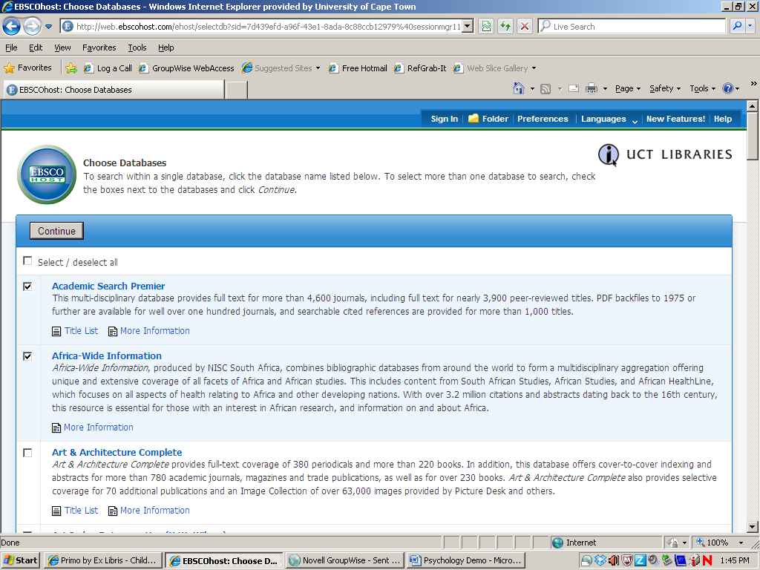
For a really broad search, including South African, medical, social, press, educational and philosophical aspects of a topic, you might want to select the following Ebsco databases:
- Academic Search Premier,
- Africa-Wide Information,
- Communication & Mass Media
- CINAHL,
- EconLit
- Health Source: Nursing/Academic Edition,
- Humanities International Complete,
- MEDLINE,
- SocINDEX with Full Text,
- eBook Collection (EBSCOhost),
- Teacher Reference Center
For a Psychological slant you might want to add PsycInfo.
They do not, alas, share the same indexing protocols, but, coming from the same platform, they do respond identically to nice, detailed, Boolean searching:
(child* or children or pre-teen or pre-adolesc*) and (poverty or deprivat* or poor) and polit* and (urban or town* or city) and (Afric* or black) not African American
This brought up 882 results, ranked by relevance – with some nice stuff:
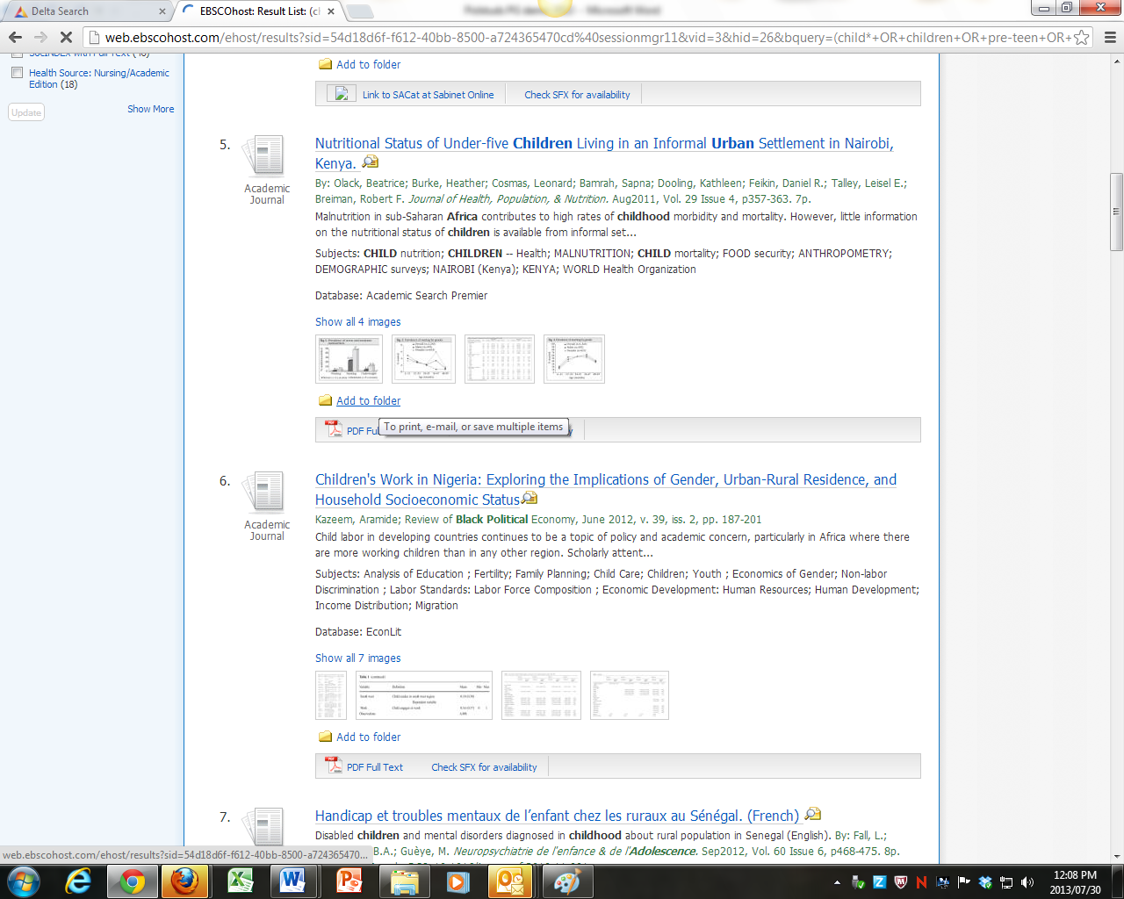
I can limit results by date (handy for weeding out the pre-1994 watershed for SA) and also restrict results to peer-reviewed journals.
I would not restrict it to full text only, though, because, it (a) leads me to miss important stuff and (b) it lies – remember, as above, that just because it is not full text on the Ebsco databases, doesn’t mean that I can’t find it full text on any other that we have, by using the SFX button, as we have seen above.
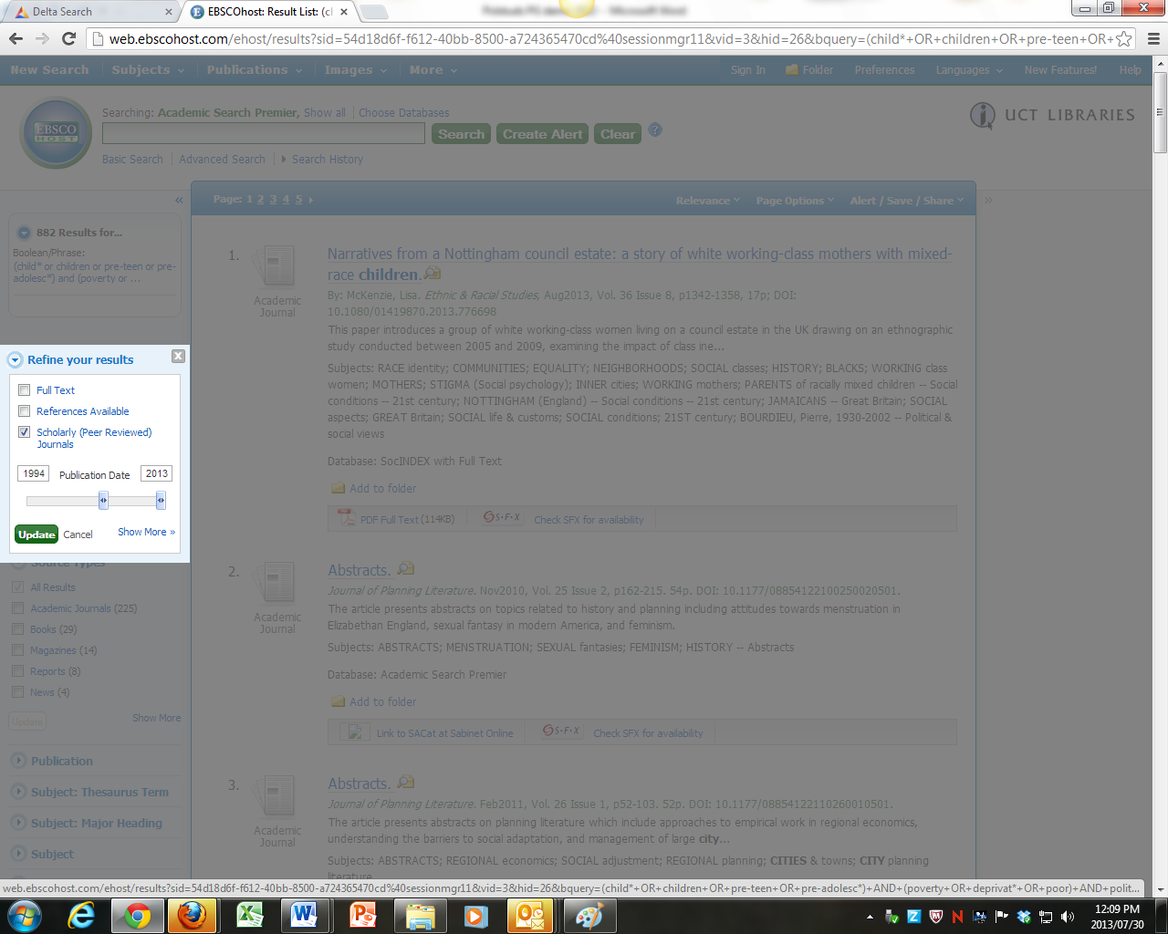
This cuts the result list down to 130, which is easy enough to whiz through.
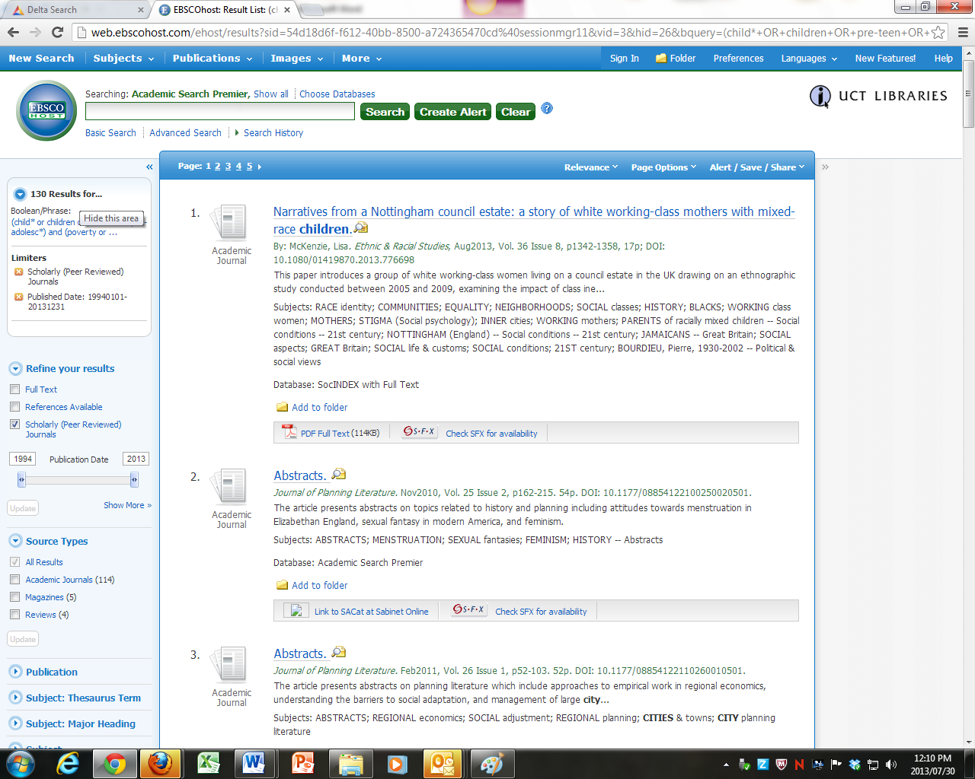
Results can be added to a folder. This folder will disappear after your session, though – unless you open an account with a private login to the Ebsco databases.
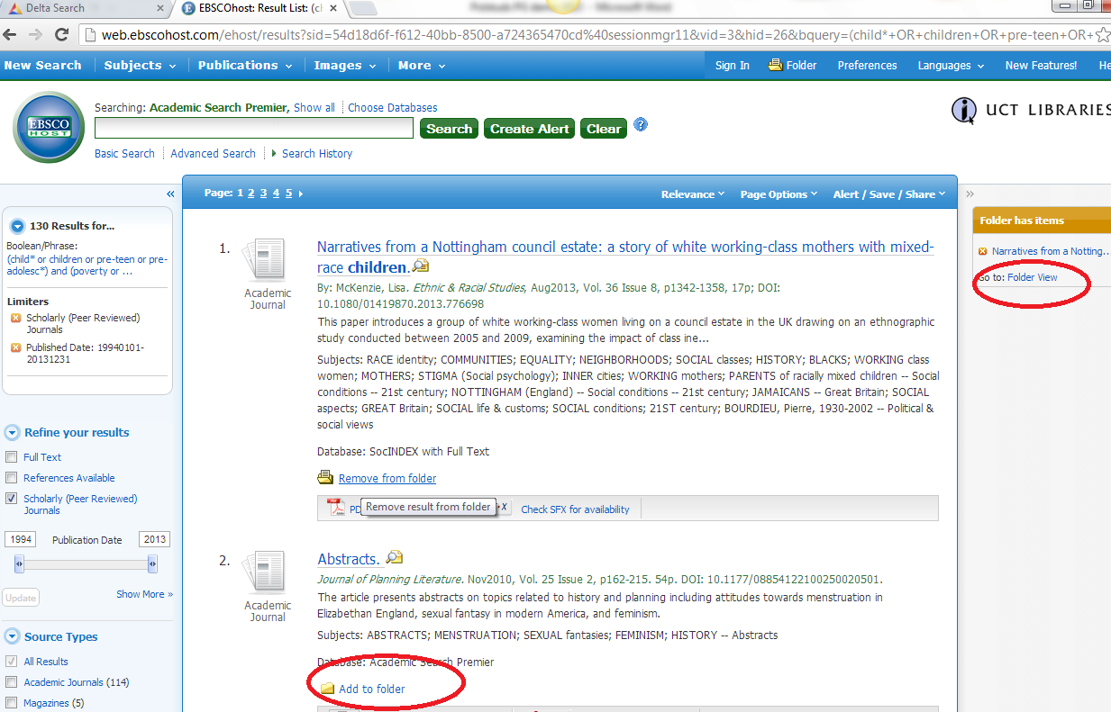

From the folder you can email, save as a file or export the results to RefWorks.
Saving as a file is a good way of dealing with a large list of results. You can look at the abstracts and decide which to pursue first.
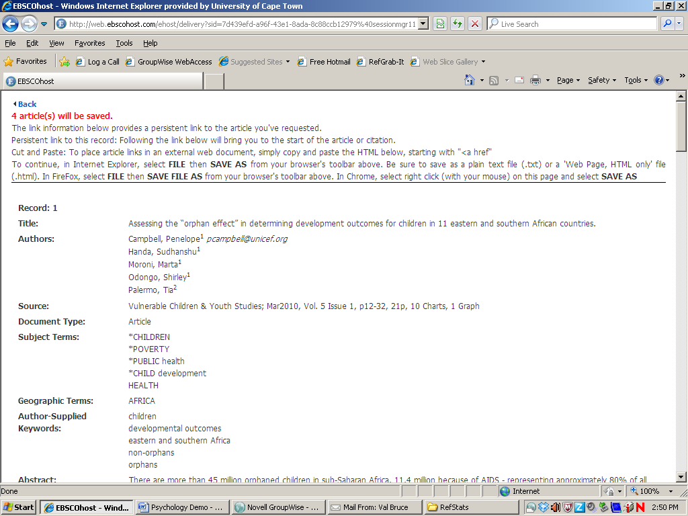
By clicking on the hotlink under each record you can return to the database and pursue any full text:
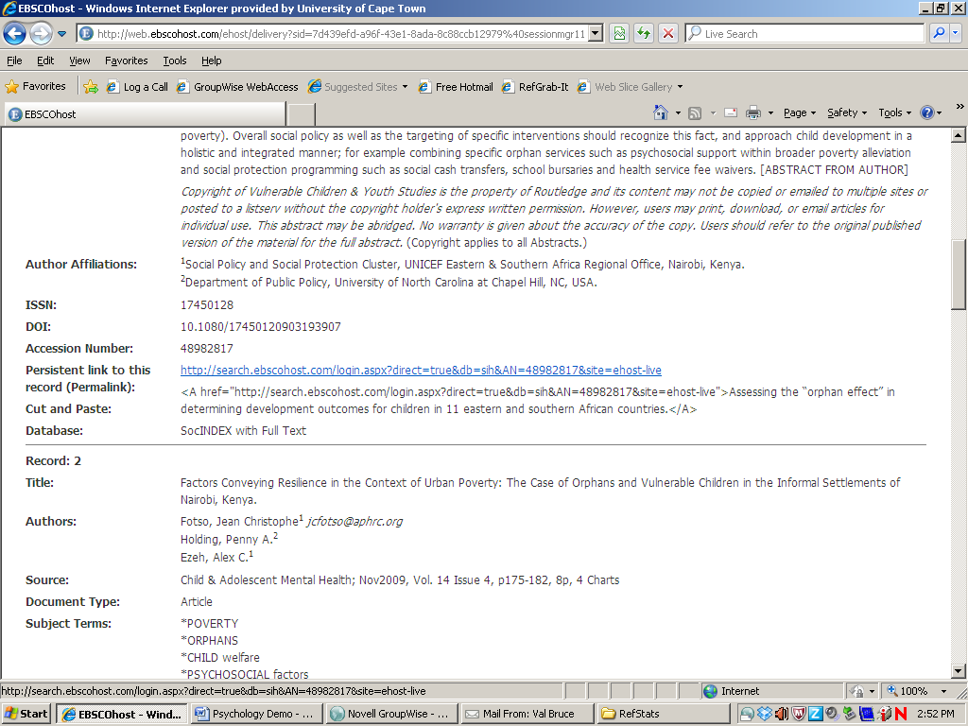
If you are logged into the Ebsco databases as an individual, you can store the search as an alert.
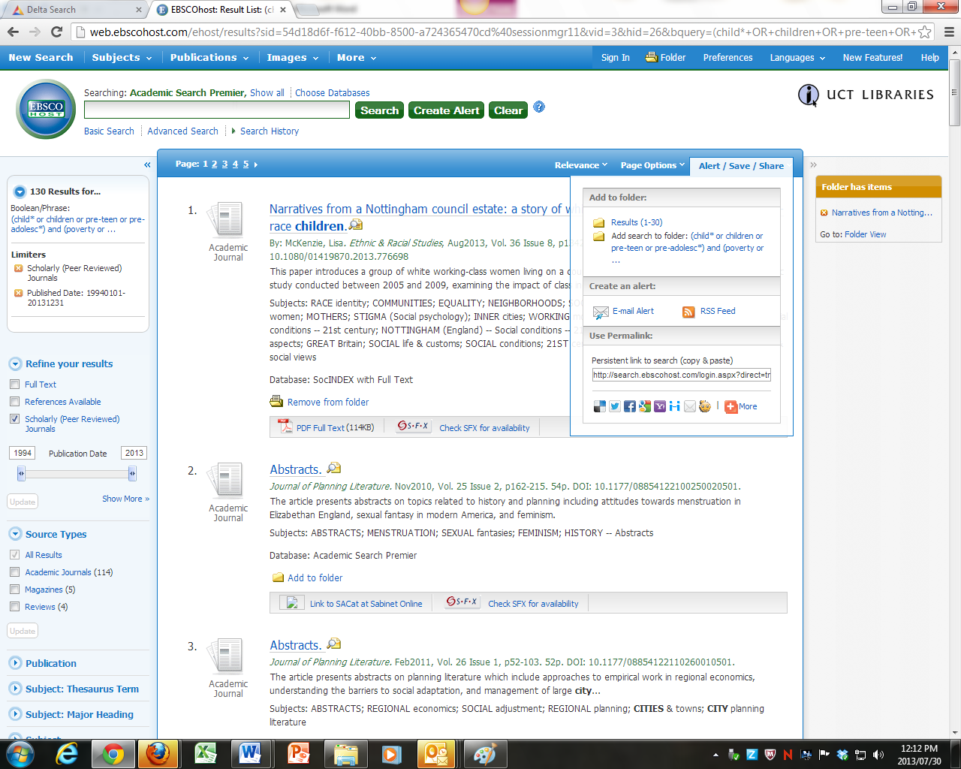
The big snag, though, is that if we stop subscribing to these databases, or switch to another provider, your access will be lost.
So I’d hesitate to save anything on Ebsco’s bit of cyberspace, at least as my only source. I’d definitely back it up on a flash and CD and hard drive and e-mail it to myself in cyberspace and keep a printout rolled up in a sock under my mattress etc…

Citation Searching
Citation Databases are used for following the influence of a particular author or article forwards – seeing who has cited it.
Once-upon-a-time Citation databases were very specialized beast, in fact they were printed indexes well before they became electronic, the ISI Citation database, for example, is a direct descendant of these indexes.
It is found under the ISI web of Science database, under I on our Databases list.
Click on Cited Reference Search:
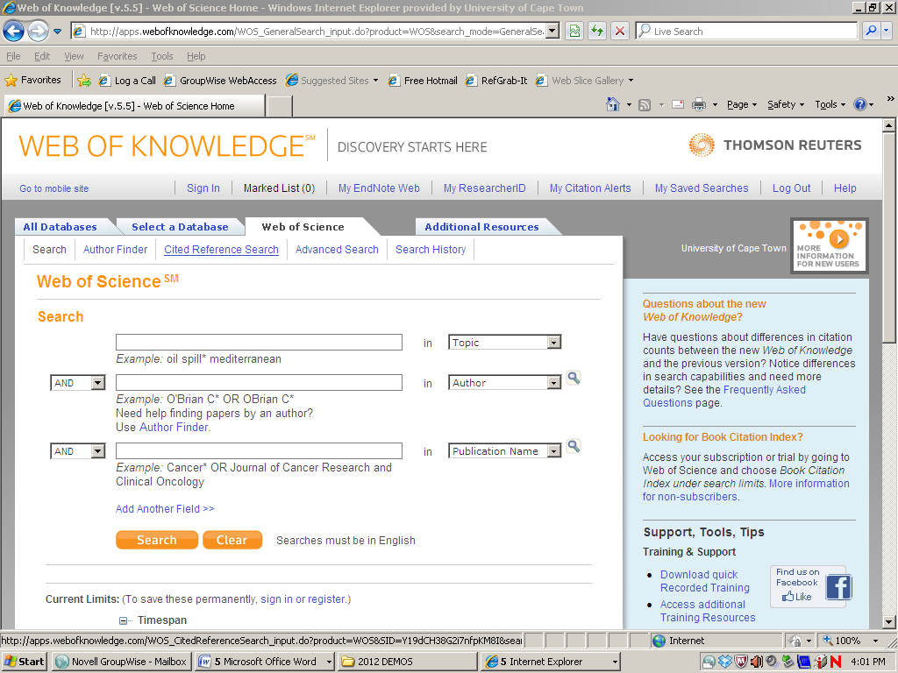
Input the author’s name and the official abbreviation of the work cited as indicated. There is a list of the abbreviations available.
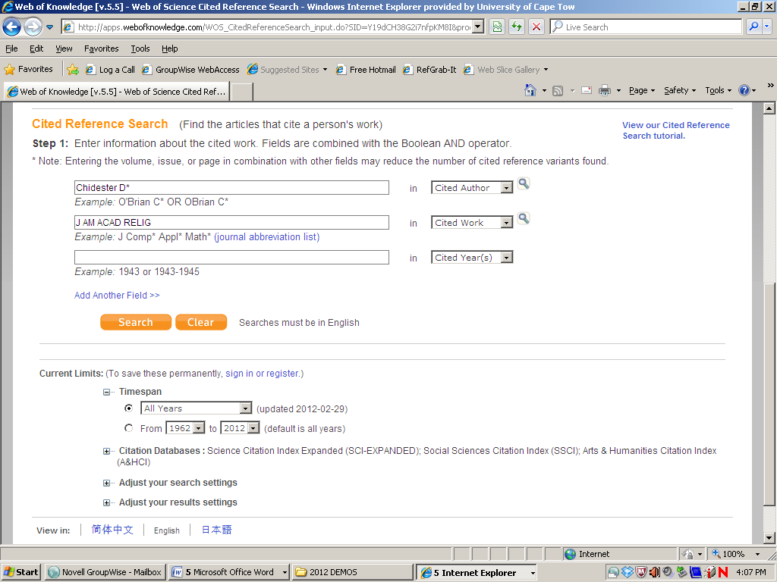
You will then get a list of citing articles. From the list of citing articles you can see which articles have cited them in turn – and so on down the chain:
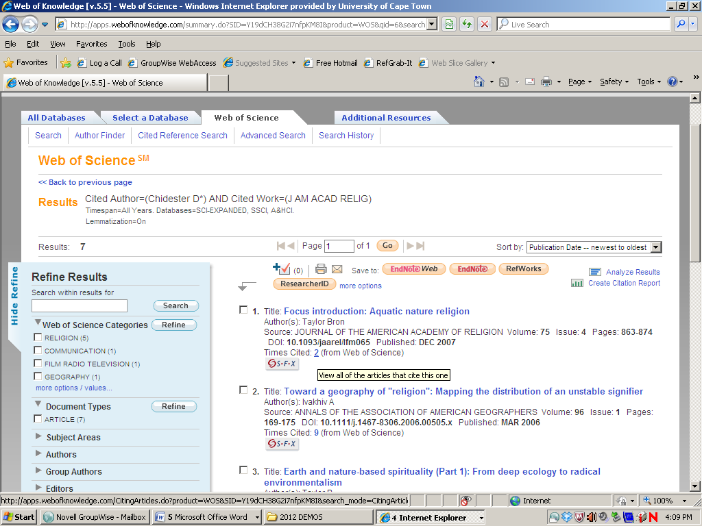
In the past I demonstrated the ISI database in some detail – but I don’t do that so much nowadays because the ISI database now has competition – which is good because the ISI database only shows citing articles from those journals which are on its own (admittedly quite big) database. It misses others, and does not do books or book chapters.
Other databases like the EBSCO databases now have a similar function – and in fact are a bit more user friendly:
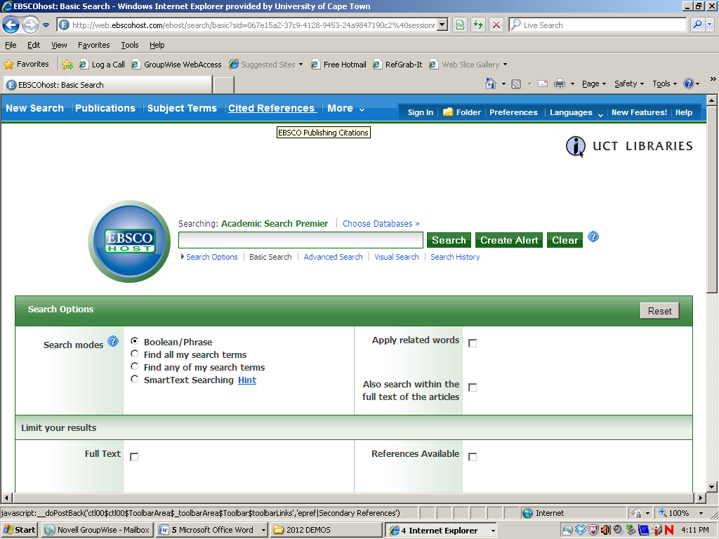
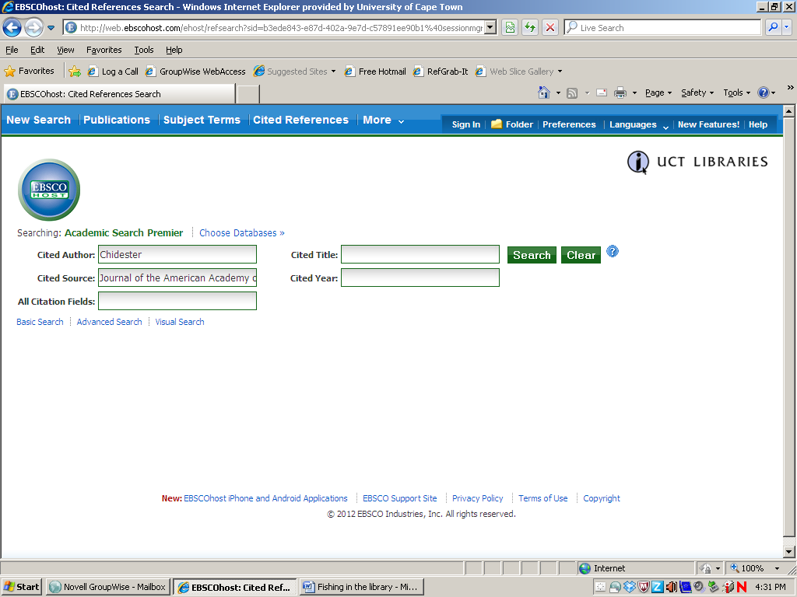
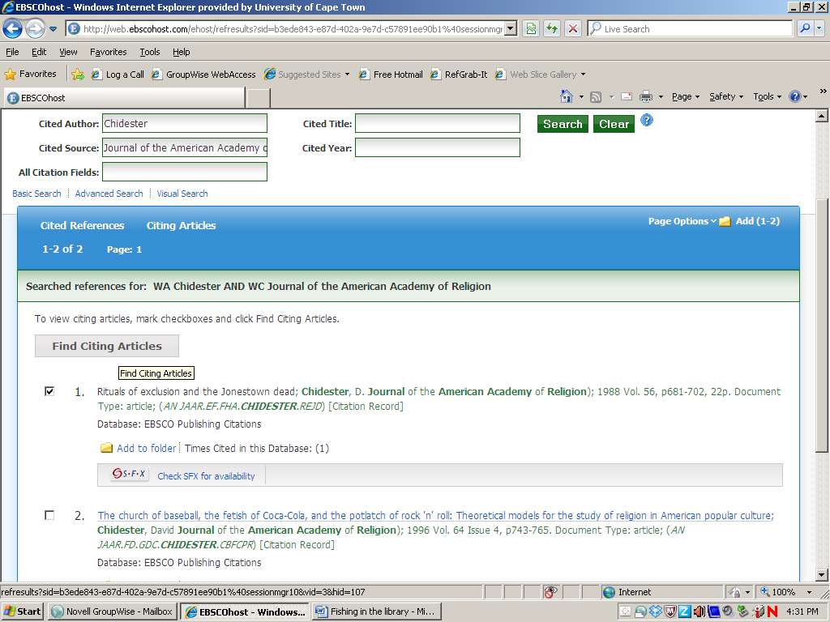
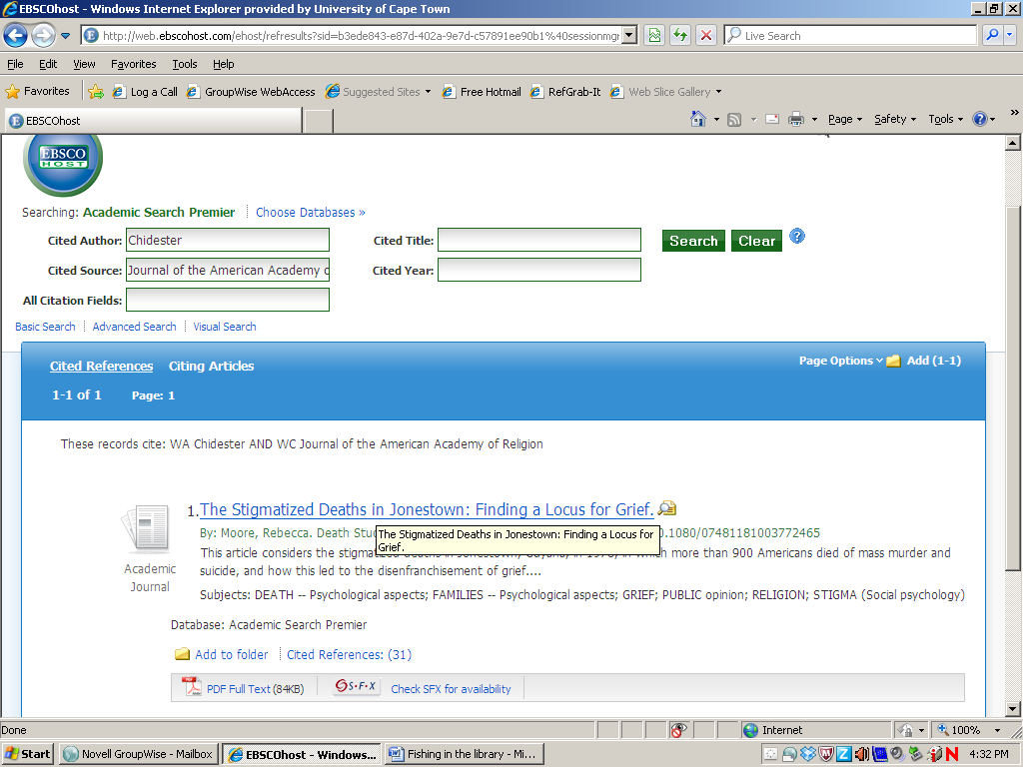

In fact you don’t even have to use this search interface – simply searching for the article normally brings up a times-cited-in-this-database link:
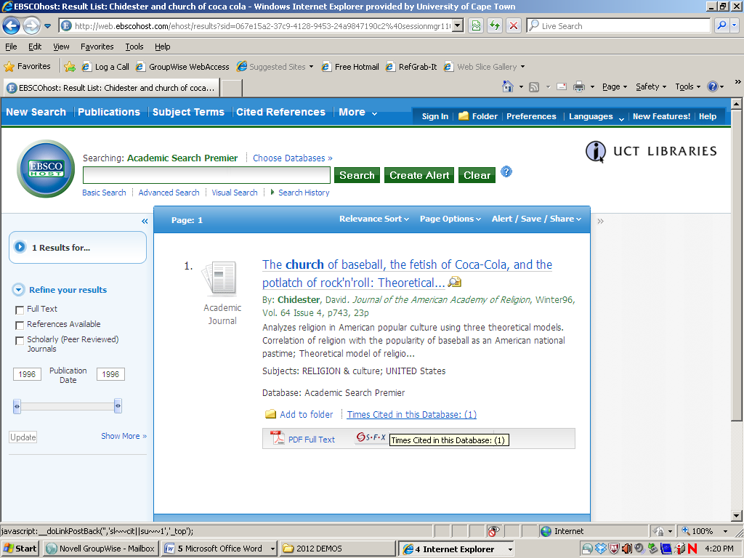

But one of the most effective challengers by far is Google Scholar. You don’t even have to do a specialized citation search on this. Just search for the article and a link to the citing articles comes up too.
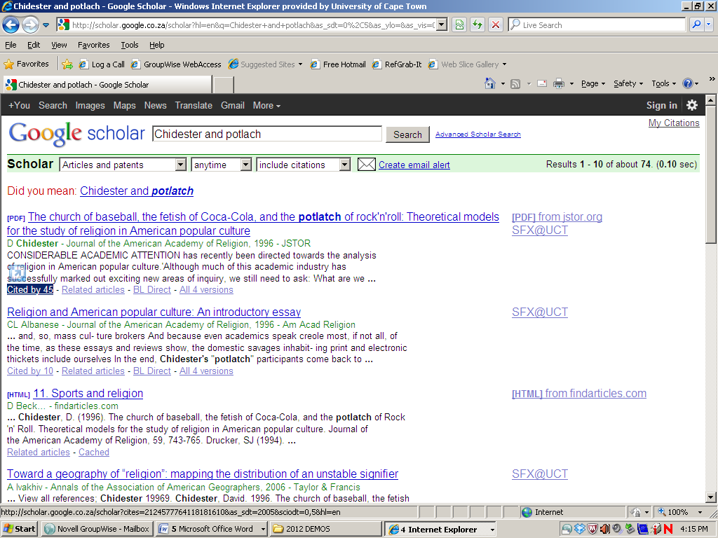
On Google Scholar there are 45 links to citing articles, on ISI there were 7, on Academic Search Premier there was 1.
Btw - you’ll notice that Google Scholar brings up a full text link to our database holdings on this search – it only does this when searched on campus or through the off campus UCT login.)
There is also a more sophisticated way of getting the citation searches out of Google Scholar – a tool called Harzing’s Publish or Perish can be downloaded to your desktop (just Google the term) and strip mines Google Scholar very efficiently indeed.
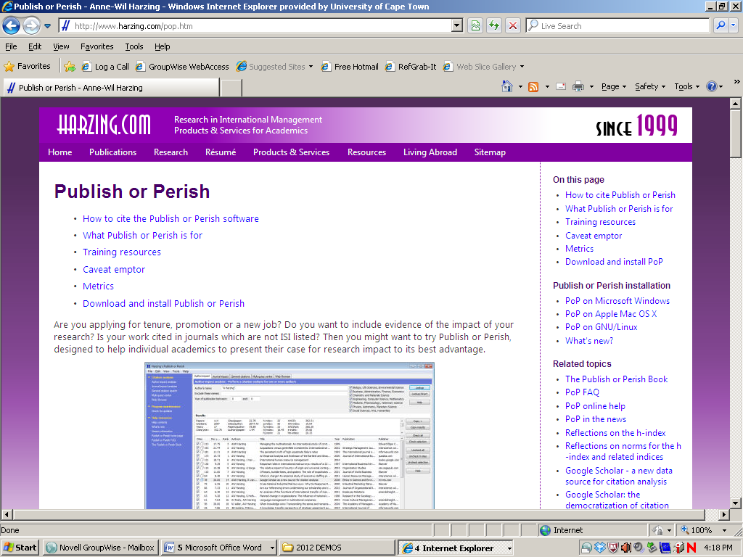
According to the blurb on this page:
Publish or Perish is a software program that retrieves and analyzes academic citations. It uses Google Scholar to obtain the raw citations, then analyzes these and presents the following statistics:
- Total number of papers
- Total number of citations
- Average number of citations per paper
- Average number of citations per author
- Average number of papers per author
- Average number of citations per year
- Hirsch's h-index and related parameters
- Egghe's g-index
- The contemporary h-index
- The age-weighted citation rate
- Two variations of individual h-indices
- An analysis of the number of authors per paper.
The results are available on-screen and can also be copied to the Windows clipboard (for pasting into other applications) or saved to a variety of output formats (for future reference or further analysis). Publish or Perish includes a detailed help file with search tips and additional information about the citation metrics.
Er… Right. This is evolution……
But for a quick and dirty citation search you are probably better off with a straight Google Scholar search and a click on the cited-by link.
At any rate - it is becoming clear that there is a lot of material out there and that you are going to be generating some monster reference lists.
To keep track of them, and to generate a pain-free bibliography it helps to know about….

Referencing & RefWorks

You can mouse over Research Help on the Library Homepage to get a drop-down menu, which includes referencing help and the link for the RefWorks database.
If you want to reference by hand, you can download guides to the different referencing styles, including the Harvard UCT style, the most commonly used at UCT.

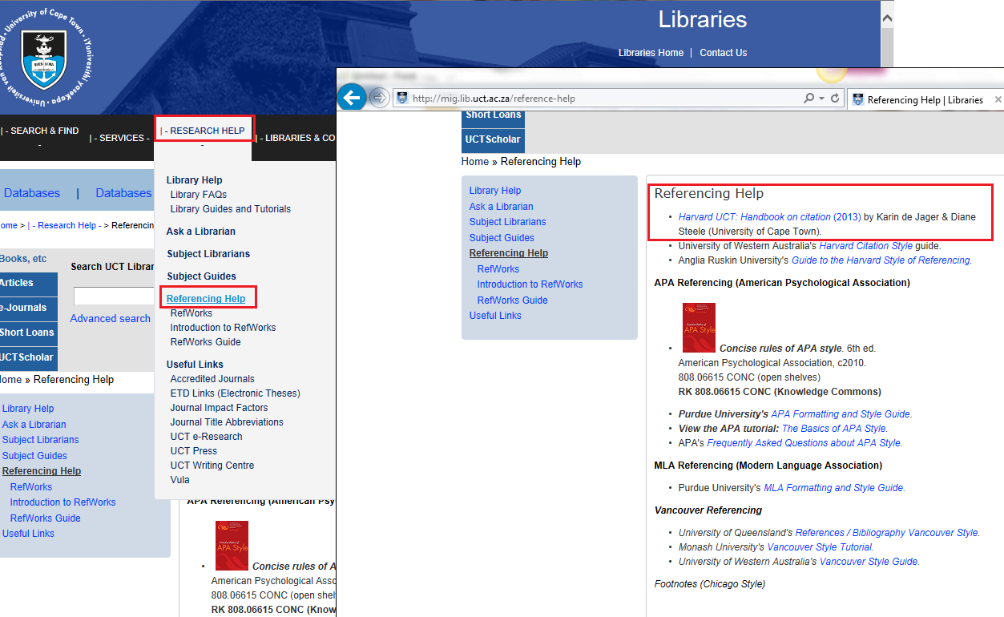

But you can also click on the RefWorks link

With RefWorks you can:

* import references from your book catalogues and journal databases
* create your own personal database of references
* annotate the references for finding by keywords
* automatically format your papers and bibliographies in seconds

There are two parts to RefWorks:
- The RefWorks database, on which you store your references in cyberspace,
- The Write-N-Cite function, which is downloaded to your Word program so you can cite as you type.

- The RefWorks Database

The first time you use RefWorks, you will need to create a personal account. You will then be able to store your references permanently on the RefWorks site. This means that you will be able to log in to RefWorks from any computer with an internet connection, and still access your references.

If you are off-campus you will need to use the EZ Proxy off-campus login to access our electronic resources and may be asked for a “Group Code” (RWUCT) to confirm that you are from UCT.

You can find the login screen on the library homepage at www.lib.uct.ac.za. Mouse over Research Help and select RefWorks from the drop-down menu:

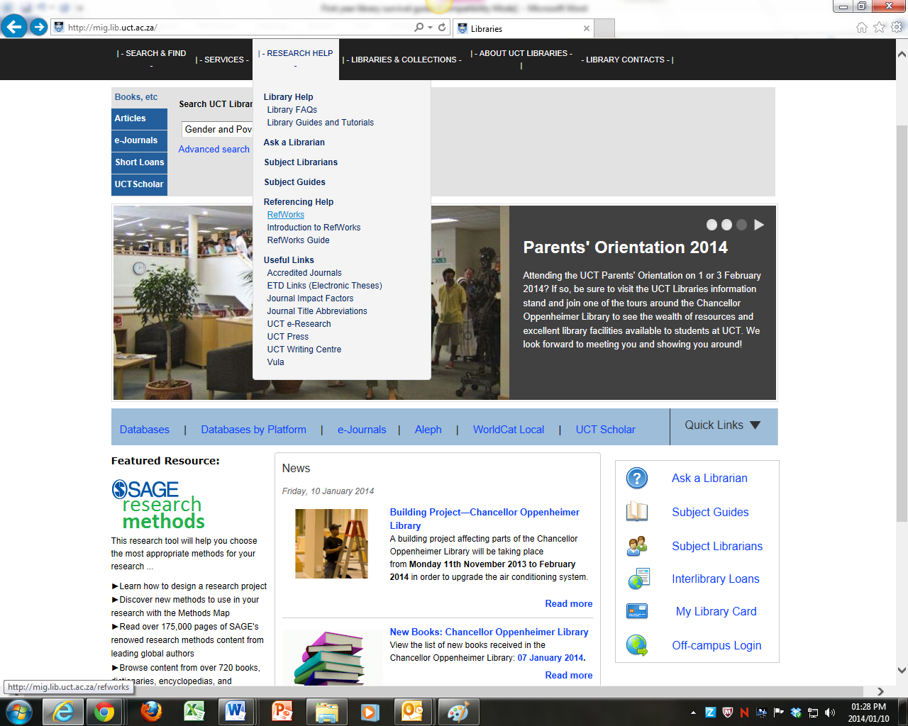

Once you have logged on to RefWorks you will be presented with a screen like this (except that mine is full of references.)

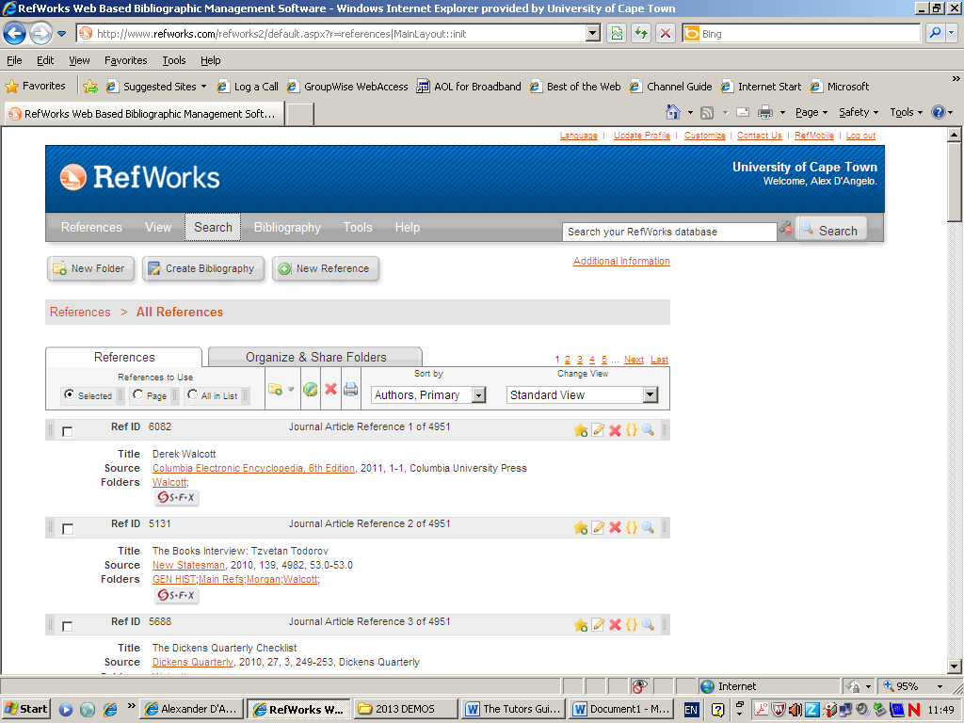

WorldCat Local and most of our journal databases allow you to export references directly to RefWorks.
You can also enter the references manually, using various fields appropriate to the item - book, journal, etc. and various referencing styles. This is particularly important if you are referencing a chapter in a multi-authored book.

2) The second element of RefWorks – Citing as you type.

In order to cite references as you type, you will need to download a separate RefWorks program called Write-N-Cite to the computer you use to write on.
The Tools menu on RefWorks allows you to download Write-N-Cite software to your computer.
Write-N-Cite will thereafter appear as an icon on your Word program.

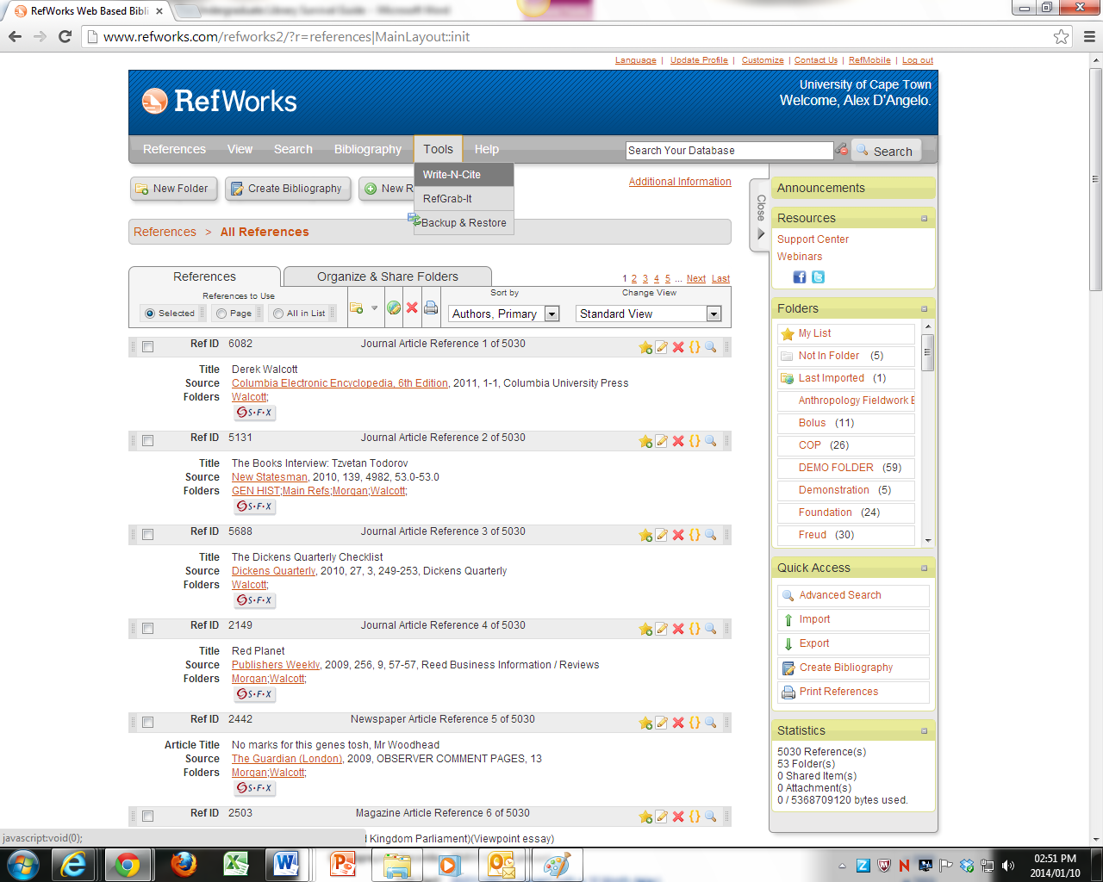

Write-N-Cite will attach itself under the Add-Ins tab on Word. It should also exist as an Icon on your desktop.
Opening the Write-N-Cite icon, and logging in to RefWorks, allows you to cite as you type, simply by clicking next to the relevant record on your RefWorks database.
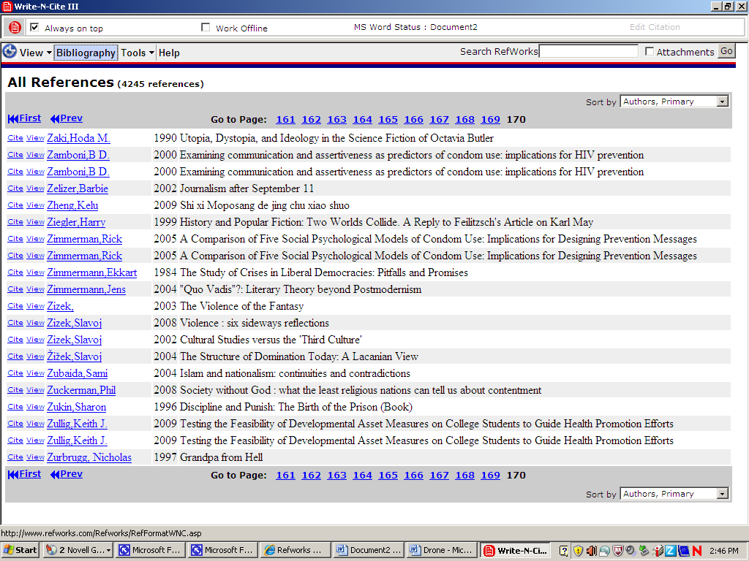

Resulting in:

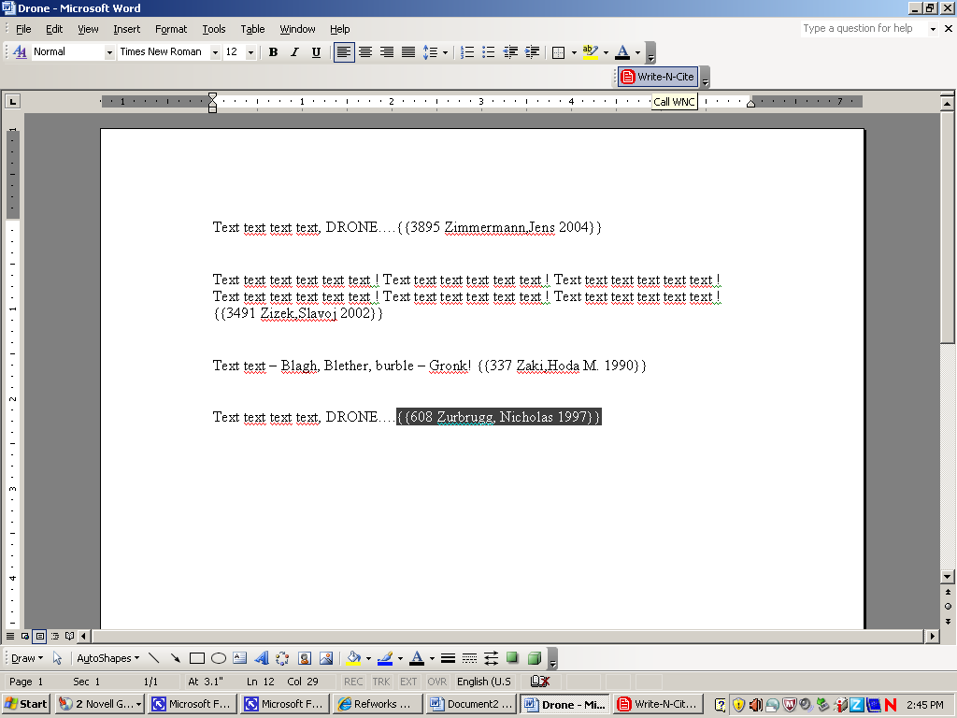

You can then click on the Bibliography option in Write-N-Cite.

You can chose from a range of available styles, and switch between them instantly.

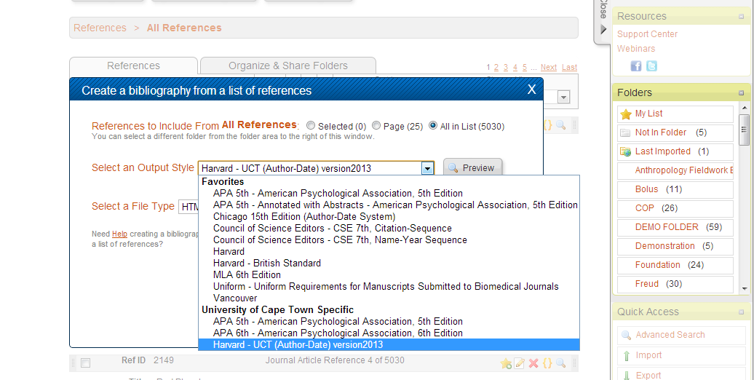

This will magically generate a bibliography for your paper and the in-text citations (though you’ll need to add citation page numbers in by hand afterwards.)

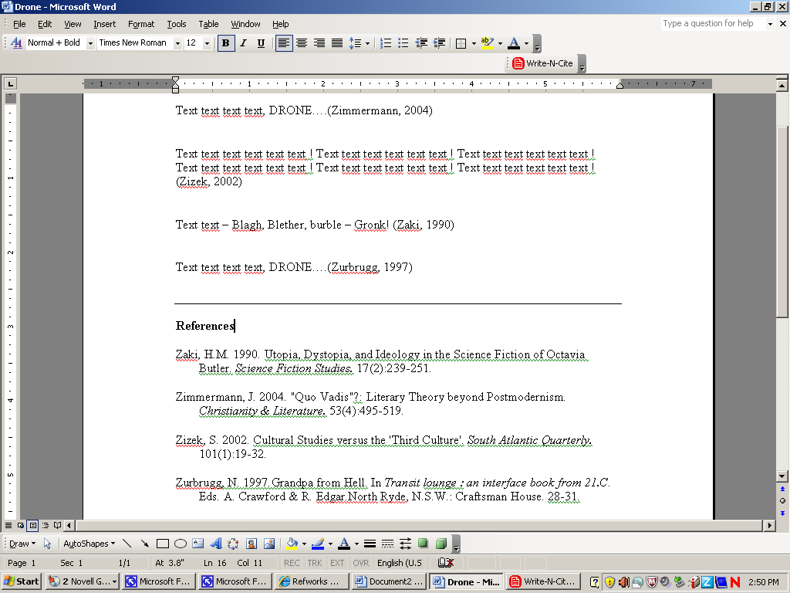

(Tip. The Knowledge Commons in the Library, and the Research Commons for masters and Doctoral students, are good sources of help with using RefWorks.)

DRAWING IT ALL TOGETHER
This is what your Subject Librarians do.
Together we will help you check the local, national, and, if necessary, world catalogues. We will help search for theses, locally and internationally. We will help with citation indexes and identify and help search a good selection of databases, in particular helping identify search terms and strategies appropriate both to your topic and to the database being searched. And we will call in colleagues from other specialized areas when required, Government Publications or Manuscripts and Archives, for example.
Please do not hesitate to contact us for help.



