Essay Structure and Outlining
Writing a Well-Structured Essay
AIMS:
- Clarify what a well-structured essay is.
- Explain what goes into the different sections of an academic essay
- Illustrate the importance of an outline.
- Empower students with the tools to ‘build’ an essay

Lecture:
Outline the four components of the lecture – Structure of an Essay, Definition & Purpose of Outlining and Creating an Outline, – along with the overall aims of the lecture (as stated above).

Structure of an Essay
Well-structured papers are easy for the reader to follow and digest. It is imperative that academic papers are clear, concise and present an argument that flows logically. The introduction begins by presenting the thesis statement and from there onwards there should be a continuous thread that links every paragraph of the essay until the conclusion is reached. Structure is therefore central to writing a good academic essay. Writing a paper with a specific structure in mind ensures the logical flow of the paper and makes it easier for readers to follow the argument being presented.

Introduction:
A good introduction should not only capture the reader's attention, but should act as a summary/roadmap of the paper to follow. The introduction and conclusion are the most important parts of an academic paper. The introduction (clarity on the purpose of the paper, the methods used/roadmap of the essay) and conclusion (the findings and the shortcomings ), while the body offers the actual content.
An introduction must include: Significance of the topic (why is this issue/topic important?), background & context, clarity on the purpose of the paper- thesis statement, the methods that will be used to support the argument/roadmap of the essay.
Emphasise:
- Do NOT just repeat the topic/question.
- It must be clear right from the beginning exactly what you are arguing.
- You may need to briefly define any key terms in the essay.
Although, it is not necessary to always follow a strict formula when writing the introductory paragraph, the following elements should usually be present:
- What is the essay about? This is a general introduction to the topic. Avoid repeating the essay question – the reader will know the question that you have been given, so repeating it here adds no value!

- What argument(s) will be made? Every essay is an exercise in convincing the reader through logical arguments. The introduction should briefly explain what arguments will be made in order to convince the reader. (Aims of your essay)

- How will the question be answered? This ties in very closely with the previous point. You might want to mention that in order to make your arguments, you will look at a case study, or make comparisons, or assess a given dataset, or contrast two different theoretical perspectives. The key issue is making clear to the reader the approach that you will be taking and its relevance to your argument as well as making sure to give the basic structure.

Body
This is the main part of your essay, which is where your analysis will begin. This part of the paper provides support for your thesis statement, (evidence/ if applicable - a case study). It is important to show evidence that supports the arguments being made. A good essay will counter possible criticisms – your arguments are unlikely to be completely convincing without you examining potential counterarguments. Engaging with evidence that seems to contradict your argument(s), and effectively rebutting it, is very important.
Acknowledging some weaknesses in your argument is not necessarily a bad thing. By making such concessions you are often able to present a fuller picture than by simply arguing one side of an issue. Explaining that your case is solid but not completely watertight is more easily defendable than adopting an absolutist position.

Check-list:
- develop your argument with the necessary ideas, facts, evidence.
- Put it in a logical order; what needs to be addressed first, second, last; follow your introduction and the roadmap outlined.
- Build the body with paragraphs that cover one clear idea and help support your main argument.
- Try to ensure that each paragraph has a topic sentence which illustrates what the main idea of the paragraph will be, following which you provide evidence to prove that main idea in order to better guide the flow of ideas
- Always link ideas within the paragraphs back to the thesis statement. Link the ideas being presented together; tell the reader why you are defining/discussing/explaining the concepts and theories that you are covering.
- Include counter-arguments: illustrate knowledge of both sides of the argument.
Conclusion
Conclusion – summarise your argument, point out its implications.
Avoid bringing up a new idea/concept in your conclusion! The conclusion restates the thesis statement, summarises findings, and offers final remarks.
Conclusion: A good conclusion will often reflect much of what was said in the introduction. This shows consistency. It should offer a summary of the findings of the paper, repeating the thesis statement, and include any criticisms or shortcomings that were present in the argument.
Emphasize what you have shown by using phrases like:
- Thus it is clear that...
- This essay has illustrated that....
Use the conclusion as a checklist. Ensure that you have indeed illustrated/shown/clarified the points you suggest in the conclusion!
Logical flow
Once you have a set structure in mind, you can draw up an outline for the paper. This is a good way to ensure that the paper flows logically and it is an exercise that should be completed before you start writing any academic paper. Pay special attention to the way in which the essay moves from one paragraph to the next. A simple but effective approach is to structure your essay so that each paragraph builds on, and adds something, to the previous one. New evidence that is presented in later sections of the essay build on the assumptions made and premises presented in previous paragraphs. As you are working through the essay, you should constantly refer back to your introduction and/or the given question that you are trying to answer. Ask yourself, whether what you have just written helps in answering that question. Overall, then, you are looking for an essay that builds logically from one paragraph to the next, while constantly remaining on topic and contributing to your overall argument or answer.

Outlining
What is an outline:
An outline is the skeleton of a writer’s ideas, it is an essay plan. It helps the writer organize their material logically by helping him/her sort and classify the material systematically. Outlines also indicate the main ideas and arguments for your paper as well as the subtopics under each main point.
This means that you should structure your essay in a way that shows how your ideas are related to one another, and how they relate to your main argument. The structure of your essay should follow a coherent ‘story line’ or pattern, with each paragraph relating to the one before it and to your main argument.

Why should you create an outline?
- It will help you organize your ideas, which makes it much more likely that you will be able to produce a coherent argument.
- Constructs an ordered overview of your writing.
- You avoid doing the complex thinking at the same time as trying to find the right words to express your ideas.

Creating an Outline
Analyse the Question
(Students should have covered this in the previous lecture).
Begin by reading the question carefully. This is very important as it will familiarise you with the general focus of the question. Next, cautiously examine and underline the key words and concepts in the question.
Another thing to keep in mind is to balance your essay. If the question is asking a two-part question, make sure you cover both questions, probably spending half of the essay on one question and half on the other. If it asks you to explain three theories, divide your word count in three.

Exercise

Ask students to analyse this question:
- What are the key words and concepts?
- What is expected of them in answering this question?
- Deconstruct & Re-phrase this question.

Essay Question:
What are some of the factors that led to the democratic transition in South Africa?

Brainstorm
The next step is to generate ideas from the course material which are relevant to the topic.
A common way to do this is through mind maps. Briefly explain what a mind map is (with the key point being that mind-maps enable them to link ideas together). Below is an example of a mind map taken from the reading and writing guide.

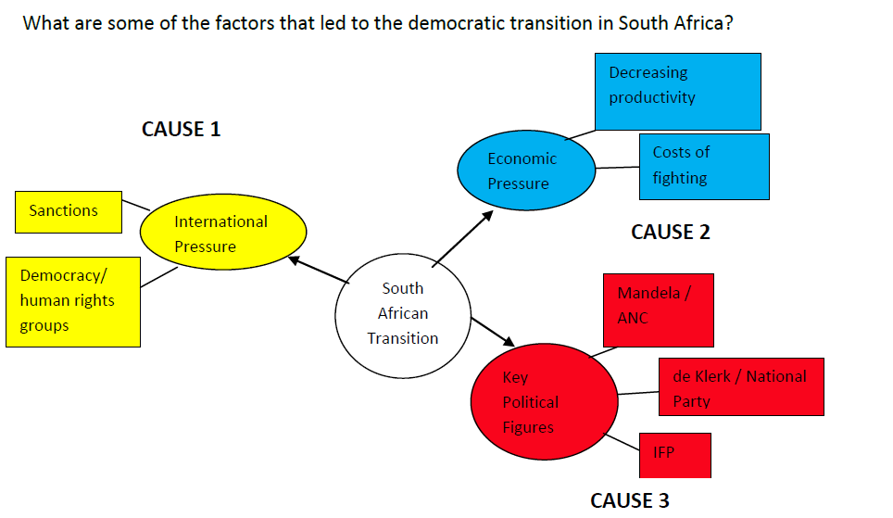

Emphasise that to generate these ideas, they must do the assigned weekly readings, as all topics are largely based on course content.
Before doing research, it’s important to note the initial thoughts about the question, based on what they already know about the topic from lectures, tutorials and general knowledge. This will help students formulate their argument and give them some direction for answering the question; and therefore can construct a draft plan.

Choose
From the ideas generated in the brainstorming phase, the next step is to choose the ideas or points of argument which are the most relevant to the question and its central issue, leaving out points which are not directly relevant to the essay question.
It is impossible to cover everything in an essay, and your markers will be looking for evidence of your ability to choose material and put it in order.
You should be able to link each idea to your thesis statement, and clearly explain the link between the point and the essay question.
Defend
There is no right or wrong answer to most questions posed in the social sciences, there are simply good or bad arguments. It is important students support their argument with evidence in order to convince the reader of their position, and must therefore find information that will strengthen this argument. They must defend their position or response.

The final outline should then be in the structure of an essay as illustrated in the example below.
Essay Question:
What are some of the factors that led to the democratic transition in South Africa?
Introduction
The purpose of the essay, context and background, thesis statement, the methods used/roadmap of the essay.
Body
I. Domestic political figures
a. Key parties and stances
i. ANC
ii. NP
iii. IFP

b. Political calculations and decision-making
II. Economic factors
a. Decreasing economic productivity and output
b. Costs of continued fighting
III. International pressure
a. Sanctions and lost prestige
b. Democracy/human rights group pressure

Conclusion
Summary of content discussed in body: how economic and international pressure came to bear on political decision making and the main political actors (must show how this content has supported the thesis statement).

This lesson plan is licenced under the Creative Commons Attribution 2.5 South Africa License. To view a copy of this licence, visit http://creativecommons.org/licenses/by-sa/2.5/za/

Or

Send a letter to Creative Commons, 171 Second Street, Suite 300, San Francisco, California 94105, USA.

