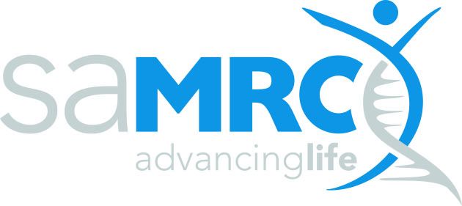

**Environment and Health Research Unit (EHRU)**

**Senior Scientist (Environment, climate and public health)**

**Permanent Position**

**Based at either, Pretoria, Johannesburg (Doornfontein campus of UJ), Cape Town or Durban)**

The South African Medical Research Council Environment and Health Research Unit (EHRU) conducts research on a range of environmental factors affecting the health of the South African population. Studies related to climate and health, air pollution health impacts, the health of mining communities and urban poverty are conducted across the country.

A post is available for a Senior Scientist within the Environment and Health Research Unit (EHRU) of the South African Medical Research Council. The research focus area is the broad field of environment, climate and health. .

We are seeking a dynamic and self-driven individual with expertise and experience in the conduct of epidemiological studies related to the environment, climate and public health. The candidate will be part of a team working on existing projects and supervising junior staff, as well as be involved in the writing of proposals for new projects as this research area is grown into a programme of national and international significance. Primary functions include the management of projects, including time management, project goals and deliverables, and staff support and supervision, toward successful completion. This role requires that one be involved in all stages of the research from project development to publication and other translational activities.

**Key results areas:**

* Project work: Co-ordination of projects, organisation of data and managing field staff; perform office functions and participate in the efficient operation and management of the EHRU.
* Research output: Publish research findings in peer-reviewed, indexed scientific journals and other publications. Present research at conferences and meetings.
* Proposal writing: Collaborate as co-investigator in proposal writing.
* Capacity development of others: Supervise Masters students, give external lectures, provide technical support and mentoring to junior staff and students.

**Requirements:**

* A Master’s degree or equivalent in environmental epidemiology, public health, community health or other relevant field.
* A good understanding of the relationship between climate and environmental health.
* At least 2 years research experience in the field of public health, community health or other relevant field. Additional experience would be an advantage.
* Experience in research management, including financial and other controls of multi-stakeholder projects.
* A high level of computer literacy. Proficiency in statistical software packages, such as STATA and R, is preferred and would be an advantage.
* A track record of publications.
* Excellent verbal and written communication skills and computer literacy.
* Excellent financial, data, people and time management skills.
* The ability to function well as part of a multidisciplinary and diverse team, and work across sectors.
* Valid code 8 driver’s license.
* Willingness to travel.

A cost-to-company remuneration package will be negotiated in accordance with qualifications and experience. The total cost to company salary benchmark is in the region of R435 000 per annum. Appointment will be based on competence, experience and proven outputs.

Forward your application, comprising (i) a detailed CV, (ii) a covering letter of motivation (describing qualifications and how each of the job requirements are met) and contact details of three referees, as well as a (iii) separate statement summarizing potential contribution to the research focus areas (namely climate and health), (iv) a copy of your identity document and (v) copies of your highest qualifications, to Mrs Lee-Anne Louw, Human Resources Division, SAMRC, PO Box 19070, Tygerberg 7505 or fax: 082 742 8365 or email: [recruitment@mrc.ac.za](mailto:recruitment@mrc.ac.za) by 25 July 2016 by 16:30.

**Please quote the reference number R959 in the subject line of your email, CV and all other communications. Certified copies of your ID and highest formal qualifications must be submitted with this application. Should you application not contain the required information and documents, it will unfortunately not be considered.**

The SAMRC retains the right not to make an appointment. In accordance with the SAMRC’s Employment Equity Plan, preference will be given to suitably qualified candidates from the designated groups. For this reason, we require race, gender and disability status to be specified. Disabled persons are encouraged to apply. Should no feedback be received within thirty days of the closing date, kindly consider your application as unsuccessful.