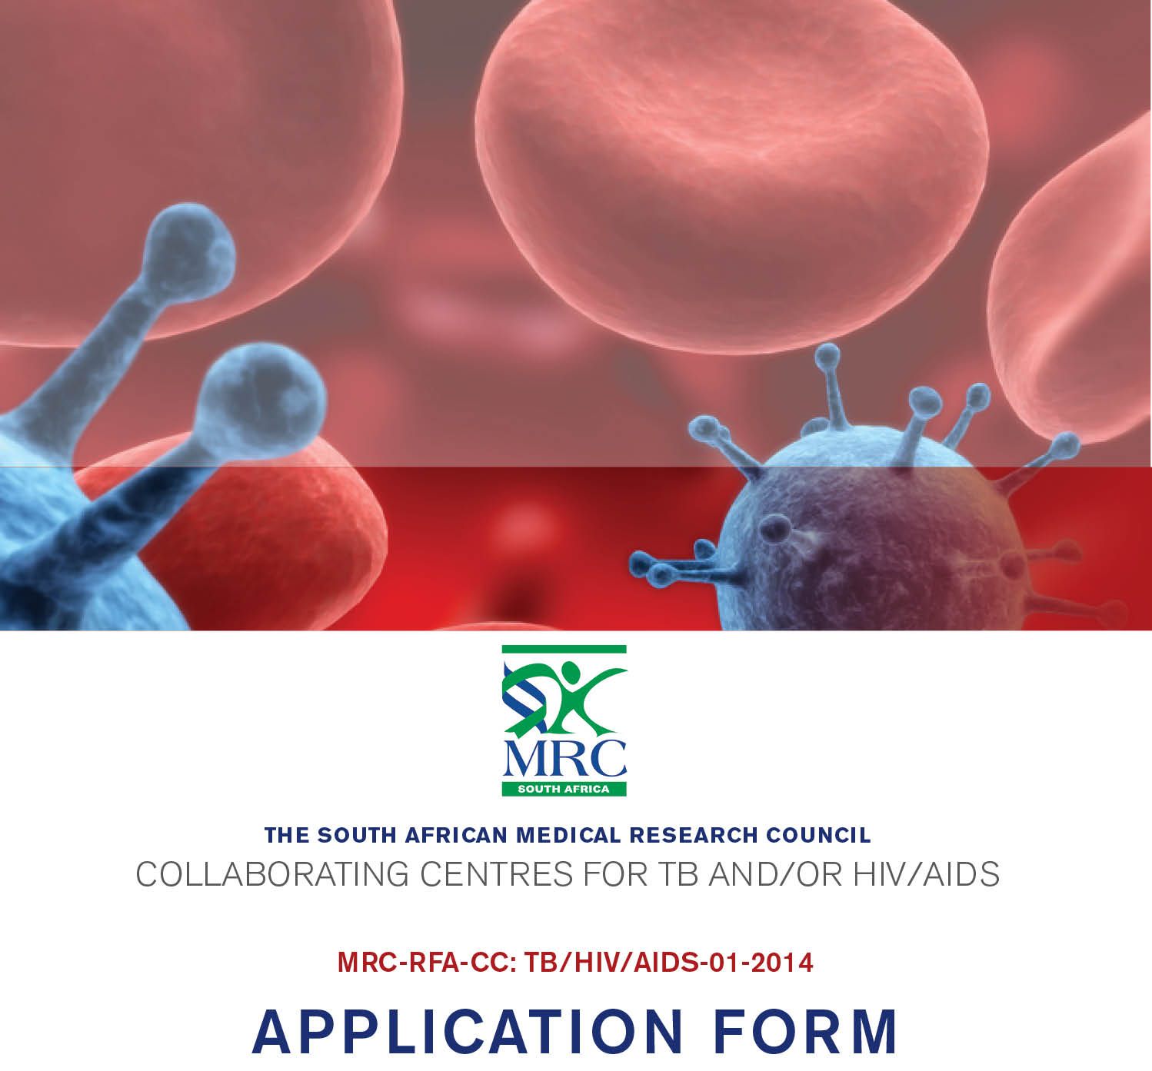

Instructions
- Use Arial font size 11, single spacing to complete the application form.
- The proposal may not exceed 12 pages, excluding the Annexures.
- Completed applications must be sent to cctbhiv@mrc.ac.za and copied to research.health@uct.ac.za
- The closing date for applications is 21 October 2014. Late applications will not be accepted.

1. PRINCIPAL INVESTIGATOR (PI) DETAILS
Title
Name & surname
South African ID no: |  |  | Gender
Qualifications
(State degrees/diplomas & name of institutions where degrees were obtained)
Position
Department
School/Faculty
Name and address of university/research institution
Contact no(s) | Work: | Cell:
Email

2. SAMRC COLLABORATING CENTRES FOR TB AND/OR HIV/AIDS
Proposed name of Centre
Collaborating Centre abbreviation (optional)
- Proposed Principal Investigator (SAMRC Collaborating Centre Coordinator) (max two pages)
- Provide a detailed description of the Principal Investigator’s scientific standing in the field of TB and/or HIV/AIDS research. Also include the PI’s leadership and administrative capabilities to show that (s)he has the skills and or experience to manage the SAMRC Collaborating Centre successfully.
- Proposed research team (max two pages)
- Provide a description of the senior scientists (at least three) who will make up the SAMRC Collaborating Centre and their scientific contributions in TB and/or HIV/AIDS research.
- Provide a detailed description of the scientific contributions made by the applying group and collaborators to date in TB and/or HIV/AIDS research.
- Provide a detailed track record of the publications and policy/practice impact of the research, if any, conducted by this group of collaborators in the past.
- Background (max one page)
- Provide the background of why the proposed Centre is likely to produce research of high impact.
- Provide a description of the TB and/or HIV/AIDS research area(s) that will be the focus of the proposed Centre.
- Describe the nature, source, extent and impact of the research/challenge to be addressed by the Centre.
- Scientific rationale (max one page)
- The scientific rationale for the proposed collaboration and how the proposed collaboration will address the research/challenge identified above; and
- The mechanism by which the proposed Centre is expected to contribute to an integrated cross-disciplinary research programme for advancing TB and/or HIV/AIDS-relevant knowledge, and/or contribute to improvements in health outcomes.
- Research projects (max two pages)
- Provide a description of at least three projects to be pursued by the Centre. These may be expansions of existing projects with new objectives.
- Outline of networking activities over next three years (max two pages)
Provide an account of the overall research approach, and:
- specifics of the Centre’s collaborating plan including any multi-disciplinary aspects
- an overview of proposed research methods and/or experimental techniques to be employed,
- the data-collection and analysis strategies/approaches to be adopted.
- Research infrastructure (max one page)
Describe the availability/access to research infrastructure, laboratory resources, at-risk and patient populations, databases, biobanks and other unique technologies that will enhance the research endeavours. Include a justification and description of site development where needed
- Capacity development plan and networking plan(max one page)
Provide details of the capacity development plans for:
- postgraduate students and post-doctoral staff;
- staff/student exchange programmes, if applicable
- outreach to researchers at other institutions
- support and pairing with under-resources sites/new investigators.
- Expected outputs/outcomes (max one page)
This section should include an outline of the expected direct and/or indirect outputs/outcomes of the terms of the Centre’s mandate.
- Impact of Centre (max one page)
Provide a description of the potential impact of the proposed Centre.

PRINCIPAL INVESTIGATOR (SAMRC Collaborating Centre coordinator)
Name (please print) | Position
Signature | Date

ANNEXURES

Please attach the following as Annexures to the application:
- A full CV of the Principal Investigator (SAMRC Collaborating Centre coordinator) listing a May 2014 Scopus H-index including his/her 20 most cited journal articles in TB and/or HIV/AIDS research using Vancouver referencing
- A brief bio-sketch (two-page NIH format) of senior scientists and key researchers

