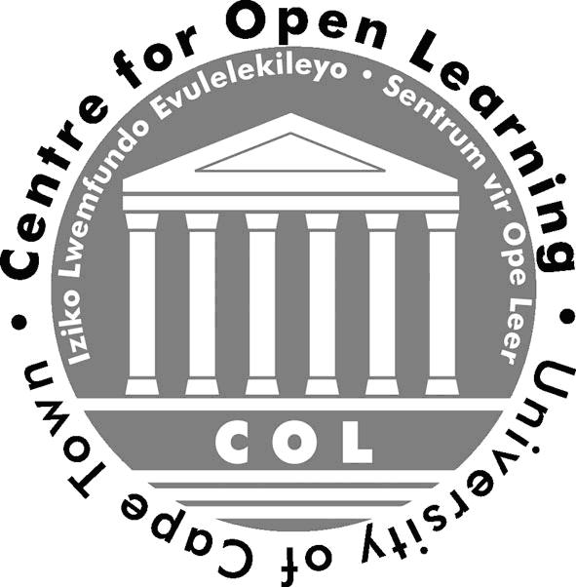


APPLICATION FORM:
PUBLIC AND CONTINUING EDUCATION

Clinical Management of TB Course

Venue: Online (VULA electronic platform) Course Fees: R10,000
Dates: 20 July – 2 November 2015 (online, with 0 contact days)

COMPLETE IN FULL. Use ONE form per person registering.
Please print and tick all relevant boxes. Incomplete forms will not be processed.
Title: |  |  |  |  | First Name:
Surname: |  |  |  |  | ID Number:
Contact details (to be completed in full by all)
Address:
 |  |  |  | Postal Code:
HPCSA / SANAC / SAPC number (where applicable):
Home Tel: ( ) |  |  |  |  | Cell:
Work Tel: ( ) |  |  |  |  | Fax: ( )
Email address:
First language: |  |  |  |  |  | Gender:  (Tick one) |  | Male |  | Female
Age Group:  (Tick one) | Under 20 | 20–29 | 30–39 |  |  |  | 40–49 | 50–59 | 60–69 |  | Over 69
Employer:
Occupation: |  |  |  |  |  | Sector:
Are you a graduate of UCT? Yes No |  |  |  |  |  | If yes, what year and degree?
Have you applied for a scholarship? Yes No |  |  |  |  |  | If yes, for which course (TB, HIV, TB/HIV Co-infection)?
This information is required for UCT reporting purposes:
Race: ________________________________________ Nationality: _________________________________________

Disability (please circle): YES/NO If yes, please specify: ___________________________________________________

Highest educational qualification achieved: ________________________________________________________________

Signature: Date:
Please include a brief essay (no longer than ½ page in length) describing your background and work experience thus far; reasons for wanting to do the course; and how you think it will assist you in your line of work.

Return completed form and essay by fax at (021) 406 6255 or email at Melissa.Slabbert@hiv-research.org.za

