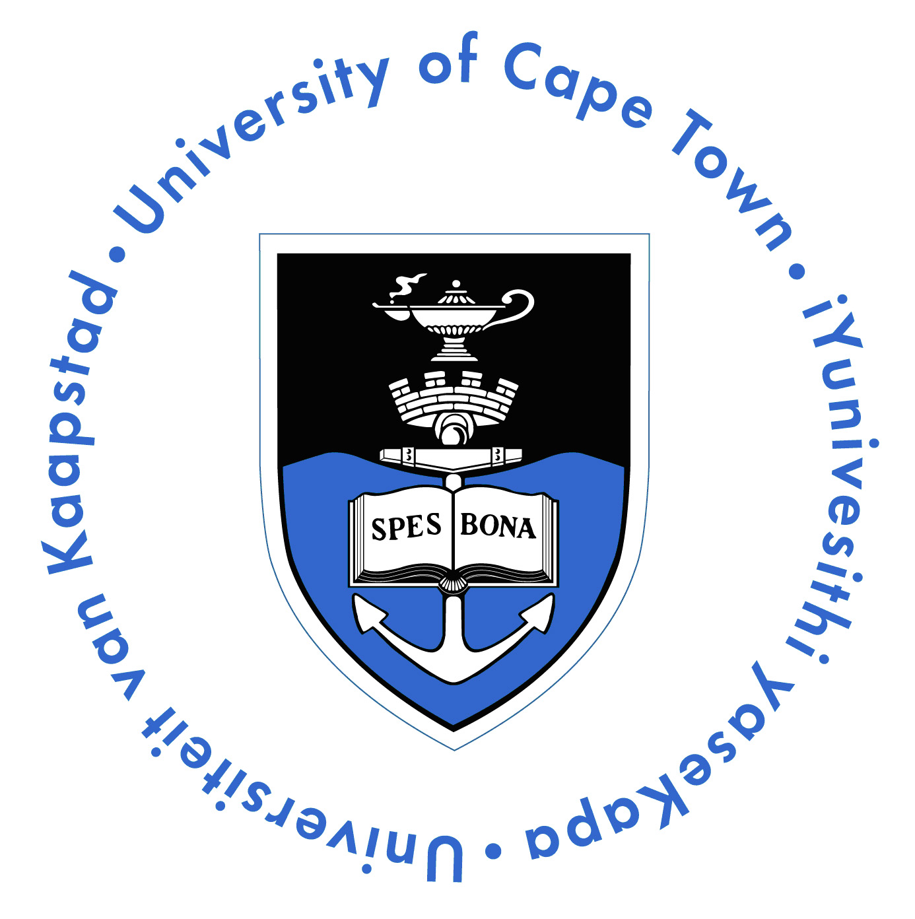
Department of Human Biology

Faculty of Health Sciences
University of Cape Town
Anzio Road
Observatory 7925
South Africa
Phone: +27-21-406 6235
Fax: +27-21-448 7226

Dear Postgraduate Student

You are hereby invited to apply to work as a demonstrator for the first year of the MBChB programme. Practical sessions in year 1 MBChB take place from 14h00 to 17h00 on Tuesday, Wednesday and Thursday afternoons, in either the Level 6 Histology Laboratory or the Drennan Teaching Laboratory.

Demonstrators applying are expected to participate in a training workshop, from 13h30 to 17h00 on Monday, 8th February in the Drennan Teaching Laboratory, Level 2, Anatomy Building. Attendance is optional for those demonstrators who have already completed the training workshop in previous years.

Please complete the sign-up sheet below by typing in your name in the slots that you are available to demonstrate and submit to Dr Kishor Bugarith kishor.bugarith@uct.ac.za by 12H00 on Tuesday, 9th February. Final allocations will be made after the training workshop.

LIFE CYCLE [HUB1006F] 2016: PRACTICAL SIGN-UP SHEET
Name and Surname
Email Address
Contact Number
Department and Division

I have attended the Demonstrator Training Workshop: YES NO

WEEK | TOPIC | TUESDAY | WEDNESDAY | THURSDAY
16/02 | Introduction to Microscopy and Biological Drawings
23/02 | Epithelium & Connective Tissue Proper
01/03 | Muscle & Nervous Tissue
08/03 | Growth and Development
15/03 | Body Shape & Adolescence
5/04 | Endocrine System
12/04 | Introduction to Medical Terminology and Genetics
19/04 | Embryology, Pregnancy, and Birth
03/05 | Endocrine Tutorial
10/05 | Ageing, Stem Cells & Cloning

