 

**SEMINAR SERIES**

**The Division of Immunology (NHLS) invites you to attend the following seminar**

**Speaker**

**Dr Jonny Peter**

**Title**

**“HLA and drug allergy”**

**Venue**

**South African Bone Marrow Registry Seminar Room**

**J57, GSH Old Out-Patient’s Building**

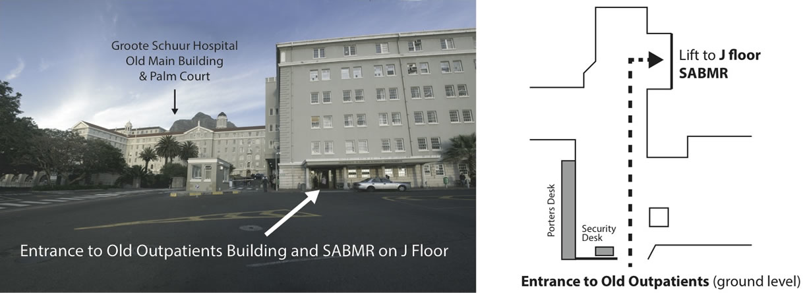

**Date and Time**

**Tuesday, 9 June 2015**

**12h30-13h30**

Jonathan Peter is a physician, specialised in internal medicine at the University of Cape Town, South Africa. He is the recipient of several awards for medical training including the Suzman Medal for Fellowship of the College of Physicians in 2009. His clinical and research interests include: i) primary immunodeficiency diseases, ii) the immune- pathogenesis and –therapy of TB including TB vaccines, and iii) the development and validation of rapid diagnostics suitable for use in resource-limited, HIV-endemic settings. He completed his PhD, focused on novel diagnostic approaches for smear negative and sputum scarce TB including urinary LAM, under the supervision of Professor Keertan Dheda at the UCT Lung Infection and Immunity unit. Jonathan has over 45 publications in high impact factor journals, and H-index of 14, and has received support from several prestigious grants including a Discovery Academic Fellowship, a NIH Fogarty International Clinical Fellowship, and Carnegie Academic Fellowship. Jonathan recently completed a Oxford Nuffield Medical Fellow with a joint appointment in Clinical Immunology, John Radcliffe Hospital and TB vaccinology, Jenner Vaccine Institute. In February 2015 he took up fulltime post in the division of Clinical Immunology and Allergology at UCT where he continues his work as a clinician scientist.