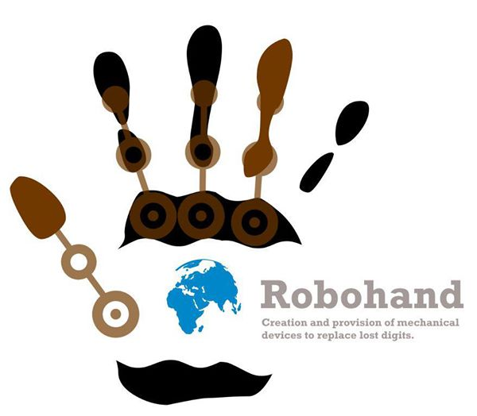
Robohand – ‘Open Microphone’ Sessions
Richard van As from Robohand will be presenting three sessions at Frank Joubert Art Centre where he will interact with the public and answer questions. He will have a 3d printer and prosthetic hands to demonstrate.
The times are: Monday March 10, 7pm - 9pm
Wednesday March 12, 6pm - 9pm
Thursday March 13, 6pm – 9pm
You may arrive during a session and/or leave before it ends; the idea is for informal interaction/ questions and answers rather than a lecture.
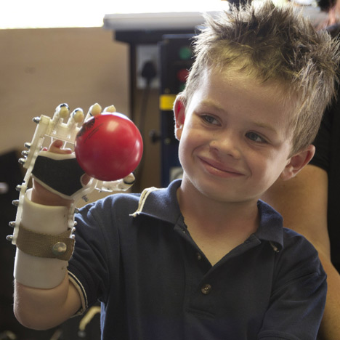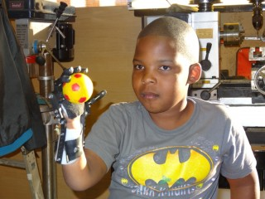
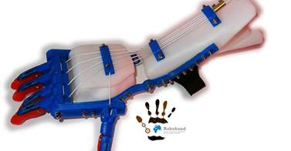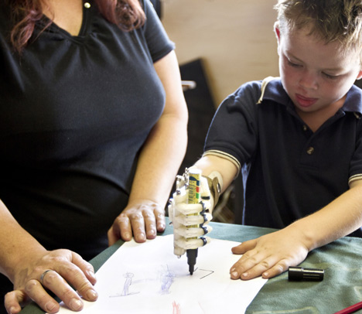
Frank Joubert art Centre
Vredenhof road (off Keurboom Road)
Claremont/Newlands
www.frankjoubertartcentre.co.za 021 6832720
Ian Pells 083 7421415
ian@ianpells.com

