Design Changing Lives
Ian Pells has begun collaborating with Robohand, an organization that creates and supplies 3d printed prosthetic fingers and hands. Ian is a Product Design and Ceramics teacher at Frank Joubert Art Centre and teaches Ceramics at Herschel Primary.
Through his teaching work with Tembaletu School at Frank Joubert Art Centre, Ian has identified students who could benefit from these prostheses. Ian has arranged for Richard van As from Robohand to visit Cape Town for two weeks in March. Students from Tembaletu and several other children will be fitted with robohands during this time.
Funds are needed for Richards air fare and for Orthoplastic to fit hands onto children during the visit. Please assist if you can.
Ian Pells Standard bank Mowbray (024909) acc # 071351469 ref: Robohand and your name.
If you are donating from a company please send your logo and contact info to ian@ianpells.com and I will post it on our page that is to be launched about this project. The url we have reserved is designchanginglives.com, this page will be live in the next week.
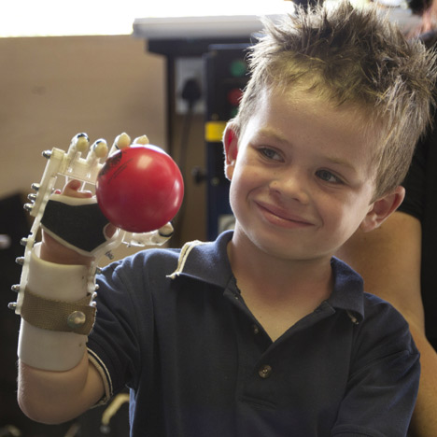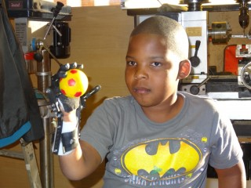
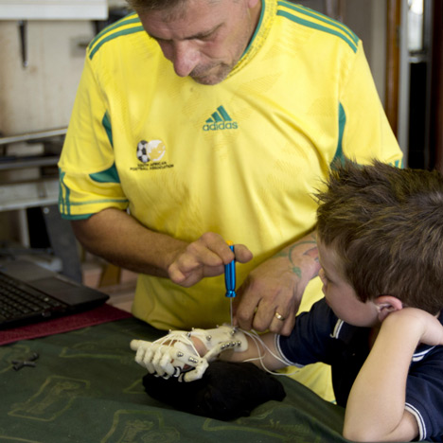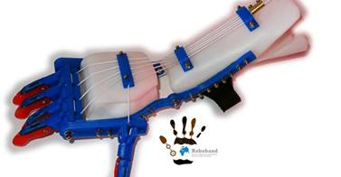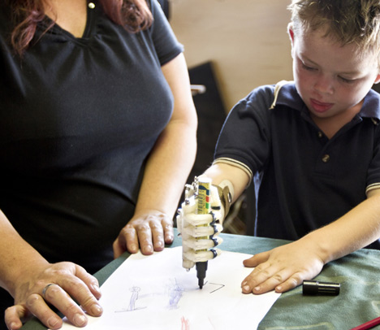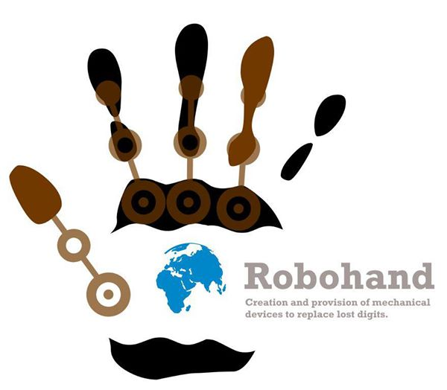

The Robohand Story

Richard Van As, a South African carpenter, lost four fingers from his right hand to a circular saw two years ago.
He was unable to afford the tens of thousands of dollars to get a myoelectric hand, which detects a muscle's electric impulses to activate an artificial limb.
"After my accident, I was in pain, but wouldn't take painkillers. I barely slept, and the more pain I had the more ideas I got," he told The Associated Press. "Sometimes you have to chop fingers off to start thinking."
He decided to build his own hand. After seeing a video posted online of a mechanical hand made for a costume in a theater production, he reached out to its designer, Ivan Owen, in Seattle.
Enter Robohand - a device that Van As and Owen invented that is made from cables, screws, 3-D printing and thermoplastic. It uses the rotation of a joint to enable five plastic digits to grasp. The device looks like a robot's hand in a science fiction movie, costs about US$500 to make and can be reproduced using plans on the internet and a 3-D printer.
Van As is now on a mission to spread the mechanism to people without fingers or hands all over the world. The two gadget-lovers collaborated on developing a design for the device for a wide range of ages that could be used to grab objects, unlike most existing arm prostheses. Van As has fitted Robohands on about 170 people, from toddlers to adults, thanks to donations.
At first they used a milling machine, making Van As a metal robotic forefinger digit that helps him work in carpentry to this day. That's when they perfected the shape for the robotic fingers.
"Ivan was a gift to me," Van As said.
Then they turned to 3-D printing which creates the device in plastic. The 3-D printer gives much greater flexibility, allowing the device to be re-sized on the computer for each user and then manufactured through the printer.
A glove-like covering is fitted in thermoplastic, and then fingers are created on the 3-D printer by melting and stacking plastic to make Lego-like digits which are connected to the glove with small cables and screws.
They then started working on a design to help children with Amniotic Band Syndrome, a condition where children are born without appendages because their circulation is cut off in the womb by amniotic bands.
Robohands are different from other prostheses for three simple reasons: "functionality, simplicity and cost," Van As said.
At US$500, a Robohand is significantly cheaper than the typical US$10,000 to US$15,000 cost for a conventional below-the-elbow prosthesis, said Eric Neufeld a US-based certified Prosthetist and Orthotist and the director of Range of Motion Project, known as ROMP, which provides prosthetic limbs to those who cannot afford them around the world.
"There are very few options just for digits, so that is another problem they are addressing," Neufeld said.
"It's a pioneering thing they are doing. It gets people thinking about what other components can be made in the same way," he said, adding that he will watch Robohands closely for possible use by his organisation.
Eventually, Van As said he'd like to see Robohands kits available for sale at stores, so that anyone could simply build one for themselves. He's waiting for the design to be patented. Already people from Australia to Newfoundland are volunteering to print Robohands.
"We took the 3-D printing world by surprise," Van As said. "It wasn't the first medical breakthrough in the 3-D world, but people are eager to get a hold of it now."
Van As grins as he holds up a tiny white and blue Robohand in his shop. "This is for a 2-year-old in Australia." Casts of other arms are strewn about the garage workshop, which is also full of spools of 3-D printing material, machines, experiments and constructions.
Twelve-year old Dylan Laas got his Robohand in March. His mother, Jacqui, said her son, who does not have a right hand because of Amniotic Band Syndrome, is approaching activities with new interest thanks to the gadget.
"It looks cool. It makes me look like Darth Vader ... It's fun to use," he said, adding that he can't wait to go swimming with it.

