UNIVERSITY OF CAPE TOWN

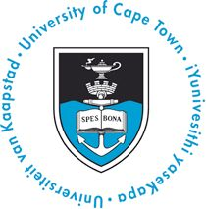

DEPARTMENT OF CLINICAL LABORATORY SCIENCES
Faculty of Health Sciences, Observatory, 7925, South Africa
Head of Department: Prof Carolyn Williamson
Sen Admin Officer: Adielah van der Schyff
Telephone: (27)(21) 4066757
Fax: (27)(21) 4047645
Email: Adielah.vanderschyff@uct.ac.za

CALL FOR ABSTRACTS
RESEARCH DAY 2015

The Research Day Organising Committee of the Departments of Clinical Laboratory Sciences and Human Biology, of the University of Cape Town, would like to invite all MSc, PhD, MMed and MPhil students to present their research.
The 2015 Research Day will take place on Wednesday 2nd September 2015 in the New Learning Centre, Anatomy Building. A number of prizes for the best oral and poster presentations will be awarded.
A second call for abstracts will be sent out on the 28th May with details for abstract submission.

Yours sincerely,

Marise Heyns
Chair: Organising Committee

