Join us as we present and celebrate recent research undertaken by staff and students

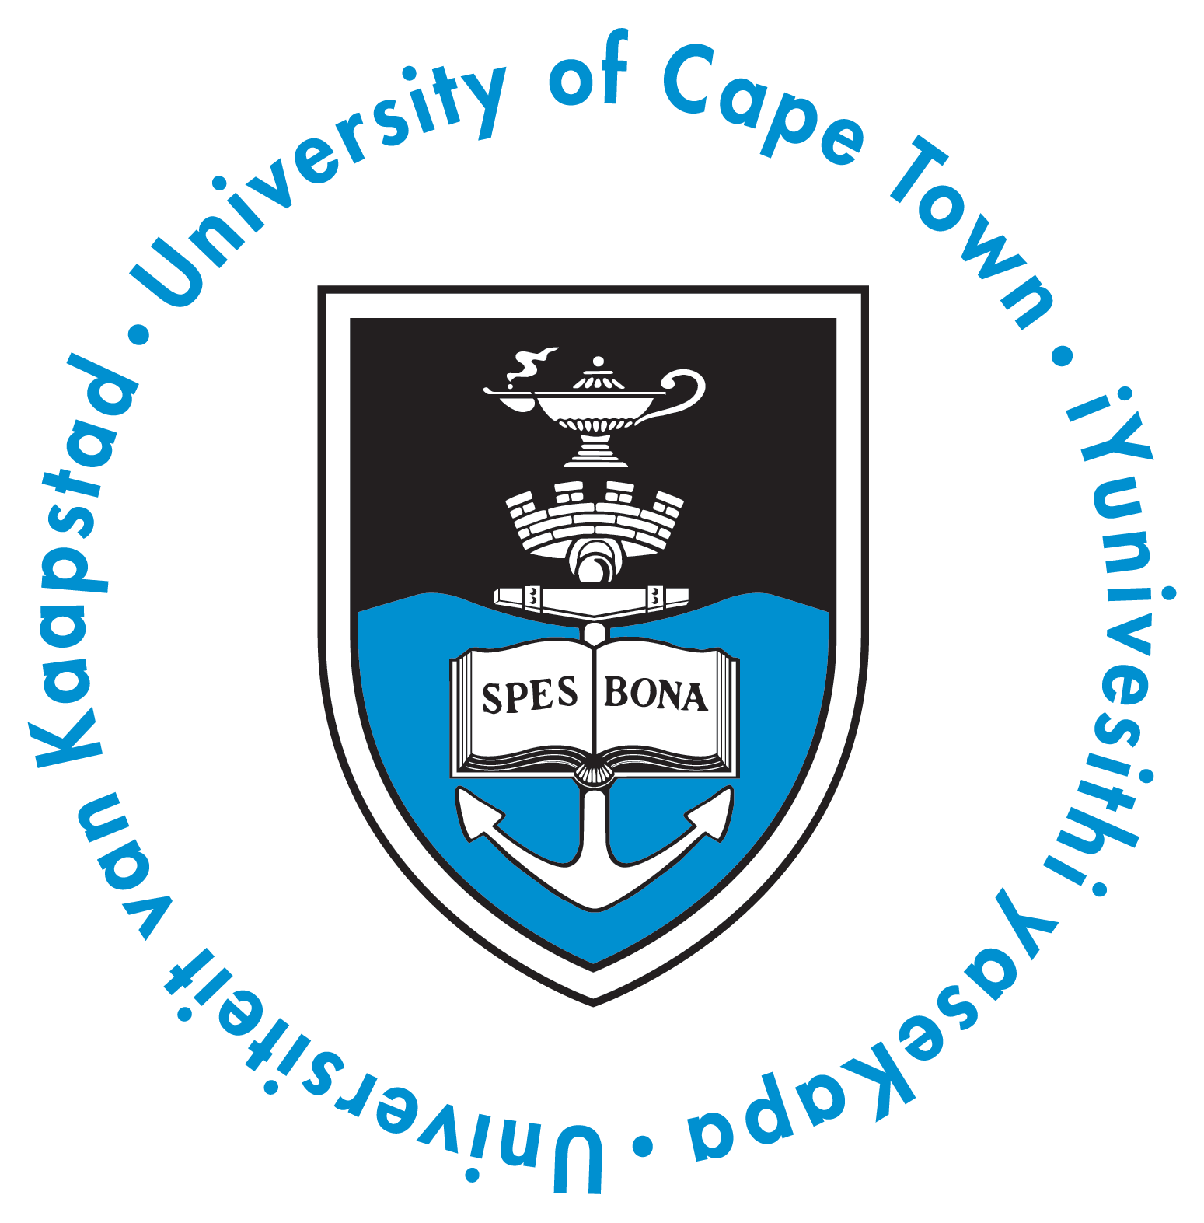

SCHOOL OF PUBLIC HEALTH AND FAMILY MEDICINE
RESEARCH DAY
Addressing poverty and inequality through research

THURSDAY, 15 SEPTEMBER 2016
VALEDICTORY OF

Professor Rodney Ehrlich
Former Head of Occupational Medicine Division
“The system is in their tale – the case of Occupational Medicine”

Opening
12h00 – 12h25 |  | Registration Tea
12h30 – 12h40 |  | Welcome by A/Prof Hanne-Andrea Rother, Chair of Departmental Research Committee and Head of Division of Environmental Health
12h40 – 12h55 Keynote opening address – Prof Crain Soudien, CEO of Human Sciences Research Council
Presentations
13h00 – 13h30 | Women’s Health Research Unit (WHRU) & Social and Behavioural Sciences Division
13h30 – 14h00 Health Economics Unit (HEU), Health Economics Division & Health Policy and Systems Division
14h00 – 14h30 | Centre for Environmental and Occupational Health Research (CEOHR), Occupational Medicine Division & Environmental Health Division
14h30 – 15h00 | Public Health Medicine Division & Family Medicine Division
15h00 – 15h30 | Tea and Poster Viewing
15h30 – 16h00 | Centre for Infectious Disease Epidemiology Research (CIDER) & Epidemiology and Biostatistics Division
16h00 – 17h00 | Postgraduate Student Poster Presentations and Awards

Valedictory
17h00 – 17h10 Introduction of Valedictory of Prof Rodney Ehrlich – Prof Landon Myer
17h10 – 17h55 Valedictory Address – Prof Rodney Ehrlich
Closing
17h55 – 18h05 | Vote of Thanks and Closing – Professor Mohamed Jeebhay, HOD of School of Public Health and Family Medicine
18h05 – 19h05 | Socializing function with eats

*

Please RSVP to Liza Smith (Liza.smith@uct.ac.za) for catering purposes before 12th September 2016

Programme
WOLFSON LECTURE THEATRE & FOYER
CPD available: 6 general points

