 [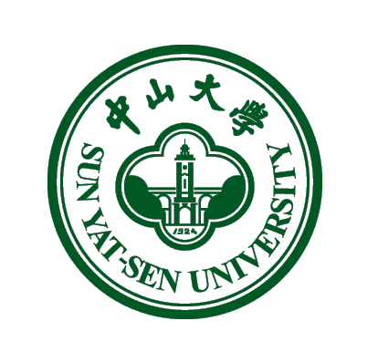](http://www.google.co.za/url?sa=i&source=imgres&cd=&cad=rja&uact=8&ved=0CAwQjRwwAA&url=http://en.wikipedia.org/wiki/Sun_Yat-sen_University&ei=LZlZVbiBHMjsUpXRgdAN&psig=AFQjCNF4lzWpiXGVPZRHViPwuNyIyqtQxA&ust=1432021677561826)

**HEALTH SCIENCES FACULTY**

WOULD LIKE TO PRESENT A LUNCH TIME TALK BY

PROFESSOR Yiping li

**"An overview of Sun Yat-sen University Zhongshan School of Medicine and Novel hepatitis C virus infectious cell culture systems"**



*Yiping Li, Ph.D., Professor of Molecular Virology, Institute of Human Virology, Zhongshan School of Medicine, Sun Yat-sen University (SYSU), Guangzhou, China. In 2004, Dr. Yiping Li received Ph.D. degree in Biochemistry and Molecular Biology from China Agricultural University, Beijing, China. From 2003 to 2004 and 2006 to 2007, he worked as a visiting scholar, project researcher, and postdoctoral researcher in the National Veterinary Institute, Technical University of Denmark (previous Royal Danish Veterinary Institute). From 2005, he started hepatitis C virus (HCV) research in the Vaccine and Infectious Disease Organization (VIDO), University of Saskatchewan, Canada, and then joined the Copenhagen Hepatitis C Program (CO-HEP), Hvidovre Hospital and Faculty of Health and Medical Sciences, University of Copenhagen, Denmark. Dr. Li took a professor position in Zhongshan School of Medicine, SYSU in January 2014.*

*Dr. Yiping Li’s research interests are in the infection and immunity of HCV. Dr. Li has made important contributions, which have included the discoveries on the host RNA insertion-mediated viral resistance to antiviral effect of miR-122 antagonism, the development of novel full-length infectious culture systems for HCV genotypes 1a, 2a and 2b, as well as chimeric culture systems for HCV genotypes 3a, 4a, 5a, and 6a. Dr. Li’s works have led to publications on well-known journals, such as PNAS, Gastroenterology, Hepatology, PLoS Pathogens, Journal of Virology, and Virology. In addition, Dr. Li also worked on animal viruses and Campylobacter. Dr. Li’s research activities have produced 25 publications, 3 U.S. patent applications and 21 conference abstracts; these have included 12 first author publications (served also as corresponding author in 3 publications) and 5 oral presentations out of 13 first author abstracts in outstanding conferences.*

**Date: Friday 22 May 2015**

**Time: 12h00 -13h00**

**Venue: Jolly Lecture Theatre, IDM**

**For an appointment with Professor Yiping Li, please contact: nikki.henry@uct.ac.za**