****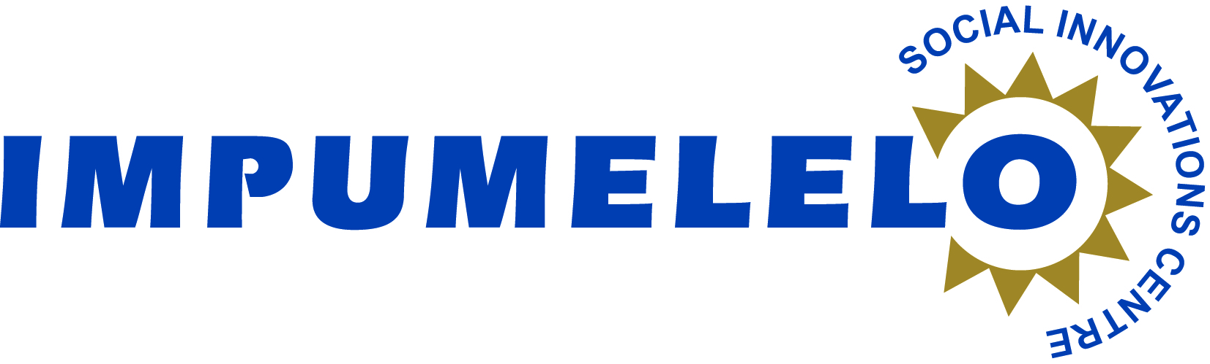

**Health-Care Summit on 14 March 2014**

Impumelelo Social Innovation Centre in partnership with the University of Stellenbosch Business School (USB) will host a HEALTH- CARE SUMMIT on Friday 14th of March at USB, Auditorium, Room 210, USB, Bellville Campus (Time: 09h30-15h00). Projects from the Western Cape, KwaZulu-Natal, Eastern Cape and Mpumalanga will be presented.

This is a unique learning opportunity to present exemplary social innovations in the health–Care sector to key government managers, students and academics, and representatives from NGOs and CBOs, to learn from Impumelelo’s Award Winners. The Health-Care Summit is an ideal platform for the cross-pollination of ideas, for peers to learn from each other, for exposing others to solutions that do exist, and for showcasing the myriad of solutions to SA’s intractable health problems.

Impumelelo is a leading awards programme in South Africa. The Health-Care Summit provides a platform and forum for award winning projects to share lessons and to encourage and train others to adopt and replicate their successes elsewhere in South Africa.

The Health-Care Summit focuses on 13 Health-Care and HIV/TB Award Winners which are examples of innovative strategies and systemic interventions addressing various challenges within the health-care sector.

The following projects are presenting:

* Desmond Tutu HIV Foundation Sizophila Project
* FASD, Prevention and Intervention
* Administrative Support for TB Programme
* ARV Clubs for managing large numbers of patients
* Total Control of the Epidemic
* UKZN: 20 000+ Project PMTCT
* SACTWU Worker Health Programme
* TB/HIV Care Association: Project Integrate-Sisonke
* Closing the Gaps
* Perinatal Mental Health Programme
* Phelophepa Health Care Train
* Umthombo Youth Development Foundation
* Uitenhage Eye Clinic

Senior managers and academics will be exposed to the processes to the successful systemic interventions designed to relieve the health-care system from the burden of disease. The range of projects aims to transform policy into action, to improve the quality of life of citizens, and to create opportunities for citizen responsibility.

For more information on Impumelelo or to attend please contact:

Chris Mingo

T: 021 424 6360

E: [chris@impumelelo.org.za](mailto:chris@impumelelo.org.za)

C: 071 610 7123