Physiology at the Extremes
04 September 2014

Seminar hosted by University of Cape Town, Division of Forensic Medicine.

NEW Developments
We added three new value enhancing features.
Deadline for early registration extended
to

01 August 2014

Additional international speakers to
address the alcohol and drug risks in
extreme situations.
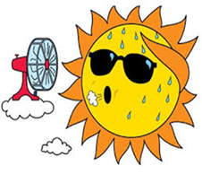
Speakers
Prof Mike Tipton
Dr Paul Skett
Stephanie Sharp
Dr Caroline D'Alton



For more information please visit our website http://extremephysiology2014.co.za/

