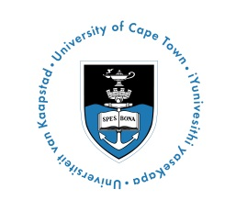

**IMPERIAL-UNIVERSITY OF CAPE TOWN GLOBAL HEALTH FELLOWS PROGRAMME**

**APPLICATION FORM**

Thank you for your interest in the Imperial-University of Cape Town Global Health Fellows Programme, 25-31 January 2015. Please complete the following form to submit an application, ensuring that you refer to the applicant criteria as outlined in the programme advertisement.

**APPLICATION DEADLINE: 16 DECEMBER 2014 at 23h59.**

To submit, email your completed application form and 2-pg CV to [Kathryn.Wood@uct.ac.za](mailto:Kathryn.Wood@uct.ac.za).

If you have any questions, please contact [Yolande.Harley@uct.ac.za](mailto:Yolande.Harley@uct.ac.za).

Applicants should expect to hear back about whether they have been shortlisted for the programme by end December 2014.

**YOUR DETAILS**

|  |  |
| --- | --- |
| Title |  |
| First name |  |
| Last name |  |
| Phone number |  |
| Email |  |
| Department |  |
| Programme of study |  |
| Registration date |  |

|  |
| --- |
| Please explain in detail how you meet the applicant criteria as outlined in the detailed advertisement and why you are a strong applicant for this programme [500 words max] |
|  |

|  |
| --- |
| Please explain your interest in Global Health and how you plan to engage with current topics in Global Health [500 words max] |
|  |

**YOUR CURRENT SUPERVISOR**

Please provide the name and contact information of your current supervisor at UCT

|  |  |
| --- | --- |
| Title |  |
| First name |  |
| Last name |  |
| Phone number |  |
| Email |  |
| Department |  |
| Position |  |

I confirm that my supervisor has agreed for me to attend this course

|  |  |
| --- | --- |
| Yes | No |

**CURRICULUM VITAE**

Please submit a copy of your CV with your application [2 pages max]